RELIABILITY TEST REPORT

PRODUCT: S58M/VT7100

Issue Date: October 2, 2000

PREPARED BY:
Steven H.C. Li n
Engineer:
Reliability Engineering Department

APPROVED BY: REVIEWED BY:
Homer Yu Glavin Hsu
Director: Technical Manager
Component & Reliability Engineering Reliability Engineering Department
Center

0. Conclusion
I. The test results are listed as follows:
1. Acceptance Criteria of C3 Entry
2. Voltage Dips & Short Interruptions Immunity Test
3. Electrical Fast Transient/Burst Immunity Test
4. Surge Immunity Test
5. Electrostatic Discharge Susceptibility Test
6. DC Margin Test
7. Line Voltage and Frequency Test
8. Power ON/OFF Characteristics
9. Temperature/Thermal Profile Test
10. Operating Temperature and Humidity Test
11. Non-operating Temperature and Humidity Test
12. Operating Vibration Test t
13. Non-operating Vibration Test
14. Acoustic Noise Measurement
15. Transportation Drop Test
16. AC Power Consumption Measurement Note

Note: The SKU B system add on LEADTEK Winfast Geforce 256 32MB SDR+TV Out + DVI VGA card, so power consumption to high, can’t under EPA SPEC. 30W.

II. Details of Some Definitions:
1. The following definitions of the Performance Criteria are defined by Acer Inc. according to IEC-1000-4-11 Basic Standard. On the basis of the operating conditions and functional specifications of the equipment under test, the test results shall be classified as in the following, Unless, different specifications are given by product specifications.

Performance Criteria | Error Level | Description
A | No Error | Normal performance within the specification limits.
B | Soft Error | Temporary degradation or loss of function or performance which is self-recoverable.
C | Re-start Error | Temporary degradation or loss of function or performance which requires operator intervention or system reset.
D | Damage Error | Degradation or loss of function which is not recoverable due to damage of equipment (components) or software, or loss of data.

2. Test Software:
Scorpion 1
• HDD R/W and Compare repeatedly
• FDD R/W and Compare repeatedly
• CD-ROM/DVD-ROM Play Movie CD

Scorpion 2
• QAPluse or HDD13.EXE (for Acoustic noise test only)

III. Test Configuration List:
Brand / model | SKU A (505) | SKU B (506)
Main Board | S58M-1 | S58M-1
CPU | P iii 550 MHz/100MHz | P iii 733MHz/133MHz
Heat-sink
Memory | MICRON 64MB 0.18u / PC-100 | MICRON 128MB 0.18u /PC-133
System chipset | Intel F82815 | Intel F82815
HDD | Seagate U10 15.3GB (ST315323A) | Seagate Cuda II 15.3GB (ST315320A)
FDD | Panasonic JU-256A-046P C | Panasonic JU-256A-046P C
Daughter Board | S58M USB/Audio board
CD-ROM | AOPEN 48X CD-948E/AKU F
Modem card | Askey 56K Modem 1456VQH20E | Askey 56K Modem 1456VQH20E
Key Board | API 6511-UA41/E | API 6511-UA41/E
CDRW |  | SONY CRX140E (8X4X32)
DVD-ROM |  | HITACHI 8X GD-7000
VGA card |  | LEADTEK Winfast Geforce 256 32MB SDR+TV Out + DVI
LAN card |  | 3com 3C905C-TXM
Mouse | Primax USB 3D, MOSXU | Primax USB 3D, MOSXK
SPS | DELTA 5V/3A DPS-200PB-82 | Hipower 200W
Housing | H80 | H80

Brand / model | SKU C (507) | SKU D
Main Board | S58M-1 | S58M-1
CPU | P iii 866 MHz/133MHz | P iii 500MHz
Heat-sink
Memory | Infineon 128MB 0.19u /PC-133 | Infineon 128MB 0.19u /PC-100
System chipset | Intel F82815 | Intel F82815
HDD | Seagate Cuda II ST320430A (20.4GB) | Seagate U10 20.4GB (ST320423A)
FDD | Panasonic JU-256A-046P C | Panasonic JU-256A-046P C
CD-ROM |  | AOPEN 48X CD-948E/AKU F
CDRW | LG 8X4X32X VED-8080 IBE
DVD-ROM | HITACHI 8X GD-7000
VGA card | LEADTEK Winfast 3D S325 (M64) 32MB | ATI RAGE 128/XPERT99
LAN | NIC-559A | ALN 325 W/8139B-F
Modem card | Ambit T62M154.00 | Ambit T62M154.01
Daughter Board | S58M USB/Audio board
Key Board | API 6511-UA41/E | API 6511-UA41/E
Mouse | Logitech U48A | Primax 2D, MUSXJ
SPS | DELTA 5V/3A DPS-200PB-82 | Hipower 200W
Housing | H80 | H80

1. Acceptance Criteria of C3 Entry

(a) Test Equipment:
1. Blank FDD
2. VCD
3. QAFE test program

(b) Test Criteria:
1. Function check:
No any major problem allowed in each function check; each minor problem should be scheduled to
be cleared in limited time period.
2. Appearance/mechanical function check:
No major mechanical function problem (e.g. Floppy disk locked in FDD drive, CDROM tray
can not be ejected, etc.) , no obvious assembly gap (0.8mm), no uniformity problem, no unit
wobbles (0.5mm)

Test Result:
1. Function check
 | Test Item | Results
 | Test Item | SKU A | SKU B | SKU C | SKU D
1 | Power on, Enter and Exit Windows 98 and power off for 5 times | PASS | PASS | PASS | PASS
2 | Check device manager of system property in control panel | PASS | PASS | PASS | PASS
3 | QAFE quick check (use battery only) | PASS | PASS | PASS | PASS
4 | Scorpion I test program long run test | PASS | PASS | PASS | PASS
Table 1-1
2. Appearance/mechanical function check:
 | Test Item | Results
 | Test Item | SKU A | SKU B | SKU C | SKU D
1 | Check all doors and covers mechanical function | PASS | PASS | PASS | PASS
2 | Check all switches and buttons mechanical function | PASS | PASS | PASS | PASS
3 | Check if there are units wobbles (moving distance is more than 0.5mm) | PASS | PASS | PASS | PASS
4 | Check if the assembly gap is more than 0.8mm | PASS | PASS | PASS | PASS
5 | Check if there are uniformity problems | PASS | PASS | PASS | PASS
Table 1-2

2. Voltage Dips & Short Interruptions Immunity Test
(a) Test Equipment:
1. Pacific Power Source 140TMX
2. CHROMA programmable AC Source, Model: 6120
3. Other relevant equipment

(b) Test Specifications:
U_{T}: The lower and upper limit of input AC voltage of the SPS (e.g. if input range of the adapter is 100Vac to 240Vac, then U_{T} = 100Vac and 240Vac)
Condition | Test level  (% of U_{T}) | Duration (ms) | Number of disturbance | Polarity | Time interval between shoots
1 | 0 | 5000 | 3 | 90°  and  0°, 180° | Depends on the time  to enter windows  environment
2 | 40 | 100 | 3 | 90°  and  0°, 180° | Depends on the time  to enter windows  environment
3 | 70 | 10 | 6 | 90°  and  0°, 180° | 10s

Table 2-1

Note: U_{T} stands for the test nominal voltage.

(e) Test Criteria:
1. Adapter only
Condition | Performance criterion (permitted)
1 | C
2 | C
3 | B

Table 2-2
Test Result:
A. U_{T}: the lower limit of input voltage of the SPS
Test level  % U_{T} | Voltage dip and short interruptions  % U_{T} | Duration | Performance Criteria | Phase | Result
 |  |  |  |  | SKU B | SKU C
0 | 100 | 5000 ms | C | 0° | Pass | Pass
 |  |  |  | 90° | Pass | Pass
 |  |  |  | 180° | Pass | Pass
40 | 60 | 100 ms | C | 0° | Pass | Pass
 |  |  |  | 90° | Pass | Pass
 |  |  |  | 180° | Pass | Pass
70 | 30 | 10 ms | B | 0° | Pass | Pass
 |  |  |  | 90° | Pass | Pass
 |  |  |  | 180° | Pass | Pass
Table 2-3

B. U_{T}: the upper limit of input voltage of the SPS
Test level  % U_{T} | Voltage dip and short interruptions  % U_{T} |  |  | Duration | Performance Criteria | Phase | Result
 |  |  |  |  |  |  | SKU B | SKU C
0 |  |  | 100 | 5000 ms | C | 0° | Pass | Pass
 |  |  |  |  |  | 90° | Pass | Pass
 |  |  |  |  |  | 180° | Pass | Pass
40 |  | 60 |  | 100 ms | C | 0° | Pass | Pass
 |  |  |  |  |  | 90° | Pass | Pass
 |  |  |  |  |  | 180° | Pass | Pass
70 |  | 30 |  | 10 ms | B | 0° | Pass | Pass
 |  |  |  |  |  | 90° | Pass | Pass
 |  |  |  |  |  | 180° | Pass | Pass
Table 2-4

3. Electrical Fast Transient/Burst Immunity Test
(a) Test Specifications:
.1. Input AC power ports
- Rise time of one pulse : 5ns
- Impulse duration : 50ns
- Repetition frequency of the impulses : 5kHz
- Charge voltage : +/- 1kV
- Duration of the test for each condition : 1 minutes
- Ports to be tested : L & N
.2. Ports for signal lines and control lines (if modem or network adapter module is built in the system)
- Rise time of one pulse : 5ns
- Impulse duration : 50ns
- Repetition frequency of the impulses : 5kHz
- Charge voltage : +/- 0.5kV
- Duration of the test for each condition : 1 minutes
Note: Capacitive coupling clamp used

(b) Test Criteria:
1.Test on AC power port:
Error Level / Testing voltage | ±500V | ±750V | ±1000V | ±1250V
Performance criteria permitted | A | A | B | Margin Test for reference
Table 3-1
2.Test on signal line or control line:
Error Level / Testing voltage | ±250V | ±500V | ±750V
Performance criteria permitted | A | B | Margin Test for reference
Table 3-2
Test Results
- Input AC power ports
Order | Test Point |  | Burst applied |  | Performance during test |  | Results
 |  |  |  |  |  |  | SKU B |  | SKU C
1 | L |  | + 500 V |  | A |  |  | Pass | Pass
2 | N |  | + 500 V |  | A |  |  | Pass | Pass
3 | L |  | - 500 V |  | A |  |  | Pass | Pass
4 | N |  | - 500 V |  | A |  |  | Pass | Pass
5 | L |  | + 750 V |  | A |  |  | Pass | Pass
6 | N |  | + 750 V |  | A |  |  | Pass | Pass
7 | L |  | - 750 V |  | A |  |  | Pass | Pass
8 | N |  | - 750 V |  | A |  |  | Pass | Pass
9 | L |  | + 1000 V |  | B |  |  | Pass | Pass
10 | N |  | + 1000 V |  | B |  |  | Pass | Pass
11 | L |  | - 1000 V |  | B |  |  | Pass | Pass
12 | N |  | - 1000 V |  | B |  |  | Pass | Pass
13 | L (for reference) |  | + 1250 V |  | B |  |  | Pass | Pass
14 | N (for reference) |  | + 1250 V |  | B |  |  | Pass | Pass
15 |  | L (for reference) |  | - 1250 V | B | Pass |  |  | Pass
16 |  | N (for reference) |  | - 1250 V | B | Pass |  |  | Pass
Table 3-3

Note: Burst applied to L and N is asynchronous

2. Signal line or control line
Order | Test Point | Burst applied | Performance  during test | Results
 |  |  |  | SKU B | SKU C
1 | Modem line | + 250 V | A | Pass | Pass
2 | Modem line | - 250 V | A | Pass | Pass
3 | Modem line | + 500 V | B | Pass | Pass
4 | Modem line | - 500 V | B | Pass | Pass
5 | Modem line  (for reference) | + 750 V | B | Pass | Pass
6 | Modem line  (for reference) | - 750 V | B | Pass | Pass
7 | Network line | + 250 V | A | Pass | Pass
8 | Network line | - 250 V | A | Pass | Pass
9 | Network line | + 500 V | B | Pass | Pass
10 | Network line | - 500 V | B | Pass | Pass
11 | Network line  (for reference) | + 750 V | B | Pass | Pass
12 | Network line  (for reference) | - 750 V | B | Pass | Pass
Table 3-4

4. Surge Immunity Test
(a) Test Specification
Test Mode | Test Voltage | Polarity | Phase Shifting | No. of surges | Repetition Rate
Line to line  (differential mode) | 1kV | Positive &  negative | 0°, 90° and 270° | 5 | 1 surge/minute
Line to ground  (common mode) | 2kV | Positive &  negative | 0°, 90° and 270° | 5 | 1 surge/minute
Table 4-1
Note: Lower voltage levels must pass the test too.
(b) Test Criteria:
1. AC power port: Line to Line
Error Level \Testing voltage | ±500V | ±750V | ±1000V | ±1250V
Performance criteria permitted | A | A | B | Margin Test for reference
Table 4-2
2. AC power port: Line to ground
Error Level \Testing voltage | ±1000V | ±1500V | ±2000V | ±2250V
Performance criteria permitted | A | A | B | Margin Test for reference
Table 3-3
Test Result:
1. Line to Line (No. of surges applied in each sub-item: 5)
Item | Mode |  | Phase |  | Impulse Voltage |  | Performance | Result
 |  |  |  |  |  |  |  | SKU B | SKU C
1 | L to N | 0° |  | 500V |  | A |  | Pass |  | Pass
2 | L to N | 90° |  | 500V |  | A |  | Pass |  | Pass
3 | L to N | 270° |  | 500V |  | A |  | Pass |  | Pass
4 | L to N | 0° |  | -500V |  | A |  | Pass |  | Pass
5 | L to N | 90° |  | -500V |  | A |  | Pass |  | Pass
6 | L to N | 270° |  | -500V |  | A |  | Pass |  | Pass
7 | L to N | 0° |  | 750V |  | A |  | Pass |  | Pass
8 | L to N | 90° |  | 750V |  | A |  | Pass |  | Pass
9 | L to N | 270° |  | 750V |  | A |  | Pass |  | Pass
10 | L to N | 0° |  | -750V |  | A |  | Pass |  | Pass
11 | L to N | 90° |  | -750V |  | A |  | Pass |  | Pass
12 | L to N | 270° |  | -750V |  | A |  | Pass |  | Pass
13 | L to N | 0° |  | 1000V |  | B |  | Pass |  | Pass
14 | L to N | 90° |  | 1000V |  | B |  | Pass |  | Pass
15 | L to N | 270° |  | 1000V |  | B |  | Pass |  | Pass
16 | L to N | 0° |  | -1000V |  | B |  | Pass |  | Pass
17 | L to N | 90° |  | -1000V |  | B |  | Pass |  | Pass
18 | L to N | 270° |  | -1000V |  | B |  | Pass |  | Pass
19 | L to N | 0° |  | 1250V |  | B |  | Pass |  | Pass
20 | L to N | 90° |  | 1250V |  | B |  | Pass |  | Pass
21 | L to N | 270° |  | 1250V |  | B |  | Pass |  | Pass
22 | L to N | 0° |  | -1250V |  | B |  | Pass |  | Pass
23 | L to N | 90° |  | -1250V |  | B |  | Pass |  | Pass
24 | L to N | 270° |  | -1250V |  | B |  | Pass |  | Pass
Table 4-5
2. Line to PE: (No. of surges applied in each sub-item: 5; in case there is safety ground of the system)
Item |  | Mode |  | Phase |  | Impulse Voltage |  | Performance |  | Result
 |  |  |  |  |  |  |  |  |  | SKU B |  | SKU C
1 | L to PE |  | 0° |  | 1000V |  | A |  | Pass |  | Pass
2 | L to PE |  | 90° |  | 1000V |  | A |  | Pass |  | Pass
3 | L to PE |  | 270° |  | 1000V |  | A |  | Pass |  | Pass
4 | N to PE |  | 0° |  | 1000V |  | A |  | Pass |  | Pass
5 | N to PE |  | 90° |  | 1000V |  | A |  | Pass |  | Pass
6 | N to PE |  | 270° |  | 1000V |  | A |  | Pass |  | Pass
7 | L to PE |  | 0° |  | -1000V |  | A |  | Pass |  | Pass
8 | L to PE |  | 90° |  | -1000V |  | A |  | Pass |  | Pass
9 | L to PE |  | 270° |  | -1000V |  | A |  | Pass |  | Pass
10 | N to PE |  | 0° |  | -1000V |  | A |  | Pass |  | Pass
11 | N to PE |  | 90° |  | -1000V |  | A |  | Pass |  | Pass
12 | N to PE |  | 270° |  | -1000V |  | A |  | Pass |  | Pass
13 | L to PE |  | 0° |  | 1500V |  | A |  | Pass |  | Pass
14 | L to PE |  | 90° |  | 1500V |  | A |  | Pass |  | Pass
15 | L to PE |  | 270° |  | 1500V |  | A |  | Pass |  | Pass
16 | N to PE |  | 0° |  | 1500V |  | A |  | Pass |  | Pass
17 | N to PE |  | 90° |  | 1500V |  | A |  | Pass |  | Pass
18 | N to PE |  | 270° |  | 1500V |  | A |  | Pass |  | Pass
19 | L to PE |  | 0° |  | -1500V |  | A |  | Pass |  | Pass
20 | L to PE |  | 90° |  | -1500V |  | A |  | Pass |  | Pass
21 | L to PE |  | 270° |  | -1500V |  | A |  | Pass |  | Pass
22 | N to PE |  | 0° |  | -1500V |  | A |  | Pass |  | Pass
23 | N to PE |  | 90° |  | -1500V |  | A |  | Pass |  | Pass
24 | N to PE |  | 270° |  | -1500V |  | A |  | Pass |  | Pass
25 | L to PE |  | 0° |  | 2000V |  | B |  | Pass |  | Pass
26 | L to PE |  | 90° |  | 2000V |  | B |  | Pass |  | Pass
27 | L to PE |  | 270° |  | 2000V |  | B |  | Pass |  | Pass
28 | N to PE |  | 0° |  | 2000V |  | B |  | Pass |  | Pass
29 | N to PE |  | 90° |  | 2000V |  | B |  | Pass |  | Pass
30 | N to PE |  | 270° |  | 2000V |  | B |  | Pass |  | Pass
31 | L to PE |  | 0° |  | -2000V |  | B |  | Pass |  | Pass
32 | L to PE |  | 90° |  | -2000V |  | B |  | Pass |  | Pass
33 | L to PE |  | 270° |  | -2000V |  | B |  | Pass |  | Pass
34 | N to PE |  | 0° |  | -2000V |  | B |  | Pass |  | Pass
35 | N to PE |  | 90° |  | -2000V |  | B |  | Pass |  | Pass
36 | N to PE |  | 270° |  | -2000V |  | B |  | Pass |  | Pass
37 | L to PE |  | 0° |  | 2250V |  | B |  | Pass |  | Pass
38 | L to PE |  | 90° |  | 2250V |  | B |  | Pass |  | Pass
39 | L to PE |  | 270° |  | 2250V |  | B |  | Pass |  | Pass
40 | N to PE |  | 0° |  | 2250V |  | B |  | Pass |  | Pass
41 | N to PE |  | 90° |  | 2250V |  | B |  | Pass |  | Pass
42 | N to PE |  | 270° |  | 2250V |  | B |  | Pass |  | Pass

43 | L to PE | 0° | -2250V | B | Pass | Pass
44 | L to PE | 90° | -2250V | B | Pass | Pass
45 | L to PE | 270° | -2250V | B | Pass | Pass
46 | N to PE | 0° | -2250V | B | Pass | Pass
47 | N to PE | 90° | -2250V | B | Pass | Pass
48 | N to PE | 270° | -2250V | B | Pass | Pass
Table 4-6

5. Electrostatic Discharge Susceptibility Test
Test Specifications and Criteria
1. Climatic conditions shall be within the following ranges: (IEC 1000-4-2)
- Ambient Temperature: 15°C ~ 35°C
- Relative Humidity: 30% ~ 60%
- Atmospheric Pressure: 86kPa to 106kPa
2.
 |  | ESD Voltage Level
Acceptance Criteria | Air Discharge |  | Contact Discharge | Air Discharge | Contact Discharge | Air Discharge | Contact Discharge
 | ±4 kV |  | ±4 kV | ±8 kV | ±6 kV | ±15 kV | ±8 kV
B |  | Not Permitted |  | Permitted |  | Permitted
C |  | Not Permitted |  | Not permitted |  | Permitted
D |  | Not Permitted |  | Not Permitted |  | Not Permitted
Remark |  | Note (1), (2) |  |  |  | Note (3)
Table 5-1
Note: (1): It is a minimum spec. of the add-on card which built in a PC system under an operation
mode.
(2): Following the spec also if the speakers with finger guard are exposed.
(3): It is a minimum spec. of an operating PC whose add-on card under the idle mode.
3. At least 10 single discharges shall be applied to a pre-selected point
4. Time interval between successive single discharge: 1 second (standard) or 3 seconds.
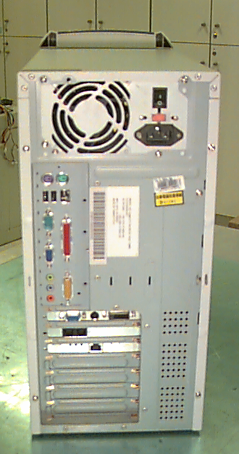
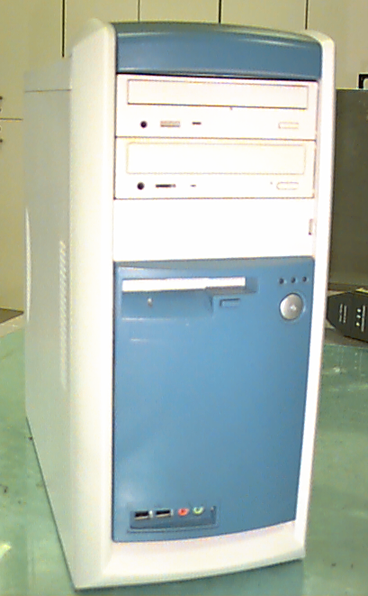
Fig-5-1 ESD test point of System

Test Report:
 | ESD Voltage Level
Test results & Performance | Air Discharge
Criteria | Voltage  Level |  | Performance  Level |  | Voltage  Level |  | Performance  Level |  | Voltage  Level |  | Performance  Level
Test Location | +4kV |  | A/B/C/D |  | +8kV |  | A/B/C/D |  | +15kV |  | A/B/C/D
LED indicators |  | Pass |  | A |  | Pass |  | B |  | Pass |  | C
Power Switch |  | Pass |  | A |  | Pass |  | B |  | Pass |  | C
Aperture around CDROM |  | Pass |  | A |  | Pass |  | B |  | Pass |  | C
Aperture around CDRW |  | Pass |  | A |  | Pass |  | B |  | Pass |  | C
Aperture around DVD-ROM |  | Pass |  | A |  | Pass |  | B |  | Pass |  | C
Aperture around FDD |  | Pass |  | A |  | Pass |  | B |  | Pass |  | C
Upper case |  | Pass |  | A |  | Pass |  | B |  | Pass |  | C
Aperture around USB ports |  | Pass |  | A |  | Pass |  | B |  | Pass |  | C
Aperture around PS/2 ports |  | Pass |  | A |  | Pass |  | B |  | Pass |  | C
Serial port connector hoods |  | Pass |  | A |  | Pass |  | B |  | Pass |  | C
Screws of SPS |  | Pass |  | A |  | Pass |  | B |  | Pass |  | C
Port Brackets |  | Pass |  | A |  | Pass |  | B |  | Pass |  | C
Aperture around Audio input/output jacks |  | Pass |  | A |  | Pass |  | B |  | Pass
Parallel port connector hoods |  | Pass |  | A |  | Pass |  | B |  | Pass |  | C
Game port Connector |  | Pass |  | A |  | Pass |  | B |  | Pass |  | C
VGA connector of VGA Card |  | Pass |  | A |  | Pass |  | B |  | Pass |  | C
Port bracket of LAN card |  | Pass |  | A |  | Pass |  | B |  | Pass |  | C
Outer screws |  | Pass |  | A |  | Pass |  | B |  | Pass |  | C
Right and Left side door |  | Pass |  | A |  | Pass |  | B |  | Pass |  | C
Front side USB/ Audio Ports |  | Pass |  | A |  | Pass |  | B |  | Pass |  | C
Table 5-2

 |  | ESD Voltage Level
Test results & Performance Criteria |  | Contact Discharge
 |  | Voltage  Level |  | Performance  Level |  | Voltage  Level | Performance  Level |  | Voltage  Level |  | Performance  Level
Test Location |  | +4kV |  | A/B/C/D |  | +6kV | A/B/C/D |  | +8kV |  | A/B/C/D
Upper case |  | Pass |  |  | A | Pass | B |  | Pass |  | C
Serial port connector hoods |  | Pass |  |  | A | Pass | B |  | Pass |  | C
Serial port connector hoods |  | Pass |  |  | A | Pass | B |  | Pass |  | C
Screws of SPS |  | Pass |  |  | A | Pass | B |  | Pass |  | C
Port Brackets |  | Pass |  |  | A | Pass | B |  | Pass |  | C
Parallel port connector hoods | Pass |  | A |  |  | Pass | B | Pass |  | C
Game port Connector | Pass |  | A |  |  | Pass | B | Pass |  | C
VGA connector of VGA Card | Pass |  | A |  |  | Pass | B | Pass |  | C
Port bracket of LAN card | Pass |  | A |  |  | Pass | B | Pass |  | C

Outer screws | Pass | A | Pass | B | Pass | C
Right and Left side door | Pass | A | Pass | B | Pass | C
Table 5-3

6. DC Margin Test
(a) Test Specifications
DC Voltage | Requirement
5V+/-5% & 3.3V+/-5% | No any error
Table 6-1
Note: (1) The test specifications of DC voltages depend on the component (DC/DC converter)
specifications of the product (Use Product External Specifications as basis).
(2) Temperature chamber shall be simulate in no air flow environment.

(b) Test Criteria:
DC power change (+/- 5%) with 25°C environment: performance criteria A must be me

Test Result:
1. Function Test
(a) test environment
DC Voltage |  | Scorpion Test Result
 |  | SKU A |  | SKU B
5V -5% & 3.3V +5% | Pass |  | Pass
5V -5% & 3.3V -5% | Pass |  | Pass
5V +5% & 3.3V +5% | Pass |  | Pass
5V +5% & 3.3V -5% | Pass |  | Pass
Table 6-2
Note: The DC voltage depends on the component’s specification.
2. Current consumption test:
The current consumption of the EUT(M.B. only) for each applied voltage are:
SKU A:
Current Consumption Each Voltage Setting
Condition | + 5 V | + 3.3 V | + 12 V
Operating | 2.96~3.2A | 1.89~2.04A | 0.112~0.321A
Idle | 0.978~1.02A | 1.74A | 0.112~0.321A
Table 6-3

SKU C:
Current Consumption Each Voltage Setting
Condition | + 5 V | + 3.3 V | + 12 V
Operating | 4.21~5.2A | 2.07~2.31A | 0.112~0.321A
Idle | 1.678~4.182A | 1.98~2.07A | 0.112~0.321A
Table 6-4

7. Line Voltage and Frequency Test
(a) Test Specifications
1. Function Test I
Voltage 100V/120V (-/+ 10%) : 90~132V
200V/240V (-/+ 10%) : 180~264V
Frequency 50Hz (-/+ 3Hz) : 47~53Hz
60Hz (-/+ 3Hz) : 57~63Hz
Voltage variation (frequency is fixed to 50Hz or 60Hz) : 90V to 264V and 264V to 90V
Frequency variation (voltage is fixed to 115V or 230V) : 47Hz to 63Hz and 63Hz to 47Hz

(b) Test Criteria:
Performance Criteria A must be met for both test conditions
Condition | Voltage & Frequency | Time (minutes) | Condition | Voltage & Frequency | Time  (minutes)
1 | 90V / 47Hz | 15 | 9 | 180V / 47Hz | 15
2 | 90V / 53Hz | 15 | 10 | 180V / 53Hz | 15
3 | 90V / 57Hz | 15 | 11 | 180V / 57Hz | 15
4 | 90V / 63Hz | 15 | 12 | 180V / 63Hz | 15
5 | 132V / 47Hz | 15 | 13 | 264V / 47Hz | 15
6 | 132V / 53Hz | 15 | 14 | 264V / 53Hz | 15
7 | 132V / 57Hz | 15 | 15 | 264V / 57Hz | 15
8 | 132V / 63Hz | 15 | 16 | 264V / 63Hz | 15
Table 7-1
Test Results:
7-1. Fixed Frequency and Voltage test
Frequency | 50Hz |  |  |  | 60Hz
Frequency | 47 Hz |  | 53 Hz |  | 57 Hz |  | 63 Hz
Voltage ( V ) | SKU  A | SKU  B | SKU  A | SKU  B | SKU  A | SKU  B | SKU  A | SKU  B
90 | Pass | Pass | Pass | Pass | Pass | Pass | Pass | Pass
132 | Pass | Pass | Pass | Pass | Pass | Pass | Pass | Pass
180 | Pass | Pass | Pass | Pass | Pass | Pass | Pass | Pass
264 | Pass | Pass | Pass | Pass | Pass | Pass | Pass | Pass
Table7-2
7-2. Variation Frequency and Voltage test
7-2-1. SKU A:
Voltage |  |  | Frequency
Frequency(Hz) | 90V~264V | 264V~90V | Voltage (V) | 47Hz~63Hz | 63Hz~47Hz
50Hz | Pass | Pass | 115Vac | Pass | Pass
60Hz | Pass | Pass | 230Vac | Pass | Pass
Table7-3
7-2-2. SKU B:
Voltage |  |  | Frequency
Frequency(Hz) | 90V~264V | 264V~90V | Voltage (V) | 47Hz~63Hz | 63Hz~47Hz
50Hz | Pass | Pass | 115Vac | Pass | Pass
60Hz | Pass | Pass | 230Vac | Pass | Pass
Table7-4

8. Power ON/OFF Characteristics
(f) Test Specifications
(1) Basic Function Test:
System ON Time : Booting OK in MS-DOS mode
System OFF Time : 20 seconds
ON/OFF Cycle : 1000 times
2) Margin Test:
System ON/OFF time : Less than 1 second
ON/OFF Cycle : 100 times

(g) Test Criteria:
1. Basic function Test:
(1) Successfully boot to MS-DOS mode at each power on/off cycle
(2) No unacceptable RTC data loss
(3) No physical damage after test
(4) Function check OK using QAFE "quick check"
2. Margin Test:
(1) No unacceptable RTC data loss
(2) No damage or safety problem after test
(3) Function check OK using QAFE "quick check"
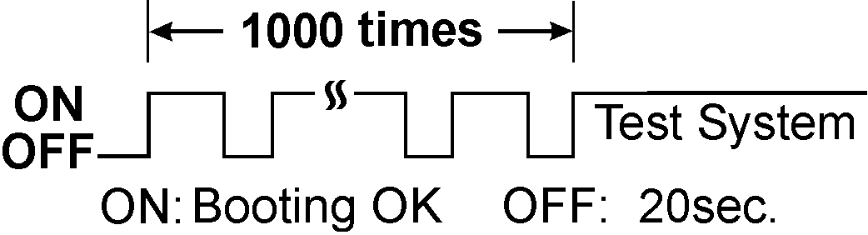
Figure 8-1 Power ON and OFF test curve for basic function test
2. Margin Test:

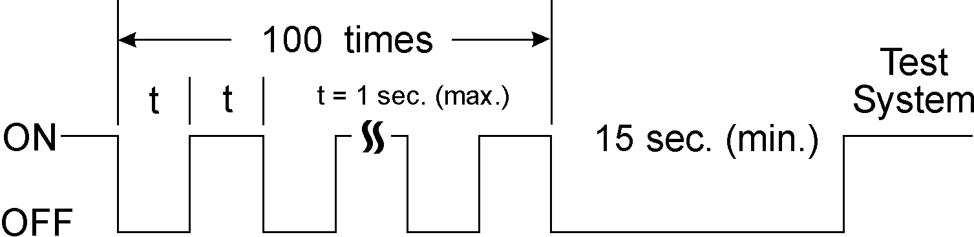
Figure 8-2 Power ON and OFF test curve for margin test

Test Results:
POWER ON/OFF Test |  | Result
 |  | SKU C | SKU D
Function Test | Boot successfully each cycle | Pass | Pass
Function Test | No RTC data loss | Pass | Pass
Function Test | No damage problem after test | Pass | Pass
Function Test | QAFE quick check | Pass | Pass
Margin Test | No RTC data loss | Pass | Pass
Margin Test | No damage problem after test | Pass | Pass
Margin Test | QAFE quick check | Pass | Pass
Table 8-1

9. Temperature/Thermal Profile Test
(a) Field of Application:
1. New notebook system
2. CPU, Chipsets, VGA, Audio, Modem, etc. chip model change
3. Battery pack model change
4. CDROM/DVD-ROM model change
5. FDD/LS-120/ZIP model change
6. HDD model change
7. System fan model change
8. Heat plate (sink) thickness, shape and model change

(b) Test Criteria:
1. Component on main board
(1) Major test points
No. | Chip Name | Point | Tc(max) ° C
1 | CPU | Center of Surface | refer to databook
2 | POWER SUPPLY CONTROLLERS | Center of Surface | 105 or refer to databook
3 | VGA CHIP | Center of Surface | 75 or refer to databook
4 | SOUND CHIP | Center of Surface | 75 or refer to databook
5 | DRAM/SRAM | Center of Surface | 75 or refer to databook
6 | CHIPSETS | Center of Surface | 75 or refer to databook
7 | MODEM CHIP | Center of Surface | 75 or refer to databook
8 | Other chips whose temperature is relative high according to the survey  of IR camera. | Center of Surface | 75 or refer to databook
Table 9-1

Test Result:
Ambient temperature in test room: 26.8°C
Attach the picture of heat plate or heat pipes here
1. Components on main board or other subsystem board using Tc(max) test criteria
SKU A:
COMPONENTS ON MAIN BOARD OR SUBSYSTEM BOARDS
Component location number(Location number of board name) | Component Name  (Vendor name;  model number) | Tc measured  (°C) | 35°C  conversion  temperature | Tc(max)  (°C) | Result
CPU | Piii 733/133MHz | 62.0 | 71.0 | 80 | Pass
Q1 of M.B. | 50N03LT | 73.6 | 82.6 | 125 | Pass
Q2of M.B. | 50N03LT | 63.92 | 72.92 | 125 | Pass
U5 of M.B. | L951XA | 49.68 | 58.68 | 75 | Pass
U13 of M.B. | SMSC 74210 | 46.16 | 55.16 | 75 | Pass
U10 of M.B. | FW82815 | 54.8 | 63.8 | 75 | Pass
U12 of M.B. | ST75185C | 48.96 | 57.96 | 75 | Pass
U19 of M.B. | INTEL 938SE | 39.20 | 48.20 | 75 | Pass
U17 of M.B. | AD1881 | 46.48 | 55.48 | 75 | Pass
VR1 of M.B. | 78M05 | 46.88 | 55.88 | 75 | Pass
Q13 of M.B. | PHD50N03 | 42.0 | 51.0 | 125 | Pass
Q9 of M.B. | PHD50N03 | 46.32 | 55.32 | 125 | Pass

COMPONENTS ON MAIN BOARD OR SUBSYSTEM BOARDS
Component location number(Location number of board name) | Component Name  (Vendor name;  model number) | Tc measured  (°C) | 35°C  conversion  temperature | Tc(max)  (°C) | Result
Q5 of M.B. | PHD50N03 | 43.2 | 52.2 | 125 | Pass
Q8 of M.B. | PHD50N03 | 45.28 | 54.28 | 125 | Pass
Q4 of M.B. | EZ1117CM | 63.92 | 72.92 | 125 | Pass
U6 of M.B. | ICS9250B | 72.8 | 81.8 | 85 | Pass
Table 9-2

SKU C:
COMPONENTS ON MAIN BOARD OR SUBSYSTEM BOARDS
Component location number(Location number of board name) | Component Name  (Vendor name;  model number) | Tc measured  (°C) | 35°C  conversion  temperature | Tc(max)  (°C) | Result
CPU | Piii 866/133MHz | 59.0 | 65.0 | 80 | Pass
U10 of M.B. | FW82815 | 53.2 | 58.2 | 75 | Pass
U7 of M.B. | SC1164CSW | 46.56 | 64.84 | 75 | Pass
U6 of M.B. | 9250BF-28 | 64.56 | 69.56 | 85 | Pass
Q1 of M.B. | 50N03LT | 63.84 | 68.84 | 125 | Pass
Q2 of M.B. | 50N03LT | 59.44 | 64.44 | 125 | Pass
L1 of M.B. | COIL | 51.44 | 56.44 | 125 | Pass
TC3 of M.B. | 1000u/16V | 48.08 | 53.08 | 105 | Pass
Note:
1.This table shows only the components whose temperature rises above 50°C.
2. Tj = Tc + Pd * θ_{JC} or Tj = T_{A} + Pd * θ_{JA} ≈ (Tc - 5) + Pd * θ_{JA}

10. Operating Temperature and Humidity Test
(a) Test Specifications
Low temperature : 0°C / humidity not controlled
High temperature & low humidity : +40°C / 20% R.H.
High temperature & high humidity : +40°C/ 80% R.H.
Notes:
1) Temperature and humidity gradient should be less than 20°C /hour and 20% R.H. /hour,
respectively, to prevent condensation.
2) Above humidity is non-condensing
3) Provided that the maximum wet-bulb temperature is 32° C at high temperature and high
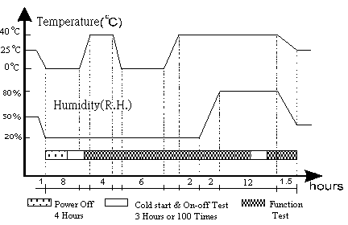 humidity condition.

Figure 10-1 Operating temperature/humidity cycling test curve
.

(b) Test Criteria:
1. Performance criteria A must be met during and after the test
2. During the test, temperature margin (5°C) must be added if number of test samples is less than
two.

Test Results:
Test Item |  | Cold start  test | On-Off Test  at low temperature | On-Off Test  at high temperature | Function Test | Physical  Check
 | SKU A | Pass | Pass | Pass | Pass | Pass
Operating | SKU B | Pass | Pass | Pass | Pass | Pass
 | SKU C | Pass | Pass | Pass | Pass | Pass
 | SKU D | Pass | Pass | Pass | Pass | Pass
Table 10-1

11. Non-operating Temperature and Humidity Test
(a) Test Specifications
A. Un-packed
Low temperature : -10°C / humidity not controlled
High temperature & low humidity : +60°C / 20% R.H.
High temperature & high humidity : +60°C/ 80% R.H.
B. Storage Package
Low temperature : -20C / humidity not controlled
High temperature & low humidity : +60°C / 20% R.H.
High temperature & high humidity : +60°C/ 90% R.H.

Notes:
1. Temperature gradient should be less than 20°C /hour and 20%RH/hour to prevent condensation.
2. Above humidity is non-condensing
3. Provided that the maximum wet-bulb temperature is 32° C at high temperature and high humidity condition.

(b) Test Criteria:
A. Un-packed
1. Performance criteria A must be met after the test
2. Appearance and mechanical function
- No dent.
- No crack
- No mold speckle
- No unclear letter, broken line
- No easily removed button
- Input and output terminals' connection must be easily matched
- No units wobbles
- No migration materials in the set's plinths (e.g. foot of EUT dropped off)
- No letters or symbols on cabinet are missing
- No transfigure, deformity
- No stiffness or squeak for buttons when pressed
- No warp or rust for metal parts
- No slack (e.g. screw loose)
B. Storage Package
1. Performance criteria A must be met after the test
2. Appearance and mechanical function
- No scratch
- No dent.
- No crack
- No mold speckle
- No unclear letter, broken line
- No easily removed button
- No obvious fingerprint to degrade the quality image of the product.
- Input and output terminals' connection must be easily matched
- No units wobbles
- No migration materials in the set's plinths (e.g. foot of EUT dropped off)
- No letters or symbols on cabinet are missing
- No transfigure, deformity
- No stiffness or squeak for buttons when pressed
- No warp or rust for metal parts
- No slack (e.g. screw loose)
- No cracks or severe damage to cushion
- No server damage or crack to carton box

(c) Test Software
QAFE quick check

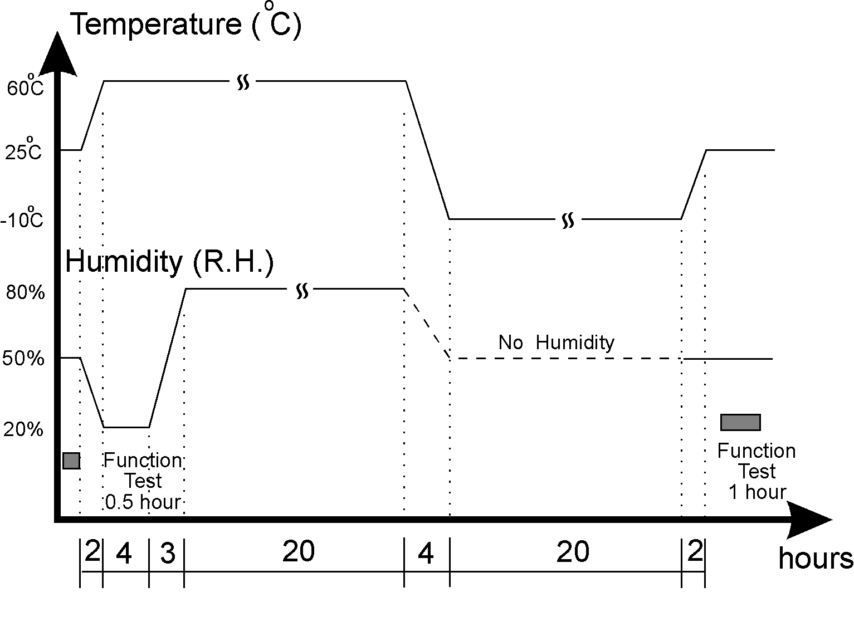
Figure 11-1 Non operating temperature/humidity test curve (unpacked)

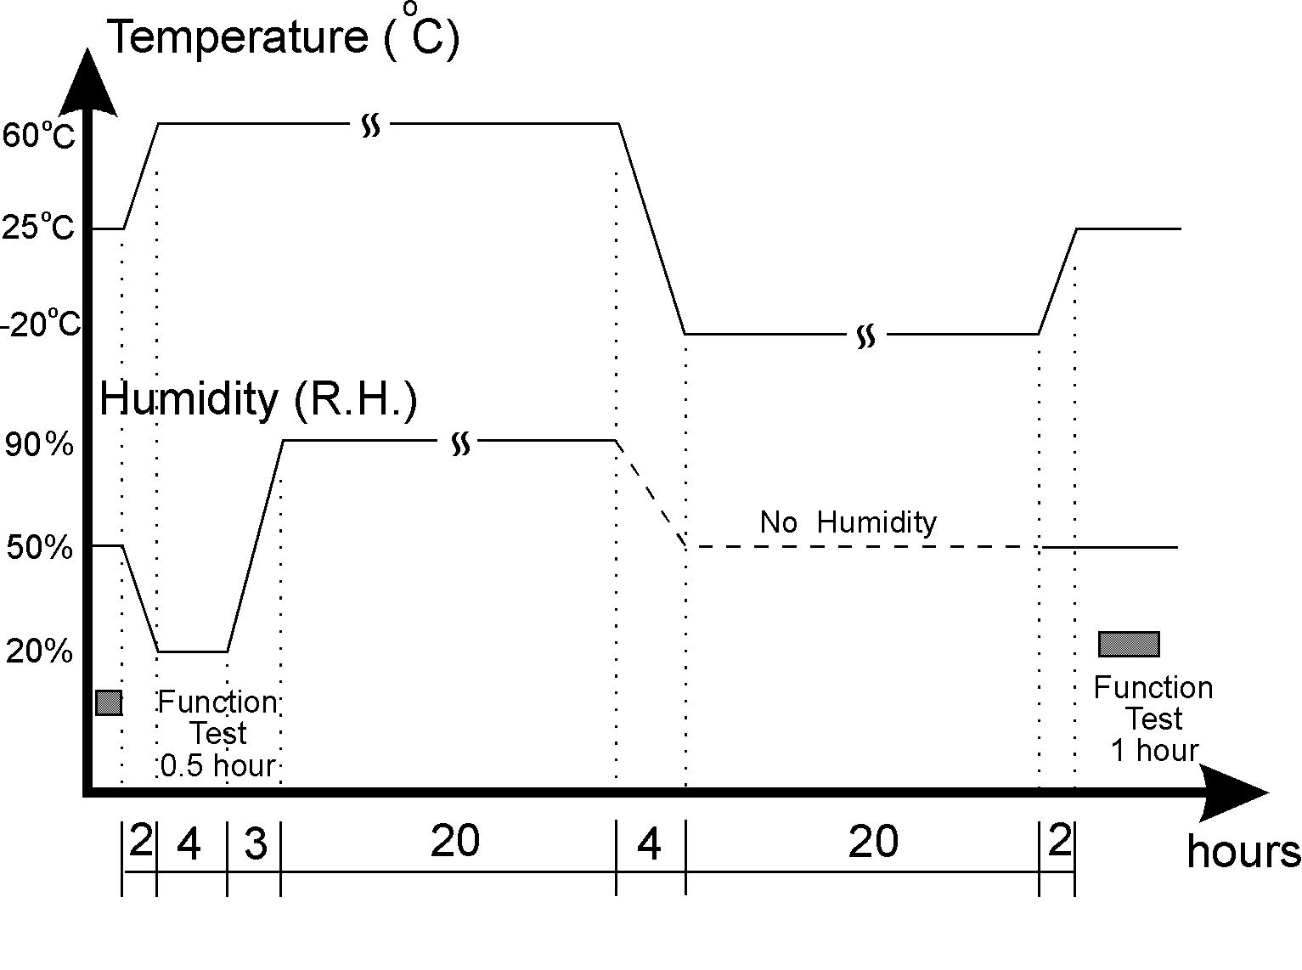
Figure 11-2 Storage's package temperature/humidity test curve.

Test Results:
Test Item |  | QAFE  Quick Check | Appearance/mechanical check | Package Check
 | SKU A | Pass | Pass | Pass
 | SKU B | Pass | Pass | Pass
Unpacked | SKU C | Pass | Pass | Pass
Unpacked | SKU D | Pass | Pass | Pass
 | SKU A | Pass | Pass | Pass
 | SKU B | Pass | Pass | Pass
Packed | SKU C | Pass | Pass | Pass
Packed | SKU D | Pass | Pass | Pass
Table 11-2

12. Operating Vibration Test
(a) Test Specifications:
The specifications below are applicable to most products. Some products, due to their peculiar
design, may require different tests. These limits must be determined by the responsible design
engineer.
Frequency Hertz | Displacement  (peak-peak)  Or Acceleration | Sweep Rate | Endurance Cycle
5 ~ 16.11 | 0.38 mm (0.015”) | 1 Octave/Minute | 1 Cycles  ( 2 sweeps )
16.11 ~ 250 | 0.2 G | 1 Octave/Minute | 1 Cycles  ( 2 sweeps )
Table 12-1
(b) Test Criteria:
During and after the test:
1. Function:
Performance criteria A, B or minor C shall be met
2. Appearance & mechanical function
The EUT should not suffer permanent deformation or fracture. No fixed part or assembly
shall be loosen. No moving or movable part of an assembly should become free or sluggish
in the testing process. No movable part should shift in setting, position or adjustment.

(c) Supplementary Information:
1. Formula of Sine Mode Vibration:
G=0.0511*Af2 or 2.013*Df2
Where G: the acceleration (1G=9.8 m/s²)
A: inches (peak to peak)
f: frequency (Hz)
D: meters (peak to peak)

So, when vibration amplitude is 0.015" and vibration frequency is 20Hz, the calculated
acceleration is 0.0511*0.015*20*20 = 0.3066G; especially, when vibration amplitude is 0.015"
and vibration frequency is 25.6Hz, the calculated acceleration is 0.0511*0.015*25.6*25.6 =
0.50G

2. The number of octave for a sweep is given by:
N = Log2(f2/f1) = 3.322Log₁₀(f2/f1)
where: N = number of octaves
f1 = the lower frequency of sweep
f2 = the upper frequency of sweep
When 0<N<1 set N=1

So, if the logarithm sweep rate is one octave per minute, the time required to sweep from f1 to f2
or from f2 to f1 is "Log₂(f2/f1)" minutes.

For the operating vibration, frequency is sweep from 5Hz to 250Hz and then from 250Hz to
5Hz in octave/minutes sweep rate, the test duration required for one cycle is Log₂(250/5)*2 =
11.3 minutes.

3. Test axes: The EUT shall be excited along the three orthogonal axes, generally in x, y, z-axis
(refer to Figure 12-1).

4. Qualification Test: the qualified test is complete when all key component of the EUT pass the
overall test. When a failure occurs, the test should be stopped. The failure shall be analyzed and
then find an effective countermeasure, then the test can continue. Each component is considered
as qualified when it has been exposed to the overall test.

5. Mounting and fixturing: The product shall be mechanically connected to the vibration tester
either directly or by means of a fixture. The points/area of vibration input to the product shall to
be the same as during shipment.

6. Single point & multi-point control method:
a) Single point method is achieved by using the signal the reference point in order to maintain
this point at the specified level. (Acceleration sensing point in control loop)
b) Multi-points is used when the deviation on the reference points are over ± 6dB from original
specified vibration level . This method can be used to control the overall EUT in the
Z
specified level. The control points must be described in the report.
Y
Figure 12-1 The three orthogonal axes of EUT Vibration Test
X

Test Results:
1. Attach the picture of mounting state here
2. Attach the acceleration curve of the component which causes "minor C" performance
3.
Test Item | Function Test |  |  | Appearance & mechanical function Check
Test Item | SKU A | SKU B | SKU C | SKU A | SKU B | SKU C
X orthogonal axis | Pass | Pass | Pass | Pass | Pass | Pass
Y orthogonal axis | Pass | Pass | Pass | Pass | Pass | Pass
Z orthogonal axis | Pass | Pass | Pass | Pass | Pass | Pass
Table 12-2

13. Non-operating Vibration Test
(a) Test Specifications:
1. packed/Sine Mode: (Test time: 53 minutes/axis)
Frequency (Hertz) | Displacement  (peak-peak)  Or Acceleration | Sweep Rate | Endurance Cycle
5 ~ 27.1 | 0.6G | 0.5 Octave/Minute | 2 Cycles  (4 sweeps)
27.1 ~ 50 | 0.016"(0.4mm) | 0.5 Octave/Minute | 2 Cycles  (4 sweeps)
50 ~ 500 | 2.0G | 0.5 Octave/Minute | 2 Cycles  (4 sweeps)
Table 13-1
(b) Test Criteria:
After the test:
1. Function:
Performance criteria A shall be met
2. Appearance & mechanical function
The EUT should not suffer permanent deformation or fracture. No fixed part or assembly
shall be loosen. No moving or movable part of an assembly should become free or sluggish
in the testing process. No movable part should shift in setting, position or adjustment.

Test Results:
1. packed vibration (Sine mode)
Test Item | Function Test |  |  | Physical Check
Test Item | SKU A | SKU B | SKU C | SKU A | SKU B | SKU C
X orthogonal axis | Pass | Pass | Pass | Pass | Pass | Pass
Y orthogonal axis | Pass | Pass | Pass | Pass | Pass | Pass
Z orthogonal axis | Pass | Pass | Pass | Pass | Pass | Pass
Table 13-2

14. Acoustic Noise Measurement

Sound Pressure Level
(a) Specifications:
Operator  Position  (dBA) | Idle mode | ≤ 38 | Bystander  Position  /LpA (dBA) | Idle mode | ≤ 38
Operator  Position  (dBA) | Operating (a)* | ≤ 42 | Bystander  Position  /LpA (dBA) | Operating (a)* | ≤ 40
Operator  Position  (dBA) | Operating (b)* | ≤ 46 | Bystander  Position  /LpA (dBA) | Operating (b)* | ≤ 44
Operator  Position  (dBA) | Operating (c)* | ≤ 46 | Bystander  Position  /LpA (dBA) | Operating (c)* | ≤ 44
Operator  Position  (dBA) | Operating (d)* | ≤ 46 | Bystander  Position  /LpA (dBA) | Operating (d)* | ≤ 44
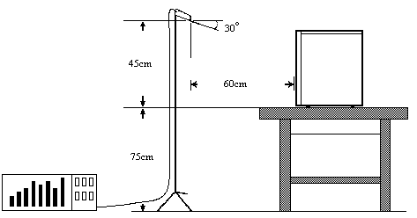Table 14-1 Acoustic Noise Specifications
(b) Test Criteria:
Meet the specifications
Attach Figure 14-1 & 14-2 here

Figure 14-1 Operator Position
Test Result:
Background Noise Level: 19.8dB
1. Operator Position
 |  | Noise Level (dBA)
Location | IDLE |  | FDD | HDD  15.3GB  Seagate | CD-ROM  AOPEN  CD-940AKU
Measured | 33.7dB |  | 36.8 dB | 40.1dB | 43.4 dB
Spec. | ≤ 40 dB |  | ≤ 42dB | ≤ 46dB | ≤ 46 dB
Result | Pass |  | Pass | Pass | Pass
Table 14-2
SKU C
 |  | Noise Level (dBA)
Location | IDLE |  | FDD | HDD  20.4GB  Seagate | CD-RW  Sony  CRX-14E | DVD  HITACHI  GD-7000
Measured | 35.5 dB |  | 37.5 dB | 41.7 dB | 41.5 dB | 42.4 dB
Spec. | ≤ 40 dB |  | ≤ 42 dB | ≤ 46 dB | ≤ 46 dB | ≤ 46 dB
Result | Pass |  | Pass | Pass | Pass | Pass
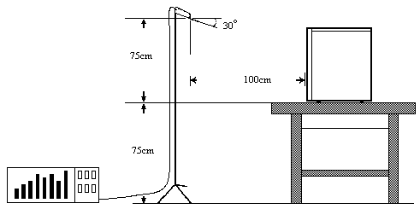Table 14-3

Figure 14-2 Bystander Position
2. Bystander Position
SKU A
 | Noise Level ( dB ) /LpA
location |  | IDLE | FDD | CD-ROM  AOPEN  CD-948E/AKU | HDD  Seagate  15.3GB
Front |  | 30.8 dB | 34.5 dB | 38.4 dB | 37.1 dB
Left |  | 34.2 dB | 37.7 dB | 39.2 dB | 39.5 dB
Rear |  | 35.5 dB | 38.4 dB | 39.3 dB | 39.4 dB
Right |  | 35.2 dB | 38.8 dB | 38.3 dB | 40.0dB
/LpA |  | 34.27 dB | 37.64 dB | 38.82 dB | 39.13 dB
Spec. |  | ≤ 38 dB | ≤ 40 dB | ≤ 44 dB | ≤ 44 dB
Result |  | Pass | Pass | Pass | Pass
Table 14-4

SKU C
 | Noise Level ( dB ) /LpA
location |  | IDLE | FDD | HDD  Seagate  20.4GB | CD-RW  SONY  CRX-140E | DVD-ROM  Hitachi  GD-7000
Front |  | 33.1 dB | 33.2 dB | 38.7 dB | 36.1 dB | 38.2 dB
Left |  | 36.8 dB | 38.0 dB | 42.3 dB | 39.3 dB | 38.8 dB
Rear |  | 37.9 dB | 37.7 dB | 41.3 dB | 38.4 dB | 40.0 dB
Right |  | 37.6 dB | 36.8 dB | 43.2 dB | 38.5 dB | 39.5 dB
/LpA |  | 36.71 dB | 36.78 dB | 41.67 dB | 38.23 dB | 39.18 dB
Spec. |  | ≤ 38 dB | ≤ 40 dB | ≤ 44 dB | ≤ 42 dB | ≤ 44 dB
Result |  | Pass | Pass | Pass | Pass | Pass
Table 14-5

Note:
Lpi = Noise measured at direction I
n = Number of directions (Typically, n=4)

15. Transportation Drop Test
(a). Test Specifications
Packaged Gross Weight |  | Drop Height
KG | lb | cm | inch | No. of Drops
0 ~ 9.1 | 0 ~ 20 | 76 | 30 | 10
> 9.1 ~ 18.2 | > 20 ~ 40 | 61 | 24 | 10
> 18.2 ~ 27.3 | > 40 ~ 60 | 46 | 18 | 10
> 27.3 ~ 45.4 | > 60 ~ 100 | 31 | 12 | 10
10 drops : 1 corner , 3 edges and 6 surfaces
Table 15-1
(b). Test Criteria:
1. Function: performance criteria A must be met after the test
2. Appearance & Mechanical Function after the test
- No scratch
- No dent.
- No crack
- No mold speckle
- No unclear letter, broken line
- No easily removed button
- No obvious fingerprint to degrade the quality image of the product.
- Input and output terminals' connection must be easily matched
- No units wobbles
- No migration materials in the set's plinths (e.g. foot of EUT dropped off)
- No letters or symbols on cabinet are missing
- No transfigure, deformity
- No stiffness or squeak for buttons when pressed
- No warp or rust for metal parts
- No slack (e.g. screw loose)
- No cracks to cushion
- No server damage to carton box

(c) Test Results:
Drop Height : 61 cm | Function Test (QAFE) |  | Physical Check
Drop Height : 61 cm | SKU B | SKU C | SKU B | SKU C
The Weakest corner of product | Pass | Pass | Pass | Pass
The shortest edge radiating from the corner 5-3-2 | Pass | Pass | Pass | Pass
The next shortest edge radiating from the corner 5-3-2 | Pass | Pass | Pass | Pass
The longest edge radiating from the corner 5-3-2 | Pass | Pass | Pass | Pass
Surface 2 | Pass | Pass | Pass | Pass
Surface 4 | Pass | Pass | Pass | Pass
Surface 5 | Pass | Pass | Pass | Pass
Surface 6 | Pass | Pass | Pass | Pass
Surface 3 | Pass | Pass | Pass | Pass
Surface 1 | Pass | Pass | Pass | Pass
Table 15-2

Check items | Result
Check items | SKU B | SKU C
Off-track test | Pass | Pass
Package appearance | Pass | Pass
Cushion appearance | Pass | Pass
Table 15-3

16. AC Power Consumption Measurement
(a) Referenced External Standard:
U.S. EPA energy star computers: U.S. EPA's Atmospheric Pollution Prevention Division
(b) Test Specifications
A) Test conditions:
1. Ambient Temperature : 24 .3 °C
2. Input AC Voltage : 115Vac, 60Hz and 230Vac, 50Hz
3. Line Impedance : less than 0.25 ohm
4. Total Harmonic Distortion (voltage) : < 5%
B) Input AC power shall be less than 30 watts in low-power state (no battery pack installed).
(c) Test Criteria:
To Meet USA EPA energy star program for computers
a) Power management features must be activated before shipping with initial pre-set default.
b) Power management pre-set default times: 15 to 30 minutes
c) 30 Watt maximum in low-power state.

Test Result:
SKU A
AC test condition  Configuration | 115Vac, 60Hz |  | 230Vac, 50Hz
AC test condition  Configuration | (Wac) | BTU | (Wac) | BTU
Windows 95/98 low power state  (within 30 minutes after system idle) | 55.8W | 190.3896 | 55.3W | 188.6836
Scorpion I (system Operating condition) | 29.3W | 99.9716 | 29.1W | 99.2892
Table 16-1
SKU B
AC test condition  Configuration | 115Vac, 60Hz |  | 230Vac, 50Hz
AC test condition  Configuration | (Wac) | BTU | (Wac) | BTU
Scorpion I (system Operating condition) | 85.2W | 290.7024 | 84.2W | 287.2704
Windows 98 low power state  (within 30 minutes after system idle) | 33.8W | 115.3256 | 33.6W | 114.6432
Table 16-2
SKU C
AC test condition  Configuration | 115Vac, 60Hz |  | 230Vac, 50Hz
AC test condition  Configuration | (Wac) | BTU | (Wac) | BTU
Scorpion I (system Operating condition) | 69.3W | 236.4516 | 68.8W | 234.7456
Windows 95/98 low power state  (within 30 minutes after system idle) | 29.9W | 102.0188 | 29.8W | 101.6776
Table 16-3
Note: 1. Different test configurations including various system memory sizes, storage devices,
different Add on cards, CPUs, HDD/FDD/CD-ROM/DVD/CDRW operating status, aetc.
2. Sample 1 result is over EPA Spec. 30W

