Q 4. The system installed a interal 56K V.90 of mini-PCI Fax/Modem. How to install driver?
Ans :
Insert the Driver CD to access the driver or download it from our website .
Step 1. Select "Start" -> "Settings" -> "Control Panel".
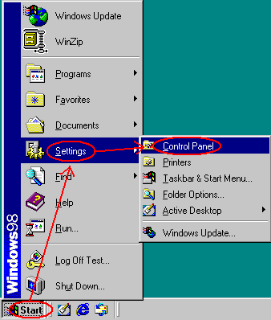
Step 2. Select "System".
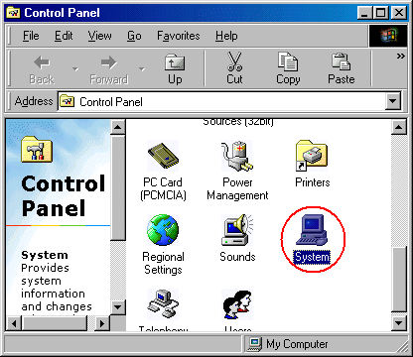
Step 3. Select "PCI Communication Device" in "Device Manager" manu -> Click on "Properties".
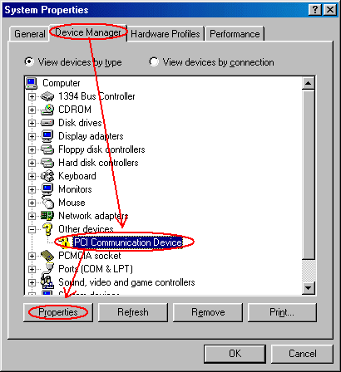
Step 4. Select "Reinstall Driver" button in the General tab.
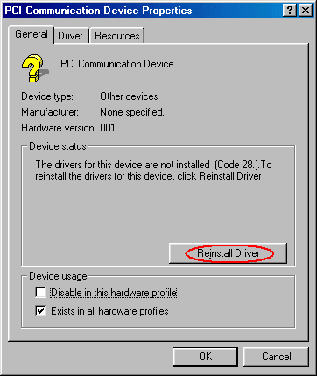
Step 5. Select "Next".
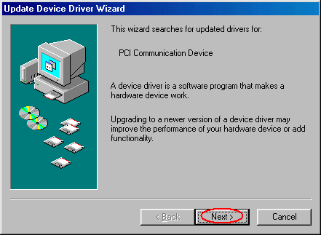
Step 6. Click on "Next" for searching updated drivers.
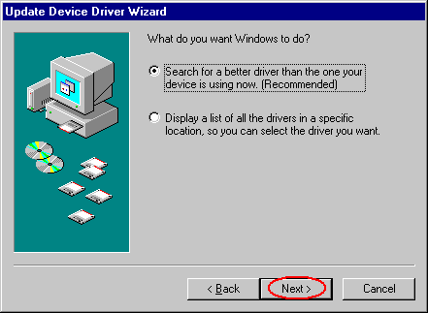
Step 7. Select "Browse" (for the correct path where the driver) -> "Next".
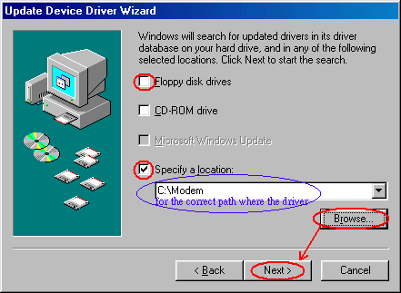
Step 8. Click "Next" to use the updated driver.
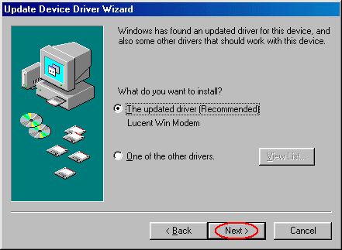
Step 9. Choose "Next".
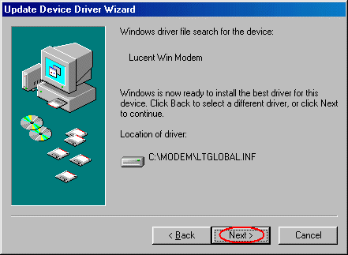
Step 10. Select "Next".
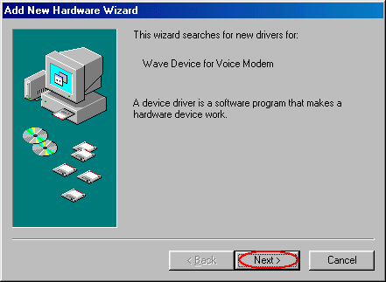
Step 11. Choose 'Search for a better driver..' , and then click "Next".
Step 12. Select "Browse" (for the correct path where the driver) -> "Next".
Step 13. Select "Next".
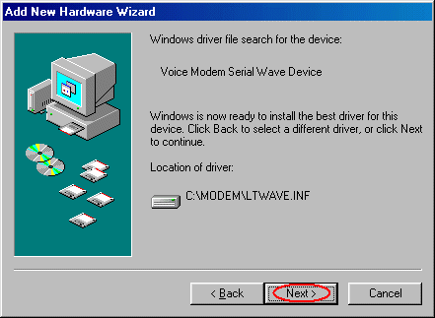
Step 14. Click on "Finish" button for Voice Modem Serial Wave Device.
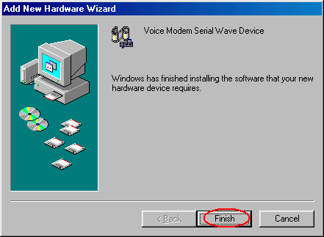
Step 15. Click on "Finish" button for Lucent Win Modem.
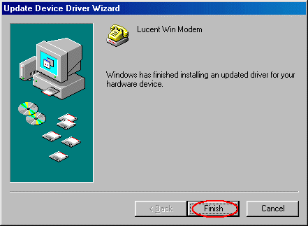
Step 16. Select "Close" in Lucent Win Modem Properties.
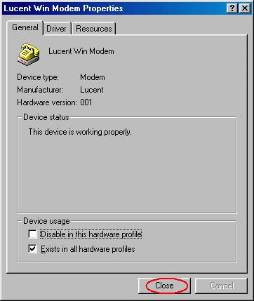
Step 17. Select "OK" in System Properties.
