TM-VA370EB
PCI/ AGP/AMR Mainboard

Version: 1.0

Warning: Never run the processor without the heatsink properly
and firmly installed. Permanent Damage Will result!

Copyright
Copyright © 1999 by this manufacturer. All rights reserved. No part of this publication may be reproduced, transmitted, transcribed, stored in a retrieval system, or translated into any language or computer language, in any form or by any means, electronic, mechanical, magnetic, optical, manual or otherwise, without the prior written consent of this manufacturer.

Disclaimer
This manufacturer makes no representations or warranties, either expressed or implied, with respect to the contents hereof and specifically disclaims any warranties, merchantability or fitness for any particular purpose. Any software described in this manual is sold or licensed “as is”. Should the programs prove defective following their purchase, the buyer (and not this manufacturer, its distributor, or its dealor) assumes the entire cost of all necessary servicing, repair, and any incidental or consequential damages resulting from any defect in the software. Further these manufacturer reserves the right to revise this publication and to make changes from time to time in the contents hereof without obligation to notify any person of such revision or changes.

Trademark Acknowledgement
Intel and Pentium are registered trademarks of Intel Corporation. Award is a registered trademark of Award Software Inc. Other brand and product names are trademarks and/or registered trademarks of their respective holders.

Printed in Taiwan

Overview
The TM-VA370EB is a Dual CPU Soeckt 370 based mainboard that utilizes VIA 694A+686B chipset, a high level of integrated function. This mainboard is designed for Celeron & 133 MHz CuMine FC-PGA CPU, and support new architectures such as high speed AGP graphic port, ATA66/100, Bus Master IDE, Sound On Board, SDRAM memory and expandable to a maximum 1.5GB.
In addition to above features, this mainboard implements most advanced technology such as Synchronous switching regulator, CPU thermal protection, CPU fan monitoring, System voltage monitoring, Over currentt protection, Wake On Modem, Wake On LAN, Keyboard Power On, PS/2 mouse Power On.

CONTENTS
Copyright 2
Disclaimer 2
Overview 3
CONTENTS 4
Introduction 5
Specifications 6
Setup Guide 8
layout Diagra………………………………………………….…8
Jumper Settings………………………………………………….9

EscoCAM - An Integrated Module 12
Connection Guide of EscoCAM ……………………………..14
BIOS Updated Note…………….. …………………………….17

BIOS Setup 18
Getting Help 18
Standard CMOS Setup 19
Advanced Setup 20
Power Management 22
PCI / Plug and Play Setup 24
Optimal Settings 25
Features Set 26
CPU PnP Setup 28
Hardware Monitor 29
Change Password 30
Exit ……………………………………………………………..30

Driver & Software…. 31

System Block Diagram ………………………………………..35
Post Code 36

Problem Sheet 43

Memo……………………………………………………………..44

Introduction

Specifications

System Chipset | VIA 694X+686B chipset.
Dual CPU | Support 300-800 (Ex. Clk 66 MHz); CuMine FC-PGA 450-800 (Ex. Clk 100 MHz); CuMine FC-PGA 533-1GHz (Ex.Clk 133 MHz) CPU.
Memory | Expandable to 1.5GB (3 banks) with three 168-pin DIMM socket {support 3.3 V EDO (66MHz only) / SDRAM (66/100 &133 MHz for VIA chipset)}.
Sound On Board |  | AC 97 Codec Complaint PC97 2.1 specification,  Supports 18-bit ADC and DAC as well as 18-bit  Stereo full duplex codec.
I/O | Two high speed 16550 compatible serial ports, one Multi-Mode.  Parallel Port support SPP/EPP/ECP standard mode.  Two onboard PCI IDE Ports (32-bit data transfer). LS-120/ ZIP FDD, IrDA/ ASK IR/ Consumer IR.  Dual USB ports  Support two 360/720KB/1.2/1.44/2.88MB floppy disk devices.  One PS/2 Mouse port.
BIOS | AMI System BIOS installed in socket (Flash and PnP).
Expansion slots |  | 1x AGP(x4) slot, 4xPCI Master Slots and 1x AMR.
Voltage |  | Auto
Dimension |  | 4-layer PCB, size (30.5cm x 24.5cm).
Bundled Software |  | *Super VB : Provides anti-virus protection.  *Super Voice : For data, FAX and voice  communication.  *Gamut 2000: Provides professional audio  features.  *Media Ring Talk : Provides PC to PC, or PC to  phone internet communication.  *Corel WordPerfect Suite 8 : A office application  suite under Windows.  *3 DEEP : Provides for adjust color, contrast and  brightness of monitor.
Package Content |  | * Mainboard  * Manual & CD Diskette  * 1x FDD, 1xDMA66/100 Cables
Others |  | Hardware Monitor, ATA66/100,  Modem Ring On, LAN Wake Up.

Setup Guide

Layout Diagram
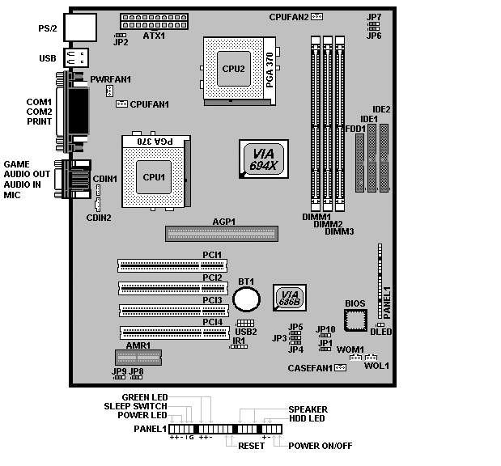

Jumper Setting
- JP1 : Clear CMOS
JP1
1-2 On | Normal Operation (Default)
2-3 On | Clearing CMOS Data

- JP2 : Keyboard/USB wake-up
JP2
1-2 On | Enable
2-3 On | Disable

- JP5 : BIOS Write Protection:
JP5
1-2 On | Disable
2-3 On | Enable (Read Only)

- JP6 & JP7 CPU Jumper Setting:
This mainboard is available with Auto Clocking Detect
for 100/133. However, if you want to run over-clocking,
the forced setting is required :

JP6 : 100 MHz Clock Setting

JP6
1-2 On | Normal
2-3 On | Force to set up 100 MHz

JP7 : 133 MHz Clock Setting
JP7
1-2 On | Normal
2-3 On | Force to set up 133 MHz

Warning:

When just use one single CPU, Intel CPU must be installed in the CPU1 socket and single Cyrix CPU must be in the CPU2 socket.

When use dual CPUs, do not use CPUs with different Clocking (Frequency) or different Multiplier.

- JP8 : Onboard Audio Codec
JP8
1-2 On | Enable
2-3 On | Disable

- JP9 : Onboard Codec Priority:
JP9
1-2 On | Primary Codec
2-3 On | Secondary Codec

- JP10 : AC Resume:
JP10
1-2 On | Disable
2-3 On | Enable

- USB2 : USB Connector
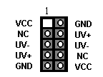

- SIR1 : Infrered Port (IrDA)
1 – VCC
2 – NC
3 – IRRx
4 – GND
5 – IRTx

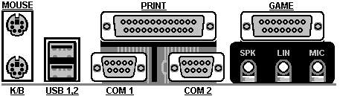

EscoCAM – An Integrated Module

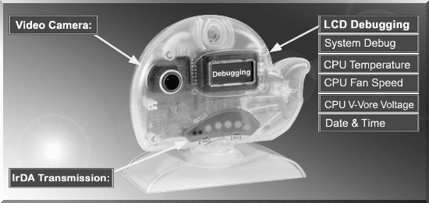

It’s so valuable that you don't have to pay thrice to buy three fashionable devices of PC Camera, Debugging and IrDA ware now because we have integrated them into our EscoCAM in the shape of a lovely whale to escort your system. The whale is the king of the sea and the symbol of all-mighty power. With PC camera, Debug, CPU heat monitor and IrDA device built into the EscoCAM, we offers you the unbeatable solution to upgrade the value of your PC system.

1. PC Camera:
As video and audio email is gaining popularity, PC cameras are making inroads into PC systems and it will increasingly become a standard PC peripheral. In view of this strong market demand, we has timely launched its state-of-the-art PC cameras. Besides, our PC Camera is allowed to adjust the Focus of Camera via Keyboard
or mouse instead of wheel. It’s a patent design in PC Camera. Hope you enjoy
this new technology.

2. External Debug :
When initializing system, LCD will check the peripherals of CPU, Chipset, DRAM, BIOS, Keyboard, CMOS, VGA card, Devices, FDD, HDD and Cache…Once peripherals were not been properly installed or defective, the LCD display will show out the detective place. After system successfully booted up, Time & Date, CPU Temperature, CPU V-Core Voltage, CPU Fan Speed will take turn to show out on the LCD display.
3. Monitor CPU Temp. And FAN Working Status:
Audio, video and multi-tasking functions call for faster and faster CPUs to improve system efficiency. However, faster CPUs will generate more heat which must be dissipated in a timely manner. Therefore, a more efficient fans to dissipate heat is as important as watch-out of fan working situation. In this Internet era, people are using their computers for longer and longer time which can easily cause overheat and damage to the CPU. Prolonged use of the computer will increase CPU temperature.
It is therefore necessary to have a device to constantly monitor the CPU temperature, CPU fan speed and V-Core voltage and timely remind user.

4. IrDA For Data Transmission :
As more and more computers, notebook, mobile phone and PDA are installed
with the IrDA device for wireless transmission, we also developed its own
IrDA device for this purpose.

The Connection of EscoCAM

I. For TM-VAK7 Mainboard :
If you use TM-VAK7P, the most updated mainboard, it’s already built-in all the
circuit of EscoCAM so that user don’t need a extra daughter card to connect it.
The connection drawing as follows:

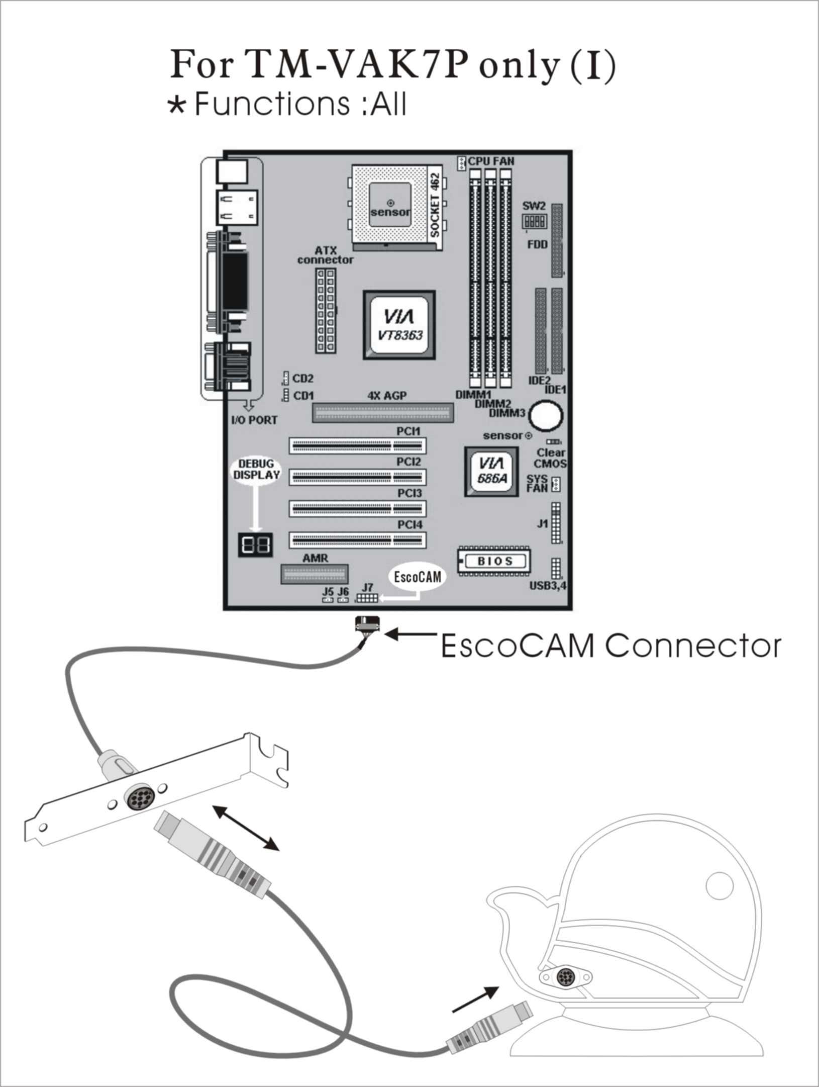

II. For All Others Mainboards:
If the mainboard you used is not TM-VAK7, you need A PCI daughter card to
be inserted and make connection as follows:

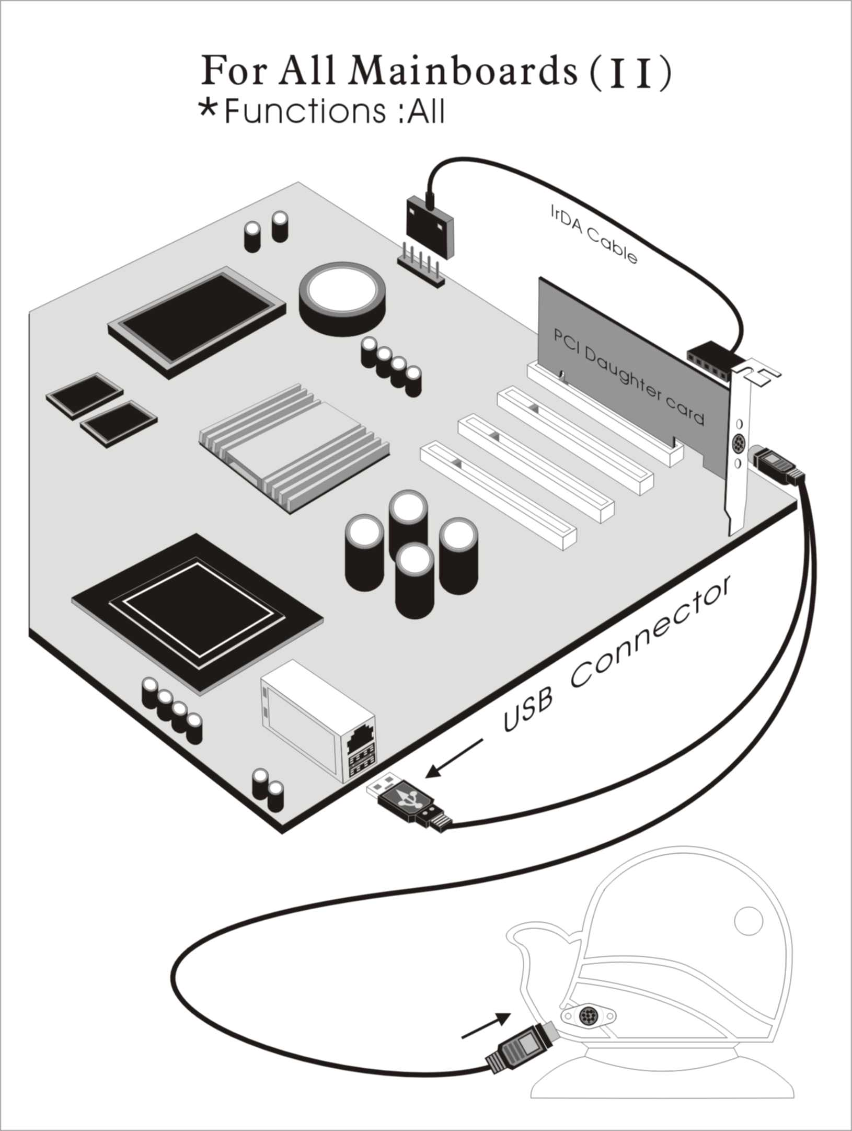

III. Or, if you just want use the function of PC Camera, the connection
drawing as follows:

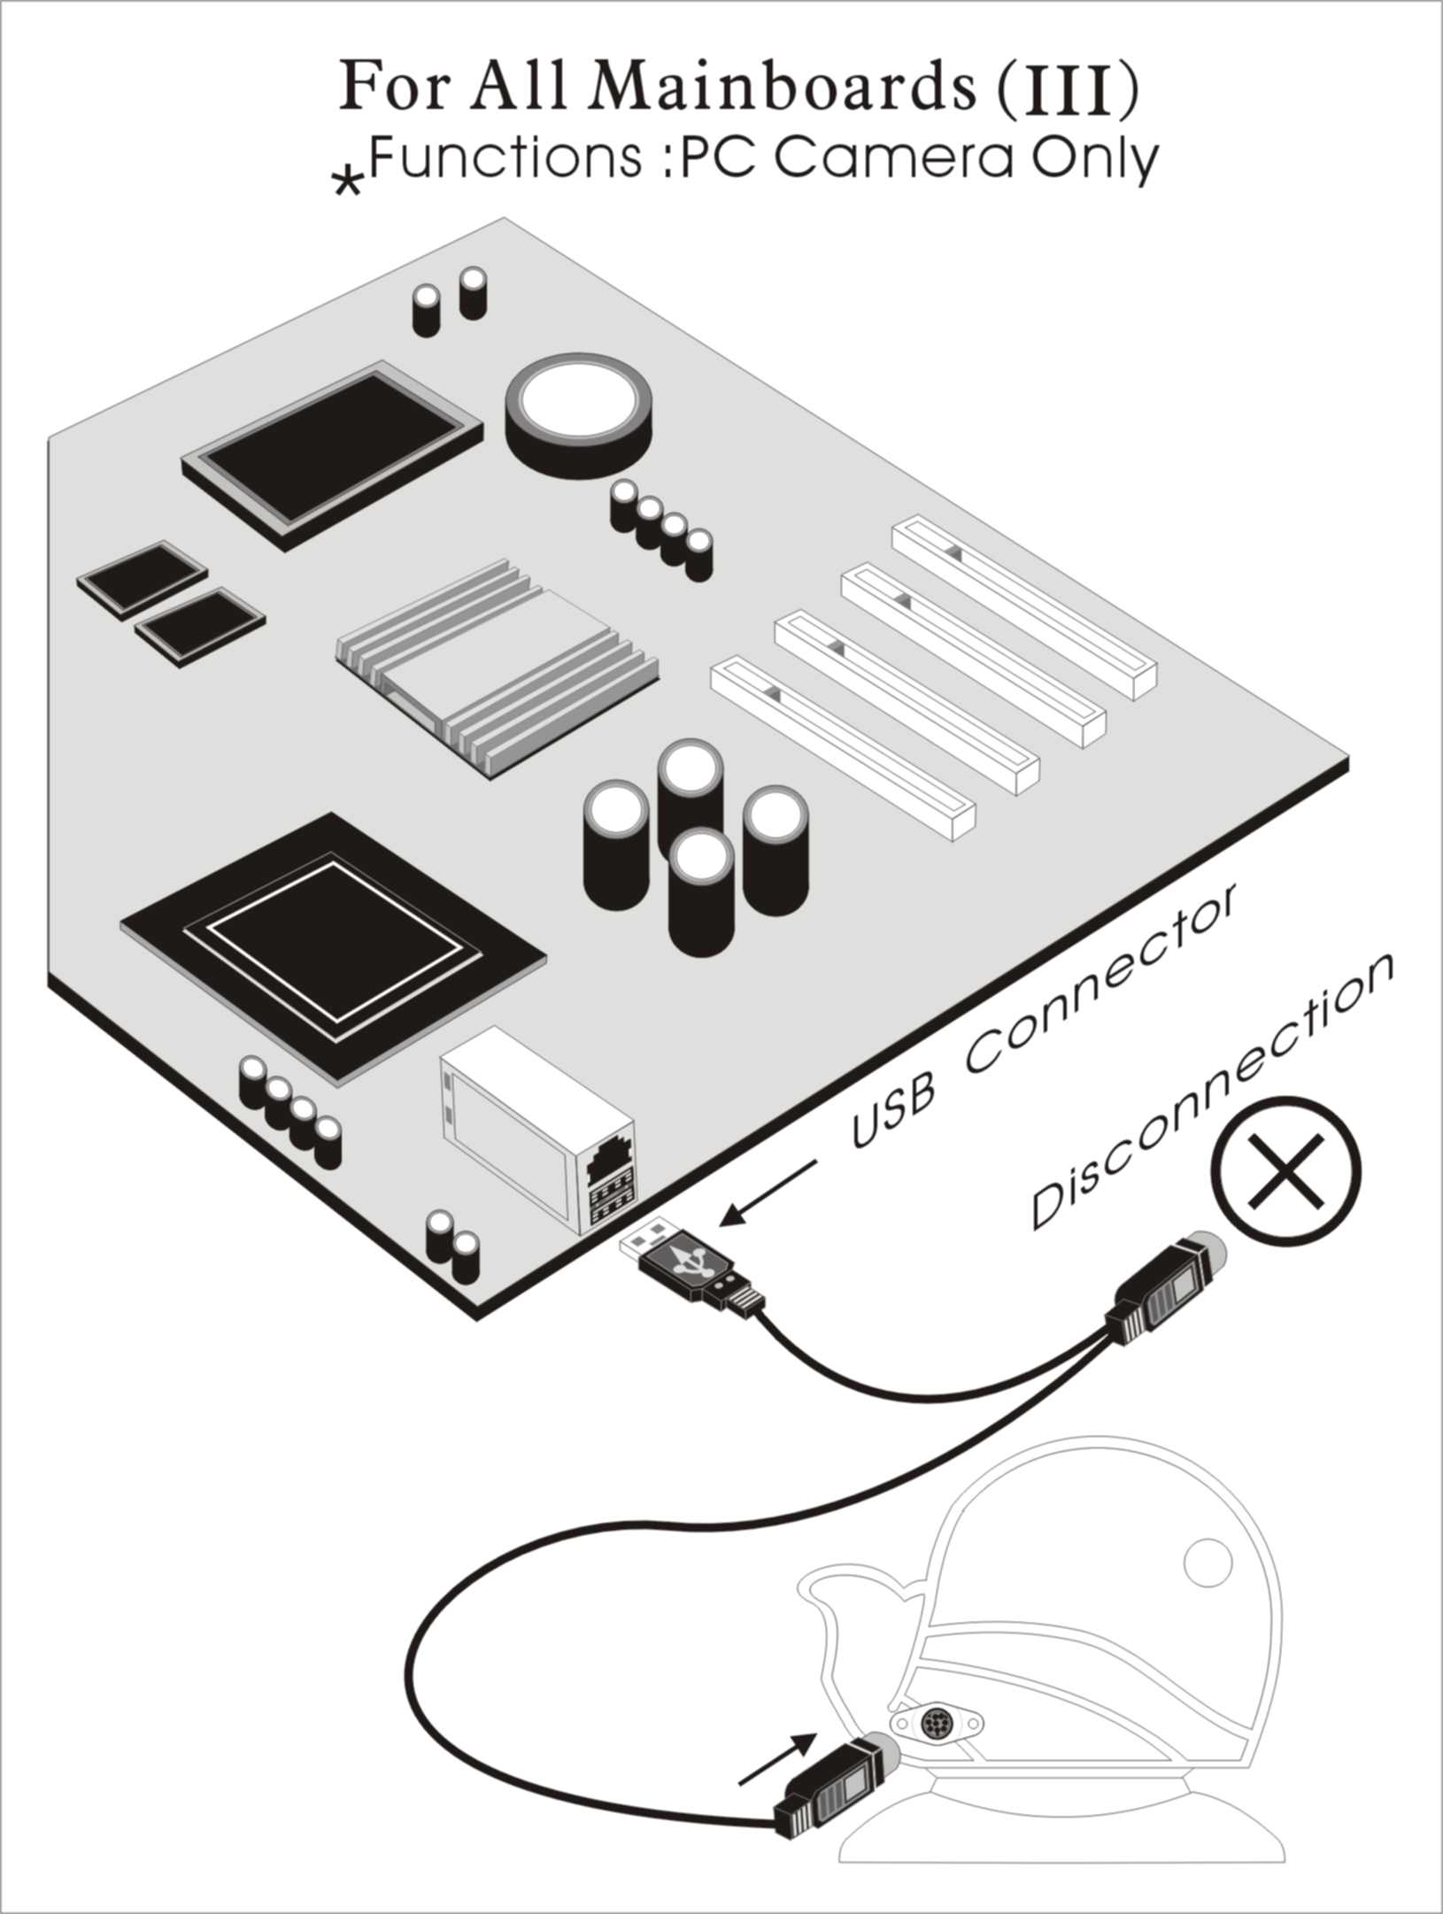

BIOS Update Note

Do not update the BIOS if no abnormalities occur. However, if BIOS update is needed, consult your dealer first. Prior to updating your BIOS, you are recommended to save the original BIOS values.

1. Download the AMI BIOS Flash Utility file (AMIFL818.exe)

2. Download the BIOS file used by your mainboard(e.g., xxx.BIN)

3. Reboot your system (but do not run Himem.sys and Emm386.exe)
to execute the new BIOS program.

4. Execute these commands: AMIFL818 xxx.BIN

