Introduction

Specifications

System Chipset | Intel 82430 TX chipset.
CPU | One 321-pin socket 7 for Intel Pentium (P54C/CQS/ CS, P55C), AMD 5k86, K5, K6, Cyrix 6x86 (L, M), IDT C6 processors, support 90/100/ 120/133/150/166/180/200/225/233/266/300MHz.
Memory | Expandable to 256MB (4 banks) with four 72-pin SIMM sockets onboard (Support Fast Page Mode and EDO DRAM 5-2-2-2) and two 168-pin DIMM socket (support Syncchronous DRAM module 5-1-1-1).
Cache | 64-bit 256/512KB L2 Pipeline Burst SRAM onboard.
I/O | Winbond 83977, two high speed 16550 compatible serial ports, one Multi-Mode.  Parallel Port support SPP/EPP/ECP standard mode.  Two onboard PCI DE Ports (32 bit data transfer).  Support two 360/720KB/1.2/1.44/2.88MB floppy disk devices.  One PS/2 Mouse port.
BIOS | Award System BIOS installed in socket (Flash and PnP).
Expansion slots |  | Four PCI Master Slots and three 16-bit ISA Slots.
Dimension |  | 4-layer PCB, 2/3 baby size (220mm x 250mm).
Others |  | Support Ultra DMA/33, ACPI, SM Bus, GPID, USB Bus, Keyboard Power On/Off, Modem Ring On, ATX Power supply.

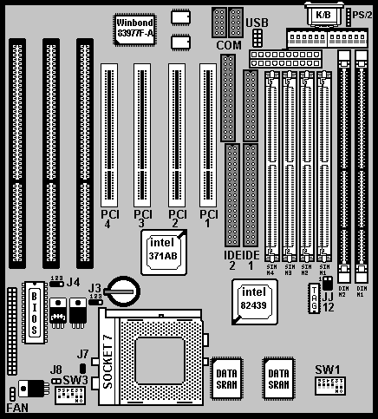
Setup Guide

Layout Diagram

Switch Settings for CPUs
On = Short; Off = Open
Intel, AMD, Cyrix | SW1 |  |  |  | SW1
Intel, AMD, Cyrix | 1 | 2 | 3 | RATE | 4 | 5 | 6 | CLK
Pentium 75 MHz | Off | Off | Off | 1.5 | X | X | X | 50
Pentium 90 MHz | Off | Off | Off | 1.5 | On | Off | Off | 60
Pentium 100 MHz | Off | Off | Off | 1.5 | Off | Off | Off | 66
Pentium 120 MHz | On | Off | Off | 2 | On | Off | Off | 60
Pentium 133 MHz | On | Off | Off | 2 | Off | Off | Off | 66
Pentium 150 MHz | On | On | Off | 2.5 | On | Off | Off | 60
Pentium (MMX) 166 MHz | On | On | Off | 2.5 | Off | Off | Off | 66
Pentium (MMX) 200 MHz | Off | On | Off | 3 | Off | Off | Off | 66
Pentium (MMX) 233 MHz | Off | Off | Off | 3.5 | Off | Off | Off | 66
Pentium (MMX) 266 MHz | On | Off | On | 4 | Off | Off | Off | 66
AMD-5k86-P75-75MHz | Off | Off | Off | 1.5 | X | X | X | 50
AMD-5k86-P90-90MHz | Off | Off | Off | 1.5 | On | Off | Off | 60
AMD-K5-75MHz -PR75 | Off | Off | Off | 1.5 | X | X | X | 50
AMD-K5-90MHz -PR90 | Off | Off | Off | 1.5 | On | Off | Off | 60
AMD-K5-100MHz-PR100 | Off | Off | Off | 1.5 | Off | Off | Off | 66
AMD-K5-90MHz-PR120 | Off | Off | Off | 1.5 | On | Off | Off | 60
AMD-K5-100MHz-PR133 | Off | Off | Off | 1.5 | Off | Off | Off | 66
AMD-K5-133MHz-PR166 | On | On | Off | 1.75 | Off | Off | Off | 66
AMD-K6(MMX)-166MHz | On | On | Off | 2.5 | Off | Off | Off | 66
AMD-K6(MMX)-200MHz | Off | On | Off | 3 | Off | Off | Off | 66
AMD-K6(MMX)-233MHz | Off | Off | Off | 3.5 | Off | Off | Off | 66
AMD-K6(MMX)-266MHz | On | Off | On | 4 | Off | Off | Off | 66
AMD-K6(MMX)-300MHz | On | On | On | 4.5 | Off | Off | Off | 66
Cyrix 6x86-100MHz-P120+ | On | Off | Off | 2 | X | X | X | 50
Cyrix 6x86-110MHz-P133+ | On | Off | Off | 2 | On | On | Off | 55
Cyrix 6x86-120MHz-P150+ | On | Off | Off | 2 | On | Off | Off | 60
Cyrix 6x86-133MHz-P166+ | On | Off | Off | 2 | Off | Off | Off | 66
Cyrix 6x86-150MHz-P200+ | On | Off | Off | 2 | Off | On | Off | 75
Cyrix MX-150MHz-PR166 | On | On | Off | 2.5 | On | Off | Off | 60
Cyrix MX-166MHz-PR200 | On | On | Off | 2.5 | Off | Off | Off | 66
Cyrix MX-200MHz-PR233 | Off | On | Off | 3 | Off | Off | Off | 66
Cyrix MX-233MHz-PR266 | Off | Off | Off | 3.5 | Off | Off | Off | 66

CPU Voltage Settings
- The CPU voltage default setting is 3.30V(for Intel P54C), and
J7=On(Short), J8=Off(Open).

- Switch voltage is applied, making the temperature lower and voltage steadier.
- All the voltage specifications adopted here are the averages of the working voltage suggested by the CPU makers, to make any CPU applied work with the best performance.
- Set the V I/O and Vcore to the same voltage, if you use a single voltage CPU.
- In Single voltage CPU VI/O=Vcore.

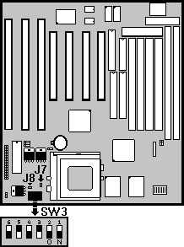

Single voltage CPU (Intel P54C, Cyrix 6x86, AMD 5k86/K5) |  |  |  |  |  | J7 | J8
3.52V |  | 3.45V |  | 3.30V |  | On | Off

Dual voltage CPU(Intel P55C, Cryrix 6x86L, MX-6x86, AMD-K6) |  |  |  |  |  | J7 | J8
V I/O 3.45V |  | V I/O 3.30V |  | Vcore3.20V |  | Off | On
Vcore2.90V |  | Vcore2.80V |  | Vcore2.20V |  | Off | On

CPU Frequencies

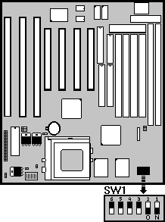
- The CPU type default setting is Intel Pentium 166MHz=66 MHz＊2.5.

- When a CPU with 75MHz is applied, the PCI Bus CLK output becomes 37MHz. Under this circumstance, some VGA cards may not fit well. Then the system becomes unsteady, tends to hang up easily or even results in boot failure. Use another VGA card instead when any of the above-mentioned conditions happens.

Multipliper Factor for Intel CPU

1.5 |  | 2 |  | 2.5 |  | 3
Multipliper Factor for AMD-K6 or Cyrix MX-6x86 CPU

3.5 |  | 4 |  | 4.5 |  | 5

Intel P54C |  | X1.5 |  |  | X2 |  |  | X2.5 |  | X3
Cyrix 6x86(L) |  | None |  |  | X2 |  |  | None |  | None
AMD-5k86/K5 |  | X1.5 |  |  | None |  |  | X1.75 |  | None
55 MHz |  |  | 60MHz |  |  | 66MHz |  |  | 75MHz |  | 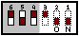
PCI Bus Clk  27 MHz |  |  | PCI Bus Clk  30 MHz |  |  | PCI Bus Clk  33 MHz |  |  | PCI Bus Clk  37 MHz

DRAM, EDO RAM Installation Procedures:

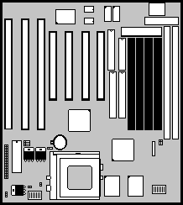
- SIMM Socket output voltage is 5V, expandable to 256MB.

- Support 5V Fast Page Mode/ Extended Data Out RAM.

- The BIOS DRAM default setting is 70 ns. Change the BIOS “Chipset Feature Setup” default setting to 60ns for better performance, if the chipset is marked 60ns.

- Change nothing if EDO RAM is used. BIOS automatically detects the RAM type.

- With 586 CPUs, two FPM/EDO RAM Modules are required on SIMM sockets to compose a bank for the system to start.

SDRAM, Cache Memory Installation Procedures:

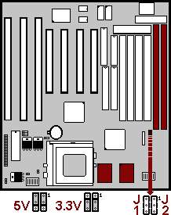
- A 168-pin DIMM can support up to 128MB EDO/SDRAM.

- Default setting: 3.3V.

- First, verify the working voltage of the EDO/SDRAM module in either DIMM socket (DIMM1 or DIMM2-table free).

- You can set up the BIOS “Chipset Feature Setup” to the best working condition basing on the type of EDO/SDRAM you are using.

- The Dual Inline Memory Module (DIMM) must be 3.3 Volt and Unbuffered Synchronus DRAM (SDRAM) 8MB, 16MB, 32MB or 64MB. The following illustration shows the type of DIMM Module.

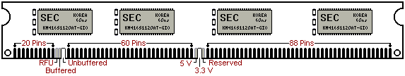
168-PIN SDRAM DIMM Notch Key Definitions

- Sync SRAM (Pipeline Burst SRAM) If Sync SRAM Modules are installed, they consists of Pipeline Burst 2 PCs 32K x 32-6 for 256KB or 2 PCs 64Kx32-6) for 512KB Sync SRAM.

Other Jumper Settings

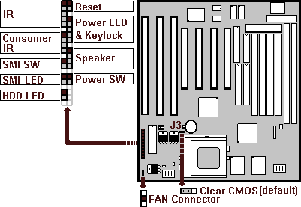

- Speaker:
Connect to the system’s speaker for beeping.
- Keylock:
Keyboard lock switch and Power LED connector.
- Reset:
Short to restart system.
- HDD LED:
LED ON when on board PCI IDE hard disk activates.
- SMI LED:
LED ON when system is in any Saving mode.
- Keyboard Power On/Off Function (Patent Is Under Application!!!)
1.Turn on the system by pressing the “Ctrl-***” keys simultaneously
(Strike the “*” key 3 times while holding the “Ctrl” key.)
2. Press “Ctrl-***” again to turn off the system. This function becomes
invalid during POST (Power-On-Self-Test).
3. CPU Fan Auto Turn Off: The CPU fan automatically turns off when the
system enters the Suspend state. Remember to connect the CPU fan
to its connector on the mainboard to enable this function.
- SMI SW:
Short to enter sleep mode. A keystroke or mouse movement (mouse driver exits) will instantly “wake up” the system.

- POWER SW (FOR ATX POWER SUPPLY):
The button should be a momentary switch that is normally open. Pushing the ATX Power Switch will immediately change the system status. Before or during “POST”, you need to hold the button for four seconds in order to turn off the system.

- J3: Clear CMOS
Turn off the system and short pins 2-3 (J3) to clear CMOS. Then short pins 1-2 before turning it on. You may damage the chipset if you power on the system by shorting pins 2-3.

J3
1-2 | Normal operation(Default).
2-3 | for clearing CMOS Data.

- CPU Cooler Fan connector
This is the connector for CPU cooler. Never use the jumper to short the connector. Serious damages caused this way will not be warrantied.

- Modem Ring On Function Operation: (Only available by using ATX Power Supply)
1. Enter BIOS setup.
2. Select Power Management Setup.
3. Resume by Ring: Enable.
4. Save BIOS setup and Reboot.
5. Booting from DOS, Windows, or Windows 95.
6. Turn off the system by:
a. ATX-Power Switch
b. Keyboard Power On/Off
c. Windows 95 Software Power Off
7. System Waiting for Modem Ring On
When Modem Ringing Signal Active, System will wake-up.

- USB1/USB2: USB Connector

