This publication, including all photographs, illustrations and software, is protected under international copyright laws, with all rights reserved. Neither this manual, nor any of the material contained herein, may be reproduced without the express written consent of the manufacturer.
The information in this document is subject to change without notice. The manufacturer makes no representations or warranties with respect to the contents hereof and specifically disclaims any implied warranties of merchantability or fitness for any particular purpose. Further, the manufacturer reserves the right to revise this publication and to make changes from time to time in the content hereof without obligation of the manufacturer to notify any person of such revision or changes.

Trademarks
IBM, VGA, and PS/2 are registered trademarks of International Business Machines.
Intel, Pentium, Pentium-II, Pentium-III, MMX, and Celeron are registered trademarks of Intel Corporation.
Microsoft, MS-DOS and Windows 95/98/NT/2000 are registered trademarks of Microsoft Corporation.
Sound Blaster is a trademark of Creative Technology Ltd.
PC-cillin and ChipAwayVirus are trademarks of Trend Micro Inc.
AMI is a trademark of American Megatrends Inc.
A3D is a registered trademark of Aureal Inc.
SuperVoice is a registered trademark of Pacific Image Communications Inc.
MediaRing Talk is a registered trademark of MediaRing Inc.
3Deep is a registered trademark of E-Color Inc.
Other names used in this publication may be trademarks and are acknowledged.

Copyright © 2001
All Rights Reserved
M773 Series, V1.1B
IBXX/April 2001

Notice:
The user must find a properly compatible AGP VGA card in the 133MHz system, because the AGP clock frequency will be over 66MHz.

Table of Contents

Chapter 1: Introduction 1
Key Features 2
Package Contents 5
Static Electricity Precautions 6
Pre-Installation Inspection 6
Chapter 2: Mainboard Installation 7
Mainboard Components 8
I/O Ports 9
Install A CPU 9
Install Memory 11
Setting Jumper Switches 12
Install the Mainboard 14
Install the Extension Brackets 16
Install Other Devices 17
Expansion Slots 19
Add-In Card Options 20
Chapter 3: BIOS Setup Utility 21
Introduction 21
Running the Setup Utility 22
Standard CMOS Setup Page 23
Advanced Setup Page 24
Power Management Setup Page 26
PCI / Plug and Play Setup Page 27
Load Optimal Settings 28
Load Best Performance Settings 28
Features Setup Page 29
CPU PnP Setup Page 30
Hardware Monitor Page 31
Change Password 32
Exit 32
Chapter 4: Software & Applications 33
Introduction 33
Installing Support Software 33
Auto-installing under Windows 98 35
Using the PCI Audio Software 37
The Four Speakers System 37

Chapter 1

Introduction

This mainboard has a Socket 370, which uses an Intel PPGA/ FCPGA Celeron or FCPGA Pentium III processor. You can install any one of these processors on the mainboard. The mainboard supports Socket 370 and front-side bus speeds of 66MHz, 100MHz or 133MHz.

This mainboard uses the Intel 440BX chip which provides CPU Plug & Play through firmware and Ultra DMA 66 function. The mainboard has a built-in PCI 3D Sound System and a V.90 Fax/Modem DAA module is shipped with the mainboard. In addition, the mainboard has a full set of ATX I/O Ports including PS/2 keyboard and mouse ports, two USB ports, a parallel port and two serial ports.

This mainboard has all the features you need to develop a powerful multimedia workstation that is network ready, and has built-in communications. The board is ATX size and has power connectors for an ATX power supply.

Key Features
The key features of this mainboard include:

Socket-370 Processor Support
- Supports PPGA/FCPGA Celeron and FCPGA Pentium III CPUs
- Supports 66MHz, 100MHz or 133MHz Front-Side Bus

All processors are automatically configured using firmware and a synchronous Host/DRAM Clock Scheme.

Memory Support
- Two DIMM slots for 168-pin SDRAM memory modules
- Support for 66MHz, 100MHz and 133MHz memory bus
- Maximum installed memory is 2 x 256 MB = 512 MB

Expansion Slots
- One AGP Slot
- Four 32-bit PCI slots
- Two 8/16-bit ISA slots

Onboard IDE channels
- Primary and Secondary PCI IDE channels
- Support for PIO (programmable input/output) modes
- Support for Multiword DMA modes
- Support for Bus Mastering and Ultra DMA 33/66 modes

Power Supply and Power Management
- ATX power supply connector
- ACPI and previous PMU support, suspend switch, keyboard power on/off
- Supports Wake on Modem, Wake on LAN and Wake on Alarm

Sound System
- Complies with the PC98 audio specification
- 16-bit CODEC for full-duplex playback and recording
- HRTF 3D professional audio supports both Direct Sound 3D® and A3D®-compatible interfaces plus support for 4-channel speakers
- Driver support for MS-DOS, Microsoft Windows 95/98/2000/NT 4.0
- Built-in 32ohm earphone buffer and 3D surround sound
- Provides MPU-401 Game/MIDI port and legacy Sound Blaster 16 support
- Downloadable Wave-table Synthesizer supports Direct Music®
- Stereo Mixer supports analog mixing from CD-Audio and Line In

Onboard I/O Ports
- Provides PC99 Color Connectors for easy peripheral device connections
- Floppy disk drive connector with 1Mb/s transfer rate
- Two serial ports with 16550-compatible fast UART
- One parallel port with ECP and EPP support
- Two USB ports
- Two PS/2 ports for keyboard and mouse
- One infrared header for optional module

Hardware Monitoring
- Built-in hardware monitoring for CPU & System temperatures, fan speeds and mainboard voltages

Fax/Modem DAA Module
- 56 Kbps Fax/Modem DAA module
- Supports V.90, V.34, V.32bis, V.32, V.22bis, V.22
- Supports Auto Fallback and MNP 5, V.42bis data compression with 115,200-compatible Virtual UART
- Requires 16MB RAM and Microsoft Windows 95/98/NT

Onboard Flash ROM
- Automatic CPU and board configuration
- Supports Plug and Play configuration of peripheral devices and expansion cards
- Built-in virus protection using Trend’s ChipAwayVirus provides boot process virus protection.

Bundled Software
- PC-Cillin2000 provides automatic virus protection under Windows 95/98/NT/2000
- SuperVoice is data, fax and voice communication software
- MediaRing Talk provides PC to PC or PC to Phone internet phone communication
- 3Deep delivers the precise imagery and displays accurate color in your monitor
- WinDVD2000 is a DVD playback application (optional)

Dimensions
- ATX form factor (30.5cm x 22cm)

Package Contents
Attention: This mainboard series includes two different models. They are M773MR (Modem Ready) and M773 (without Modem).
Please contact your local supplier for your purchase model.
Each model will support different specification, list as below:
Model | Specification
M773MR | Support a Fax/Modem DAA module
M773 | ---

Your mainboard package ships with the following items:
- The mainboard
- This User’s Guide
- 1 UDMA/66 IDE cable
- 1 Floppy disk drive cable
- Support software on CD-ROM disk

Static Electricity Precautions
Components on this mainboard can be damaged by static electricity. Take the following precautions when unpacking the mainboard and installing it in a system.
- Keep the mainboard and other components in their original static-proof packaging until you are ready to install them.
- During installation, wear a grounded wrist strap if possible. If you don’t have a wrist strap, discharge static electricity by touching the bare metal of the system chassis.
- Handle the mainboard carefully by the edges. Avoid touching the components unless it is absolutely necessary. During installation put the mainboard on top of the static-protection packaging it came in with the component side facing up.

Pre-Installation Inspection
- Inspect the mainboard for damage to the components and connectors on the board.
- If you suspect that the mainboard has been damaged, do not connect power to the system. Contact your mainboard vendor and report the damage.

Chapter 2

Mainboard Installation

To install this mainboard in a system, follow the procedures in this chapter:

- Identify the mainboard components
- Install a CPU
- Install one or more system memory modules
- Verify that any jumpers or switches are set correctly
- Install the mainboard in a system chassis (case)
- Connect any extension brackets or cables to the mainboard connector headers
- Install any other devices and make the appropriate connections to the mainboard connector headers.

Note:
- Before installing this mainboard, make sure jumper JP1 is set to Normal, the default setting is set to Clear CMOS. See this chapter for information on locating JP1 and the setting options.
- Never connect power to the system during installation. Doing so may damage the mainboard.

Mainboard Components
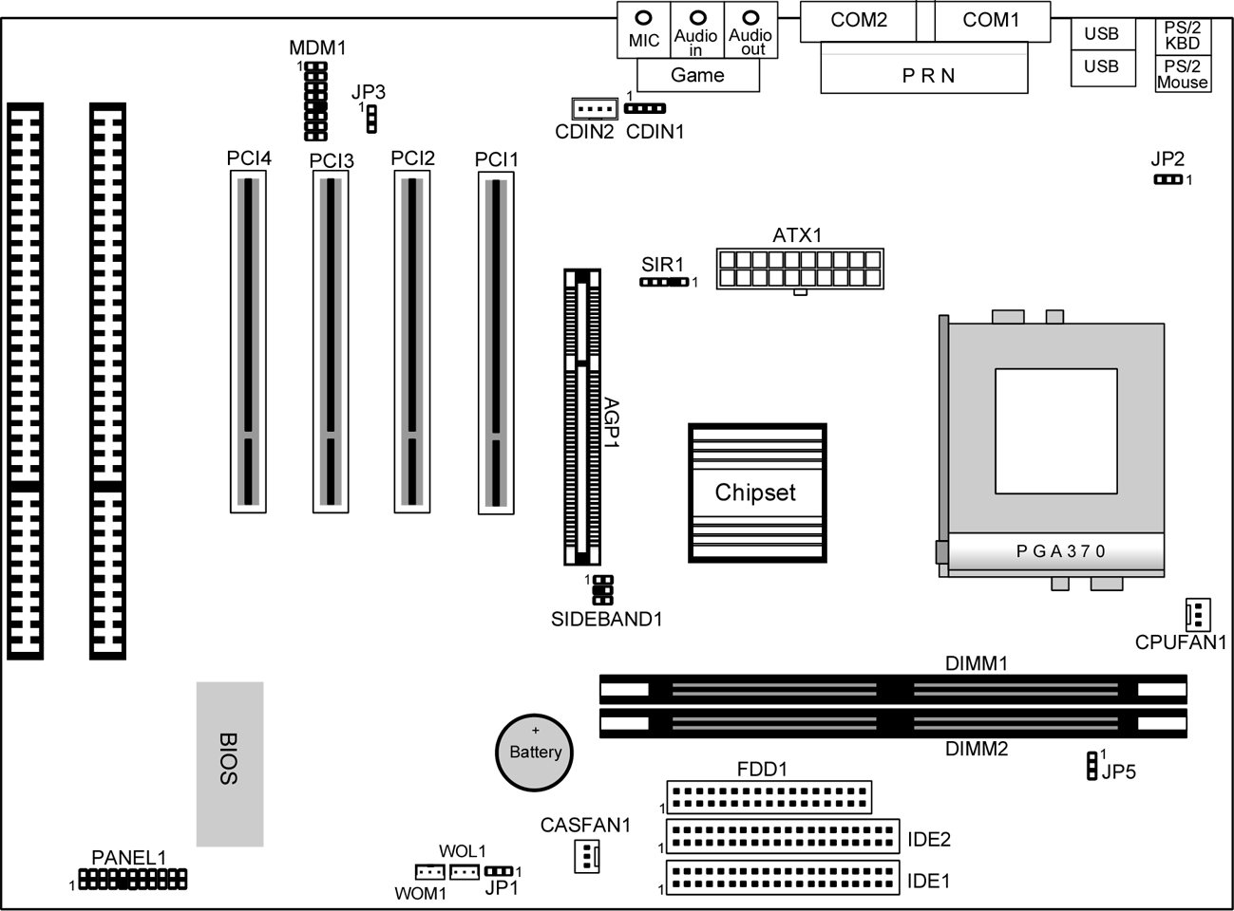
Use the diagram below to identify the major components on the mainboard.

Note: Any jumpers on your mainboard that do not appear in this illustration are for testing only.

I/O Ports
The illustration below shows a side view of the built-in I/O ports on the mainboard.

Install A CPU
This mainboard has a Socket-370 which supports PPGA/FCPGA Celeron and FCPGA Pentium III processors.

Do not try to install a Socket 7 processor in the Socket-370. A Socket 7 processor such as the Pentium-MMX, or the AMD K5/K6 does not fit in the Socket 370.
The following list notes the processors that are currently supported by this mainboard.

FCPGA Pentium III: 500~1130MHz, FSB: 100MHz, 133MHz
PPGA/FCPGA Celeron: 300~700MHz, FSB: 66 MHz

Installing a Socket-370 Processor
A processor installs into the ZIF (Zero Insertion Force) Socket-370 on the mainboard.

- Locate the Socket-370 and CPUFAN1. Pull the locking lever out slightly from the socket and raise it to the upright position.
Pin-1 Corner
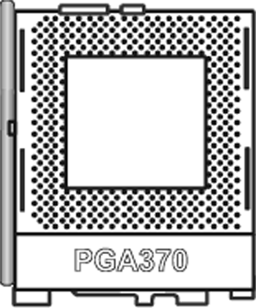
Socket-370
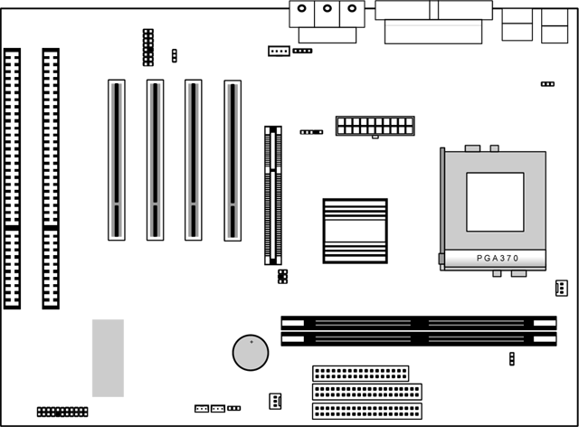

CPUFAN1

- On the processor, identify the Pin-1 corner by its beveled edge.
- On the Socket-370, identify the Pin-1 corner. The Pin-1 corner is at the end of the locking lever when it is locked.
- Match the Pin-1 corners and insert the processor into the socket. No force is required and the processor should drop into place freely.
- Swing the locking lever down and hook it under the catch on the side of the socket. This secures the CPU in the socket.
- All processors should be installed with a combination heatsink/cooling fan, connect the cable from the fan to the CPU fan power connector CPUFAN1.

Install Memory
The mainboard has two DIMM sockets for system memory modules. You must install at least one memory module in order to use the mainboard.

DIMM1

DIMM2

For this mainboard, you must use 168-pin, 3.3V unbuffered SDRAM memory modules. If the installed CPU uses a 100MHz system bus, you must use PC100 or PC133 memory. If the installed CPU uses a 66MHz system bus, you must use PC66 memory. You can install any size memory module from 8 MB to 256MB, so the maximum memory size is 2 x 256MB = 512 MB.

The edge connectors on the memory modules have cut outs, which coincide with spacers in the DIMM sockets so that memory modules can only be installed in the correct orientation.

To install a module, push the retaining latches at either end of the socket outwards. Position the memory module correctly and insert it into the DIMM socket. Press the module down into the socket so that the retaining latches rotate up and secure the module in place by fitting into notches on the edge of the module.

Setting Jumper Switches
Jumpers are sets of pins which can be connected together with jumper caps. The jumper caps change the way the mainboard operates by changing the electronic circuits on the mainboard. If a jumper cap connects two pins, we say the pins are SHORT. If a jumper cap is removed from two pins, the pins are OPEN.

JP3
1

1

JP2

JP5
JP1
1

1

Jumper JP1: Clear CMOS Memory
Use this jumper to clear the contents of the CMOS memory. You may need to clear the CMOS memory if the settings in the Setup Utility are incorrect and prevent your mainboard from operating. To clear the CMOS memory, disconnect all the power cables from the mainboard and then move the jumper cap into the CLEAR setting for a few seconds.
Function | Jumper Setting
Normal Operation | Short Pins 1-2
Clear CMOS Memory | Short Pins 2-3

Jumper JP2: Keyboard Power On Selector
If you enable the keyboard power on feature, you can use hot keys on your keyboard as a power on/off switch for the system.
Note: The system must provide 1A on the +5VSB (+5V Standby) signal before using the Keyboard Power On function.
Function | Jumper Setting
Enable Keyboard Power On | Short Pins 1-2
Disable Keyboard Power On | Short Pins 2-3

Jumper JP3: Audio System Enable/disable Jumper
This 3-pin jumper can be used to enable or disable the onboard audio system. If you prefer to install a different audio system on a third party expansion card, you must disable the onboard audio in order to free up resources for the alternate sound card.
Function | Jumper Cap
Enable audio system | Short pins 1-2
Disable audio system | Short pins 2-3

Jumper JP5: 133 MHz System Bus Selector
This mainboard provides CPU Plug and Play technology, so there is no jumper for the CPU speed setting. But you need to set the jumper JP5 as below for a 133 MHz system bus CPU. Then enter to BIOS Setup to set the FSB item to 133 MHz.
Function | Jumper Setting
66/100 MHz | Short Pins 1-2
133 MHz | Short Pins 2-3

Install the Mainboard
Install the mainboard in a system chassis (case). The board is a micro-ATX size mainboard with a twin-tier of I/O ports. You can install this mainboard in any ATX case. Special micro-ATX cases are also available with a reduced number of expansion slot bays and a smaller power supply unit. Ensure that your case has an I/O cover plate that matches the ports on this mainboard.

Install the mainboard in a case. Follow the instructions provided by the case manufacturer using the hardware and internal mounting points on the chassis.

ATX1

CASFAN1

1
PANEL1

- Connect the power connector from the power supply to the ATX1 connector on the mainboard.
- If there is a cooling fan installed in the system chassis, connect the cable from the cooling fan to the CASFAN1 fan power connector on the mainboard.
- Connect the case switches and indicator LEDs to the PANEL1 switch and LED connector header.
See the illustration below for a guide to the PANEL1 connector pin assignments.
22
21
Power LED
Pins 2-4-6
Speaker
Pins 1-3-5-7
Keylock
Pins 8-10
HDD LED
Pins 15-16
2
1
Reset Switch
Pins 17-18
Power Button Pins 21-22
Suspend LED
Pins 13-14
Suspend Switch
Pins 19-20

Install the Extension Brackets
The extension brackets are used to connect features on the mainboard to external connectors that can be attached to the system chassis. Follow the steps below to install the extension brackets.

Note: All the ribbon cables used on the extension brackets have a red stripe on the Pin-1 side of the cable.

Fax/Modem Module
The Fax/Modem DAA module plugs directly into the mainboard in line with to an expansion slot opening in the system chassis. When you remove the slot cover from the system chassis, you can access the LINE and TEL RJ11 connectors on the metal edge of the Fax/Modem DAA module.
MDM1-Modem Header
1

- Locate the MDM1 modem header on the mainboard.
- Plug the Fax/Modem DAA module into the header.
- Remove the modem header slot cover.
Modem DAA Module
Modem Header
Line & Tel
RJ11 Sockets

Install Other Devices
Install and connect any other devices in the system following the steps below.

IDE2
1
1
1
FDD1
IDE1

Floppy Disk Drive
The mainboard ships with a floppy disk drive cable that can support one or two drives. Drives can be 3.5” or 5.25” wide, with capacities of 360K, 720K, 1.2MB, 1.44MB, or 2.88MB.
Install your drives and connect power from the system power supply. Use the cable provided to connect the drives to the floppy disk drive header FDD1.

IDE Devices
IDE devices include hard disk drives, high-density diskette drives, and CD-ROM or DVD-ROM drives, among others.
The mainboard ships with an IDE cable that can support one or two IDE devices. If you connect two devices to a single cable, you must configure one of the drives as Master and one of the drives as Slave. The documentation of the IDE device will tell you how to configure the device as a Master or Slave device. The Master device connects to the end of the cable.
Install the device(s) and connect power from the system power supply. Use the cable provided to connect the device(s) to the Primary IDE channel connector IDE1 on the mainboard.
If you want to install more IDE devices, you can purchase a second IDE cable and connect one or two devices to the Secondary IDE channel connector IDE2 on the mainboard. If you have two devices on the cable, one must be Master and one must be Slave.

Internal Sound Connections
If you have installed a CD-ROM drive or DVD-ROM drive, you can connect the drive audio cable to the onboard sound system.
On the mainboard, locate the two 4-pin connectors CDIN1/2. There are two kinds of connector because different brands of CD-ROM drive have different kinds of audio cable connectors. Connect the cable to the appropriate connector.

1
CDIN2 CDIN1

SIR1
1 VCC

3 IRRX
4 IRTX
5 GND

Infrared Port
You can connect an infrared port to the mainboard. You can purchase this option from third-party vendors.
- Locate the infrared port SIR1 header on the mainboard.
- If you are adding an infrared port, connect the ribbon cable from the port to the SIR1 header and then secure the port to an appropriate place in your system chassis.

Expansion Slots
This mainboard has one AGP slot, four 32-bit PCI expansion slots and two 8/16-bit ISA slots.
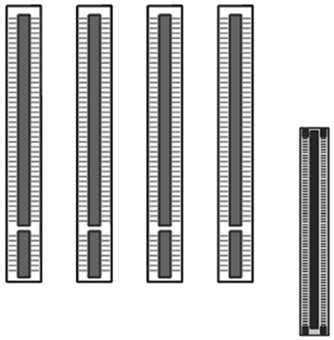
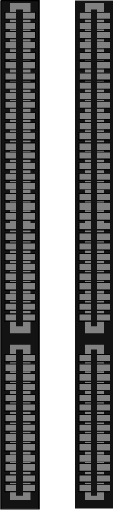
PCI2
PCI1
AGP1
PCI3
PCI4

ISA2 ISA1

Follow the steps below to install an add-in card to one of the slots.
- Determine which slot you need to use. The table below shows the functions of the slots.
AGP | AGP stands for Accelerated Graphics Port. Use this slot to install a graphics adapter which has an AGP edge connector.
PCI | PCI stands for Peripheral Components Interconnect. Use this slot to install current add-in cards which have a 32-bit PCI edge connector.
ISA | ISA stands for Industry Standard Architecture. Use this slot to install older, legacy add-in cards which have an 8/16-bit ISA edge connector.
- Locate the ISA or PCI or AGP slot on the mainboard.
- Remove the blanking plate from the appropriate expansion slot on the system chassis.
- Install the edge connector of the expansion card into the slot and press it quite firmly down so that it is seated correctly.
- Secure the bracket of the card into the expansion slot in the system chassis using the screw that held the blanking plate in place.

Add-In Card Options
This mainboard has a Wake On LAN and a Wake On Modem connectors that can be used by an installed network adapter and an installed modem adapter. It also has a SB-Link connector that can be used by an installed PCI Sound Blaster audio card.
1

SIDEBAND1-SB-Link Header

WOM1 Header
WOL1 Header

Wake On LAN (WOL)
You can configure your system so that it powers down by software and can be resumed by alarms. If you have installed a LAN adapter expansion card, connect the card to the Wake On LAN header WOL1. This allows incoming traffic to resume the system from a software power down. You need to enable this feature in the system setup utility.

Wake On Modem (WOM)
If you have installed a fax/modem card, connect the fax/modem to the Wake On Modem header WOM1. You can then use the setup utility to program your computer to resume from a power saving mode whenever there is an incoming call to the fax/modem.

SB-Link
If you have disabled the built-in sound system and installed a PCI Sound Blaster audio card, you can connect the card to the SIDEBAND1 header on the mainboard. The SB-Link circuit solves some problems that can occur when you try to play some older computer games which run in the DOS real-mode environment.

Chapter 3

BIOS Setup Utility

Introduction
The BIOS Setup Utility records settings and information about your computer such as the date and time, the kind of hardware installed, and various configuration settings. Your computer uses this information to initialize all the components when booting up and functions as the basis for coordination between system components.

If the Setup Utility configuration is incorrect, it may cause the system to malfunction. It can even stop your computer from booting properly. If this happens, you can use the clear CMOS jumper to clear the CMOS memory used to store the configuration information, or you can hold down the Page Up key while you reboot your computer. Holding down the Page Up key also clears the CPU PnP Setup information, you may need to set the CPU speed again.

You can run the setup utility and manually make changes to the configuration. You might need to do this to configure some of the hardware that you install on or connect to the mainboard, such as the CPU, system memory, disk drives, etc.

Running the Setup Utility
Each time your computer starts, before the operating system loads, a message appears on the screen that prompts you to “Hit <DEL> if you want to run SETUP”. When you see this message, press the Delete key and the Main menu page of the Setup Utility appears on your monitor.

AMIBIOS SIMPLE SETUP UTILITY – VERSION 1.21.01
©2000 American Megatrends, Inc. All Rights Reserved
Standard CMOS Setup Features Setup

Advanced Setup CPU PnP Setup

Power Management Setup Hardware Monitor

PCI / Plug and Play Setup Change Password

Load Optimal Settings Exit

Load Best Performance Settings

ESC: Quit ↑↓←→ : Select Item (Shift)F2 : Change Color F5 : Old Values
F6: Optimal values F7: Best performance values F10: Save&Exit

You can use the cursor arrow keys to highlight any of the options on the main menu page. Press Enter to select the highlighted option. To leave the setup utility, press the Escape key. To cycle through the Setup Utility’s optional color schemes hold down the Shift key and press F2.
Some of the options on the main menu page lead to tables of items with installed values. In these pages, use the cursor arrow keys to highlight the items, and then use the PgUp and PgDn keys to cycle through the alternate values for each of the items. Other options on the main menu page lead to dialog boxes which require you to answer Yes or No by hitting the Y or N keys.
If you have already made changes to the setup utility, press F10 to save those changes and exit the utility. Press F5 to reset the changes to the original values. Press F6 to install the setup utility with a set of default values. Press F7 to install the setup utility with a set of high-performance values.

Standard CMOS Setup Page
Use this page to set basic information such as the date and time, the IDE devices, and the diskette drives. If you press the F3 key, the system will automatically detect and configure the hard disks on the IDE channels.

AMIBIOS SETUP – STANDARD CMOS SETUP
©2000 American Megatrends, Inc. All Rights Reserved
Date (mm/dd/yy) : Tue Nov 14, 2000
Time (hh/mm/ss) : 14:26:53
LBA Blk PIO 32Bit
Type Size Cyln Head WPcom Sec Mode Mode Mode Mode
Pri Master : Auto Off
Pri Slave : Auto Off
Sec Master : Auto Off Sec Slave : Auto Off

Floppy Drive A : 1.44MB 3 1/2”
Floppy Drive B : Not Installed

Month : Jan – Dec ESC : Exit
Day : 01 – 31 ⬆⬇ : Select Item
Year : 1901 – 2099 PU/PD/+/- : Modify
(Shift)F2 : Color
F3 : Detect All HDD

Date & Time | Use these items to set the system date and time
Pri Master  Pri Slave  Sec Master  Sec Slave | Use these items to configure devices connected to the Primary and Secondary IDE channels. To configure an IDE hard disk drive, choose Auto. If the Auto setting fails to find a hard disk drive, set it to User, and then fill in the hard disk characteristics (Size, Cyls, etc.) manually. If you have a CD-ROM drive, select the setting CDROM. If you have an ATAPI device with removable media (e.g. a ZIP drive or an LS-120) select Floptical.
Floppy Drive A  Floppy Drive B | Use these items to set the size and capacity of the floppy diskette drive(s) installed in the system.

Advanced Setup Page
Use this page to set more advanced information about your system. Take some care with this page. Making changes can affect the operation of your computer.

AMIBIOS SETUP – ADVANCED SETUP
(C) 2000 American Megatrends, Inc. All Rights Reserved
Trend ChipAway Virus Enabled
Quick Boot Enabled
1st Boot Device IDE-0
2nd Boot Device Floppy
3rd Boot Device CDROM
Try Other Boot Devices Yes
S.M.A.R.T. for Hard Disks Disabled
BootUp Num-Lock On
Floppy Drive Swap Disabled
Floppy Drive Seek Disabled
Password Check Setup
Boot To OS/2 No
L2 Cache Enabled
System BIOS Cacheable Enabled
ESC : Quit ↑↓←→ : Select Item
F1 : Help PU/PD/+/- : Modify
F5 : Old Values (Shift)F2 : Color
F6 : Load Optimal values
F7 : Load Best performance values

Trend ChipAway Virus | This mainboard has built-in virus protection in the firmware. Use this item to enable or disable the built-in virus protection.
Quick Boot | If you enable this item, the system starts up more quickly be elimination some of the power on test routines.
1st Boot Device  2nd Boot Device  3rd Boot Device | Use these three items to determine the order and priority that your computer follows to load an operating system at start-up time.
Try Other Boot Device | If you enable this item, the system will also search for other boot devices if it fails to find an operating system from the first three locations.
S.M.A.R.T. Capability | Enable this item if your hard disk(s) supports SMART (Self-Monitoring, Analysis and Reporting Technology).
BootUp Num-Lock | This item determines if the Num Lock key is active or inactive at system start-up time.
Floppy Drive Swap | If you have two diskette drives installed and you enable this item, drive A becomes drive B and drive B becomes drive A.
Floppy Drive Seek | If you enable this item, your system will check the diskette drives at start up time. Disable this item unless you are using an old 360K diskette drive.
PS/2 Mouse Support | Set this item to auto so that it will automatically detect if you are using a mouse with a PS/2 interface.
Password Check | If you have installed a password on your system, use this item to determine if the password is required to enter the setup utility (Setup) or required at start-up time and to enter the setup utility (Always).
Boot To OS/2 | Enable this item if you are booting the OS/2 operating system and you have more than 64MB of memory installed.
L2 Cache | Leave this item enabled since all the processors that can be installed on this board have internal cache memory.
System BIOS Cacheable | If you enable this item, a segment of the system BIOS will be cached to main memory for faster execution.

Power Management Setup Page
This page sets some of the parameters for the system power management operation.

AMIBIOS SETUP – POWER MANAGEMENT SETUP
(C) 2000 American Megatrends, Inc. All Rights Reserved
Power Management/APM Disabled
Video Power Down Mode Suspend
Standby Time Out Disabled
Suspend Time Out Disabled
Throttle Slow Clock Ratio 50%
Modem Ring Power On Disabled
Lan Card Power On Disabled
Keyboard Power On Disabled
Stroke Keys Selected N/A
RTC Alarm Power On Disabled
RTC Alarm Date 15
RTC Alarm Hour 12
RTC Alarm Minute 30
RTC Alarm Second 30
ESC : Quit ↑↓←→ : Select Item
F1 : Help PU/PD/+/- : Modify
F5 : Old Values (Shift)F2 : Color
F6 : Load Optimal values
F7 : Load Best performance values

Power Management/APM | Use this item to enable or disable the power management routines. If you enable the power management, you can use the items below to set the power management operation.
Video Power Down Mode | This item defines which power-saving mode is required to power down the monitor.
Standby Time Out | This sets the timeout for standby mode in minutes. If the time selected passes without any system activity, the computer will enter the power-saving standby mode.
Suspend Time Out | This sets the timeout for suspend mode in minutes. If the time selected passes without any system activity, the computer will enter the power-saving suspend mode.
Modem Ring Power On | If you enable this item, incoming calls to the fax/modem can resume the system from a power-saving mode or a software power down.
LAN Card Power On | If you enable this item, network traffic to the LAN adapter can resume the system from a power-saving mode or a software power down.
Keyboard Power On  Stroke Keys Selected | If you enable this item, you can turn the system on and off by pressing hot keys on the keyboard. You must enable the Keyboard Power On jumper in order to use this feature.  Use the item below this one to select the hot keys to power on the system.
RTC Alarm Power On | If you enable this item you can set an alarm on the system realtime clock that will resume the system from a power-saving mode or a software power down.
RTC Alarm Date / Hour / Minute / Second | If you have enabled the RTC Alarm Power on, use these items to set the time and date of the alarm.

PCI / Plug and Play Setup Page
This page sets some of the parameters for devices installed on the system PCI bus, and devices that use the system plug and play capability.

AMIBIOS SETUP – PCI / PLUG AND PLAY SETUP
(C) 2000 American Megatrends, Inc. All Rights Reserved
Plug and Play Aware O/S No
Primary Graphics Adapter PCI
Allocate IRQ to PCI VGA Yes
IRQ7 ISA/EISA
ESC : Quit ↑↓←→ : Select Item
F1 : Help PU/PD/+/- : Modify
F5 : Old Values (Shift)F2 : Color
F6 : Load Optimal values
F7 : Load Best performance values

Plug and Play Aware O/S | Enable this item if you are using an O/S that supports Plug and Play such as Windows 95 or 98.
Primary Graphics Adapter | Use this item to define if your primary graphics adapter is installed in a PCI slot or on an AGP bus.
Allocate IRQ to PCI VGA | If this item is enabled, an IRQ will be assigned to the VGA graphics system.
IRQ 7 | If you set this item to PCI/PnP, the system will dynamically allocate IRQ 7 as they are required. If you set IRQ 7 to ISA/EISA, it will be reserved for a non-plug and play ISA or EISA device.

Load Optimal Settings
If you select this item and press Enter a dialog box appears. If you press Y, and then Enter, the setup utility is loaded with a set of optimal default values. The optimal default values are not very demanding and they should allow your system to function with most kinds of hardware and memory chips.

Load Best Performance Settings
If you select this item and press Enter a dialog box appears. If you press Y, and then Enter, the setup utility is loaded with a set of best-performance default values. The optimal default values are quite demanding and your system might not function properly if you are using slower memory chips or other kinds of low-performance components.

Features Setup Page
This page sets some of the parameters for peripheral devices installed on the system.

AMIBIOS SETUP – Features SETUP
(C) 2000 American Megatrends, Inc. All Rights Reserved
OnBoard FDC Auto
OnBoard Serial Port1 3F8h/COM1
OnBoard Serial Port2 2F8h/COM2
Serial Port2 Mode Normal
IR Duplex Mode Enabled
OnBoard Parallel Port 378h
Parallel Port Mode Normal
Parallel Port IRQ 7
Parallel Port DMA N/A
OnBoard PCI IDE Both
OnBoard Sound Enabled
OnBoard Modem Enabled
OnBoard USB Function Enabled
USB Function for DOS Disabled
IDE Ultra DMA Support Auto
ESC : Quit ↑↓←→ : Select Item
F1 : Help PU/PD/+/- : Modify
F5 : Old Values (Shift)F2 : Color
F6 : Load Optimal values
F7 : Load Best performance values

Onboard FDC | Use this item to enable or disable the onboard floppy disk drive interface.
Onboard Serial Port1 | Use this item to enable or disable the onboard serial port COM1/3, and to assign a port address.
Onboard Serial Port2 | Use this item to enable or disable the onboard serial port COM2/4, and to assign a port address.
Serial Port2 Mode | Use this item to allocate the resources of the second serial port. Under Normal, the resources are allocated to the onboard serial port. Under ASKIR or IrDA, the resources are allocated to the onboard IR port.
IR Duplex Mode | Use this item to define if the optional infrared port is full-duplex or half-duplex.
Onboard Parallel Port | Use this item to enable or disable the onboard parallel port LPT1, and to assign a port address
Parallel Port Mode | Use this item to determine the parallel port mode. You can select Normal, ECP (Extended Capabilities Port), EPP (Enhanced Parallel Port), or Bi-Dir.
Parallel Port IRQ | Use this item to assign an IRQ to the parallel port.
Parallel Port DMA | Use this item to assign a DMA channel to the parallel port.
Onboard IDE | Use this item to enable or disable either of the two onboard IDE channels, Primary or Secondary.
Onboard Sound/ Modem | Use these items to enable or disable the onboard audio/modem chip.
Onboard USB Function | Enable this item if you plan to use the USB ports on this mainboard.
USB Function for DOS | Enable this item if you plan to use the USB ports on this mainboard in a DOS environment.
IDE Ultra DMA Support | Use these items to enable or disable the Ultra DMA function to support the IDE devices.

CPU PnP Setup Page
This page lets you manually or automatically to configure the mainboard for the CPU.

AMIBIOS SETUP – CPU PnP SETUP
©2000 American Megatrends, Inc. All Rights Reserved
CPU Speed 933 MHz
CPU Base Freq. Auto

ESC : Quit ↑↓←→ : Select Item
F1 : Help PU/PD/+/- : Modify
F5 : Old Values (Shift)F2 : Color
F6 : Load Optimal values
F7 : Load Best performance values

CPU Speed | Use this item to set the internal clock speed of your CPU.
CPU Base Freq. | Use this item to sets the external clock frequency for the CPU. The options include Auto, 100 and 133MHz. Set the CPU clock based on the requirements of the CPU installed on the board.
Note: If you manually set the wrong speed and the system won’t run properly, press the Page Up key while the system is booting and a default setting will replace the incorrect CPU setting.

Hardware Monitor Page
This page lets you set the parameters for hardware monitoring and manually or automatically configure the mainboard for the CPU.

AMIBIOS SETUP – HARDWARE MONITOR
(C) 2000 American Megatrends, Inc. All Rights Reserved
--- System Hardware Monitor ---
System Temperature
CPU Temperature 30°C/86°F
CPU Fan Speed
Chassis Fan Speed
Vcc 5.000 V
Vcc3 3.300 V
Vcore 2.000 V
+12V 12.000 V

ESC : Quit ↑↓←→ : Select Item
F1 : Help PU/PD/+/- : Modify
F5 : Old Values (Shift)F2 : Color
F6 : Load Optimal values
F7 : Load Best performance values

CPU / System Temperature | Use these items to monitor the threshold temperature for the CPU and system.
FAN Speeds, voltages | Use these items to monitor the parameters for the fan speeds and the mainboard voltages.

Change Password
If you highlight this item and press Enter, a dialog box appears which lets you enter a password. You can enter no more than six letters or numbers. Press Enter after you have typed in the password. A second dialog box asks you to retype the password for confirmation. Press Enter after you have retyped it correctly. The password is required at boot time, or when the user enters the setup utility.

Change or Remove the Password
Highlight the Change Password item and type in the current password. At the next dialog box, type in the new password, or just press Enter to disable password protection.

Exit
Highlight this item and press Enter to save the changes that you have made in the Setup utility configuration and exit the program. When the Save and Exit dialog box appears, press Y to save and exit, or press N to exit without saving.

Chapter 4

Software & Applications

Introduction
The support software CD-ROM that is included in the mainboard package contains all the drivers and utility programs needed to properly run our products. Below you can find a brief description of each software program, and the location for your mainboard version. More information on some programs is available in a README file, located in the same directory as the software.
If the operating system used in your system is Windows 98, it will automatically install all the drivers and utilities for your board. See the Auto-Installing under Windows 98 section.

Installing Support Software
The software on the support CD-ROM is for Windows 95/NT/2000 and Windows 98. The installation procedure differs depending on which Operating System you have, but the automatic installation is now for Win98 only.

Installing under Windows 95/NT/2000
To install support software for Windows 95/NT/2000 follow this general procedure:
- Insert the support CD-ROM disc in the CD-ROM drive.
(The system might get an error message from the PnP function. Don’t care the message. You don’t really need that file to install the drivers)
- Use My Computer or Windows Explorer to look at the directory structure. You must use the Open command in the right-button menu. Double-clicking on the drive icon will result in an error message because the disc’s AutoRun feature doesn’t work in Windows 95/NT/2000.
- Execute the EXE file name given in the description below.
Note: The correct path name for each software driver is provided, where D: identifies the CD-ROM drive letter – modify if necessary.

Bus Master IDE Driver
The IDE Bus Master Drivers allows the system to properly manage the IDE channels on the mainboard. You need to install an IDE driver if you are running Windows 98.
Find the software here:
- D:\IDE\SMSC\

Audio Driver
The Sound driver allows the system to generate optimal sound effects. Find the driver and Audio applications here:
- D:\SOUND\Driver\C-Media\

Fax/Modem Drivers and Software
Find the fax/modem drivers and software here:
- D:\Modem\Driver\PCI\
- D:\Modem\SuperVoice\ [Telecom management software]
- D:\Modem\MediaRing Talk

USB Driver
The USB Driver allows the system to recognize the USB ports on the mainboard. You need to install this driver if you are running Windows 95. Windows 95 OSR2 does not require this driver.
This driver is available for:
- Win95 – D:\USB\EUSBSUPP\USBSUPP.EXE
- Win95 (Chinese) – D:\USB\CUSBSUPP\CUSBSUPP.EXE

3Deep Software
Find the software here:
- D:\3Deep\3Deep 3.3\Setup.EXE

BIOS Update Utility
The BIOS Update utility allows you to update the BIOS file on the mainboard to a newer version. You can download the latest version of the BIOS setup available for your mainboard from the website.
- D:\UTILITY\AMINFxxx.EXE

PC-Cillin Software
The PC-cillin software program provides anti-virus protection for your system. Find this program here:
- D:\PC-CILLIN\

Auto-installing under Windows 98
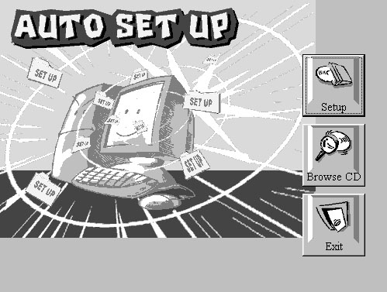
The support software CD-ROM disc loads automatically under Windows 98. When you insert the CD-ROM disc in the system CD-ROM drive the Autorun feature will automatically bring up the install screen. The screen has three buttons on it, Setup, Browse CD and Exit. See the following screen illustration.
When you click on the Setup button the software installation program will run and you can select what kind of installation you want to do, as explained later in this section.
The Browse CD button is the standard Windows command that allows you to examine the contents of the disc using the Windows 98 file browsing interface.
The Exit button closes the Auto Setup window. To run the program again, reinsert the CD-ROM disc in the drive or click on AutoRun in the context sensitive menu for the CD-ROM drive icon in a file browser window.

Installing Software with Auto Setup
To install support software for the system board follow this procedure:
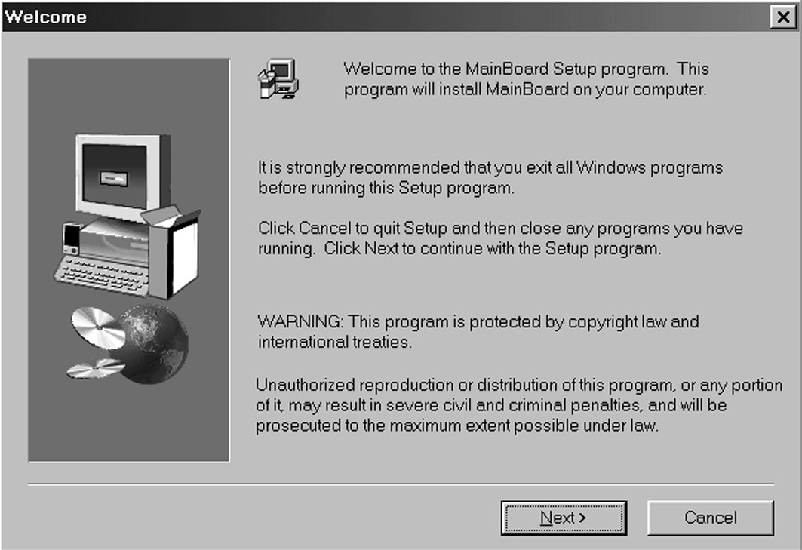
- Click on the Setup button. The install program will load and display the following screen. Click the Next button.
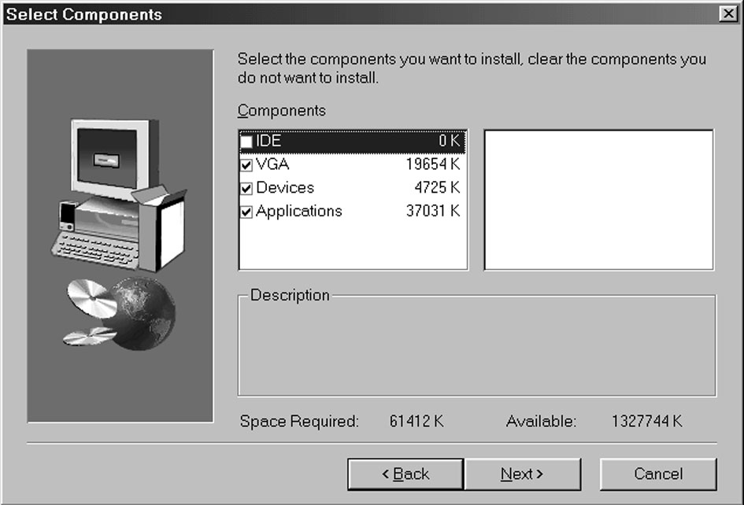
- Select the items that you want to setup by clicking on it (the default options are recommended). Click the Next button to proceed.
- The support software will automatically install.

Once any of the installation procedures start, software is automatically installed in sequence. You will need to follow the onscreen instructions, confirm commands and allow the computer to restart as few times as is needed to complete installing whatever software you selected to install. When the process is finished, all the support software will be installed and working.

There are some utilities that you have to manually install if you need, check to the above section.

Using the PCI Audio Software
- Before you install the PCI Sound Pro drivers, make sure your Operating System has been installed, otherwise the onboard PCI audio might be detected as an “Other device” by the OS device manager.
- After the drivers are properly installed, choose the MULTIMEDIA icon in the CONTROL PANEL when you need to use the Software Wave-Table drivers as a MIDI output device. Select the MIDI tab and click on “C-media SoftMidi Synthesis (Win98) / Driver (Win95)”, then click “OK” to confirm.
- A Windows application named Audio Rack is provided with the PCI Sound Pro drivers, which gives you control over all the audio functions through a user interface that is as simple to use as a home stereo system. We recommend that you use the Audio Rack’s System Mixer to control your computer’s audio volume, recording devices and recording gain.
- If the devices you are using require the MIDI port as the control interface, you need to select the MULTIMEDIA icon in the CONTROL PANEL. Select the MIDI tab and click on “CM8738 MPU-401” (Win98) or “CM8738/C3DX PCI Audio External MIDI Port” (Win95), and then click “OK” to confirm.
- For more information, refer to the PCI Sound Pro manual on the CD that ships with this mainboard.

The Four Speakers System
The onboard PCI Sound Pro audio system supports 2 wave channels (front/rear) known as the 4 speaker system. If you are running applications which use the DirectSound® 3D or A3D® audio interface, your system can simulate realistic 3D sound through a 4 speaker setup. Follow the steps below to install a 4-speaker setup.

Speaker Installation
Connect the front two speakers to the Line-out jack on the sound ports extension bracket. Connect the rear two speakers to the Line-in/Rear jack on the sound ports extension bracket. The original Line-in can be moved to Aux.

Speaker Position
Set up your speakers similar to the following figure to get the best audio result.

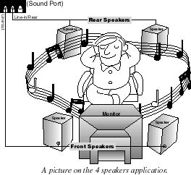

Mixer Setup
There is a 4-speakers option in the Volume Control of the Mixer when you are setting up the PCI Audio Application. Click on the 4 SPK icon to enable this option. This means that the output to the rear speakers is sent through the Line-in/Rear jack. In order to avoid hardware conflicts, DO NOT enable this option when the Line-in/Rear jack is connected with a line-in device. While the 4 speakers mode is enabled, turn on/off the output of the front speakers and adjust the volume of the speakers so that the front/rear speakers have the same volume.

Demo
Execute the “Helicopter” demo in the C3D HRTF Positional Audio Demos of the PCI Audio Application. When you hear the helicopter flying behind you, it means that the rear speakers are working properly.

