TM-VAK7P
PCI/ AGP Mainboard
Onboard Debug

Version: 1.0

Copyright
Copyright © 1999 by this manufacturer. All rights reserved. No part of this publication may be reproduced, transmitted, transcribed, stored in a retrieval system, or translated into any language or computer language, in any form or by any means, electronic, mechanical, magnetic, optical, manual or otherwise, without the prior written consent of this manufacturer.

Disclaimer
This manufacturer makes no representations or warranties, either expressed or implied, with respect to the contents hereof and specifically disclaims any warranties, merchantability or fitness for any particular purpose. Any software described in this manual is sold or licensed “as is”. Should the programs prove defective following their purchase, the buyer (and not this manufacturer, its distributor, or its dealor) assumes the entire cost of all necessary servicing, repair, and any incidental or consequential damages resulting from any defect in the software. Further these manufacturer reserves the right to revise this publication and to make changes from time to time in the contents hereof without obligation to notify any person of such revision or changes.

Trademark Acknowledgement
Intel and Pentium are registered trademarks of Intel Corporation. Award is a registered trademark of Award Software Inc. Other brand and product names are trademarks and/or registered trademarks of their respective holders.

Printed in Taiwan

Overview
The TM-VAK7P is a AMD Athlon based mainboard that utilizes VIA KT133 + 686A chipset, a high level of integrated function. The AMD Athlon is a seventh-generation micro architecture with an integrated L2 Cache, which is powerful enough to support bandwidth requirements of a large range of applications, hardware, graphics and memory technologies.
Socket A is the name for AMD’s new socketed interace designed to support both AMD Duron and AMD Athlon processors. This innovation is made possible by integrating the L2 cache memory on chip with the processor. Socket A will help enable smaller enclosures and ultimately result in a wider variety of solutions in the market.
The AMD Duron processor is drived from the AMD Athlon processor core. It features full-speed, on-chip cache memory, a 200 MHz front size side system bus, and enhanced 3Dnow! Technology. Although both processors are related, there are key differences. The AMD Athlon processor is targeted at the performance segment, and as such will have more cache memory and higher clock speeds.
The most unique feature of the board is its capability to debug onboard or externally via the connection of 3-in-1 module (Referring to page ).
xxxxxxxxxxxxxxx
When the CPU, DRAM, FDD, or VGA cards have not been properly installed, a DIY user can isolate problems through reading the Debug display and instructions in the manual. To professional system test engineers or maintenance engineers, the Debug display can work as an 80 Port Debug Card. In other words, they can use this debug sensor function to do testing and maintenance in lieu of the 80 Port Debug card.

CONTENTS
Copyright 2
Disclaimer 2
Overview 3
CONTENTS 4
Introduction 6
A.Specifications 5
Setup Guide 7
A.Layout Diagra………………………………………………….7

B.Jumper Settings……………………………………………….8

C.Smart Debug On Borad 9
D.CPU Voltage and Frequencies 13
E.EDO/ SDRAM Installation Procedures: 13
F.Check List To Bios Update 12
G. Keyboard PS/2 Mouse Power On and Modem Ring On..13
H. System Health Monitor 15

AWARD BIOS Setup 17
A.Getting Help 18
B.The Main Menu 18
1.Standard CMOS Setup 19
2.BIOS Features Setup 20
3.Chipset Features Setup 24
4.Power Management 27
5.PNP/PCI Configuration Setup 31
6.Load BIOS Default 34
7.Load Setup Default 34
8.Integrated Peripherals Setup 32
9.Supervisor Password 37
10.IDE HDD Auto Detection 38
11.Hard Disk Lw Level Format Utility 38

12.Exiting the Setup Program 40

Technical information 41

A.POST Code 48
PROBLEM SHEET………………………………………………52
Utility guide 53

Introduction

Specifications

System Chipset | VIA KT133 +686A chipset.
CPU | Supports Socket A AMD Duron and Athlon processors at 500 MHz to 1GHz.
Memory | Supports up to 1.5GB of PC133/VC133 memory (minimum 32MB) on board.
I/O | *Two high speed 16550 compatible serial ports,  one Multi-Mode.  *Parallel Port support SPP/EPP/ECP standard  mode.  *Two onboard PCI IDE Ports (32-bit data transfer).  LS-120/ ZIP FDD, IrDA/ ASK IR/ Consumer IR.  2 x USB ports, 2 x USB as optional.  *Support two 360/720KB/1.2/1.44/2.88MB floppy  disk devices.  *One PS/2 Mouse port.
BIOS | Award System BIOS installed in socket (Flash and PnP).
Expansion slots |  | 1 x AGP slot, 4x PCI Master Slots and 1x AMR
Voltage |  | Auto
Dimension |  | 4-layer PCB, size (300mm x 240mm).
Others |  | CPU Auto Temperature Sensor & Music Alarm, voltage monitor and CPU Fan monitor, Bus Master/ Ultra ATA33/66, ACPI, Modem Ring On, LAN Wake Up, Sound on board, Debug on board.

A.System Block Diagram

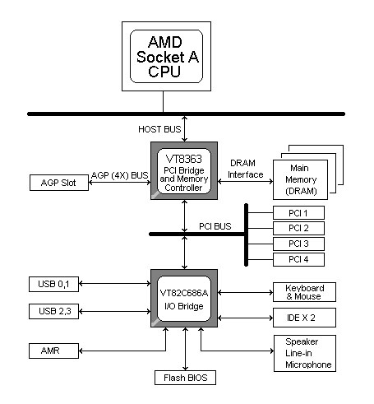

B.Layout Diagram

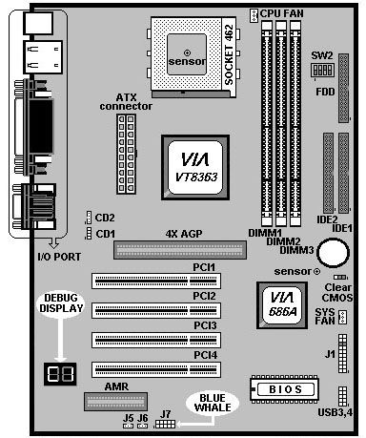

C. Jumper Settings

- Power ON/OFF (For ATX Power Supply) :
The button should be a momentary switch that is normally open.
Pushing the ATX Power Switch will immediately change the system
Status. Before or during “POST”, it takes 4 seconds to turn off
the system.

- J5: LAN Wake Up
Pin1 : 5VSB
Pin 2 : GND
Pin 3 : LAN WAKE UP

- J6: Internal & External MODEM Wake Up
Pin 1: MODEM WAKE UP
Pin 2 : GND
Pin 3 : 5VSB

J6 is to support Internal Modem card and two Serial ports are able
to support the External Modem Ring-In. Once users connect the
external Modem to COM1 or COM2, the TM-VAK7P allows users
to turn their system through the remote and host’s dial-up control.

- J7 : 3-in-1 Killer Kits Connector.

- J8 : USB External Connector
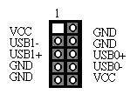
- J9 : CD1

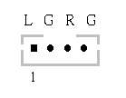
- J10 : CD2
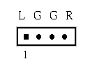
- SW1 : CPU Clock Ratio Table

Ratio | 1 | 2 | 3 | 4
5.0x | On | Off | On | On
5.5x | On | Off | On | Off
6.0x | On | Off | Off | On
6.5x | On | Off | Off | Off
7.0x | Off | On | On | On
7.5x | Off | On | On | Off
8.0x | Off | On | Off | On
8.5x | Off | On | Off | Off
9.0x | Off | Off | On | On
9.5x | Off | On | Off | Off
10.0x | Off | Off | Off | On
10.5x | Off | Off | Off | Off
11.0x | On | On | On | On
11.5x | On | On | Off | On
12.0x | On | On | Off | Off

- SW2 : CPU Frequency

Ratio | 1 | 2 | 3 | 4
66 | On/Off | Off | On | On
75 | Off | Off | Off | On
79 | Off | On | Off | Off
83 | On | Off | Off | On
100 | On/Off | Off | On | Off
110 | Off | On | Off | On
115 | Off | On | On | Off
120 | Off | On | On | On
124 | On | On | Off | Off
129 | On | On | Off | On
133 | On/Off | Off | Off | Off
138 | On | On | On | Off
143 | On | On | On | On

- CLR_CMOS
JP
1-2 | Normal Operation (Default)
2-3 | For Clearing CMOS Data

C.LED Debug & Voice Debug On Board

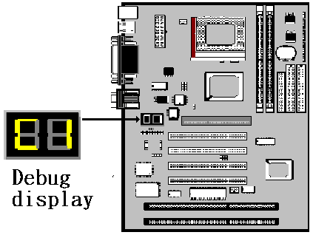
Error Message | LED Error code | Voice Debug
DRAM defect or improper connection | C1\C6 | Please check memory.
CPU defect or improper connection | FF | Please check CPU.
Display card defect or improper connection | OD | Please check display card  or memory.
Cache RAM Defect | 61 | Please check Cache RAM
Keyboard defect | 05 | Please check keyboard.
Floppy defect or improper connection | 4E | Please check Floppy Disk  Drive connector or BIOS.
When CPU temperature over the set point. |  | Your CPU temperature is too high.
When Mainboard was seriously demaged in some of components. | Refer to page 52-56 for other Error Codes. | The Mainboard components may be demaged, please sent it bck to your supplier for repairing.
*Voice Debug Operation : After connecting 4 pin PC speaker, it works .

CPU Voltage and Frequencies

Celeron-370 CPU is a frequency fixed CPU. The CPU type and working voltage for the CPU shall be automatically detected.

E. EDO/ SDRAM Installation Procedures:
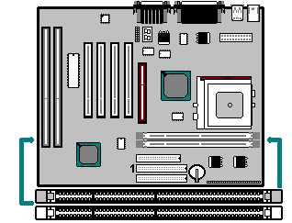

- A 168-pin DIMM can support up to 512MB 3.3V EDO/ SDRAM .

- To avoid compatibility and reliability problems, you are recommended to test the 168-pin SDRAMs before buying them since the PCB specifications differ.

- First, verify the working voltage of the EDO/ SDRAM module in either DIMM socket.

- BV370M only supports 3.3V EDO/ SDRAM module. The following illustration shows you the difference between 3.3V and 5V to ensure your correct selection of 3.3V DIMM module for using.

- You can set up the BIOS “Chipset Feature Setup” to the best working condition basing on the type of EDO/ SDRAM you are using.

- The BIOS DRAM default setting is 60 ns. Change the BIOS “Chipset Feature Setup” default setting to 50ns for better performance, if the chipset is marked 50ns.

- Change nothing if EDO RAM is used. BIOS automatically detect the RAM type.

- MEMO for Installing System:
⊕ Concerning memory setup, you can find how to from “Chipset Feature Setup” under BIOS setup. However, to avoid system unstable or system hang, user without engineering background is not suggested to change BIOS set up.
⊕ If system boot failure, please clean DIMM socket (with clean oil) or polish Gold-Finger of DRAM with soft eraser, and try again.

- The Dual Inline Memory Module (DIMM) must be 3.3 Volt and Unbuffered Synchronous DRAM (SDRAM) 8MB, 16MB, 32MB, 64MB, 128MB or 256MB. The following illustration shows the type of DIMM Module.
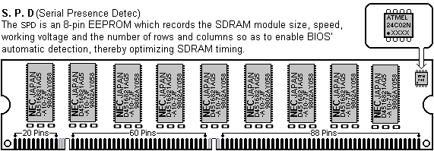
168-PIN PC-100 SDRAM DIMM Notch Key Definitions
