TM-VAK7PE(EB)
PCI/ AGP Mainboard

Version: 1.0

Copyright
Copyright © 2000 by this manufacturer. All rights reserved. No part of this publication may be reproduced, transmitted, transcribed, stored in a retrieval system, or translated into any language or computer language, in any form or by any means, electronic, mechanical, magnetic, optical, manual or otherwise, without the prior written consent of this manufacturer.

Disclaimer
This manufacturer makes no representations or warranties, either expressed or implied, with respect to the contents hereof and specifically disclaims any warranties, merchantability or fitness for any particular purpose. Any software described in this manual is sold or licensed “as is”. Should the programs prove defective following their purchase, the buyer (and not this manufacturer, its distributor, or its dealer) assumes the entire cost of all necessary servicing, repair, and any incidental or consequential damages resulting from any defect in the software. Further these manufacturer reserves the right to revise this publication and to make changes from time to time in the contents hereof without obligation to notify any person of such revision or changes.

Trademark Acknowledgement
AMD Duron and Athlon are registered trademarks of AMD. Award is a registered trademark of Award Software Inc. Other brand and product names are trademarks and/or registered trademarks of their respective holders.

Printed in Taiwan

Overview
The TM-VAK7PE(EB)is a AMD Athlon based mainboard that utilizes VIA KT133 + 686A chipset, a high level of integrated function. The AMD Athlon is a seventh-generation micro architecture with an integrated L2 Cache, which is powerful enough to support bandwidth requirements of a large range of applications, hardware, graphics and memory technologies.
Socket A is the name for AMD’s new socket interface designed to support both AMD Duron and AMD Athlon processors. This innovation is made possible by integrating the L2 cache memory on chip with the processor. Socket A will help enable smaller enclosures and ultimately result in a wider variety of solutions in the market.
The AMD Duron processor is driven from the AMD Athlon processor core. It features full-speed, on-chip cache memory, a 200 MHz front size side system bus, and enhanced 3Dnow! Technology. Although both processors are related, there are key differences. The AMD Athlon processor is targeted at the performance segment, and as such will have more cache memory and higher clock speeds.

CONTENTS
Copyright 2
Disclaimer 2
Overview 3
CONTENTS 4
Introduction 6
Mainboard Layout……………………………………………….7

Jumper Settings………………………………………………….8

EscoCAM, An Integrated Escort Module For PC 11
Connection Guide Of EscoCAM..……………………………13
BIOS Update Note 16
Hardware Monitor …………………………………………… 17

AWARD BIOS Setup 18
Getting Help 19
Standard CMOS Setup 20
BIOS Features Setup 21
Chipset Features Setup 25
Integrated Peripherals Setup 29
Power Management 32
PNP/PCI Configuration Setup 36
Load BIOS Default 39
PC Health Status 38
Frequency / Voltage Control 38

Load Setup Default 39
Supervisor Password 39

Exiting the Setup Program 40

Technical information 41

System Block Diagram 41
I/O Connector Map 42
The Computer Boot Flow Chargt 44
Time and DMA Channels Map 47

POST CODE……..………………………………………………..49PROBLEM SHEET………………………………………………..57
Utility guide 58
MEMO 59

Introduction

Specifications

System Chipset | VIA KT133 +686A chipset.
CPU | Supports Socket A AMD Duron and Athlon processors at 500 MHz to 1GHz.
Memory | 2 x DIMM Supports up to 1024MB of PC133/ VC133 memory (minimum 32MB) on board.
I/O | *Two high speed 16550 compatible serial ports,  one Multi-Mode.  *Parallel Port support SPP/EPP/ECP standard  mode.  *Two onboard PCI IDE Ports (32-bit data transfer).  LS-120/ ZIP FDD, IrDA/ ASK IR/ Consumer IR.  2 x USB ports, 2 x USB as optional.  *Support two 360/720KB/1.2/1.44/2.88MB floppy  disk devices.  *One PS/2 Mouse port.
BIOS | Award System BIOS installed in socket (Flash and PnP).
Expansion slots |  | 1 x AGP slot, 5x PCI Master Slots and 1x AMR
Sound On Board |  | AC 97 Codec Complaint PC97 2.1 specification,  Supports 18-bit ADC and DAC as well as 18-bit  Stereo full duplex codec.
Dimension |  | 4-layer PCB, size (300mm x 200mm).
Others |  | CPU Auto Temperature Sensor & Music Alarm, voltage monitor and CPU Fan monitor, Bus Master/ Ultra ATA33/66, ACPI, Modem Ring On, LAN Wake Up.

Mainboard Layout

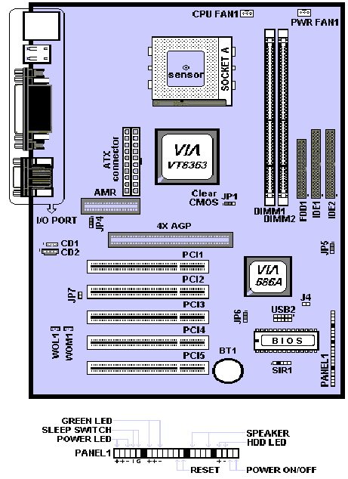

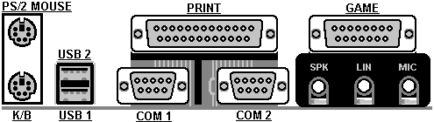

Jumper Settings

- Power ON/OFF (For ATX Power Supply) :
The button should be a momentary switch that is normally open.
Pushing the ATX Power Switch will immediately change the system
Status. Before or during “POST”, it takes 4 seconds to turn off
the system.

USB2 : USB EXTERNAL CONNECTOR
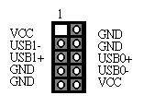

- JP1: CLR_CMOS

1-2 | Normal Operation (Default)
2-3 | For Clearing CMOS Data

- JP2 : USB Port 1-2

Short 1-2 | Disable
Short 2-3 | Enable

- JP4: Codec/AMR Option Jumper

Short 1-2 | Enable On Board Codec
Short 2-3 | Enable AMR Slot

- JP5 : BIOS Write Protection Jumper

Short 1-2 | Disable
Short 2-3 | Enable

- JP6 : USB Port 3-4

Short 1-2 | Disable
Short 2-3 | Enable

- JP7 : Define On Board Codec Mode

Open | Master
Short | Slave

- CD1

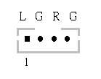
.
- CD2
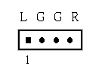

EscoCAM – An Integrated Module

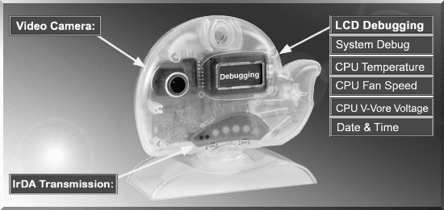

It’s so valuable that you don't have to pay thrice to buy three fashionable devices of PC Camera, Debugging and IrDA ware now because we have integrated them into our EscoCAM in the shape of a lovely whale to escort your system. The whale is the king of the sea and the symbol of all-mighty power. With PC camera, Debug, CPU heat monitor and IrDA device built into the EscoCAM, we offers you the unbeatable solution to upgrade the value of your PC system.

1. PC Camera:
As video and audio email is gaining popularity, PC cameras are making inroads into PC systems and it will increasingly become a standard PC peripheral. In view of this strong market demand, we has timely launched its state-of-the-art PC cameras. Besides, our PC Camera is allowed to adjust the Focus of Camera via Keyboard
or mouse instead of wheel. It’s a patent design in PC Camera. Hope you enjoy
this new technology.

2. External Debug :
When initializing system, LCD will check the peripherals of CPU, Chipset, DRAM, BIOS, Keyboard, CMOS, VGA card, Devices, FDD, HDD and Cache…Once peripherals were not been properly installed or defective, the LCD display will show out the detective place. After system successfully booted up, Time & Date, CPU Temperature, CPU V-Core Voltage, CPU Fan Speed will take turn to show out on the LCD display.
Advantages of Debug Device For User:
In comply with fast development of IT and e-Commerce, the time of people
to stay together with PC will be beyond what we can image. Eventually, the
high density use of PC is unavoidable to cause high defect rate. Especially,
when warranty is over, user will is not in a position to bargain the upraising repair cost. The worse is that users are always overcharged when they have don’t have any sense about defect status. However, once PC system is equipped with basic debugging devices, user is able to easily understand how far the hardware problem going; thereby drastically minimize the time and cost from RMA.

3. Monitor CPU Temp. And FAN Working Status:
Audio, video and multi-tasking functions call for faster and faster CPUs to improve system efficiency. However, faster CPUs will generate more heat which must be dissipated in a timely manner. Therefore, a more efficient fans to dissipate heat is as important as watch-out of fan working situation. In this Internet era, people are using their computers for longer and longer time which can easily cause overheat and damage to the CPU. Prolonged use of the computer will increase CPU temperature.
It is therefore necessary to have a device to constantly monitor the CPU temperature, CPU fan speed and V-Core voltage and timely remind user.

4. IrDA For Data Transmission :
As more and more computers, notebook, mobile phone and PDA are installed
with the IrDA device for wireless transmission, we add in this extra value in the
EscoCAM.

The Connection of EscoCAM

I. For TM-VAK7 Mainboard :
If you use TM-VAK7P, the most updated mainboard, it’s already built-in all the
circuit of EscoCAM so that user don’t need a extra daughter card to connect it.
The connection drawing as follows:

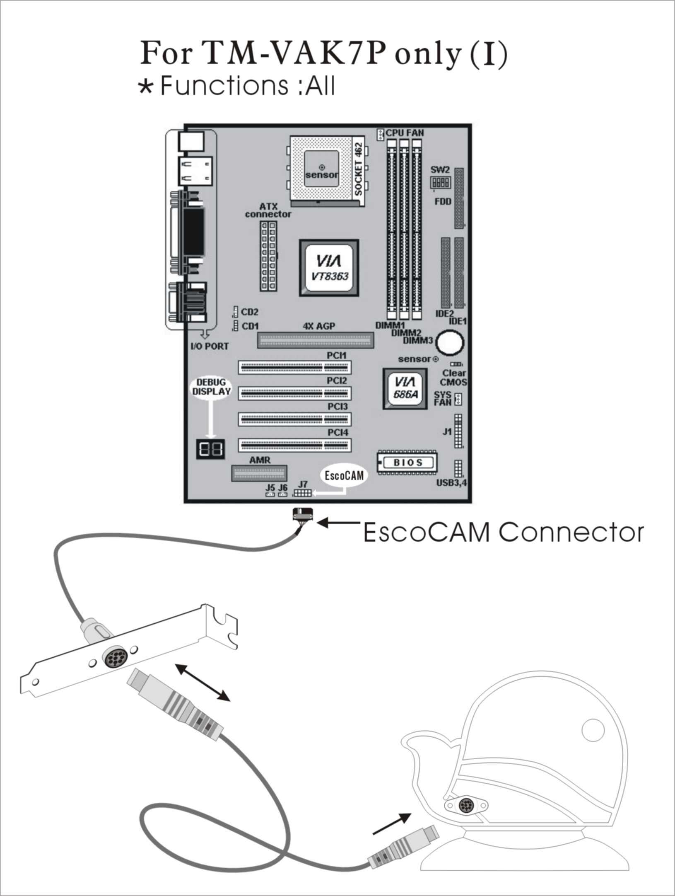

II. For All Others Mainboards:
If the mainboard you used is not TM-VAK7, you need A PCI daughter card to
be inserted and make connection as follows:

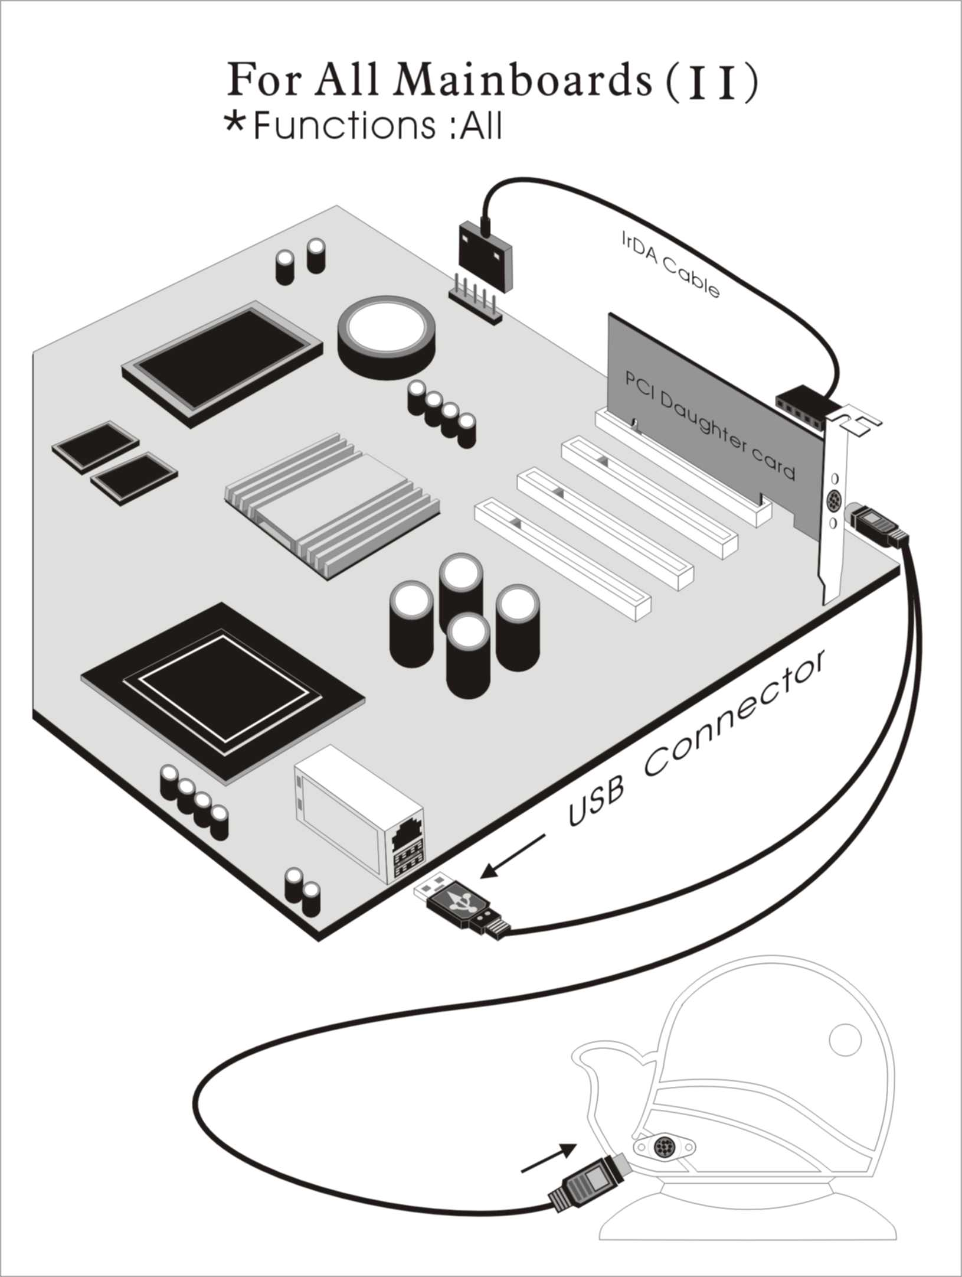

III. Or, if you just want use the function of PC Camera, the connection
drawing as follows:

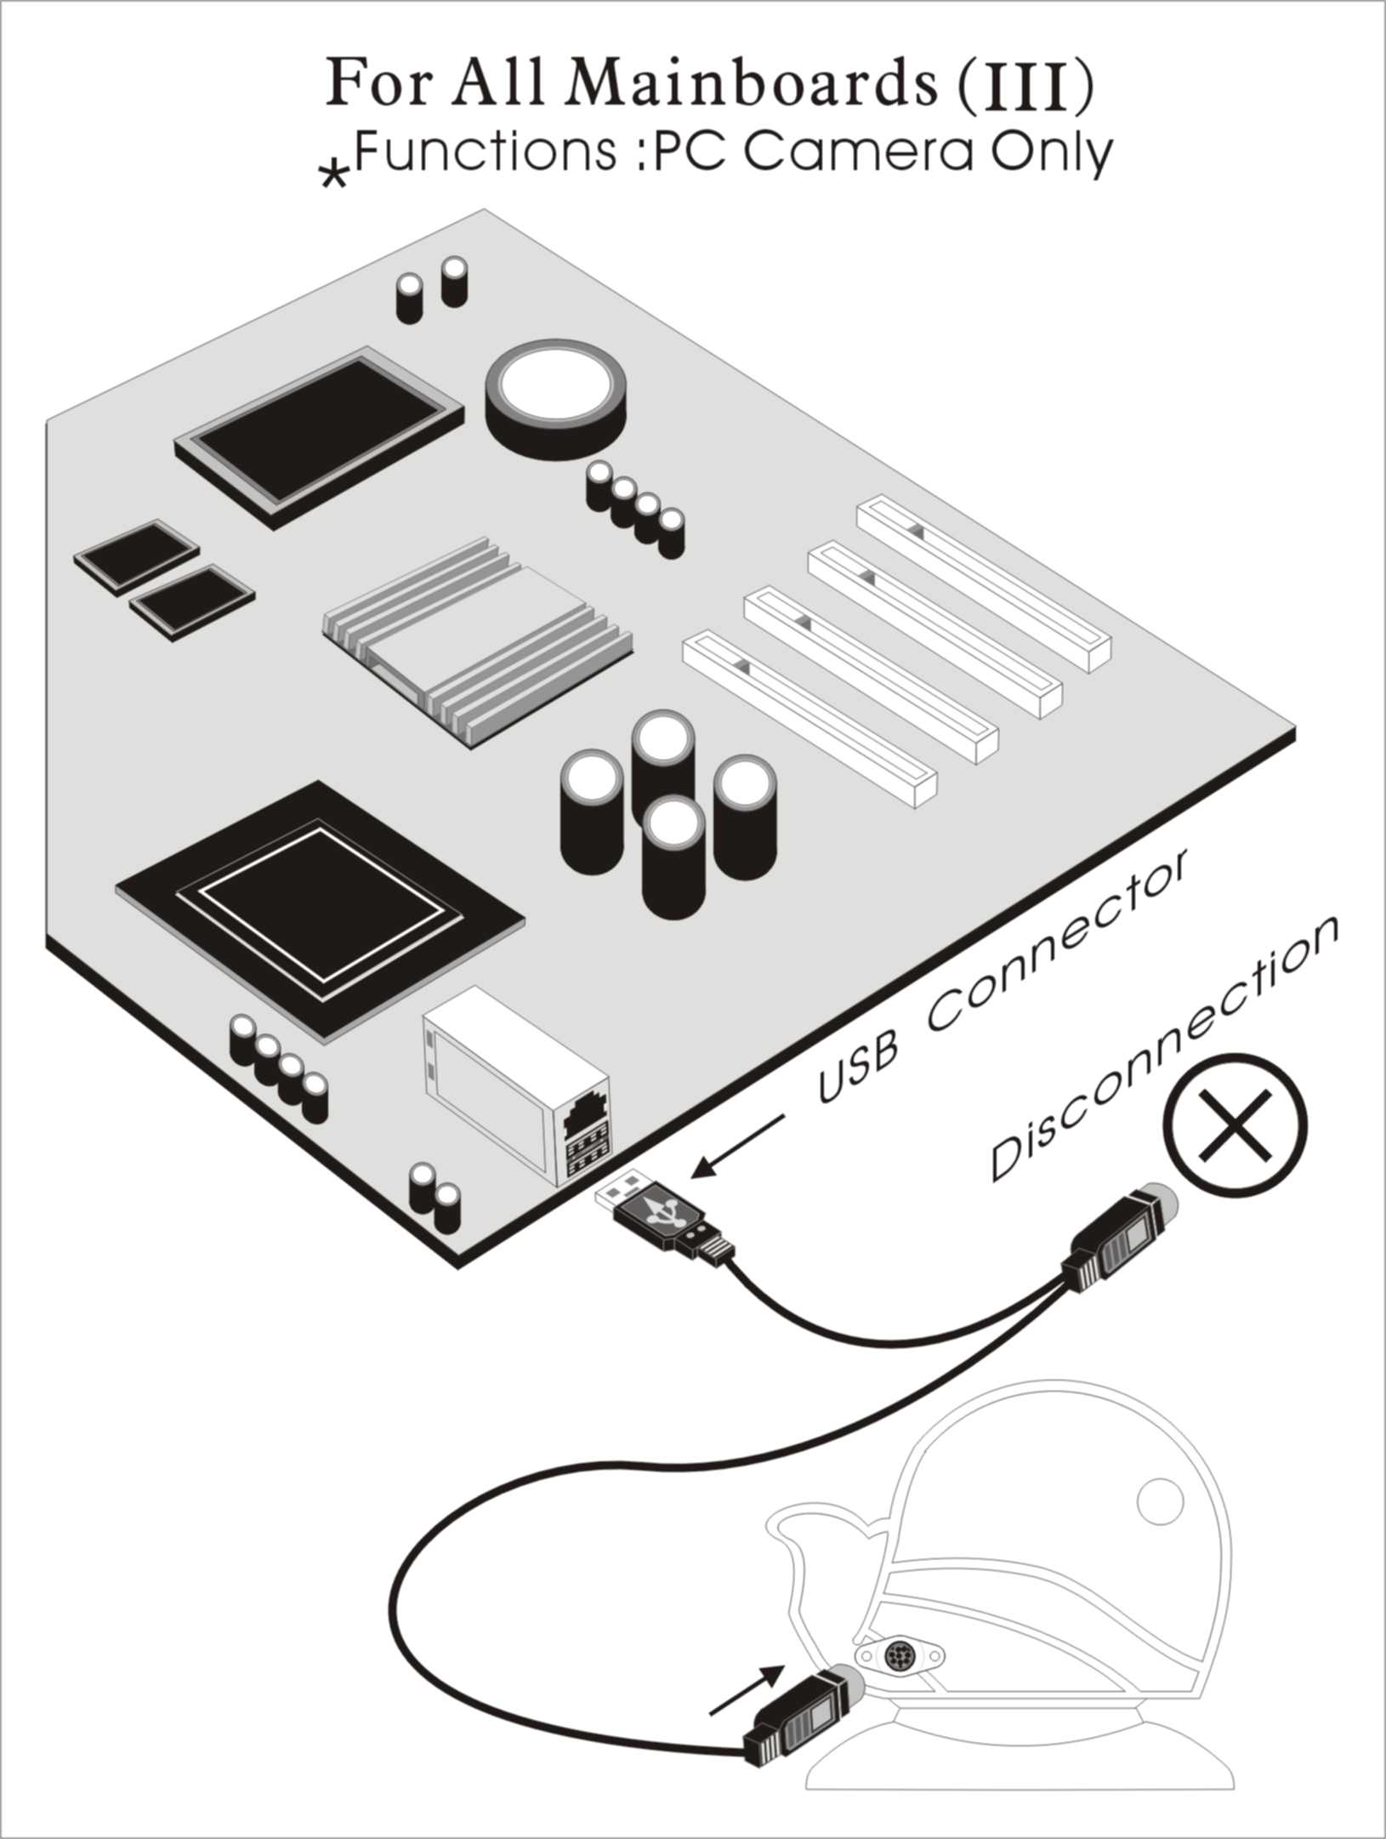

BIOS Update Note

Do not update the BIOS if no abnormalities occur. However, if BIOS update is needed, consult your dealer first. Prior to updating your BIOS, you are recommended to save the original BIOS values.

1. Download the AWARD BIOS Flash Utility file (Awdflash.exe)

2. Download the BIOS file used by your mainboard(e.g., BXV110N.BIN)

3. Reboot your system (but do not run Himem.sys and Emm386.exe)
to execute the new BIOS program.

4. Execute these commands: Awdflash BXV110N.BIN

5. When this message displays: "Do you want to save BIOS (Y/N)?"
Type "N"

6. When this message displays: "Are you sure to program (Y/N)?"
Type "Y"

Hardware Monitor

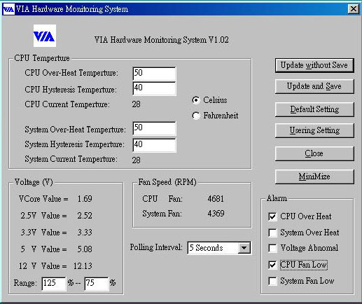

- Hardware Monitoring: Installed VIAhm.exe in the start of system
to enable this function.
- CPU Temperature : Display Current CPU temperature and will alarm when CPU temperature is higher than the set point.
- System Temperature : Display Current System temperature and will alarm when System temperature is higher than the set point.
- CPU Fan Speed : Display Current CPU Fan speed and will alarm when Fan speed is lower than the set point
- Chassis Fan Speed : Display Current Chassis Fan speed and will alarm when Chassis Fan speed is lower than the set point.
- CPU voltage level of the CPU V-Core : Display 3.3V, 5V, 12V.

