TM-VA370E
PCI/ AGP/AMR Mainboard

Version: 1.0

Copyright
Copyright © 1999 by this manufacturer. All rights reserved. No part of this publication may be reproduced, transmitted, transcribed, stored in a retrieval system, or translated into any language or computer language, in any form or by any means, electronic, mechanical, magnetic, optical, manual or otherwise, without the prior written consent of this manufacturer.

Disclaimer
This manufacturer makes no representations or warranties, either expressed or implied, with respect to the contents hereof and specifically disclaims any warranties, merchantability or fitness for any particular purpose. Any software described in this manual is sold or licensed “as is”. Should the programs prove defective following their purchase, the buyer (and not this manufacturer, its distributor, or its dealor) assumes the entire cost of all necessary servicing, repair, and any incidental or consequential damages resulting from any defect in the software. Further these manufacturer reserves the right to revise this publication and to make changes from time to time in the contents hereof without obligation to notify any person of such revision or changes.

Trademark Acknowledgement
Intel and Pentium are registered trademarks of Intel Corporation. Award is a registered trademark of Award Software Inc. Other brand and product names are trademarks and/or registered trademarks of their respective holders.

Printed in Taiwan

Overview
The TM-VA370E is a PPGA-Celeron based mainboard that utilizesVIA 694A+686A chipset, a high level of integrated function. This mainboard is designed for Celeron & 133 MHz CuMine FC-PGA CPU, and support new architectures such as high speed AGP graphic port, ATA33/66(VIA) Bus Master IDE, Sound On Board, SDRAM memory and expandable to a maximum 768MB. There is no second level cache onboard since the cache is on the CPU.
In addition to above features, this mainboard implements most advanced technology such as Synchronous switching regulator, CPU thermal protection, CPU fan monitoring, System voltage monitoring, Over currentt protection, Modem Wake Up, Keyboard Power On, PS/2 mouse Power On, Debug sensor on board.

CONTENTS
Copyright 2
Disclaimer 2
Overview 3
CONTENTS 4
Introduction 6
Specifications 5
Setup Guide 7
ayout Diagra……………………………………………………...7
Jumper Settings………………………………………………….8

EscoCAM - An Integrated Module 9
Connection Guide of EscoCAM ……………………………..11
BIOS Updated Note…………….. …………………………….14

E. Hardware Monitor …………………………………………15

AWARD BIOS Setup 16
A.Getting Help 17
B.The Main Menu 17
1.Standard CMOS Setup 18
2.BIOS Features Setup 19
3.Chipset Features Setup 23
4. Integrated Peripherals 27
5. Power Management 30
6.PNP/PCI Configuration Setup 34
7. PC Health Status ..…………………………………………36
8. Frequency / Voltage Control………………………………36
9. Load BIOS Default 37
10. Load Setup Default 37
11.Supervisor Password 37
12.Exiting the Setup Program 38

Technical information 39

A.POST Code 44
PROBLEM SHEET………………………………………………52
Utility guide 53

How to use external 3.5" drive bay. 54

Introduction

Specifications

System Chipset | VIA 694A+686A chipset.
CPU | Intel PPGA-Celeron processors, support 300/333/ 366/400/433/466/500/533/566/600 (Ex. Clk 66 MHz); CuMine FC-PGA 450/500/550/ 600/ 650/ 700/750/ 800 (Ex. Clk 100 MHz); CuMine FC-PGA  533/600/667/733/800 (Ex.Clk 133 MHz) CPU.
Memory | Expandable to 1.5GB (3 banks) with three 168-pin DIMM socket {support 3.3 V EDO (66MHz only) / SDRAM (66/100 &133 MHz for VIA chipset)}.
I/O | Two high speed 16550 compatible serial ports, one Multi-Mode.  Parallel Port support SPP/EPP/ECP standard mode.  Two onboard PCI IDE Ports (32-bit data transfer). LS-120/ ZIP FDD, IrDA/ ASK IR/ Consumer IR.  Dual USB ports  Support two 360/720KB/1.2/1.44/2.88MB floppy disk devices.  One PS/2 Mouse port.
BIOS | Award System BIOS installed in socket (Flash and PnP).
Expansion slots |  | 1x AGP slot, 5xPCI Master Slots and 1x AMR.
Voltage |  | Auto
Dimension |  | 4-layer PCB, size (300mm x 180mm).
Others |  | CPU Auto Temperature Sensor & Music Alarm, voltage monitor and CPU Fan monitor, Bus Master/ Ultra DMA/33, ATA/66, ACPI, AGP Bus, Keyboard Power On, Modem Ring On, LAN Wake Up, Sound on board.

Setup Guide

Layout Diagram

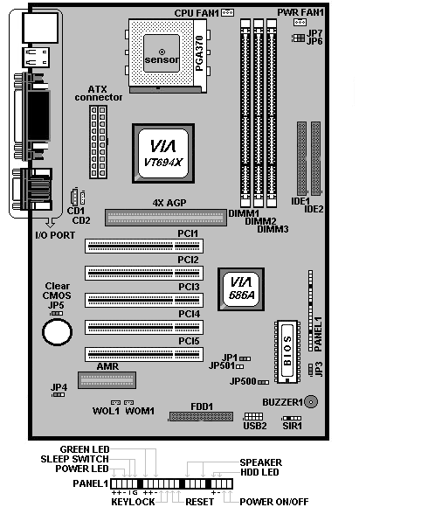

Jumper Setting
- JP1 : Clear CMOS
JP1
Short 1-2 | Normal Operation (Default)
Short 2-3 | Clearing CMOS Data
- JP3 : BIOS Flash
JP3
Short 1-2 | Disable BIOS Flashing
Short 2-3 | Enable BIOS Flashing
- JP4 : Onboard Codec & AMR selection
JP4
Short 1-2 | On Board Codec
Short 2-3 | AMR Slot
- JP5 : AMR Master/Slave Selection
JP5
Short 1-2 | AMR Slave
Short 2-3 | AMR Master
- JP6/JP7 : CPU Frequency Selection
CPU Freq. | JP6 | JP7
66 MHz | Short 1-2 | Short 1-2
100 MHz | Short 2-3 | Short 1-2
105 MHz | Short 1-2 | Short 2-3
133 MHz | Short 2-3 | Short 2-3

- JP500/501
JP500 is for setting on board ROM voltage and JP501 is for setting ROM size so that do not make any adjustment on both jumpers !!

- USB2 : USB Connector
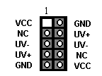

EscoCAM – An Integrated Module

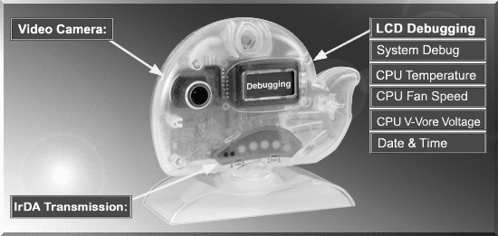

It’s so valuable that you don't have to pay thrice to buy three fashionable devices of PC Camera, Debugging and IrDA ware now because we have integrated them into our EscoCAM in the shape of a lovely whale to escort your system. The whale is the king of the sea and the symbol of all-mighty power. With PC camera, Debug, CPU heat monitor and IrDA device built into the EscoCAM, we offers you the unbeatable solution to upgrade the value of your PC system.

1. PC Camera:
As video and audio email is gaining popularity, PC cameras are making inroads into PC systems and it will increasingly become a standard PC peripheral. In view of this strong market demand, we has timely launched its state-of-the-art PC cameras. Besides, our PC Camera is allowed to adjust the Focus of Camera via Keyboard
or mouse instead of wheel. It’s a patent design in PC Camera. Hope you enjoy
this new technology.

2. External Debug :
When initializing system, LCD will check the peripherals of CPU, Chipset, DRAM, BIOS, Keyboard, CMOS, VGA card, Devices, FDD, HDD and Cache…Once peripherals were not been properly installed or defective, the LCD display will show out the detective place. After system successfully booted up, Time & Date, CPU Temperature, CPU V-Core Voltage, CPU Fan Speed will take turn to show out on the LCD display.
3. Monitor CPU Temp. And FAN Working Status:
Audio, video and multi-tasking functions call for faster and faster CPUs to improve system efficiency. However, faster CPUs will generate more heat which must be dissipated in a timely manner. Therefore, a more efficient fans to dissipate heat is as important as watch-out of fan working situation. In this Internet era, people are using their computers for longer and longer time which can easily cause overheat and damage to the CPU. Prolonged use of the computer will increase CPU temperature.
It is therefore necessary to have a device to constantly monitor the CPU temperature, CPU fan speed and V-Core voltage and timely remind user.

4. IrDA For Data Transmission :
As more and more computers, notebook, mobile phone and PDA are installed
with the IrDA device for wireless transmission, we also developed its own
IrDA device for this purpose.

The Connection of EscoCAM

I. For TM-VAK7 Mainboard :
If you use TM-VAK7P, the most updated mainboard, it’s already built-in all the
circuit of EscoCAM so that user don’t need a extra daughter card to connect it.
The connection drawing as follows:

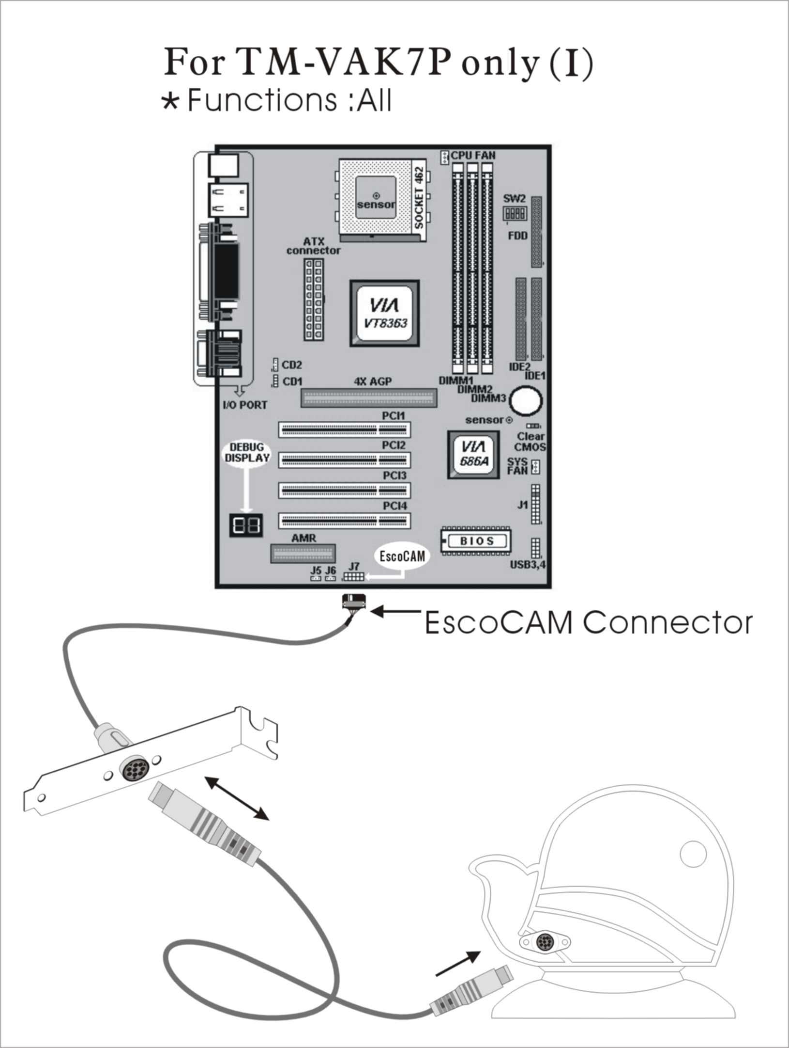

II. For All Others Mainboards:
If the mainboard you used is not TM-VAK7, you need A PCI daughter card to
be inserted and make connection as follows:

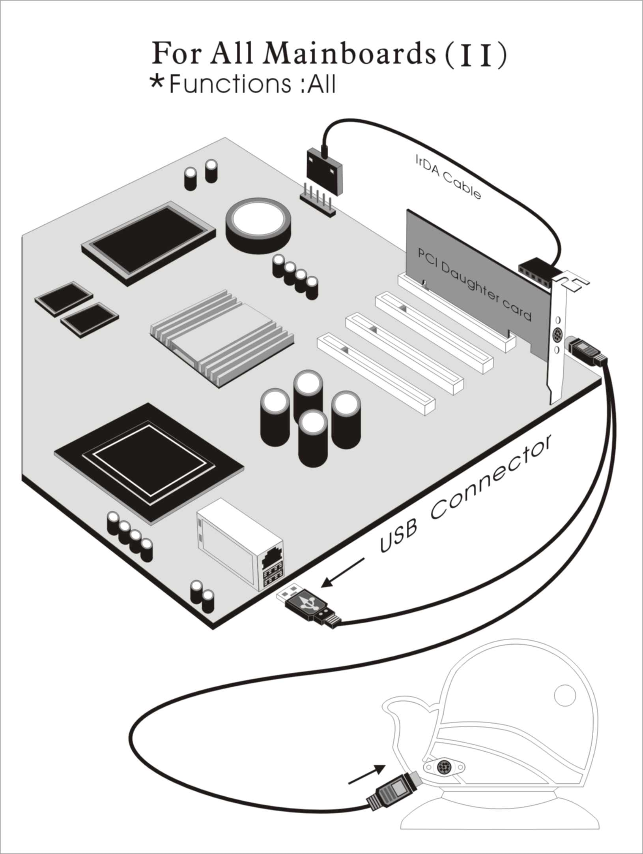

III. Or, if you just want use the function of PC Camera, the connection
drawing as follows:

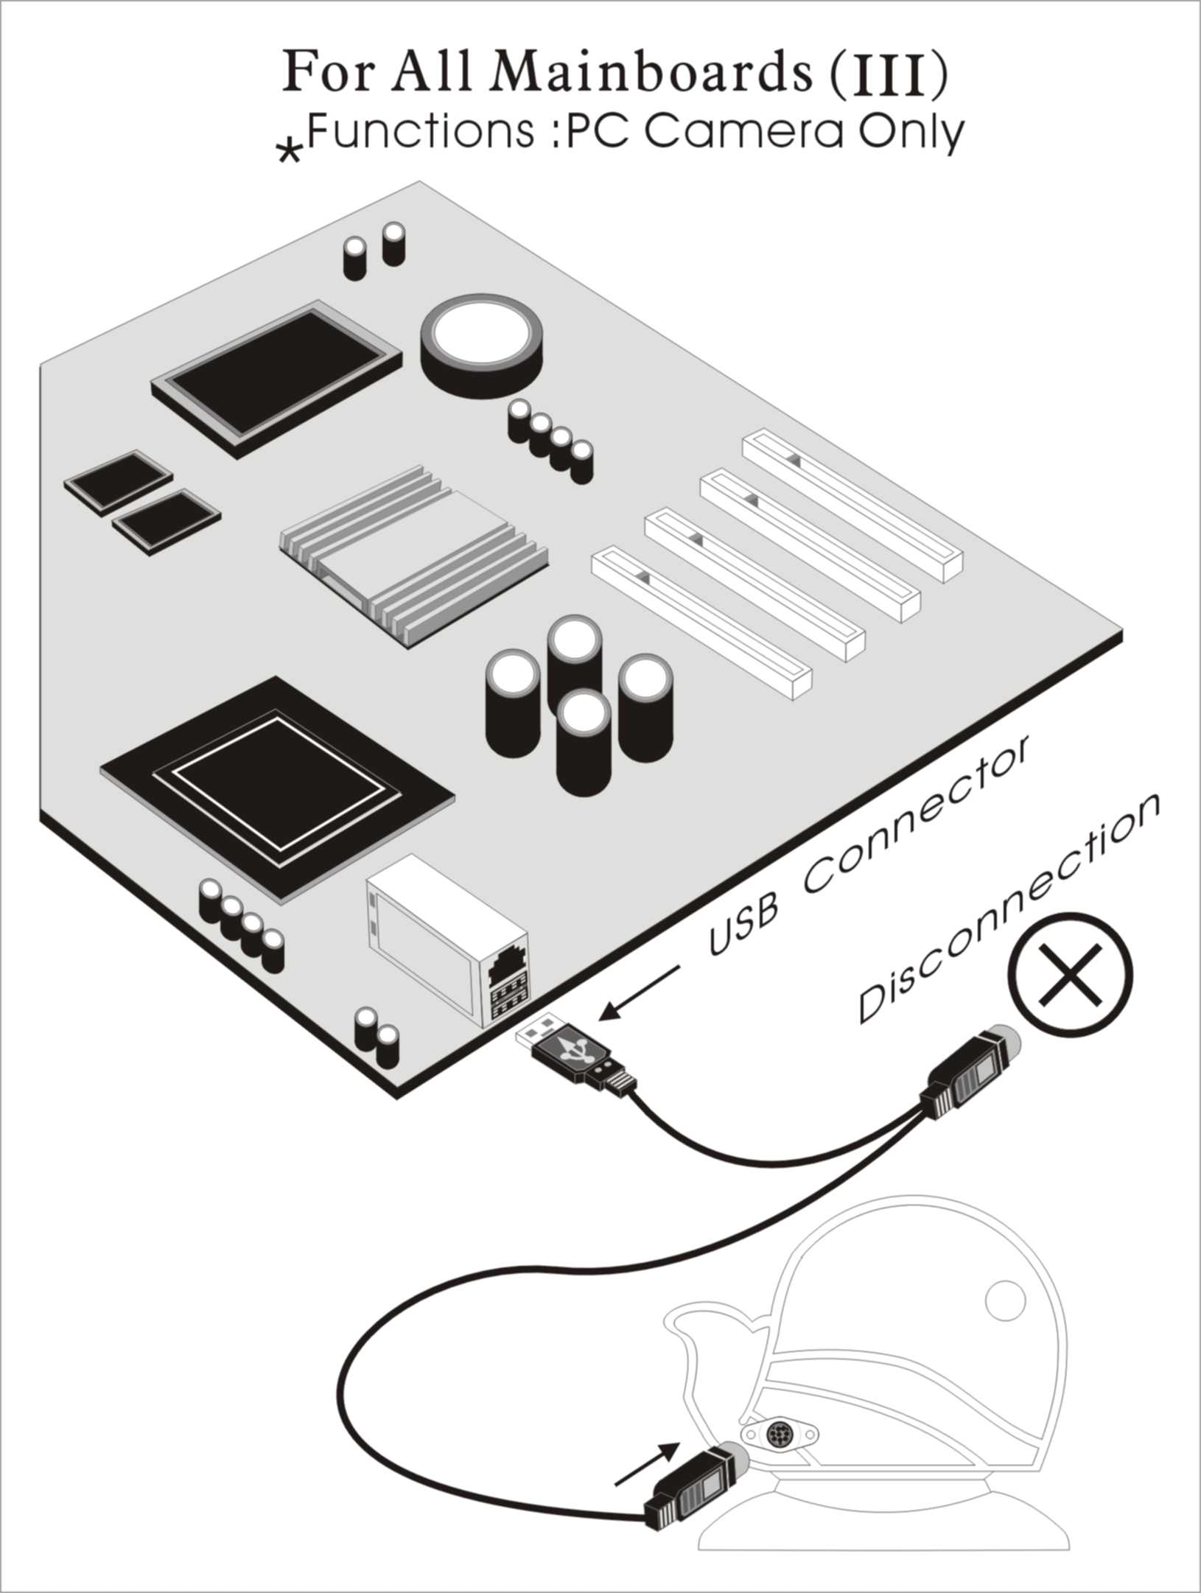

BIOS Update Note

Do not update the BIOS if no abnormalities occur. However, if BIOS update is needed, consult your dealer first. Prior to updating your BIOS, you are recommended to save the original BIOS values.

1. Download the AWARD BIOS Flash Utility file (Awdflash.exe)

2. Download the BIOS file used by your mainboard(e.g., XXXXXXX.BIN)

3. Reboot your system (but do not run Himem.sys and Emm386.exe)
to execute the new BIOS program.

4. Execute these commands: Awdflash XXXXXXX.BIN

5. When this message displays: "Do you want to save BIOS (Y/N)?"
Type "N"

6. When this message displays: "Are you sure to program (Y/N)?"
Type "Y"

Hardware Monitor

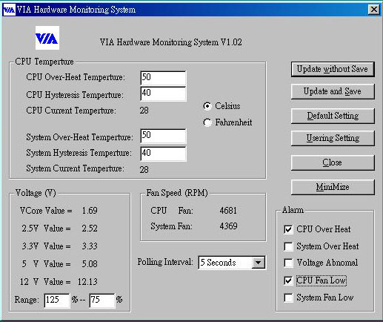

- Hardware Monitoring: Installed VIAhm.exe in the start of system
to enable this function.
- CPU Temperature : Display Current CPU temperature and will alarm when CPU temperature is higher than the set point.
- System Temperature : Display Current System temperature and will alarm when System temperature is higher than the set point.
- CPU Fan Speed : Display Current CPU Fan speed and will alarm when Fan speed is lower than the set point
- Chassis Fan Speed : Display Current Chassis Fan speed and will alarm when Chassis Fan speed is lower than the set point.
- CPU voltage level of the CPU V-Core : Display 3.3V, 5V, 12V.

