Introduction

Specifications

System Chipset | ALi ALADDIN-V chipset.
CPU | One 321-pin socket 7 for Intel Pentium (P55C), AMD (K6, K6-2), Cyrix (6x86 L, MX, M II) processors, support 120/133/150/166/200/233/  266/300/350/366/380/400 MHz.
Memory | Expandable to 768MB (66MHz only) with two 72-pin SIMM sockets onboard (Support Fast Page Mode and EDO DRAM and two 168-pin DIMM socket (support Synchronous DRAM module).
Cache | 64-bit 512KB L2 Pipeline Burst SRAM onboard.
I/O | Two high speed 16550 compatible serial ports, one Multi-Mode.  Parallel Port support SPP/EPP/ECP standard mode.  Two onboard PCI IDE Ports (32 bit data transfer).  Support two 720KB/ 1.2/ 1.44/ 2.88MB floppy disk devices.  One PS/2 Mouse port.
BIOS | Award System BIOS installed in socket (Flash and PnP).
Expansion slots |  | One AGP slot, three PCI Master Slots and two 16-bit ISA Slots.
Dimension |  | 4-layer PCB, baby size (220mm x 210mm).
Others |  | Support Ultra DMA/33, ACPI, SM Bus, GPID, USB Bus, ATX Power supply, IrDA, Debug sensor on board.

Setup Guide

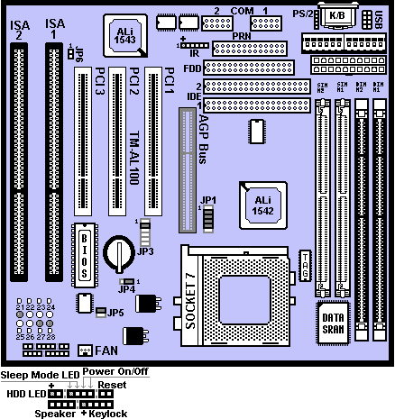
Layout Diagram

Switch Settings For CPUs
On = Short; Off = Open
Intel/ AMD/ Cyrix |  | JP1
 |  | 1-2 |  | 3-4 |  | 5-6 |  | CLK | 7-8 | 9-10 | 11-12 | RATE
Pentium (MMX) 166 MHz | OFF |  | ON |  | ON |  | 66 |  | ON | ON | OFF | 2.5
Pentium (MMX) 200 MHz | OFF |  | ON |  | ON |  | 66 |  | OFF | ON | OFF | 3
Pentium (MMX) 233 MHz | OFF |  | ON |  | ON |  | 66 |  | OFF | OFF | OFF | 3.5
Pentium (MMX) 266 MHz | OFF |  | ON |  | ON |  | 66 |  | ON | OFF | ON | 4
AMD-K6(MMX)-166MHz | OFF |  | ON |  | ON |  | 66 |  | ON | ON | OFF | 2.5
AMD-K6(MMX)-200MHz | OFF |  | ON |  | ON |  | 66 |  | OFF | ON | OFF | 3
AMD-K6(MMX)-233MHz | OFF |  | ON |  | ON |  | 66 |  | OFF | OFF | OFF | 3.5
AMD-K6(MMX)-266MHz | OFF |  | ON |  | ON |  | 66 |  | ON | OFF | ON | 4
AMD-K6(MMX)-300MHz | OFF |  | ON |  | ON |  | 66 |  | ON | ON | ON | 4.5
AMD-K6-2/ 300MHz | OFF |  | OFF |  | OFF |  | 100 |  | OFF | ON | OFF | 3
AMD-K6-2/ 333MHz | ON |  | OFF |  | OFF |  | 95 |  | OFF | OFF | OFF | 3.5
AMD-K6-2/ 350MHz | OFF |  | OFF |  | OFF |  | 100 |  | OFF | OFF | OFF | 3.5
AMD-K6-2/ 366MHz | OFF |  | ON |  | ON |  | 66 |  | OFF | OFF | ON | 5.5
AMD-K6-2/ 380MHz | ON |  | OFF |  | OFF |  | 95 |  | ON | OFF | ON | 4
AMD-K6-2/ 400MHz | OFF |  | OFF |  | OFF |  | 100 |  | ON | OFF | ON | 4
Cyrix 6x86L-120MHz-P150+ | ON |  | ON |  | ON |  | 60 |  | ON | OFF | OFF | 2
Cyrix 6x86L-133MHz-P166+ | OFF |  | ON |  | ON |  | 66 |  | ON | OFF | OFF | 2
Cyrix 6x86L-150MHz-P200+ | ON |  | ON |  | OFF |  | 75 |  | ON | OFF | OFF | 2
Cyrix MX-150MHz-PR166 | ON |  | ON |  | ON |  | 60 |  | ON | ON | OFF | 2.5
Cyrix MX-166MHz-PR200 | OFF |  | ON |  | ON |  | 66 |  | ON | ON | OFF | 2.5
Cyrix MX-200MHz-PR233 | OFF |  | ON |  | ON |  | 66 |  | OFF | ON | OFF | 3
Cyrix MX-233MHz-PR266 | OFF |  | ON |  | ON |  | 66 |  | OFF | OFF | OFF | 3.5
Cyrix M II-225MHz-300GP | ON |  | ON |  | OFF |  | 75 |  | OFF | ON | OFF | 3
Cyrix M II-233MHz-300GP | OFF |  | ON |  | ON |  | 66 |  | OFF | OFF | OFF | 3.5
Cyrix M II-250MHz-333GP | OFF |  | OFF |  | OFF |  | 100 |  | ON | ON | OFF | 2.5
Cyrix M II-300MHz-350GP | OFF |  | OFF |  | OFF |  | 100 |  | OFF | ON | OFF | 3.0

Smart Debug On Board
When the CPU, DRAM, Cache RAM, FDD or VGA card have not been properly installed, user can isolate those basic problems through the Debug Sensor LED and instructions from the manual. To Professional system engineers or maintenance engineers, the Debug Sensor can work as an 80 Port Debug Sensor Card.

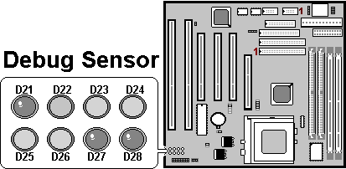

Error code |  | Display | Message | Solution
 | C1 | None | Can’t detect DRAM | 1. Reinstall or replace the SDRAM.  2. Reinstall or replace the BIOS.
 | C6 | None | Can’t detect DRAM | 1. Reinstall or replace the SDRAM.  2. Reinstall or replace the BIOS.
 | OD | None | Can’t detect VGA card | 1. Reinstall or replace the VGA card.  2. Replace the BIOS.
 | 4E | Yes | Can’t detect Floppy disk | 1. Replace the BIOS. (if no screen)  2. Enter the BIOS Setup menu to reset.  3. Check that the FDD cable and the power  connector are properly connected.  4. Reconnect the FDD cable or replace the FDD.
 | 61 | Yes | L2 cache problem | 1. Enter BIOS Setup to disable the external cache.

Note To Installing The Mainboard

Touch the non-coated area on the computer case or use a grounded wire to release static electricity before you open the anti-static electricity bag and take out the mainboard. It's likely to damage the mainboard components while taking out the board without first releasing static electricity. During installation, avoid touching the components on the mainboard.

CPU Voltage Settings

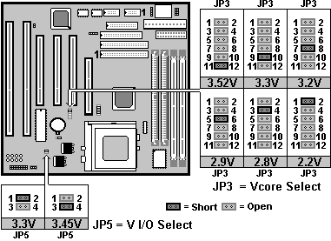
- VI/O default setting : 3.30V Vcore default setting : 2.80V
- Switch voltage is applied, making the temperature lower and voltage steadier.
- All the voltage specifications adopted here are the averages of the working voltage suggested by the CPU makers, to make any CPU applied work with the best performance.
- In Single voltage CPU VI/O = Vcore.
- Remember to make sure CPU voltage set up is 100% correct. Any voltage error setup happened in Dual Voltage CPU will cause system unstable or doesn’t work, or even worse is that it will burn out your CPU.

CPU Ex. Clock And Ratio Select
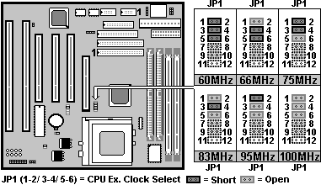
- The CPU type default setting is Intel Pentium 166MHz=66 MHz＊2.5.
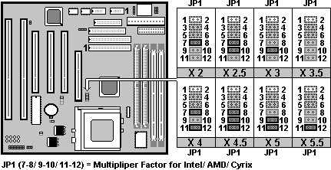
- When you short JP6, the PCI Bus CLK output becomes 37MHz. Under this circumstance, some VGA cards may not fit well. Then the system becomes unsteady, tends to hang up easily or even results in boot failure. Use another VGA card instead when any of the above-mentioned conditions happens.

Memory Installation Procedures:
- SIMM Socket output voltage is 5V, expandable to 256MB.
- A SDRAM can support up to 512MB EDO (66MHz) / SDRAM (66MHz/ 100MHz).
- AL100 only supports 3.3V EDO/ SDRAM module. The following illustration shows you the difference between 3.3V and 5V to ensure your correct selection of 3.3V DIMM module for using.
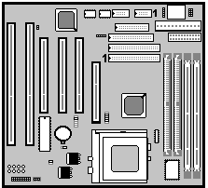
- First, verify the working voltage of the EDO/ SDRAM module in either DIMM socket.
- Change nothing if EDO RAM is used. BIOS automatically detect the RAM type.
- You are recommended to use SDRAMs. With SPD that are compliant with PC-100. This will enable BIOS to detect the SDRAM speed, thereby fully bring into play the efficiency of the SDRAM.
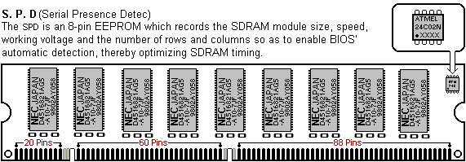
- To avoid compatibility and reliability problems, you are recommended to test the 168-pin SDRAMs before buying them since the PCB specifications differ.

- You can set up the BIOS “Chipset Feature Setup” to the best working condition basing on the type of EDO/ SDRAM you are using.
- The BIOS DRAM default setting is 60 ns. Change the BIOS “Chipset Feature Setup” default setting to 50ns for better performance, if the chipset is marked 50ns.
- MEMO for Installing System:
⊕ Concerning memory setup, you can find how to from “Chipset Feature Setup” under BIOS setup. However, to avoid system unstable or system hang, user without engineering background is not suggested to change BIOS set up.
⊕ If system boot failure, please clean DIMM socket (with clean oil) or polish Gold-Finger of DRAM with soft eraser, and try again.

Other Jumper Settings
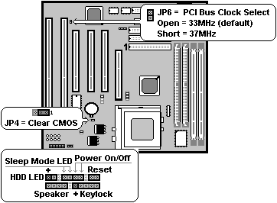
- Speaker: Connect to the system’s speaker for beeping.
- Keylock: Keyboard lock switch and Power LED connector.
- Reset: Short to restart system.
- HDD LED: LED ON when on board PCI IDE hard disk activates.
- Sleep Mode LED: LED ON when system is in sleep mode.
- POWER On/ Off SW (FOR ATX POWER SUPPLY):
The button should be a momentary switch that is normally open. Pushing
the ATX Power Switch will immediately change the system status. Before
or during “POST”, you need to hold the button for four seconds in order to
turn off the system.

- JP4: Clear CMOS
Turn off the system and short pins 2-3 (JP4) to clear CMOS. Then short
pins 1-2 before turning it on.
JP4
1-2 | Normal operation(Default).
2-3 | for clearing CMOS Data.

- CN1: USB Connector

