This publication, including all photographs, illustrations and software, is protected under international copyright laws, with all rights reserved. Neither this manual, nor any of the material contained herein, may be reproduced without the express written consent of the manufacturer.
The information in this document is subject to change without notice. The manufacturer makes no representations or warranties with respect to the contents hereof and specifically disclaims any implied warranties of merchantability or fitness for any particular purpose. Further, the manufacturer reserves the right to revise this publication and to make changes from time to time in the content hereof without obligation of the manufacturer to notify any person of such revision or changes.

Trademarks
IBM, VGA, and PS/2 are registered trademarks of International Business Machines.
Intel, Pentium/II/III, MMX, and Celeron are registered trademarks of Intel Corporation.
Microsoft, MS-DOS and Windows 95/98/NT/2000 are registered trademarks of Microsoft Corporation.
PC-cillin and ChipAwayVirus are trademarks of Trend Micro Inc.
Award is a trademark of Award Software Inc.
A3D is a registered trademark of Aureal Inc.
SuperVoice is a registered trademark of Pacific Image Communications Inc.
MediaRing Talk is a registered trademark of MediaRing Inc.
3Deep is a registered trademark of E-Color Inc.
Other names used in this publication may be trademarks and are acknowledged.

Copyright © 2001
All Rights Reserved
M786 Series, V1.2A
V133X/April 2001

Table of Contents

Chapter 1: Introduction 1
Key Features 2
Package Contents 5
Static Electricity Precautions 6
Pre-Installation Inspection 6
Chapter 2: Mainboard Installation 7
Mainboard Components 8
I/O Ports 9
Install A CPU 9
Install Memory 11
Setting Jumper Switches 12
Install the Mainboard 14
Optional Extension Brackets 15
Install Other Devices 16
Expansion Slots 18
Chapter 3: BIOS Setup Utility 21
Introduction 21
Running the Setup Utility 22
Standard CMOS Features Page 23
Advanced BIOS Features Page 24
Advanced Chipset Features Page 26
Integrated Peripherals Page 29
Power Management Setup Page 32
PnP/PCI Configurations Page 34
Hardware Monitor Page 36
Load BestPerf. Defaults 37
Load Optimized Defaults 37
Set Password 37
Save & Exit Setup 37
Exit Without Saving 38
Chapter 4: Software & Applications 39
Introduction 39
Installing Support Software 39
Auto-installing under Windows 98 41

Chapter 1

Introduction

This mainboard has a Socket-370 processor socket for an Intel PPGA/FCPGA Celeron or FCPGA Pentium III processor. You can install any one of these processors on the mainboard. The mainboard supports front-side bus speeds of 66MHz, 100MHz or 133MHz.

This mainboard uses the VIA VT133 chipset, and integrates a 3D Graphics Accelerator and Ultra DMA 33/66/100 (VT82C686B chip only) function. The mainboard has a built-in AC97 Codec, provides an AMR (Audio Modem Riser) slot to support Audio and Modem application. In addition, the mainboard has an extended set of ATX I/O Ports including PS/2 keyboard and mouse ports, two USB ports, a parallel port, a VGA port, a serial port, a game port and audio ports. An extra USB header gives you the option of connecting two more USB ports.

This mainboard has all the features you need to develop a powerful multimedia workstation. The board is Micro ATX size and has a power connector for an ATX power supply.

Key Features
The key features of this mainboard include:

Socket-370 Processor Support
- Supports PPGA/FCPGA Celeron and FCPGA Pentium III CPUs
- Supports 66MHz, 100MHz or 133MHz Front-Side Bus
All processors are a synchronous/asynchronous Host/DRAM Clock Scheme.

Memory Support
- Two DIMM slots for 168-pin SDRAM memory modules
- Support for 100/133 MHz memory bus
- Maximum installed memory is 2 x 512MB = 1GB

Expansion Slots
- One AMR slot for a special audio/modem riser card
- Three 32-bit PCI slots for PCI 2.2-compliant bus interface.
- One 8/16-bit ISA slot.

Onboard IDE channels
- Primary and Secondary PCI IDE channels
- Support for PIO modes, Bus Mastering and Ultra DMA 33/66/100 (optional VT82C686B) modes

Power Supply and Power Management
- ATX power supply connector
- ACPI and previous PMU support, suspend switch
- Supports Wake on LAN and Wake on Alarm

Built-in Graphics System
- Onboard 64-bit 2D/3D graphic engine and Video Accelerator with advanced DVD video
- 2 to 8 MB frame buffer use system memory
- Supports high resolutions up to 1600x1200

AC97 Codec
- Compliant AC97 2.1 specification
- Supports 18-bit ADC (Analog Digital Converter) and DAC (Digital Analog Converter) as well as 18-bit stereo full-duplex codec

Onboard I/O Ports
- Provides PC99 Color Connectors for easy peripheral device connections
- Floppy disk drive connector with 1Mb/s transfer rate
- One serial ports with 16550-compatible fast UART
- One parallel port with ECP and EPP support
- Two USB ports, and optional two USB ports module
- Two PS/2 ports for keyboard and mouse
- One infrared port connector for optional module

Hardware Monitoring
- Built-in hardware monitoring for CPU & System temperatures, fan speeds and mainboard voltages

Onboard Flash ROM
- Automatic board configuration support Plug and Play of peripheral devices and expansion cards
- Built-in virus protection using Trend’s ChipAwayVirus provides boot process virus protection.

Bundled Software
- PC-Cillin2000 provides automatic virus protection under Windows 95/98/NT/2000
- SuperVoice is data, fax and voice communication software
- MediaRing Talk provides PC to PC or PC to Phone internet phone communication
- 3Deep delivers the precise imagery and displays accurate color in your monitor
- WinDVD2000 is a DVD playback application (optional)

Dimensions
- Micro ATX form factor (24.4cm x 19cm)

Package Contents
Attention: This mainboard series includes two different models. They are M786MR (Modem Ready) and M786 (without Modem).
Please contact your local supplier for your purchase model.
Each model will support different specification, list as below:
Model | Specification
M786MR | Support an AMR v.90 56K Fax/Modem card
M786 | ---

Your mainboard package ships with the following items:
- The mainboard
- This User’s Guide
- 1 UDMA/66 IDE cable
- 1 Floppy disk drive cable
- Support software on CD-ROM disk

Optional Accessories
You can purchase the following optional accessories for this mainboard.
- Extended USB module

Static Electricity Precautions
Components on this mainboard can be damaged by static electricity. Take the following precautions when unpacking the mainboard and installing it in a system.
- Keep the mainboard and other components in their original static-proof packaging until you are ready to install them.
- During installation, wear a grounded wrist strap if possible. If you don’t have a wrist strap, discharge static electricity by touching the bare metal of the system chassis.
- Handle the mainboard carefully by the edges. Avoid touching the components unless it is absolutely necessary. During installation put the mainboard on top of the static-protection packaging it came in with the component side facing up.

Pre-Installation Inspection
- Inspect the mainboard for damage to the components and connectors on the board.
- If you suspect that the mainboard has been damaged, do not connect power to the system. Contact your mainboard vendor and report the damage.

Chapter 2

Mainboard Installation

To install this mainboard in a system, follow the procedures in this chapter:

Identify the mainboard components
Install a CPU
Install one or more system memory modules
Verify that any jumpers or switches are set correctly
Install the mainboard in a system chassis (case)
Connect any extension brackets or cables to the mainboard connector headers
Install any other devices and make the appropriate connections to the mainboard connector headers.

Note:
- Before installing this mainboard, make sure the jumper BAT1 is set to Normal setting. See this chapter for information on locating BAT1 and the setting options.
- Never connect power to the system during installation. Doing so may damage the mainboard.

Mainboard Components
Use the diagram below to identify the major components on the mainboard.
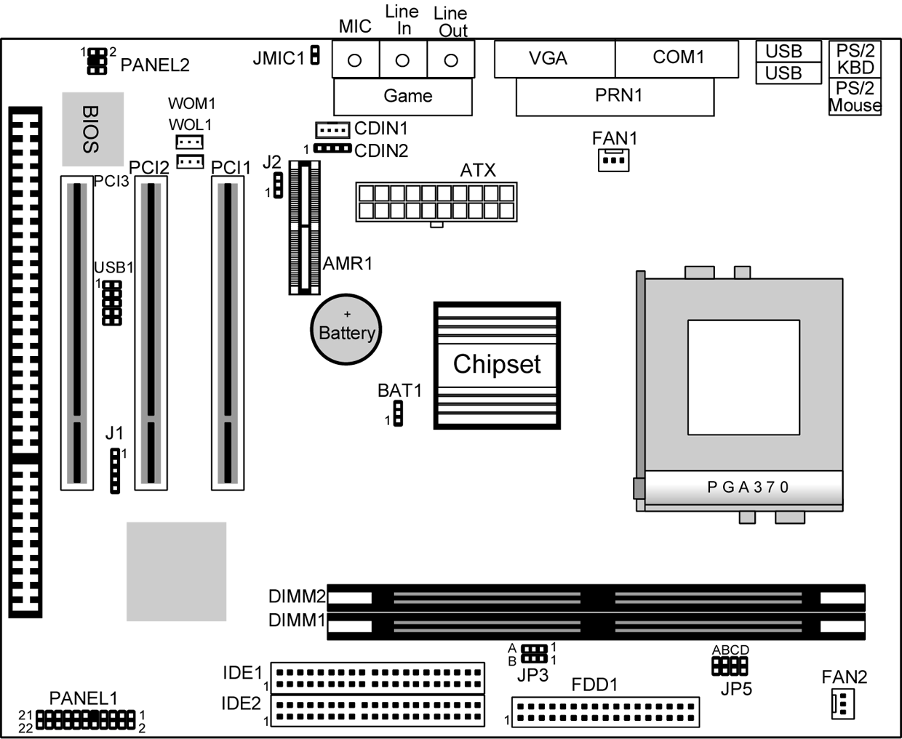
Note: Any jumpers on your mainboard that do not appear in this illustration are for testing only.

I/O Ports
The illustration below shows a side view of the built-in I/O ports on the mainboard.

Install A CPU
This mainboard has a Socket-370 which supports PPGA/FCPGA Celeron and FCPGA Pentium III processors.
Do not try to install a Socket 7 processor in the Socket-370. A Socket 7 processor such as the Pentium-MMX, or the AMD K5/K6 does not fit in the Socket 370.
The following list notes the processors that are currently supported by this mainboard.
FCPGA Pentium III: 500~1130MHz, FSB: 100MHz, 133MHz
PPGA/FCPGA Celeron: 300~700MHz, FSB: 66 MHz

Installing a Socket-370 Processor
A processor installs into the ZIF (Zero Insertion Force) Socket-370 on the mainboard.

- Locate the Socket-370 and FAN1. Pull the locking lever out slightly from the socket and raise it to the upright position.
FAN1
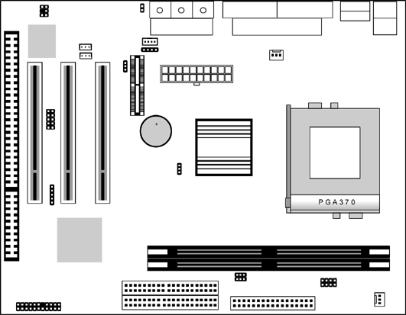
Pin-1 Corner
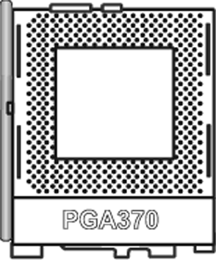

Socket-370

- On the processor, identify the Pin-1 corner by its beveled edge.
- On the Socket-370, identify the Pin-1 corner. The Pin-1 corner is at the top of the locking lever when it is locked.
- Match the Pin-1 corners and insert the processor into the socket. No force is required and the processor should drop into place freely.
- Swing the locking lever down and hook it under the catch on the side of the socket. This secures the CPU in the socket.
- All processors should be installed with a combination heatsink/cooling fan, connect the cable from the fan to the CPU fan power connector FAN1.

Install Memory
The mainboard has two DIMM sockets for system memory modules. You must install at least one memory module in order to use the mainboard.
DIMM2

DIMM1

For this mainboard, you must use 168-pin, 3.3V unbuffered PC100 or PC133 SDRAM memory modules. You can install any size memory module from 32 MB to 512 MB, so the maximum memory size is 2 x 512 MB = 1 GB.

The edge connectors on the memory modules have cut outs, which coincide with spacers in the DIMM sockets so that memory modules can only be installed in the correct orientation.

To install a module, push the retaining latches at either end of the socket outwards. Position the memory module correctly and insert it into the DIMM socket. Press the module down into the socket so that the retaining latches rotate up and secure the module in place by fitting into notches on the edge of the module.

Setting Jumper Switches
Jumpers are sets of pins which can be connected together with jumper caps. The jumper caps change the way the mainboard operates by changing the electronic circuits on the mainboard. If a jumper cap connects two pins, we say the pins are SHORT. If a jumper cap is removed from two pins, the pins are OPEN.

JP3
A
B

JMIC1
1
1
1
J2

A B C D
BAT1
1
JP5

Jumper BAT1: Clear CMOS Memory
Use this jumper to clear the contents of the CMOS memory. You may need to clear the CMOS memory if the settings in the Setup Utility are incorrect and prevent your mainboard from operating. To clear the CMOS memory, disconnect all the power cables from the mainboard and then move the jumper cap into the CLEAR setting for a few seconds.
Function | Jumper Setting
Normal Operation | Short Pins 1-2
Clear CMOS Memory | Short Pins 2-3

Jumper J2: Codec Selector
Use this jumper to select the onboard audio codec or Audio Modem Riser (AMR) slot.
Function | Jumper Setting
Primary codec onboard | Short Pins 1-2
Primary Codec on AMR slot | Short Pins 2-3

Jumper JP3: CPU Frequency Selectors
This jumper consists of two sets of 3-pin jumpers JP3-A and JP3-B. Use the jumper to select the frequency for the installed CPU.
Frequency | 66 MHz | 100 MHz | 105 MHz | 133 MHz
JP3-A | 2-3 | 2-3 | 1-2 | 1-2
JP3-B | 2-3 | 1-2 | 2-3 | 1-2

Jumper JP5: CPU Multiplier Selectors
This jumper consists of four sets of 2-pin jumpers JP5-D, JP5-C, JP5-B and JP5-A. Use the jumper to select the multiplier for the installed CPU.
CPU Multiplier Selector: JP5
Multiplier | 2.0 | 2.5 | 3.0 | 3.5 | 4.0 | 4.5 | 5.0
JP5-D | short | short | short | short | short | short | short
JP5-C | short | open | short | open | short | open | short
JP5-B | short | short | open | open | short | short | open
JP5-A | short | short | short | short | open | open | open
CPU Multiplier Selector: JP5
Multiplier | 5.5 | 6.0 | 6.5 | 7.0 | 7.5 | 8.0 | 8.5+
JP5-D | short | open | open | open | open | open | open
JP5-C | open | short | open | short | open | short | open
JP5-B | open | short | short | open | open | short | open
JP5-A | open | short | short | short | short | open | open

Note: The CPU speed is equal to the CPU Frequency x the CPU Multiplier.

Jumper JMIC1: Microphone-Out Selector
Use this jumper to select the Microphone-Out to the back-oriented Microphone jack or the front-oriented Microphone header.
Function | Jumper Setting
Back-oriented MIC jack | Short Pins 1-2
Front-oriented MIC header | Open Pins 1-2

Install the Mainboard
Install the mainboard in a system chassis (case). The board is an ATX size mainboard with a twin-tier of I/O ports. Ensure that your case has an I/O cover plate that matches the ports on this mainboard.
Install the mainboard in a case. Follow the instructions provided by the case manufacturer using the hardware and internal mounting points on the chassis.
PANEL2- SpeakerOut & MicrophoneIn header

LineOut -L 1

-R 5
LineOut
2 MICIN
4 GND
6 MICP
ATX

PANEL1
FAN2

Connect the power connector from the power supply to the ATX connector on the mainboard.
If there is a cooling fan installed in the system chassis, connect the cable from the cooling fan to the FAN2 fan power connector on the mainboard.
If there are a microphone-in jack and/or a speaker-out jack on the front pannel, connect the cables from the microphone-in and speaker-out jacks to the PANEL2 header on the mainboard. Then set the jumper JMIC1 to open setting.
Connect the case switches and indicator LEDs to the PANEL1 switch and LED connector header.
See the illustration below for a guide to the header pin assignments.
Reset Switch
Pins 17-18
Power LED
Pins 2-4-6
Power Button Pins 21-22

22
21
2
1

Speaker
Pins 1-3-5-7
HDD LED
Pins 15-16
Suspend LED
Pins 19-20

Optional Extension Brackets
For this mainboard, you can also obtain a USB module extension bracket. Install them by following the steps below.

Extended USB Module
This module bracket has two USB ports for more USB devices (USB port 3-4).
USB1 Header Header
VCC
NC
UV-
UV+
GND
GND
UV+
UV-
NC
VCC

- Locate the USB1 header on the mainboard.
- Plug the bracket cable onto the header.
- In the system chassis, remove a slot cover from one of the expansion slots and install the extension bracket in the opening. Use the screw that held the slot cover in place to secure the extension bracket to the chassis.

Install Other Devices
Install and connect any other devices in the system following the steps below.

IDE1
1
1 1
IDE2
FDD1

Floppy Disk Drive
The mainboard ships with a floppy disk drive cable that can support one or two drives. Drives can be 3.5” or 5.25” wide, with capacities of 360K, 720K, 1.2MB, 1.44MB, or 2.88MB.
Install your drives and connect power from the system power supply. Use the cable provided to connect the drives to the floppy disk drive header FDD1.

IDE Devices
IDE devices include hard disk drives, high-density diskette drives, and CD-ROM or DVD-ROM drives, among others.
The mainboard ships with an IDE cable that can support one or two IDE devices. If you connect two devices to a single cable, you must configure one of the drives as Master and one of the drives as Slave. The documentation of the IDE device will tell you how to configure the device as a Master or Slave device. The Master device connects to the end of the cable.
Install the device(s) and connect power from the system power supply. Use the cable provided to connect the device(s) to the Primary IDE channel connector IDE1 on the mainboard.
If you want to install more IDE devices, you can purchase a second IDE cable and connect one or two devices to the Secondary IDE channel connector IDE2 on the mainboard. If you have two devices on the cable, one must be Master and one must be Slave.

Internal Sound Connections
If you have installed a CD-ROM drive or DVD-ROM drive, you can connect the drive audio cable to the onboard sound system.
On the mainboard, locate the two 4-pin connectors CDIN1 and CDIN2. There are two kinds of connector because different brands of CD-ROM drive have different kinds of audio cable connectors. Connect the cable to the appropriate connector.

CDIN1 CDIN2

J1-IR Header

1

Infrared Port
You can connect an infrared port to the mainboard. You can purchase this option from third-party vendors.

- Locate the infrared port IR header on the mainboard.
- If you are adding an infrared port, connect the ribbon cable from the port to the header and then secure the port to an appropriate place in your system chassis.

Expansion Slots
This mainboard has three 32-bit PCI expansion slots, one AMR slot and one 8/16-bit ISA slot.

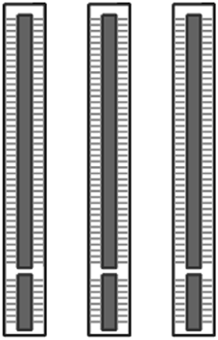
AMR1
ISA1
PCI2 PCI4
PCI3 PCI1 PCI3

Follow the steps below to install a PCI/AMR/ISA expansion card.
- Locate the AMR, PCI or ISA slots on the mainboard.
- Remove the slot cover for this slot from the system chassis.
- Insert the expansion card edge connector into the slot and press it firmly down into it so that it is fully inserted.
- Secure the expansion card bracket to the system chassis using the screw that held the slot cover in place.

AMR Slot
The AMR (Audio Modem Riser) slot is an industry standard slot that allows for the installation of a special audio/modem riser card. Different territories have different regulations regarding the specifications of a modem card. You can purchase an AMR card that is approved in your area and install it directly into the AMR slot.

Wake On Modem (WOM)
You can configure your system so that it powers down by software and can be resumed by alarms. If you have installed a fax/modem card, connect the fax/modem to the Wake On Modem header WOM1. You can then use the setup utility to program your computer to resume from a power saving mode whenever there is an incoming call to the fax/modem.

Wake On LAN (WOL)
If you have installed a LAN adapter expansion card, connect the card to the Wake On LAN connector WOL1. This allows incoming traffic to resume the system from a software power down. You need to enable this feature in the system setup utility.

WOM1 Header
WOL1 Header

Chapter 3

BIOS Setup Utility

Introduction
The BIOS Setup Utility records settings and information about your computer such as the date and time, the kind of hardware installed, and various configuration settings. Your computer uses this information to initialize all the components when booting up and functions as the basis for coordination between system components.

If the Setup Utility configuration is incorrect, it may cause the system to malfunction. It can even stop your computer from booting properly. If this happens, you can use the clear CMOS jumper to clear the CMOS memory used to store the configuration information, or you can hold down the Page Up key while you reboot your computer. Holding down the Page Up key also clears the setup information.

You can run the setup utility and manually make changes to the configuration. You might need to do this to configure some of the hardware that you install on or connect to the mainboard, such as the CPU, system memory, disk drives, etc.

`

Running the Setup Utility
Each time your computer starts, before the operating system loads, a message appears on the screen that prompts you to “Press <DEL> to enter SETUP”. When you see this message, press the Delete key and the Main menu page of the Setup Utility appears on your monitor.
CMOS Setup Utility – Copyright (C) 1984 – 2001 Award Software
Standard CMOS Features  Advanced BIOS Features  Advanced Chipset Features  Integrated Peripherals  Power Management Setup  PnP/PCI Configurations | Hardware Monitor  Load BestPerf. Defaults  Load Optimized Defaults  Set Password  Save & Exit Setup  Exit Without Saving
Esc : Quit F9 : Menu in BIOS ↑ ↓ → ← : Select Item
F10 : Save & Exit Setup
Time, Date, Hard Disk Type . . .

Listed below are explanations of the keys displayed at the bottom of the screens:
Key | Function
Esc | Escape key: Exits the current menu
← ↓ ↑ → | Cursor keys: Scroll through the items on a menu
+/−/PU/PD | Plus, minus, Page Up and Page Down keys: Modify the selected field’s values
F10 | F10 key: Saves the current configuration and exits setup
F1 | F1 key: Displays a screen that explains all key functions
F5 | F5 key: Loads previously saved values to CMOS
F6 | F6 key: Loads a best performance configuration for the normal system.
F7 | F7 key: Loads an optimum set of values for peak performance

Standard CMOS Features Page
Use this page to set basic information such as the date and time, the IDE devices, and the diskette drives.
CMOS Setup Utility – Copyright (C) 1984 – 2001 Award Software
Standard CMOS Features
Date (mm:dd:yy) Tue, Jan 9 2001  Time (hh:mm:ss) 12 : 8 : 59  IDE Primary Master Press Enter 4303 MB  IDE Primary Slave Press Enter None  IDE Secondary Master Press Enter None  IDE Secondary Slave Press Enter None  Drive A 1.44M, 3.5 in.  Drive B None  Video EGA/VGA  Halt On All , But Keyboard | Item Help
Menu Level
Change the day, month,
year and century.
↑ ↓ → ← : Move Enter : Select +/-/PU/PD:Value: F10: Save ESC: Exit F1:General Help F5:Previous Values F6:Fail-Safe Defaults F7:Optimized Defaults

Date & Time | Use these items to set the system date and time
IDE Devices | Your computer has two IDE channels (Primary and Secondary) and each channel can be installed with one or two devices (Master and Slave). Use these items to configure each device on the IDE channel. Press Enter to display the IDE sub-menu. Press Esc to close the IDE device sub-menu and return to the Standard CMOS Features page.
Floppy Drive A  Floppy Drive B | Use these items to set the size and capacity of the floppy diskette drive(s) installed in the system.
Video | This item defines the video mode of the system. This mainboard has a built-in VGA graphics system; you must leave this item at the default value.
Halt On | This item defines the operation of the system POST (Power On Self Test) routine. You can use this item to select which types of errors in the POST are sufficient to halt the system.

Advanced BIOS Features Page
Use this page to set more advanced information about your system. Take some care with this page. Making changes can affect the operation of your computer.
CMOS Setup Utility – Copyright (C) 1984 – 2001 Award Software
Advanced BIOS Features
Trend ChipAway Virus Enabled  CPU Internal Cache Enabled  External Cache Enabled  CPU L2 Cache ECC Checking Enabled  Processor Number Feature Enabled  Quick Power On Self Test Enabled  First Boot Device HDD-0  Second Boot Device Floppy  Third Boot Device CDROM  Boot Other Device Enabled  Swap Floppy Drive Disabled  Boot Up Floppy Seek Disabled  Boot Up NumLock Status On  Gate A20 Option Normal  Typematic Rate Setting Disabled  x Typematic Rate (Chars/Sec) 6  x Typematic Delay (Msec) 250  Security Option Setup  OS Select For DRAM > 64MB Non-OS2 |  | Item Help
Menu Level
Allows you to choose
the VIRUS warning
feature for IDE Hard
Disk boot sector
protection. If this
function is enabled
and someone attempts
to write data into this
area, BIOS will show a
warning message on
screen and alarm beep
↑ ↓ → ← : Move Enter : Select +/-/PU/PD:Value: F10: Save ESC: Exit F1:General Help F5:Previous Values F6:Fail-Safe Defaults F7:Optimized Defaults

Trend ChipAway Virus | This mainboard has built-in virus protection in the firmware. Use this item to enable or disable the built-in virus protection.
CPU Internal Cache | All the processors that can be installed in this mainboard use internal (level 1) cache memory to improve performance. Leave this item at the default value Enabled for better performance.
External Cache | Most processors that can be installed in this system use external (L2) cache memory to improve performance. The exceptions are older SEPP Celeron CPUs running at 266 or 300 MHz. Enable this item for all but these two processors.
CPU L2 Cache ECC Checking | This item enables or disables ECC (Error Correction Code) error checking on the CPU cache memory. We recommend that you leave this item at the default value.
Processor Number Feature | When enabled, the CPU will show its processor number (ID code).
Quick Power On Self Test | You can enable this item to shorten the power on testing (POST) and have your system start up a little faster. You might like to enable this item after you are confident that your system hardware is operating smoothly.
1st/2nd/3rd Boot Device | Use these three items to select the priority and order of the devices that your system searches for an operating system at start-up time.
Boot Other Device | If you enable this item, the system will search all other possible locations for an operating system if it fails to find one in the devices specified under the first, second, and third boot devices.
Swap Floppy Drive | If you have two floppy diskette drives in your system, this item allows you to swap the assigned drive letters so that drive A becomes drive B, and drive B becomes drive A.
Boot Up Floppy Seek | If this item is enabled, it checks the geometry of the floppy disk drives at start-up time. You don’t need to enable this item unless you have an old diskette drive with 360K capacity.
Boot Up NumLock Status | This item defines if the keyboard Num Lock key is active when your system is started.
Gate A20 Option | This item defines how the system handles legacy software that was written for an earlier generation of processors. Leave this item at the default value.
Typematic Rate Setting | If this item is enabled, you can use the following two items to set the typematic rate and the typematic delay settings for your keyboard.
Typematic Rate (Chars/Sec)/ Delay (Msec) | If the item Typematic Rate Setting is enabled, you can use these items to define how many characters per second are generated by a held-down key and how many milliseconds must elapse before a held-down key begins generating repeat characters.
Security Option | If you have installed password protection, this item defines if the password is required at system start up, or if it is only required when a user tries to enter the Setup Utility.
OS Select For DRAM > 64 MB | This item is only required if you have installed more than 64 MB of memory and you are running the OS/2 operating system. Otherwise, leave this item at the default Non-OS2.
Video BIOS Shadow | When enabled this item copies the VGA BIOS into system DRAM.
C8000-CBFFF to DC000-DFFFF Shadow | When enabled, the ROM with the specified address is copied into system DRAM. It will also reduce the size of memory available to the system.

Advanced Chipset Features Page
This page sets some of the parameters of the mainboard components including the memory, and the system logic.

CMOS Setup Utility – Copyright (C) 1984 – 2001 Award Software
Advanced Chipset Features
DRAM Timing By SPD Disabled  SDRAM Cycle Length 3  Bank Interleave Disabled  DRAM Clock Host CLK  P2C/C2P Concurrency Enabled  System BIOS Cacheable Enabled  Video RAM Cacheable Enabled  Frame Buffer Size 8M  AGP Aperture Size 64M  OnChip USB Enabled  OnChip USB 2 Disabled  USB Keyboard Support Disabled  OnChip Sound Auto  OnChip Modem Auto  PCI Master 0 WS Write Enabled  PCI#2 Access #1 Retry Enabled  AGP Master 1 WS Write Disabled  AGP Master 1 WS Read Disabled  Memory Parity/ECC Check Disabled |  | Item Help
 |  | Menu Level
↑ ↓ → ← : Move Enter : Select +/-/PU/PD:Value: F10: Save ESC: Exit F1:General Help F5:Previous Values F6:Fail-Safe Defaults F7:Optimized Defaults

DRAM Timing By SPD | This item allows you to enable or disable the DRAM timing defined by the Serial Presence Detect electrical.
SDRAM Cycle Length | This field enables you to set the CAS latency time in HCLKs of 2/2 or 3/3. The system board designer should have set the values in this field, depending on the DRAM installed. Do not change the values in this field unless you change specifications of the installed DRAM or the installed CPU.
Bank Interleave | This item allows you to enable or disable the Bank Interleave function with 2 banks or 4 banks.
DRAM Clock | Enables the user to select the DRAM Clock.
P2C/C2P Concurrency | When disabled, the CPU bus is occupied during the entire PCI operation period.
System BIOS Cacheable | When enabled, the System BIOS will be cached for faster execution.
Video RAM Cacheable | When enabled, the graphics card’s local memory will be cached for faster execution. However, if any program writes to this memory area, a system error may result.
Frame Buffer Size | This option determines the frame buffer size shared from the main memory for use by the onboard VGA display.
AGP Aperture Size | This option determines the effective size of the AGP Graphic Aperture, where memory-mapped graphic data structures are located.
OnChip USB | This item allows you to enable the USB port, if you have installed a USB device on the system board.
OnChip USB 2 | This item allows you to enable the USB 2 port, if you have installed more USB device on the system board.
USB Keyboard Support | Enables function when the USB keyboard is being used. Disabled (default) when an AT keyboard is used.
OnChip Sound | Disabling this function turns off the onboard audio chip.
OnChip Modem | This should be enabled if your system has a modem installed on the system board and you wish to use it.
PCI Master 0 WS Write | When enabled, writes to the PCI bus are executed with zero wait states.
PCI#2 Access #1 Retry | When enabled, the AGP Bus (PCI#1) access to PCI Bus (PCI#2) is executed with the error retry feature.
AGP Master 1 WS Write | This implements a single delay when writing to the AGP Bus. By default, two-wait states are used by the system, allowing for greater stability.
AGP Master 1 WS Read | This implements a single delay when reading to the AGP Bus. By default, two-wait states are used by the system, allowing for greater stability.
Memory Parity/ECC Check | If this item is enabled it allows the system to use parity checking and ECC (Error Correcting Code) to catch errors in the system memory. Enabling this item might have an impact on overall system performance.

Integrated Peripherals Page
This page sets some of the parameters for peripheral devices connected to the system.

CMOS Setup Utility – Copyright (C) 1984 – 2001 Award Software
Integrated Peripherals
On-Chip IDE Channel0 Enabled  On-Chip IDE Channel1 Enabled  IDE Prefetch Mode Disabled  Primary Master PIO Auto  Primary Slave PIO Auto  Secondary Master PIO Auto  Secondary Slave PIO Auto  Primary Master UDMA Auto  Primary Slave UDMA Auto  Secondary Master UDMA Auto  Secondary Slave UDMA Auto  Init Display First PCI Slot  Onboard FDD Controller Enabled  Onboard Serial Port 1 3F8/IRQ4  Onboard IR Port Disabled  x UART 2 Mode Standard  x IR Function Duplex Half  x TX,RX inverting enable No, Yes  Onboard Parallel Port 378/IRQ7 |  | Item Help
 |  | Menu Level
↑ ↓ → ← : Move Enter : Select +/-/PU/PD:Value: F10: Save ESC: Exit F1:General Help F5:Previous Values F6:Fail-Safe Defaults F7:Optimized Defaults

On-Chip IDE Channel 0,1 | Use these items to enable or disable the PCI IDE channels that are integrated on the mainboard.
Primary/ Secondary Master/ Slave PIO | Each channel supports a master device and a slave device. These four items let you assign which kind of PIO (Programmed Input/Output) is used by IDE devices. You can choose Auto, to let the system auto detect which PIO mode is best, or you can install a PIO mode from 0-4.
Primary/ Secondary Master/ Slave UDMA | Each channel supports a master device and a slave device. This motherboard supports UltraDMA and provides faster access to IDE devices. If you install a device that supports UltraDMA, change the appropriate item on this list to Auto. You may have to install the UltraDMA driver.
Init Display First | Use this item to define if your graphics adapter is installed in one of the PCI slots or select Onboard if you have a graphics system integrated on the mainboard.
Onboard FDD Controller | This option enables the onboard floppy disk drive controller.
Onboard Serial Port 1 | This option is used to assign the I/O address for the onboard serial port.
Onboard IR Port | This option is used to assign the I/O address for the onboard IR port or disabled.
UART2 Mode | This field is available if the Onboard Serial Port 2 field is set to any option but “Disabled.” UART Mode enables you to select the infrared communication protocol—Standard (default), HPSIR or ASKIR. HPSIR is Hewlett Packard’s infrared communication protocol with a maximum baud rate up to 115.2 Kbps. ASKIR is Sharp’s infrared communication protocol with a maximum baud rate up to 57.6 Kbps.
IR Function Duplex | This field is available when UART 2 Mode is set to either ASKIR or HPSIR. This item determines the infrared (IR) function of the onboard infrared chip. Full-duplex means that you can transmit and send information simultaneously. Half duplex is the transmission of data in both directions, but only one direction at a time.
TX, RX inverting enable | Defines the voltage level for Infrared module RxD (receive) mode and TxD (transmit) mode. This setting has to match the requirements of the infrared module used in the system.
Onboard Parallel Port | This option is used to assign the I/O address for the onboard parallel port.
Onboard Parallel Mode | This feature enables you to set the data transfer protocol for your parallel port. Normal allows data output only. Extended Capabilities Port (ECP) and Enhanced Parallel Port (EPP) are bi-directional modes, allowing both data input and output. ECP and EPP modes are only supported with EPP and ECP aware peripherals.
ECP Mode Use DMA | When the onboard parallel port is set to ECP mode, the parallel port has the option to use DMA “3” or DMA “1.”
Parallel Port EPP Type | This option sets the Enhanced Parallel Port (EPP) specification.
Onboard Legacy Audio | This option enables the onboard legacy audio function. When enabled the following items become available.
Sound Blaster | This feature is used to enable or disable a Sound Blaster card if installed.
SB I/O Base Address | This item lets you set the I/O base address for the Sound Blaster card.
SB IRQ Select | This item lets you set the Interrupt Request (IRQ) for the Sound Blaster card.
SB DMA Select | This item lets you select the Direct Memory Access (DMA) for the Sound Blaster card.
MPU-401, MPU-401 I/O Address | Use the two items to enable the MPU-401 function and set the I/O address for the game port.
Game Port (200-207H) | This item shows the I/O address for the game port.

Power Management Setup Page
This page sets some of the parameters for system power management operation.

CMOS Setup Utility – Copyright (C) 1984 – 2001 Award Software
Power Management Setup
ACPI Function Disabled  Power Management Press Enter  PM Control by APM Yes  Video Off Option Suspend --> Off  Video Off Method DPMS Support  MODEM Use IRQ 3  Soft-Off by PWRBTN Delay 4 Sec  Wake Up Events Press Enter | Item Help
 | Menu Level
↑ ↓ → ← : Move Enter : Select +/-/PU/PD:Value: F10: Save ESC: Exit F1:General Help F5:Previous Values F6:Fail-Safe Defaults F7:Optimized Defaults

ACPI Function | Use this item to enable or disable the ACPI function.
Power Management | This item acts like a master switch for the power-saving modes and hard disk timeouts. If this item is set to Max Saving, power-saving modes occur after a short timeout. If this item is set to Min Saving, power-saving modes occur after a longer timeout. If the item is set to User Define, you can insert your own timeouts for the power-saving modes.
PM Control by APM | This field allows you to control the PC Monitor’s power management features via Intel-Microsoft Advanced Power Management software. Once you have enabled the APM interface, some settings made in the BIOS Setup program may be overridden by APM.
Video Off Option | This option defines if the video is powered down when the system is put into suspend mode.
Video Off Method | This item defines how the video is powered down to save power.
MODEM Use IRQ | If you want an incoming call on a modem to automatically resume the system from a power-saving mode, use this item to specify the interrupt request line (IRQ) that is used by the modem. You might have to connect the fax/modem to the mainboard Wake On Modem connector for this feature to work.
Soft-Off by PWRBTN | Under ACPI (Advanced Configuration and Power management Interface) you can create a software power down. In a software power down, the system can be resumed by Wake Up Alarms. This item lets you install a software power down that is controlled by the normal power button on your system. If the item is set to Instant-Off, then the power button causes a software power down. If the item is set to “Delay 4 Sec.” then you have to hold the power button down for four seconds to cause a software power down.
Wake Up Events | This item opens a submenu that enables you to set events that will resume the system from a power saving mode. Select Wake Up Events and press Enter to display the following items: VGA, LPT & COM, HDD & FDD, PCI Master, PowerOn by PCI Card, Wake Up On LAN/Ring, RTC Alarm Resume, Primary INTR, and IRQs Activity Monitoring.

PnP/PCI Configurations Page
This page sets some of the parameters for devices installed on the PCI bus and devices that use the system plug and play capability.

CMOS Setup Utility – Copyright (C) 1984 – 2001 Award Software
PnP/PCI Configurations
PNP OS Installed Yes  Reset Configuration Data Disabled  Resources Controlled by Auto(ESCD)  x IRQ Resources Press Enter  x DMA Resources Press Enter  PCI/VGA Palette Snoop Disabled | Item Help
Menu Level
Default is Disabled.
Select Enabled to
reset Extended System
Configuration Data
(ESCD) when you exit
Setup if you have
installed a new add-on
and the system
reconfiguration has
caused such a serious
conflict that the OS
cannot boot.
↑ ↓ → ← : Move Enter : Select +/-/PU/PD:Value: F10: Save ESC: Exit F1:General Help F5:Previous Values F6:Fail-Safe Defaults F7:Optimized Defaults

PNP OS Installed | Setting this option to “Yes” allows the PnP OS (instead of BIOS) to assign the system resources such as IRQ and I/O address to the ISA PnP device.
Reset Configuration Data | If you enable this item and restart the system, any PnP configuration data stored in the BIOS setup is cleared from memory. New updated data is created.
Resources Controlled By | You should leave this item at the default Auto (ESCD). Under this setting, the system dynamically allocates resources to plug and play devices as they are required. If you cannot get a legacy ISA (Industry Standard Architecture) expansion card to work properly, you might be able to solve the problem by changing this item to Manual, and then opening up the IRQ Resources and Memory Resources sub-menus.  In the IRQ Resources sub-menu, if you change any of the IRQ assignations to Legacy ISA, then that Interrupt Request Line is reserved for a legacy ISA expansion card. Press Esc to close the IRQ Resources sub-menu.
PCI/VGA Palette Snoop | This item is designed to overcome some problems that can be caused by some non-standard VGA cards. This board includes a built-in VGA system that does not require palette snooping so you must leave this item disabled.

Hardware Monitor Page
This page sets some of the parameters for the hardware monitoring function of this mainboard.

CMOS Setup Utility – Copyright (C) 1984 – 2001 Award Software
Hardware Monitor
Current CPU Temp.  Current System Temp.  Current CPUFAN1 speed  Current CPUFAN2 speed  Vcore  2.5V  3.3V  5V  12V | Item Help
 | Menu Level
↑ ↓ → ← : Move Enter : Select +/-/PU/PD:Value: F10: Save ESC: Exit F1:General Help F5:Previous Values F6:Fail-Safe Defaults F7:Optimized Defaults

System Component Characteristics | These fields provide you with information about the systems current operating status. You cannot make changes to these fields. The following information is displayed:  CPU Temperature  System Temperature  CPU FAN (in RPMs)  System FAN (in RPMs)  Vcore (CPU Core voltage)  2.5V (onboard 2.5 volt)  3.3V (onboard 3.3 volt)  5V (power supply’s 5 volt)  12V (power supply’s 12 volt).

Load BestPerf. Defaults
If you select this item and press Enter a dialog box appears. If you press Y, and then Enter, the Setup Utility loads a set of best-performance default values. These defaults are quite demanding and your system might not function properly if you are using slower memory chips or other low-performance components.

Load Optimized Defaults
If you select this item and press Enter, a dialog box appears. If you press Y, and then Enter, the Setup Utility loads a set of fail-safe default values. These default values are not very demanding and they should allow your system to function with most kinds of hardware and memory chips.

Set Password
If you highlight this item and press Enter, a dialog box appears which lets you enter a password. You can enter no more than eight letters or numbers. Press Enter after you have typed in the password. A second dialog box asks you to retype the password for confirmation. Press Enter after you have retyped it correctly. The password is then required to access the Setup Utility or for that and at start-up, depending on the setting of the Password Check item in Advanced Setup.

Change or Remove the Password
Highlight this item, press Enter and type in the current password. At the next dialog box, type in the new password, or just press Enter to disable password protection.

Save & Exit Setup
Highlight this item and press Enter to save the changes that you have made in the Setup Utility configuration and exit the program. When the Save and Exit dialog box appears, press Y to save and exit, or press N to exit without saving.

Exit Without Saving
Highlight this item and press Enter to discard any changes that you have made in the Setup Utility and exit the setup program. When the Exit Without Saving dialog box appears, press Y to discard changes and exit, or press N to return to the setup main menu.

Chapter 4

Software & Applications

Introduction
The support software CD-ROM that is included in the mainboard package contains all the drivers and utility programs needed to properly run our products. Below you can find a brief description of each software program, and the location for your mainboard version. More information on some programs is available in a README file, located in the same directory as the software.
If the operating system used in your system is Windows 98, it will automatically install all the drivers and utilities for your board. See the Auto-Installing under Windows 98 section.

Installing Support Software
The software on the support CD-ROM is for Windows 95/NT/2000 and Windows 98. The installation procedure differs depending on which Operating System you have, but the automatic installation is now for Win98 only.

Installing under Windows 95/NT/2000
To install support software for Windows 95/NT/2000 follow this general procedure:
- Insert the support CD-ROM disc in the CD-ROM drive.
(The system might get an error message from the PnP function. Don’t care the message. You don’t really need that file to install the drivers)
- Use My Computer or Windows Explorer to look at the directory structure. You must use the Open command in the right-button menu. Double-clicking on the drive icon will result in an error message because the disc’s AutoRun feature doesn’t work in Windows 95/NT/2000.
- Execute the EXE file name given in the description below.

Note: The correct path name for each software driver is provided, where D: identifies the CD-ROM drive letter – modify if necessary.

Bus Master IDE Driver
The IDE Bus Master Drivers allows the system to properly manage the IDE channels on the mainboard. You need to install the driver if you are running Windows 9x.
- Windows 9x – D:\IDE\VIA\

Display Drivers and Software
Find the Display drivers and software here:
- D:\VGA\VIA8601\

Audio Driver
The Audio driver allows the system to use the onboard audio circuitry. Find the driver and audio application here:
- D:\SOUND\Driver\VIA\

AMR Modem Driver
Find the driver here:
- D:\Modem\Driver\AMR\PCtel\

USB Driver
The USB Driver allows the system to recognize the USB ports on the mainboard. You need to install this driver if you are running Windows 95. Windows 95 OSR2 does not require this driver.
This driver is available for:
- Win95 – D:\USB\EUSBSUPP\USBSUPP.EXE
- Win95 (Chinese) – D:\USB\CUSBSUPP\CUSBSUPP.EXE

3Deep Software
Find the software here:
- D:\3Deep\3Deep 3.3\Setup.EXE

BIOS Update Utility
The BIOS Update utility allows you to update the BIOS file on the mainboard to a newer version. You can download the latest version of the BIOS setup available for your mainboard from the website.
- D:\UTILITY\AMINF324.EXE

PC-Cillin Software
The PC-cillin software program provides anti-virus protection for your system. This program is available for:
- Win9x/ME – D:\PC-CILLIN\Win98\
- Win2000/NT – D:\PC-CILLIN\WinNT\SETUP.EXE

Auto-installing under Windows 98
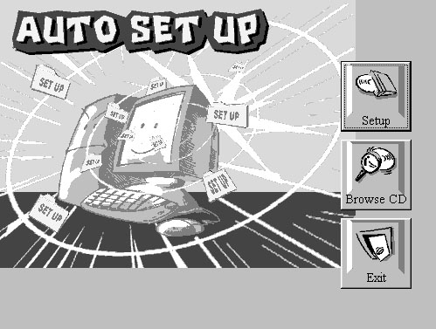
The support software CD-ROM disc loads automatically under Windows 98. When you insert the CD-ROM disc in the system CD-ROM drive the Autorun feature will automatically bring up the install screen. The screen has three buttons on it, Setup, Browse CD and Exit. See the following screen illustration.
When you click on the Setup button the software installation program will run and you can select what kind of installation you want to do, as explained later in this section.
The Browse CD button is the standard Windows command that allows you to examine the contents of the disc using the Windows 98 file browsing interface.
The Exit button closes the Auto Setup window. To run the program again, reinsert the CD-ROM disc in the drive or click on AutoRun in the context sensitive menu for the CD-ROM drive icon in a file browser window.

Installing Software with Auto Setup
To install support software for the system board follow this procedure:
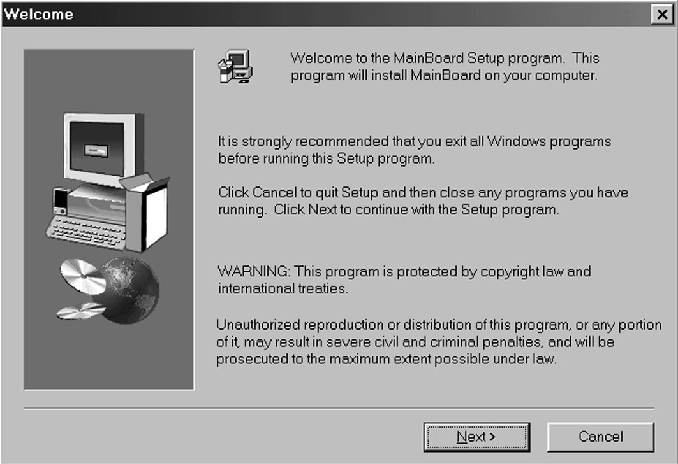
- Click on the Setup button. The install program will load and display the following screen. Click the Next button.
- Select the items that you want to setup by clicking on it (the default options are recommended). Click the Next button to proceed.
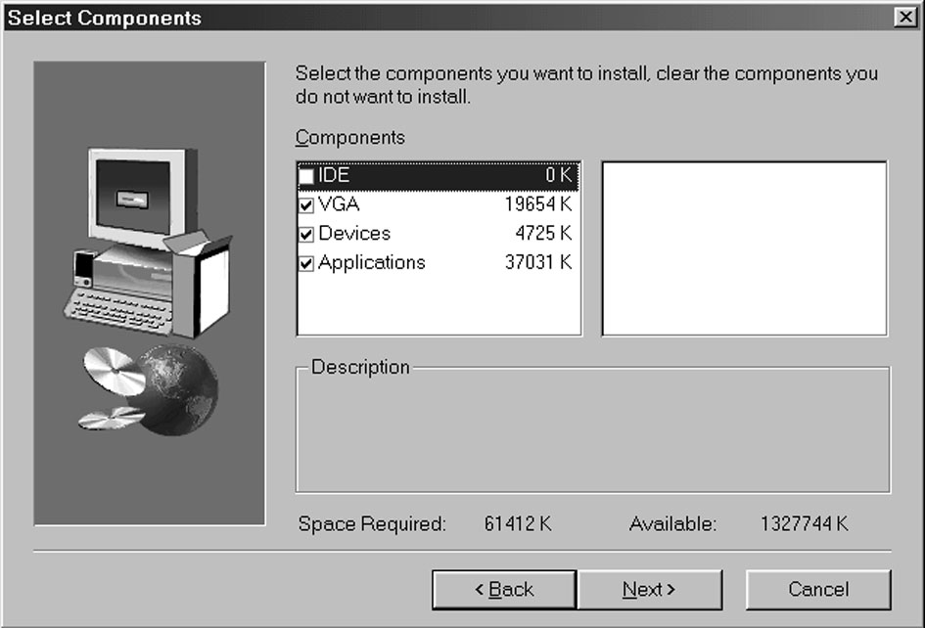
- The support software will automatically install.

Once any of the installation procedures start, software is automatically installed in sequence. You will need to follow the onscreen instructions, confirm commands and allow the computer to restart as few times as is needed to complete installing whatever software you selected to install. When the process is finished, all the support software will be installed and working.

There are some utilities that you have to manually install if you need, check to the above section.

