Chapter 1
TABLE OF CONTENT
1-1 Preface 1
1-2 Feature for 9BXAS/9BXAN/9BXAS-A/9BXAN-A/9ZXAS/9ZXAN 1
1-2-1 Overview 1
1-2-2 Key Feature 2
Chapter 2
Hardware Installation 3
2-1 Unpacking 3
2-2 9BXAS/9BXAN/9BXAS-A/9BXAN-A/9ZXAS/9ZXAN Mainboard Diagram 4
2-3 Quick Reference for Jumpers, Connectors & Expansion Socket 5
2-4 Installation Steps 6
2-5 Jumper Settings 6
2-6 System Memory (DRAM) 7
2-7 Central Processing Unit (CPU) 7
2-8 Expansion Cards 8
2-9 External Connectors 9
Chapter 3
AWARD BIOS SETUP 15
3-1 STANDARD CMOS SETUP 16
3-2 BIOS FEATURES SETUP 17
3-3 CHIPSET Features SETUP 18
3-4 POWER MANAGE MENT SETUP 19
3-5 PnP/PCI CONFIGURATION SETUP 21
3-6 LOAD OPTIMAL DEFAULTS 21
3-7 LOAD STANDARD DEFAULTS 22
3-8 INTEGRATED PERIPHERALS SETUP 22
3-9 SUPERVISOR/USER PASSWORD 23
3-10 SAVE & EXIT SETUP 23
3-11 EXIT WITHOUT SAVING 23
Chapter 4
4-1 PC HEALTH MONITOR-III SOFTWARE FOR 9BXAS/9BXAN 24
4-2 SOUND Card Driver QUICK Installation ( For 9BXAS,9ZXAS,9BXAS-A) 26
Chapter 5
Quick Troubleshooting Guide 42
Chapter 6
Frequently Asked Questions and Answers 43

Chapter 1
1-1 Preface
Thank you for chosen 9BXAS/9BXAN/9BXAS-A/9BXAN-A/9ZXAS/9ZXAN mainboard. This is a multifunction motherboard with most flexibility you can find in today’s computer market. The motherboard integrates both Intel Pentium®II / Pentium®III & Celeron™(Slot 1 & Socket 370) processor interface into a standard ATX compatible system along with 3D Stereo Sound System audio chip. Moreover, this motherboard allows you conditionally approach 133MHz * of Front Side Bus Frequency.
1-2 Feature of 9BXAS/9BXAN/9BXAS-A/9BXAN-A/9ZXAS/
9ZXAN
The 9BXAS/9BXAN/9BXAS-A/9BXAN-A/9ZXAS/9ZXAN are design for the PC user who wants highest possible quality and value in a small package. This motherboard include following main features：
1-2-1 Overview
- Support both Slot 1 & Socket 370 CPU interface (You can only use one CPU interface at a time).
- Support Jump-less solution for setting Front Side Bus Frequency (CPU Host Clock) and CPU ratio under CPU Host/PCI clock of CHIPSET FEATURES SETUP.
- Conditionally support 133MHz * of Front Side Bus Frequency. This function allow user select CPU Bus Frequency by the BIOS to approach Over-Clock possibility.
- Provide PC Health Monitoring to track CPU temperature, system temperature, system voltage, and fan speed. When CPU current temperature is over CPU warning temperature, system will slow down automatically in order to reduce the CPU’s temperature. (For 9BXAS/9BXAN only)
- Logo-DIY: Provide CBROM utility for user to create their own loge in the BIOS.
- Built in high quality PCI-Based HRTF 3D Extension Positional Audio Chip (9BXAS,9ZXAS,9BXAS-A only)
- Supports rear side speakers, C3DX positional audio in 4 channels speaker mode.
- Professional digital audio interface to support 24-bit SPDIF IN and OUT (44.1K and 48K format).
- HRTF-base 3D positional audio, supporting DirectSound™ 3D and Aural A3D™ interface.
- Digital functions that capable to provide hi-fi stereo, Dolby, 3D surround effects, and playing MP3 music.
- You can add our Optical kit (Optional) to connect any optical Input/Output device for super high quality sound transaction, such as playing & recording MD(Mini Disk)/CD; CD-ROM directly recording to MD; combine with DVD player to create a home theater system (This upgrade kit includes Optical Module, Optical Cable, and Software DVD Driver).

1-2-2 Key Feature
- Multi-Speed Support：Provide 66/75*/83*/95*/100/112*/117*/124*/133*MHz Front Side Bus Frequency to support Intel Pentium®II / Pentium®III, Celeron processor for Slot1 interface or Intel Celeron PPGA on a ZIP Socket 370 interface.
- Intel chipset：Intel’s 440BX PCI/AGPset with I/O subsystems. (For 9BXAS/9BXAN/
9BXAS-A/9BXAN-A only)
Intel’s 440ZX PCI/AGPset with I/O subsystems. (For 9ZXAS/9ZXAN only)
- DRAM Memory Support：Support 3 x 168-pin DIMM sockets (3.3V) for memory from 8M Byte to 768M Byte in either EDO (66MHz only) or SDRAM (66MHz/100MHz) type module with ECC or parity check for 9BXAS/9BXAN/9BXAS-A/9BXAN-A ; Support 2 x 168-pin DIMM Max Memory size of 256M Byte in 9ZXAS/9ZXAN.
- AGP, ISA, and PCI expansion Slots：Provide an AGP slot, one 16-bit ISA slot, and four 32-bit PCI master slots. (Three PCI master slots , one PCI slave slot for 9ZXAS)
- Super Multi-I/O: Provides two high-Speed UART compatible serial ports and one parallel port with EPP and ECP capabilities. Two floppy drives of either 5.25” or 3.5” (1.44MB or 2.88MB) are also supported without an external card.
- PCI Bus Master IDE Controller and ULTRA DMA 33: On-board PCI Bus Master IDE controller with two connectors that supports four IDE devices in two channels, provides faster data transfer rates, and supports Enhanced IDE devices such as Tape Backup, CD-ROM, ZIP, LS-120 Drives. This controller also supports PIO Modes and Bus Master IDE DMA 33Mbyte/Second.
- ACPI supporting for OS Directed Power Management.
Ring-In Wake up: When Ring-In the system can wake up from SMI Mode.
Ring-In Power On: When Ring-In the system can power on automatic by this function.
RTC Power On: Enabled RTC Power On function, you can set RTC alarm to power on the system at the time length that correspond to your setting.
Power Button: Press the button will place the system power on/off.
CPU fans auto-stopping with suspend mode.
Support Software Power Off function.
- Power Support: Efficient PWM switching power instead of traditional Linear Voltage Regulator to prevent power component from being burned-out.
- PC 99 ready
- PS/2 Mouse: This motherboard support PS/2 mouse set.
- USB Port Connector: This motherboard supports two USB port connectors for USB devices.
- Optional IrDA: This motherboard supports an optional infrared port module for wireless interface, with independent 3rd UART (32-byte FIFO).
- AGP: Accelerated Graphics Port, for to 533MB/sec data transfer rate and 66MHz Bus clock to improve graphic functions.
- ATX Form Factor: Dimensions 30.5cm x 19cm.
* Your memory module(s) must be PC133 compliant SDRAM chips and specified or marked as 8ns or 6ns.
* When you are running at 133MHz , make sure all of your PCI devices have enough tolerance to run on 44MHz . Otherwise, it may cause your system become very unstable.
Chapter 2

Hardware Installation

2-1 Unpacking
This mainboard package should contain the following:
- The 9BXAS/9BXAN/9BXAS-A/9BXAN-A/9ZXAS/9ZXAN mainboard
- USER’S MANUAL for mainboard
- Cable set for IDE x1, Floppy x1
- CD for Drivers PACK
The mainboard contains sensitive electronic components that can be easily damaged by electron-static, so the mainboard should be left in its original packing until it is installed.
Unpacking and installation should be done on a grounded anti-static mat.
The operator should be wearing an anti static wristband, grounded at the same point as the anti-static mat.
Inspect the mainboard carton for obvious damage. Shipping and handling may cause damage to your board. Be sure there are no shipping and handling damages on the board before proceeding.
After opening the mainboard carton, extract the system board and place it only on a grounded anti-static surface component side up. Again inspect the board for damage.
Press down on the entire socket IC’s to make sure that they are properly inserted. Do this only on with the board placed on a firm flat surface.
Warning: Do not apply power to the board if it has been damaged.
You are now ready to install your mainboard. The mounting hole pattern on the mainboard matches the ATX system board.
It is assumed that the chassis is designed for a standard ATX™ main board mounting. Place the chassis on the anti-static mat and remove the cover.
Take the plastic clips, Nylon stand-off and screws for mounting the system board, and keep them separate.

2-2 9BXAS/9BXAN/9BXAS-A/9BXAN-A Mainboard Diagram

( 9ZXAS/9ZXAN only have DIMM1& DIMM2 two slots)

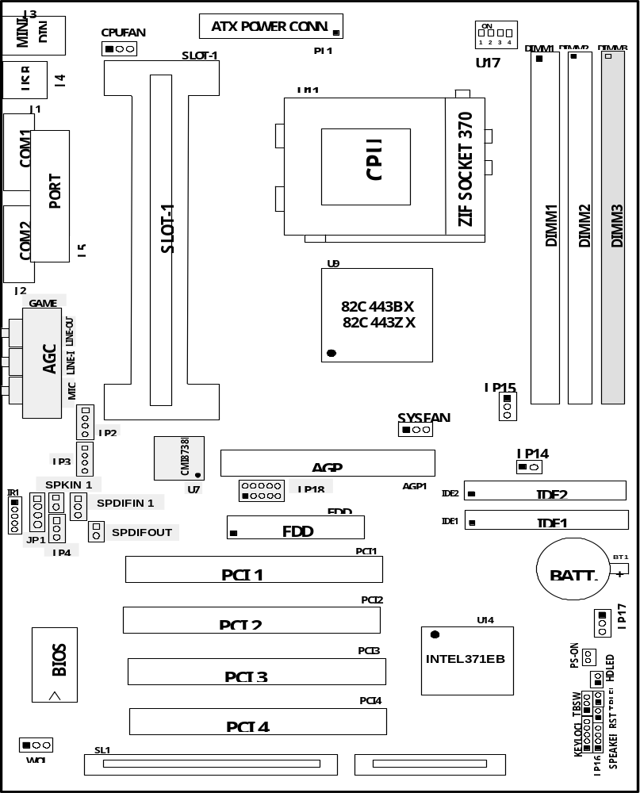

Figure 2-2

Only for 9BXAS,9ZXAS/9BXAS-A mainboard

2-3 Quick Reference for Jumpers, Connectors & Expansion Socket

Jumpers
Jumper | Name | Description | Page
JP14,JP15 | CPU Bus Frequency Selection | Refer to page 6 | p. 6
U17 | CPU Ratio Selector | Refer to page 6 | p. 6
JP17 | CMOS RAM Clear | 1-2 Normal ,2-3 Clear CMOS | p. 7

Connectors
Connector | Name | Description | Page
PL1 | ATX Power Connector | 20-Pin Block | p.9
MINI-DIN | PS/2 Keyboard/PS/2 Mouse | 6-Pin Female | p.9
USB | USB Port Connector | 5-Pin Connector | p.9
PRINT | Parallel Port Connector | 26-Pin Female | p.9
COM1, COM2 | Serial Port COMA , COMB | 9-Pin Connector | p.10
FDD | Floppy Driver Connector | 34-Pin Block | p.10
IDE1 | Primary IDE Connector | 40-Pin Block | p.10
IDE2 | Secondary IDE Connector | 40-Pin Block | p.11
HDLED | IDE activity LED | 2-Pin Connector | p.11
JP16 | Front Panel Connector | 16-Pin Block | p.11
IR1 | Infrared Module Connector | 10-Pin Block | p.12
CPUFAN, SYSFAN | FAN Connector | Extra fanning system connectors | p.12
PS-ON | ATX power button/soft power button | 2-Pin Connector | p.12
WOL | Wake On LAN | 3-pin Block | P.12

Jumpers & Connectors for 9BXAS,9ZXAS,9BXAS-A only
Item number | Name | Description | Page
JP4 | On-Board Sound Enable/Disable | 1-2 : Disabled , 2-3 : Enabled | p.13
JP1 | AUX IN | 4-pin Block | p.13
JP2 | CD-Audio | 4-pin Block | p.13
JP3 | CD-Audio | 4-pin Block | p.13
AGC | Line IN/Line Out/MIC /Game Connector | 15-pin Connector + 3 phone jack | p.13
SPKIN 1 | PC Speaker In | 2-pin Block | p.14
SPDIFIN 1 | SPDIF (Sony/Philips Digital Interface) IN | 3-pin Block | p.14
SPDIFOUT | SPDIF (Sony/Philips Digital Interface) OUT | 2-pin Block | p.14
JP18 | For Optional Optical Kit Connector | 10-pin Connector | p.14

Expansion Sockets
Socket/Slot | Name | Description
DIMM1,DIMM2, DIMM3 | DIMM Module Socket | 168-Pins DIMM SDRAM Module Expansion Socket  ( Only two DIMM slots for 9ZXAS/9ZXAN)
Slot1 | CPU Slot | Pentium II/III CPU Slot
Zip Socket370 | CPU Socket | Celeron PPGA CPU Socket
AGP SLOT | AGP SLOT | AGP Expansion Slot
PCI1, PCI2,PCI3 ,PCI4 | PCI Slot | 32-bit PCI Local Bus Expansion slots
SL1 | ISA Slot | 16-bit ISA Bus Expansion slot
2-4 Installation Steps
Before using your computer, you must follow the steps as follows:
- Set Jumpers on the Motherboard
- Install the CPU
- Install DRAM Modules
- Install Expansion card
- Connect Cables, Wires, and Power Supply
2-5 Jumper Settings
- CPU Bus Frequency Selection : JP14 , JP15
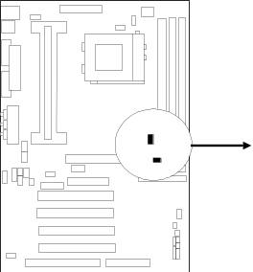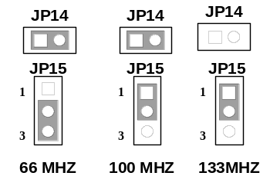
CPU External Frequency：JP15, JP14
CPU | JP15 | JP14
66MHz | 2-3 | ON
100MHz | 1-2 | ON(Default)
133MHz* | 1-2 | OFF
*Your Memory must meet the requirement to run on 133MHz the condition.
- Users also can setting the CPU Bus frequency in the “CPU Host/PCI clock” in CHIPSET FEATURES SETUP.(Please refer to page 18)
2. CPU Ratio Selector：U17
Ratio | 1 | 2 | 3 | 4 |  | Ratio | 1 | 2 | 3 | 4
2.0x | ON | ON | ON | ON |  | 5.5x | OFF | OFF | OFF | ON
2.5x | OFF | ON | ON | ON |  | 6.0x | ON | ON | ON | OFF
3.0x | ON | OFF | ON | ON |  | 6.5x | OFF | ON | ON | OFF
3.5x | OFF | OFF | ON | ON |  | 7.0x | ON | OFF | ON | OFF
4.0x | ON | ON | OFF | ON |  | 7.5x | OFF | OFF | ON | OFF
4.5x | OFF | ON | OFF | ON |  | 8.0x | ON | ON | OFF | OFF
5.0x | ON | OFF | OFF | ON

Table for the Pentium II/III and Celeron (Slot 1 and Socket 370) CPU
CPU Type | CPU BUS Clock | Ratio | CPU Frequency
Pentium II 266 , Celeron-266 | 66 MHz | 4.0X | 266 MHz
Pentium II 300 , Celeron-300/300A | 66 MHz | 4.5X | 300 MHz
Pentium II 333 , Celeron-333 | 66 MHz | 5.0X | 333 MHz
Celeron-366 | 66 MHz | 5.5X | 366 MHz
Celeron-400 | 66 MHz | 6.0X | 400 MHz
Celeron-433 | 66 MHz | 6.5X | 433 MHz
Pentium II 350 | 100 MHz | 3.5X | 350 MHz
Pentium II 400 | 100 MHz | 4.0X | 400 MHz
Pentium II 450, Pentium III 450 | 100 MHz | 4.5X | 450 MHz
Pentium III 500 | 100 MHz | 5.0X | 500 MHz
Pentium III 550 | 100 MHz | 5.5X | 550 MHz
Pentium III 600 | 100 MHz | 6.0X | 600 MHz

2. CMOS RAM Clear: JP17 (Yellow color selector)
WARNING: Make sure your computer is POWER OFF when you CLEAR CMOS.
Connect a jumper Cap over this jumper for a few seconds, will clears information stored in the CMOS RAM Chip that input by user, such as hard disk information and passwords. After CLEAR CMOS, you must enter the BIOS setup (by holding down <DEL> during power-up) to re-enter BIOS information (see BIOS SETUP).
Selections JP17
Normal 1-2 (Default)
Clear CMOS 2-3 (momentarily)
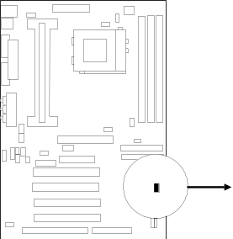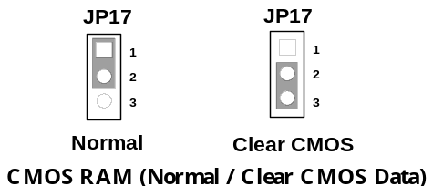
2-6 System Memory (DRAM)
The mainboard supports three 168-pins DIMM modules to the Max Memory Size of 768MB for 9BXAS/9BXAN/9BXAS-A/9BXAN-A and two DIMM modules to the Max Memory Size of 256MB for 9ZXAS/9ZXAN.
DIMM 1 | DIMM 2 | DIMM 3 | System can be Accept or Not
168-pin DIMM | x | x | Accept
168-pin DIMM | 168-pin DIMM | x | Accept
168-pin DIMM | 168-pin DIMM | 168-pin DIMM | Accept
2-7 Central Processing Unit (CPU)
2-7-1 The mainboard provides a Slot-1 for Pentium II/III processor. The CPU on board must have a fan or heat sink attached to prevent overheating.
WARNING: Without a fan or heat sink, the CPU will overheat and cause damage to both the CPU and the motherboard.
To install a CPU, first turn off your system and remove its cover. Locate the Slot- 1 and place RETENTION MODULE as following:
IMPORTANT: You must set jumper JP14,JP15 for “Bus Frequency Selection” on page6 depending on the CPU that you install.
1. Attach heat sink to the CPU.
2. Place Part A on slot-1 and gently screw four corners on top of the mother- board.
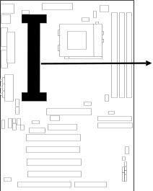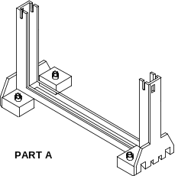
2-7-2 The mainboard also provides a 370-pin ZIF Socket 370. The CPU on motherboard must have a fan attached to prevent overheating.
To install a CPU, first turn off your system and remove its cover. Locate the ZIF socket and open it by first pulling the lever sideways away from the socket then upwards to a 90-degree right angle. Insert the CPU with the white dot as your guide. The white dot should point towards the end of the level. The CPU has a corner pin for three of the four corners, the CPU will only fit in the one orientation as shown as follow. With the added weight of the CPU fan, no force is required to insert the CPU. Once completely inserted, hold down on the fan and close the socket’s lever.
IMPORTANT: You can setting the CPU ratio and Host Frequency in the BIOS setup on page 18

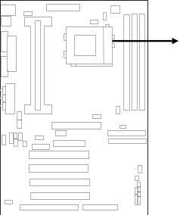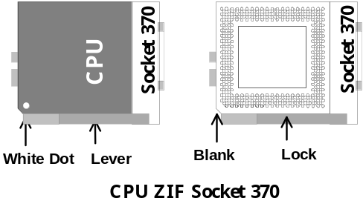
2-8 Expansion Cards
You must read the documentation come with expansion card for any hardware or software settings that may be required to setup your specific card.
Installation Procedure:
- Read the documentation from your expansion card.
- Set any necessary jumpers on your expansion card.
- Remove your computer’s cover.
- Remove the bracket on the slot you intend to use.
- Carefully align the card’s connectors and press firmly.
- Secure the card on the slot with the screw you remove in step 4.
- Replace the computer’s cover.
- Setup the BIOS if necessary.
- Install the necessary software drivers for your expansion card.
Assigning IRQs for Expansion Cards
Some expansion cards may require an IRQ to operate. Generally an IRQ must be exclusively assigned to only one device. In an standard design there are 16 IRQs available but most of them are occupied by the system and leaves 6 free for expansion cards.
With most recent device, the BIOS automatically assign an IRQ number to PCI expansion cards. Please make sure there are no any of two devices use same IRQs, otherwise your computer may experience some problems when those two devices are in use at the same time.
Assigning DMA Channels for Expansion Cards
Some devices may also need to use a DMA (Direct Memory Access) channel. DMA assignments for this motherboard are handled the same way as the IRQ assignment process described above. You can select a DMA channel in the PCI and PnP configuration section of the BIOS Setup utility.
2-9 External Connectors
1. Power Connector: ATX Power Connector (20-pin block): PL1
ATX Power Supply connector. This is a new defined 20-pins connector that usually comes with ATX case. The ATX Power Supply allows to use soft power on momentary switch that connect from the front panel switch to 2-pins Power On jumper pole on the motherboard. When the power switch on the back of the ATX power supply turned on, the full power will not come into the system board until the front panel switch is momentarily pressed. Press this switch again will turn off the power to the system board.
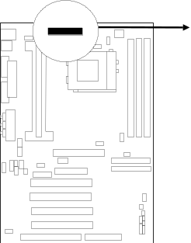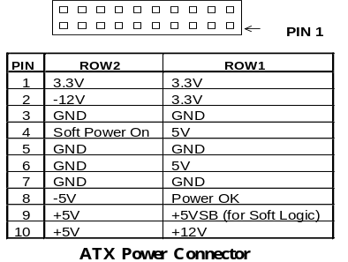
- PS/2 Mouse & PS/2 Keyboard Connector: MINI-DIN
The connectors for PS/2 keyboard and PS/2 Mouse.
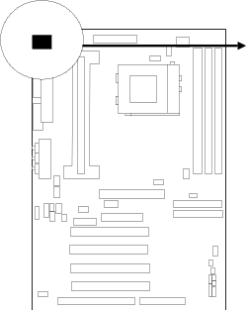
PS/2 Keyboard
PS/2 Mouse
3. USB Port connector: USB
The connectors are 4-pins connector that connect USB devices to the system board.
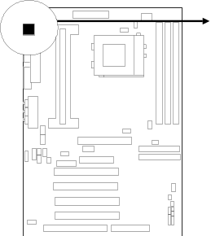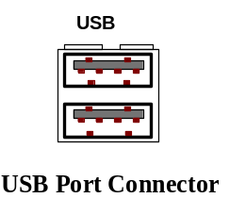
4. Parallel Port Connector (25-pin female): PRINT
Parallel Port connector is a 25-pin D-Subminiature Receptacle connector. The On-board Parallel Port can be disabled through the BIOS SETUP. Please refer to Chapter 3 “INTEGRATED PERIPHERALS SETUP” section for more detail information.
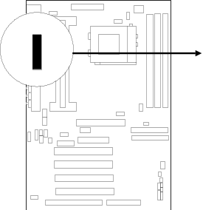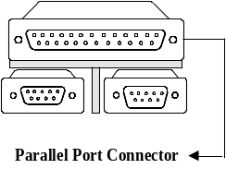
5. Serial Port COMA, COMB: COM1, COM2
COMA is the 9-pin D-Subminiature mail connector. The On-board serial port can be disabled through BIOS SETUP. Please refer to Chapter 3 “INTEGRATED PERIPHERALS SETUP“ section for more detail information.
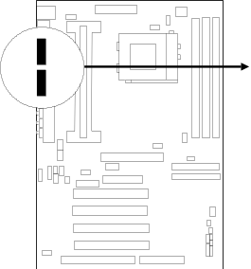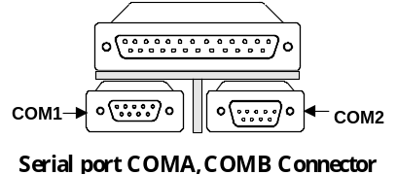
6. Floppy drive Connector (34-pin block): FDD
This connector supports the provided floppy drive ribbon cable. After connecting the single plug end to motherboard, connect the two plugs at other end to the floppy drives.
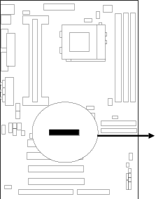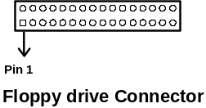
7. Primary IDE Connector (40-pin block): IDE1
This connector supports the provided IDE hard disk ribbon cable. After connecting the single plug end to motherboard, connect the two plugs at other end to your hard disk(s). If you install two hard disks, you must configure the second drive to Slave mode by setting its jumpers accordingly. Please refer to the documentation of your hard disk for the jumper settings.
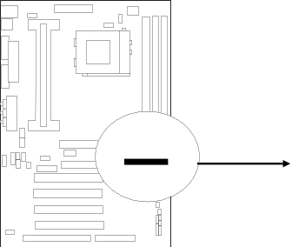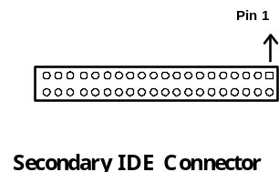

8. Secondary IDE Connector (40-pin block): IDE2
This connector connects to the next set of Master and Slave hard disks. Follow the same procedure described for the primary IDE connector. You may also configure two hard disks to be both Masters using one ribbon cable on the primary IDE connector and another ribbon cable on the secondary IDE connector.
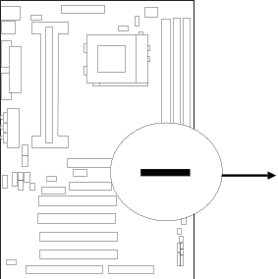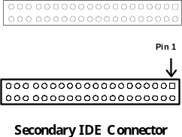
9. IDE activity LED: HDLED
This connector connects to the hard disk activity indicator light on the case.
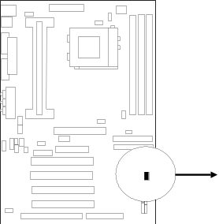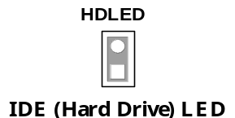

10. Turbo LED switch: TBLED
The motherboard‘s turbo function is always on. The turbo LED will remain constantly lit while the system power is on. You may wish to connect the Power LED from the system case to this lead. See the figure below.
11. Reset switch lead: RST
This 2-pin connector connects to the case-mounted reset switch for rebooting your computer without having to turn off your power switch. This is a preferred method of rebooting in order to prolong the life of the system‘s power supply. See the figure below.
12. Keyboard lock switch lead: KEYLOCK
This 5-pin connector connects to the case-mounted key switch for locking the keyboard for security purposes. See the figure below.
13. Speaker connector: SPEAKER
This 4-pins connector connects to the case-mounted speaker. See the figure below.
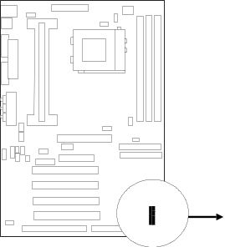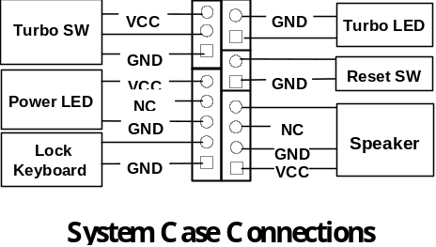
14. IR infrared module connector: IR1
This connector supports the optional wireless transmitting and receiving infrared module. This module mounts to small opening on system cases that support this feature you must also configure the setting through BIOS setup. Use the four pins as shown on the Back View and connect a ribbon cable from the module to the motherboard according to the pin definitions.
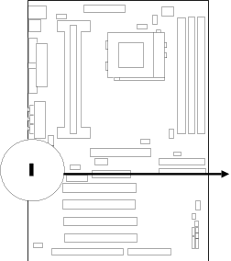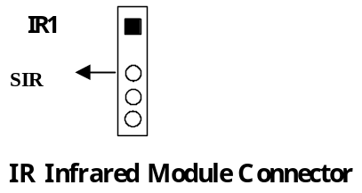
15. FAN connector: CPUFAN , SYSFAN
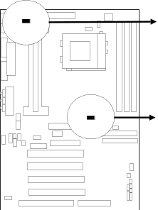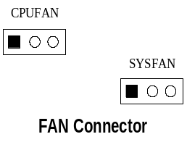
16. Power-On button connector: PS-ON
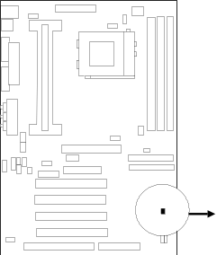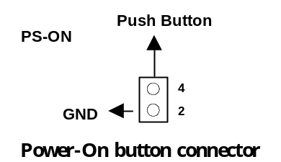
17. Wake On Lan connector: WOL

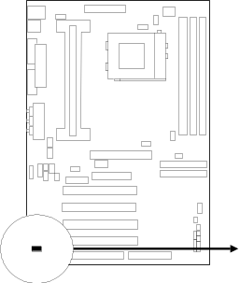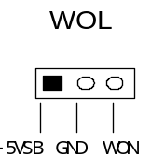
- Wake On LAN Function worked only when power supply support 5VSB more than 750mA current.
Jumpers & Connectors for 9BXAS,9BXAS-A,9ZXAS ONLY
18. On Board Audio chip Enabled / Disabled connector: JP4

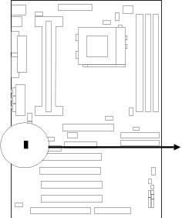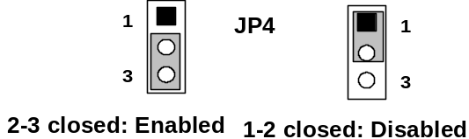
19. Auxiliary Input connector: JP1
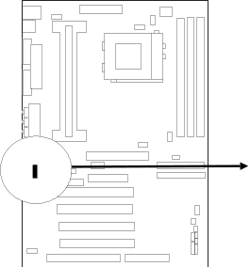
JP1
20. CD Audio in connector : JP2,JP3
JP2 and JP3 are the connectors for CD-Audio Input signal, Please connect it to CD-ROM CD-Audio output connector
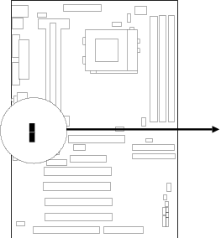
JP2 :CD-Adio/Panasonic
JP3 :CD-Audio/Sony
JP2
JP3
21. Audio and Game Connector : AGC
This Connector are 3 phone Jack for LINE-OUT,LINE-IN,MIC and a 15-pin
D-Subminiature Receptacle Connector for joystick/MIDI Device.
Line-out : audio output to speaker
Line-in : audio input to sound chip (Please plug here for second pair speakers as output channels when use 4 speakers)
MIC : Microphone Connector
Game/MIDI : for joystick or MIDI Device

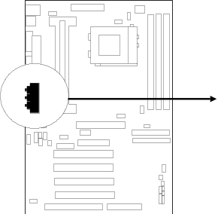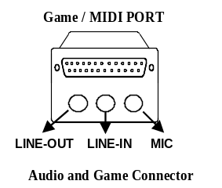
22. PC Speaker signal Input connector: SPKIN 1
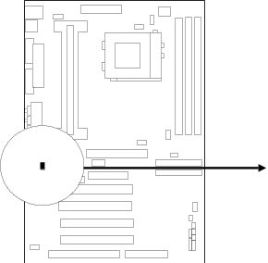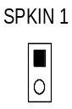
23. SPDIF (Sony / Philips Digital Interface) Input / Output Connectors: SPDIFIN 1 / SPDIFOUT
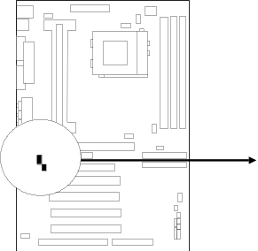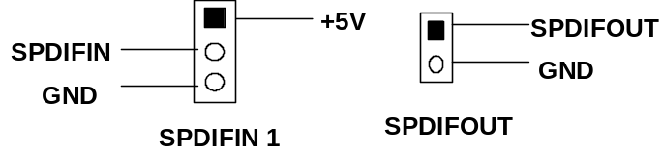
- Optical kit connector: JP18
This connector is for user that has Optical kit(optional) to provide other set of SPDIF INPUT and SPDIF OUTPUT function.
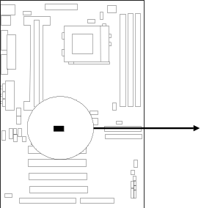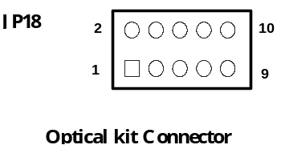

Chapter 3
AWARD BIOS SETUP
This motherboard has previously set to its best stable status. If you are not an experienced user, please do not change the default setting. When you are encounter any problem, please choice “LOAD STANDARD DEFAULTS” to restore best setting.

Award’s ROM BIOS provides a built-in Setup program which allows user modify the basic system configuration and hardware parameters. The modified data will be stored in a battery-backed CMOS RAM so data will be retained even when the power is turned off. In general, the information saved in the CMOS RAM stay unchanged unless here is configuration change in the system, such as hard drive replacement or new equipment is installed.
It is possible that CMOS had a battery failure which cause data lose in CMOS_RAM. If so, re-enter system configuration parameters become necessary.

To enter Setup Program
Power on the computer and press <Del> key immediately will bring you into BIOS CMOS SETUP UTILITY.
ROM PCI/ISA BIOS (2A69KJ1L)
CMOS SETUP UTILITY
AWARD SOFTWARE, INC.
STANDARD CMOS SETUP  BIOS FEATURES SETUP  CHIPSET FEATURES SETUP  POWER MANAGEMENT SETUP  PNP/PCI CONFIGURATION  LOAD OPTIMAL DEFAULTS  LOAD STAMDARD DEFAULTS | INTEGRATED PERIPHERALS  SUPERVISOR PASSWORD  USER PASSWORD  SAVE & EXIT SETUP  EXIT WITHOUT SAVING
Esc : QUIT ↑↓→← : Select Item
F10 : Save & Exit Setup (Shift) F2 : Change Color
Time, Date, Hard Disk Type…
Figure 3-1
The menu displays all the major selection items and allow user to select any one of shown item. The selection is made by moving cursor (press any direction key) to the item and press <Enter> key. An on-line help message is displayed at the bottom of the screen as cursor is moving to various items which provides user better understanding of each function. When a selection is made, the menu of selected item will appear so the user can modify associated configuration parameters.

3-1 STANDARD CMOS SETUP
STANDARD CMOS SETUP (Figure 3-1) allows user to configure system setting such as current date and time, type of hard disk drive installed in the system, floppy drive type, and the type of display monitor. Memory size is auto-detected by the BIOS and displayed for your reference. When a field is highlighted (direction keys to move cursor and <Enter> key to select), the entries in the field will be changed by pressing <PgDn> or <PgUp> keys or user can enter new data directly from the keyboard.

ROM PCI/ISA BIOS (2A69KJ1L)
STANDARD CMOS SETUP
AWARD SOFTWARE, INC.
Date (mm:dd:yy) : Wed, Sep, 10 1997
Time (hh:mm:ss) : 10 : 33 : 52

HARD DISKS TYPE SIZE CYLS HEAD PRECOMP LANDZ SECTOR MODE
Primary Master : Auto 0 0 0 0 0 0 Auto
Primary Slave : Auto 0 0 0 0 0 0 Auto
Secondary Master : Auto 0 0 0 0 0 0 Auto
Secondary Slave : Auto 0 0 0 0 0 0 Auto

Drive A : 1.4M , 3.25 in.  Drive B : None  Video : EGA/VGA  Halt On : All Errors | Base Memory : 640K  Extended Memory : 7168K  Other Memory : 384K  Total Memory : 8192K
Esc : Quit ↑↓→← : Select Item Pu/Pd/+/- : Modify
F1 : Help (Shift)F2: Change Color
Figure 3-2
NOTE: If hard disk Primary Master/Slave and Secondary Master/Slave were used Auto, than the hard disk size and model will be auto-detect on display during POST.
NOTE: The “Halt On:” field is to determine when to halt the system by the BIOS is error occurred during POST.

3-2 BIOS FEATURES SETUP
Select the “BIOS FEATURES SETUP” option in the CMOS SETUP UTILITY menu allows user to change system related parameters in the displayed menu. This menu shows all of the manufacturer’s default values of this motherboard. Again, user can move the cursor by pressing direction keys and <PgDn> of <PgUp> keys to modify the parameters. Pressing [F1] key to display help message of the selected item.
This setup program also provide 2 convenient ways to load the default parameter data from BIOS [F6] or CMOS [F7] area if shown data is corrupted. This provides the system a capability to recover from any possible error.
ROM PCI/ISA BIOS (2A69KJ1L)
BIOS FEATURES SETUP
AWARD SOFTWARE, INC.
Virus Warning : Disabled  CPU Internal Cache : Enabled  External Cache : Enabled  Quick Power On Self Test : Disabled  Boot Sequence : A,C,SCSI  Swap Floppy Drive : Disabled  Boot Up Floppy Seek : Enabled  Boot Up Numlock Status : On  Boot Up System Speed : High  Gate A20 Option : Fast  Typematic Rate Setting : Disabled  Typematic Rate (Chars/Sec) : 6  Typematic Delay (Msec) : 250  Security Option : Setup  Assign IRQ for VGA : Enabled | PCI/VGA Palette Snoop : Disabled  OS Select For DRAM > 64MB : Non-OS2  HDD S.M.A.R.T Capability : Disabled  Report NO FDD WIN 95 : Disabled  Video BIOS Shadow : Enabled  C8000-CBFFF Shadow : Disabled  CC000-CFFFF Shadow : Disabled  D0000-D3FFF Shadow : Disabled  D4000-D7FFF Shadow : Disabled  D8000-DBFFF Shadow : Disabled  DC000-DFFFF Shadow : Disabled
Esc: Quit ↑↓→← : Select Item  F1 : Help Pu/Pd/+/-:Modify  F5 : Old Values (Shift)F2 : Color | F6 : Load Optimal Defaults  F7 : Load Standard Defaults
Figure 3-2
NOTE: The Security Option contains “setup” and “system”. The “setup” indicates that the password setting is for CMOS only while the “system” indicates the password setting is for both CMOS and system boot up procedure.
- Security Option: This category allows you to limit access to the system and
Setup, or just to Setup. The default value is Setup.
System: The system will not boot and access to Setup will be denied if the correct password is not entered at the prompt.
Setup: The system will boot, but access to Setup will be denied if the incorrect password is entered at the prompt.
NOTE: To disable security, select PASSWORD SETTING at Main Menu and then you will be asked to enter password. Do not type anything and just press <Enter>, it will disable security. Once the security is disabled, the system will boot and you can enter Setup freely.
3-3 CHIPSET FEATURES SETUP
This section describes features of the Intel 440BX/440ZX PCIset. If your system contains a different chipset, this section will bear little resemblance to what you see on your screen.
ADVANCED OPTIONS. The parameters in this screen are for system designers, service personnel, and technically competent users only. Do not reset these values unless you understand the consequences of your changes.
ROM PCI/ISA BIOS (2A69KJ1L)
CHIPSET FEATURES SETUP
AWARD SOFTWARE, INC.
Auto Configuration : Enabled  Only for 9BXAS,9BXAN  EDO DRAM Speed Selection : 60 ns  EDO CASx# MA Wait Srate : 2  EDO RASx# Wait State : 1  SDRAM RAS-to-CAS Delay : 3  SDRAM RAS Precharge Time : 3  SDRAM CAS latency Time : 3  SDRAM Precharge Control : Disabled  DRAM Data Integrity Mode : Non-ECC  System BIOS Cacheable : Enabled  Video BIOS Cacheable : Enabled  Video RAM Cacheable : Disabled  8 Bit I/O Recovery Time : 1  16 Bit I/O Recovery Time : 1  Memory Hole At 15M-16M : Disabled  Passive Release : Enabled  Delayed Transaction : Disabled  AGP Aperture Size : 64 | Auto Detect DIMM/PCI Clk : Enabled  Spread Spectrum Modulated: Disabled  CPU Host/PCI Clock : Default  CPU Warnung Temperature : Disabled  Current System Temp. : 44°C/111°F  Current CPU Temperature : 34°C/93°F  Current CPUFAN Speed : 0 RPM  Current SYSFAN Speed : 0 RPM  Core : 2.80V +3.3V : 3.3V  +5V : 5.10V +12V : 12 V  -12V : 12 V
Esc: Quit ↑↓→←: Select Ite m  F1 : Help Pu/Pd/+/-:Modify  F5 : Old Values (Shift)F2 : Color | F6 : Load Optimal Defaults  F7 : Load Standard Defaults
Figure 3-3
- CPU HOST/PCI Clock: In this item you can choose the CPU HOST/PCI Clock. The setting are: Default ,66/33,75/37,83/41,100/33,103/34, 112/37,124/41,133/44, 105/35,110/36,115/38, 120/40,124/31,133/33.
When the setting is :’default” the CPU HOST Clock will depend on the setting of JP14 and JP15.
If JP14,JP15 is set to 66MHz only have the choice of 66/33, 75/37, 83/41on screen.
If the JP14,JP15 is setting at 100MHz, then you can have 100/33,103/34,112/37,124/41, 133/44 105/35,110/36,115/38,120/40,133/33.
*Please turn off system power if the screen does not have any display after change of the setting. Then press and hold down “ INS ” key, and turn on system power again (release “ INS ” key till the screen has display) to reset correct frequency of CPU HOST clock.

- Core:+3.3V,+5V,+12V,-12V,are show the status of system voltages.

3-4 POWER MANAGEMENT SETUP
The Power Management Setup allows you to configure you system to most effectively save energy while operating in a manner consistent with your own style of computer use.
ROM PCI/ISA BIOS (2A69KJ1L)
POWER MANAGEMENT SETUP
AWARD SOFTWARE, INC.
Power Management : Disabled  PM Control by APM : Yes  Video Off Method : V/H SYNC+Blank  Video Off After : Stand by  MODEM Use IRQ : 3  Doze Mode : Disabled  Standby Mode : Disabled  Suspend Mode : Disabled  HDD Power Down : Disabled  Throttle Duty Cycle : 62.5%  ZZ Active in Suspend : Disabled  VGA Active Monitor : Enabled  Soft-Off by PWR-BTTN : Instant-Off  CPUFAN Off In Suspend : Enabled  Resume by Ring : Enabled | IRQ 8 Break Suspend : Disabled  ** Reload Global Timer Events **  IRQ [3-7, 9-15], NMI : Enabled  Primary IDE 0 : Disabled  Primary IDE 1 : Disabled  Secondary IDE 0 : Disabled  Secondary IDE 1 : Disabled  Floppy Disk : Disabled  Serial Port : Enabled  Parallel Port : Disabled
Esc: Quit ↑↓→←: Select Item  F1 : Help Pu/Pd/+/-: Modify  F5 : Old Values (Shift)F2 : Color | F6 : Load Optimal Defaults  F7 : Load Standard Defaults
Figure 3-4
- Power Management: This category allows you to select the type (or degree) of power
saving and is directly related to the following modes:
Doze Mode , Standby Mode , Suspend Mode , HDD Power Down
There are four selections for Power Management, three of which have fixed mode settings.
Disable (default) | No power management. Disables all four modes
Min. Power Saving | Minimum power management. Doze Mode = 1 hr. Standby Mode = 1 hr., Suspend Mode = 1 hr., and HDD Power Down = 15 min.
Max. Power Saving | Maximum power management -- ONLY AVAILABLE FOR SL CPU’S. Doze Mode = 1 min., Standby Mode = 1 min., Suspend Mode = 1 min., and HDD Power Down = 1 min.
User Defined | Allows you to set each mode individually. When not disabled, each of the ranges are from 1 min. to 1 hr. except for HDD Power Down which ranges from 1 min. to 15 min. and disable.
- PM Control APM: When enabled, an Advanced Power Management device will be activated to enhance the Max. Power Saving mode and stop the CPU internal clock.
If the Max. Power Saving is not enabled, this will be preset to No.
- Video Off Method: This determines the manner in which the monitor is blanked.
V/H SYNC+Blank | This selection will cause the system to turn off the vertical and horizontal synchronization ports and write blanks to the video buffer.
Blank Screen | This option only writes blanks to the video buffer.
DPMS | Initial display power management signaling.
- Video Off After: When enabled, this feature allows the VGA adapter to operate in a power saving mode.
N/A | Monitor will remain on during power saving modes.
Suspend | Monitor blanked when the systems enters the Suspend mode.
Standby | Monitor blanked when the system enters Standby mode.
Doze | Monitor blanked when the system enters any power saving mode.
- MODEM Use IRQ: Name the interrupt request (IRQ) line assigned to the modem (if any) on your system. Activity of the selected IRQ always awakens the system.
The choices: NA, 3, 4, 5, 7, 9, 10, 11
- PM Timer: The following four modes are Green PC power saving functions which are only user configurable when User Defined Power Management has been selected see above for available selections.
- Doze Mode: When enabled and after the set time of system inactivity, the CPU clock will run at slower speed while all other devices still operate at full speed.
- Standby Mode: When enabled and after the set time of system inactivity, the fixed disk drive and the video would be shut off while all other devices still operate at full speed.
- Suspend Mode: When enabled and after the set time of system inactivity, all devices except the CPU will be shut off.
- HDD Power Down: When enabled and after the set time of system inactivity, the hard disk drive will be powered down while all other devices remain active.
- Throttle Duty Cycle: When the system enters Doze mode, the CPU clock runs only part of the time. You may select the percent of time that the clock runs.
The Choice: 12.5%, 25.0%, 37.5%, 50.0%, 62.5%, 75.0%
- ZZ Active in Suspend: When Enabled, the ZZ signal is active during Suspend mode.
The Choice: Enabled, Disabled.
- VGA Active Monitor: When Enabled, any video activity restarts the global timer for Standby mode.
The Choice: Enabled, Disabled.
- Soft-Off by PWR-BTTN: When Enabled, turning the system off with the on/off button places the system in a very low-power-usage state, with only enough circuitry receiving power to detect power button activity or Resume by Ring activity.
The Choice: Instant-Off, Delay 4 Sec.
- Resume by Ring: An input signal on the serial Ring Indicator (RI) line (in other words, an incoming call on the modem) awakens the system from a soft off state..
The Choice: Enabled, Disabled.
- IRQ 8 Break Suspend: You can Enable or Disable monitoring of IRQ8 so it does not awaken the system from Suspend mode.
The Choice: Enabled, Disabled.

Reload Global Timer Events:

When Enabled, an event occurring on each device listed below restarts the global time for Standby mode.
IRQ[3 -7, 9-15], NMI , Primary IDE 0, Primary IDE 1, Secondary IDE 0 , Secondary IDE 1 ,
Floppy Disk , Serial Port , Parallel Port

3-5 PnP/PCI CONFIGURATION SETUP
This section describes configuring the PCI bus system. PCI, or Personal Computer Interconnect, is a system which allows I/O devices to operate at speeds nearing the speed the CPU itself uses when communicating with its own special components. This section covers some very technical items and it is strongly recommended that only experienced users should make any changes to the default settings.
ROM PCI/ISA BIOS (2A69KJ1L)
PNP/PCI CONFIGURATION SETUP
AWARD SOFTWARE, INC.
PNP OS Installed : No  Resources Controlled By : Manual  Reset Configuration Data: Disabled  IRQ-3 assigned to : Legacy ISA  IRQ-4 assigned to : Legacy ISA  IRQ-5 assigned to : PCI/ISA PnP  IRQ-7 assigned to : PCI/ISA PnP  IRQ-9 assigned to : PCI/ISA PnP  IRQ-10 assigned to : PCI/ISA PnP  IRQ-11 assigned to : PCI/ISA PnP  IRQ-12 assigned to : PCI/ISA PnP  IRQ-14 assigned to : PCI/ISA PnP  IRQ-15 assigned to : PCI/ISA PnP  DMA-0 assigned to : PCI/ISA PnP | Slot 1 Use IRQ NO : AUTO  Slot 2 Use IRQ NO : AUTO  Slot 3 Use IRQ NO : AUTO  Used MEM base addr : N/A  Assign IRQ For USB : Enabled
DMA-1 assigned to : PCI/ISA PnP  DMA-3 assigned to : PCI/ISA PnP  DMA-5 assigned to : PCI/ISA PnP  DMA-6 assigned to : PCI/ISA PnP  DMA-7 assigned to : PCI/ISA PnP | Esc: Quit ↑↓→←: Select Item  F1 : Help Pu/Pd/+/-:Modify  F5 : Old Values (Shift)F2 : Color  F6 : Load Optimal Defaults  F7 : Load Standard Defaults
Figure 3-5

3-6 LOAD OPTIMAL DEFAULTS
The “LOAD OPTIMAL DEFAULTS” function loads the system Optimal default data directly from ROM and initialize associated hardware properly. This function will be necessary only when the system CMOS data is corrupted.
ROM PCI/ISA BIOS (2A69KJ1L)
CMOS SETUP UTILITY
AWARD SOFTWARE, INC.
STANDARD CMOS SETUP  Load OPTIMAL Default (Y/N)? Y  BIOS FEATURES SETUP  CHIPSET FEATURES SETUP  POWER MANAGEMENT  PNP/PCI CONFIGUR  LOAD OPTIMAL DEFAULTS  LOAD STANDARD DEFAULTS | INTEGRATED PERIPHERALS  SUPERVISOR PASSWORD  USER PASSWORD  TECTION  ORMAT  SAVE & EXIT SETUP  EXIT WITHOUT SAVING
Esc : QUIT ↑↓→← : Select Item
F10 : Save & Exit Setup (Shift) F2 : Change Color
Time, Date, Hard Disk Type…
Figure 3-6

3-7 LOAD STANDARD DEFAULTS
The “LOAD STANDARD DEFAULTS” function loads the system Standard default data directly from ROM and initialize associated hardware properly. This function will be necessary only when the system CMOS data is corrupted.
ROM PCI/ISA BIOS (2A69KJ1L)
CMOS SETUP UTILITY
AWARD SOFTWARE, INC.
STANDARD CMOS SETUP  Load STANDARD Default (Y/N)? Y  BIOS FEATURES SETUP  CHIPSET FEATURES SETUP  POWER MANAGEMENT SETUP  PNP/PCI CONFIGUR  LOAD OPTIMAL DEFAUL  LOAD STANDARD DEFAULTS | INTEGRATED PERIPHERALS  SUPERVISOR PASSWORD  USER PASSWORD  UP  EXIT WITHOUT SAVING
Esc : QUIT ↑↓→← : Select Item
F10 : Save & Exit Setup (Shift) F2 : Change Color
Time, Date, Hard Disk Type…
Figure 3-7

3-8 INTEGRATED PERIPHERALS SETUP
The “INTEGRATED PERIPHERALS SETUP” mainly deals with I/O function. This function will be necessary only when the system I/O malfunctioned or the system is unable to detects your CD-ROM or hard disk.

ROM PCI/ISA BIOS (2A69KJ1L)
INTEGRATED PERIPHERALS
AWARD SOFTWARE, INC.
IDE HDD Block Mode : Enabled  IDE Primary Master PIO : Auto  IDE Primary Salve PIO : Auto  IDE Secondary Master PIO : Auto  IDE Secondary Slave PIO : Auto  IDE Primary Master UDMA : Auto  IDE Primary Slave UDMA : Auto  IDE Secondary Master UDMA : Auto  IDE Secondary Slave UDMA : Auto  On-Chip Primary PCI IDE : Enabled  On-Chip Secondary PCI IDE : Enabled  USB Keyboard Support : Enabled  Init Display First : PCI SLOT  Power On Function : Button  KB Power On Password : Enter  Hot key Power On : Ctrl-F1  KBC Input Clock : 8MHz  Onboard FDC Controller : Enabled | Onboard SERIAL PORT 1 : 3F8/IRQ4  Onboard SERIAL PORT 2 : 2F8/IRQ3  UR2 Mode : Normal  Onboard Parallel Port : 378/IRQ7  Parallel Port Mode : SPP
Esc: Quit ↑↓→←: Select Item  F1 : Help Pu/Pd/+/-:Modify  F5 : Old Values (Shift)F2 : Color | F6 : Load Optimal Defaults  F7 : Load Standard Defaults
Figure 3-8

3-9 SUPERVISOR/USER PASSWORD
This item lets you configure the system so that a password is required each time the system boots or an attempt is made to enter the Setup program (Refer to Figure 3-3 for the details). Supervisor Password allows you to change all CMOS settings but the User Password setting doesn’t have this function. The way to set up the passwords for both Supervisor and User are as follow:
- Choose either Supervisor Password or User Password in the Main Menu and press
<Enter>. The following message appears:
“Enter Password:”
- The first time you run this option, enter your password up to only 8 characters and press <Enter>. The screen does not display the entered characters. For no password just press <Enter>.
- After you enter the password, the following message appears prompting you to
confirm the password:
“Confirm Password:”
- Enter exact the same password you just typed again to confirm the password and press <Enter>.
- Move the cursor to Save & Exit Setup to save the password.
- If you need to delete the password you entered before, choose the Supervisor Password and Press <Enter>. It will delete the password that you bad before.
- Move the cursor to Save & Exit Setup to save the option you did, otherwise the old password will still be there when you turn on your machine next time.

SAVE & EXIT SETUP
The “SAVE & EXIT SETUP” option will bring you back to boot up procedure with all the changes you just made which are recorded in the CMOS RAM.

3-11 EXIT WITHOUT SAVING
The “EXIT WITHOUT SAVING” option will bring you back to normal boot up procedure without saving any data into CMOS RAM. All of the old data in the CMOS will not be destroyed.

Chapter 4

4-1 PC HEALTH MONITOR-III SOFTWARE FOR 9BXAS, 9BXAN

PC Health Monitor-III Software for Windows 95/98
Please Run X：\INTEL\HEALTH3\SETUP.EXE
NOTES | - For Windows 95 user：You must run SETUP.EXE twice in order to complete this installation. The computer will install device identification at first time when you run SETUP.EXE. When you finish, you need re-start your computer manually and run SETUP.EXE once again to install correspond driver.  - Please follow on screen instruction to complete your installation.  - Please refer to HELP for Windows 95/98 related questions.

General Description
The PC HEALTH MONITOR-III Software, an application software based on Microsoft Windows 95, is used to control the PC HEALTH MONITOR CHIP. It can monitor the temperatures, power supply voltages and fan speeds via PC HEALTH MONITOR CHIP and show the information on screen periodically. User can use it to specify temperature, voltage and fan speed configurations used by monitor chip. By the way, the alarm warning events and polling interval could also be set by this software. If there is an abnormal event happens, it will pop up a window on screen to inform the user the abnormal situation.

Using the Software

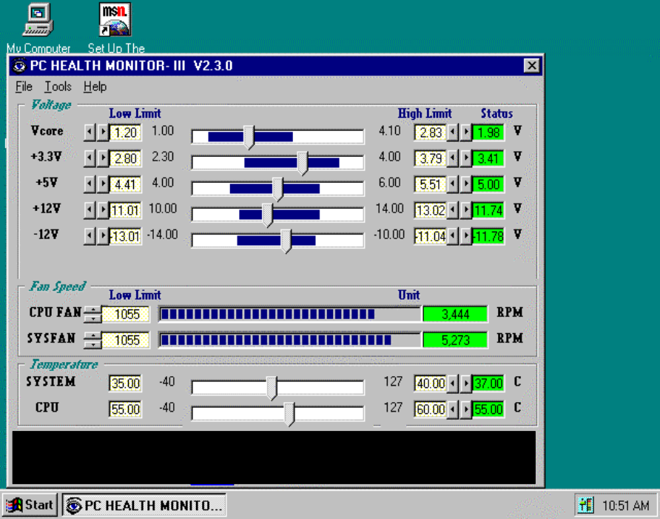

General Function
- Power Supply Voltage :
VCORE Low Limit/High Limit
3.3V Low Limit/High Limit
+5V Low Limit/High Limit
+12V Low Limit/High Limit
-12V Low Limit/High Limit
These values are used to specify the threshold values of detecting the abnormal condition of , 3.3V, +5V, +12V, -12V.
- FAN Speed
CPUFAN/ SYSFAN
If the fan RPM is lower than this value and “CPUFAN/SYSFAN” is enabled in Monitoring Config. the PC Speaker will alarm and the monitor software will pop up a window to inform user.
- Temperature
System/ CPU Low Limit/ High Limit
There values is used to specify the Temp-Over register/ Tem-under register of PC HEALTH MONITOR CHIP, If the temperature of the external thermistor is higher than this value and “System/CPU” is enabled in Monitoring Config. the monitor software will pop up a window to inform user.

Monitoring Config.
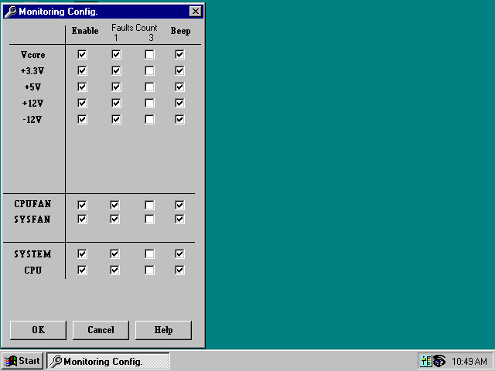

Enabled or Disabled: User can decide which item should be monitored or not by choosing the item in the configuration page.
Faults Count (1 or 3): User can decide the system to pop up the warning message when there is 1 fault detected or there are 3 consecutive faults detected.
Beep: In addition to pop up warning message user can choose to activate Beep tone if there is error detected. Beep tone will until the error is treated.

4-2 Sound Driver & Audio Rack Installation:
Special Features for CMI8738 audio chip
PCI Plug and Play (PnP) bus interface, 32 bit PCI bus master.
Full duplex playback and recording, built-in 16 bits CODEC.
HRTF 3D positional audio, supports both Direct Sound 3D® & A3D® interfaces, supports earphones, two and four channel speakers mode.
Support Windows 3.1 / 95 / 98 and Windows NT 4.0.
Built-in 32 OHM Earphone buffer and 3D surround.
MPU-401 Game/Midi port and legacy audio SB16 support.
Downloadable Wave Table Synthesizer, supports Direct Music®.
• Digital Audio (SPDIF IN/OUT)
Up to 24 bit stereo 44KHz sampling rate voice playback/recording.
Full duplex playback and recording, 120dB audio quality measured.
Auto detectable SPDIF/IN signal level from 0.5V to 5V.
• Stereo Mixer and FM Music Synthesizer
Stereo analog mixing from CD-Audio, Line-in
Stereo digital mixing from Voice, FM/Wave-table, Digital CD-Audio
Mono mixing from MIC and software adjustable volume
OPL3 FM synthesizer (4 operators)
Up to 15 melody sounds and 5 rhythm sounds (20 voices)
• Game and Midi Interface
Fully compatible with MPU-401 Midi UART and Sound Blaster Midi

mode/ Standard IBM PC joystick/game port (dual channels)

DOS Installation
Before beginning the installation, please make sure that your hard disk has sufficient space(min. 4MB). Insert the Driver CD into the CD-ROM Drive.
- Change directory to PCI audio DOS drivers folder (ex. X:\CMI8738\DOSDRV) at DOS prompt, and type:
INSTALL [Enter]
- Type DOS utilities path which you want to install.
- Program will expand the file to the path which you've specified.
4. Install program will add initial drivers into AUTOEXEC.BAT file.

Win95/98 Installation
We recommend that you install Microsoft Windows before you install this PCI sound card, and you not install any other sound card device drivers in your current system.
1. Turn on the computer , and enter the Microsoft Windows 95/98
2. Before install sound card driver please double-click “My Computer” icon, “Control Panel” icon , “System” icon, and choose “Device Manager” item.
3. Check “Other Device” item ,if there have “PCI Multimedia Audio Device”, please remove it first ,and Restart System again.
4. You will see a windows prompt like this:
“New Hardware Found PCI Multimedia Audio Device Windows has found new hardware and is installing the software for it” , then the dialog box shown Click “Next” button to go on.
- Click “Other Locations” button to specify drivers path:
“ X:\CMI8738\Win9X\DRV”
- Select “OK” to finish install.
- Now, system is installing device drivers automatically. After a while, the system will finish the installation includes the following device drivers.
CMI8738/C3DX PCI Audio Device
CMI8738/C3DX PCI Audio Joystick Device
CMI8738/C3DX PCI Audio Legacy Device
DOS mode MPU-401 Emulator
8. Install Application Software : Click “start” key
9. Select “Run”
10. Key in the drive and path for Windows application installation program, for example,
in Win95 “X:\CMI8738\Win9X\APP\Win95\SETUP.EXE”
in Win98 “X:\CMI8738\Win9X\APP\Win98\SETUP.EXE”
- Click “OK” to start the installation procedure, and follow the on-screen instructions to finish the installation. When all the application software have been installed, please shut down Windows 95/98 system, and reboot your system.

Win95/98 Un-Installation
If you install Win95/98 and a sound card at the same time, you might experience some technical difficulties(the device might not function properly). It is suggested that you proceed with the un-install procedure:

- Click "start" button.
- Select "run" item.
- Find UINSTDRV.EXE in driver disk under Win95/98 drivers folder.
- Run it.
5. Follow the on-screen instructions to re-install the hardware.

If you want to completely remove the drivers, you can also run the un-install procedure as described previously. Remove the sound card from the slot, and then reboot the system.

Windows NT 4.0 Installation
We recommend that you install Windows NT 4.0 before you install this PCI audio card, and you not install any other sound card device drivers in your current system.
1. Click “Start” button, move the highlight bar to “Setting” item, and select the “Control Panel”.
2. Double-click “Multimedia” icon.
3. Select “Devices” page, and press “Add” button.
4. Select “Unlisted or Updated Driver” item in “List of Drivers”.
5. Specify the drive and the path where NT drivers are in (such as X:\CMI8738\NT40\DRV).
6. Select “C-Media CM8738” item and press “OK” button.
7. Select proper I/O value.
8. Press “OK” button.
9. Restart the system when being asked.
- Now, you have already installed the PCI Audio Adapter under Microsoft Windows NT 4.0 successfully. if you want to install the Windows applications, continue the following steps:

- Click “start” key.

- Select “Run” item.
- Key in drive and path for Windows NT application installation program, for example, “X:\CMI8738\NT40\APP\SETUP.EXE”
- Click “OK” to start the installation procedure, and follow the on-screen instructions to finish the installation. When all of application softwares have been installed, shut down the Windows NT system, and then reboot your system.

Windows Appc. (The Audio Rack)

Introduction
By means of a user-friendly interface(as easy as operating your home stereo system), this PCI audio rack provides you with the control over your PC’s audio functions, including the advantage of four speakers mode enable/ disable, and perfect digital sound ( SPDIF ) input / output control.
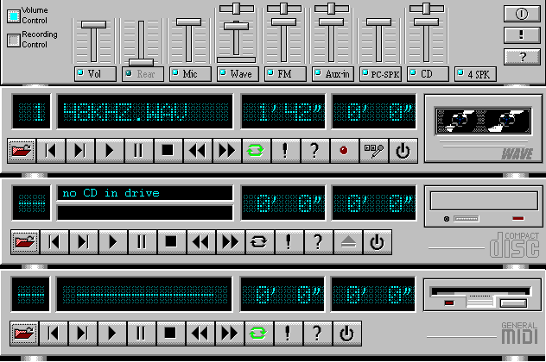
This Audio Rack consists of several major components:
Control Center: Controls the display of the PCI Audio Rack’s components.
MIDI Player: Plays MIDI music files, and allows you to create your personal song playlists, and play the song files.
Wave Player: Records and plays digital audio (wave) files. Allows you to create wave file playlists, and playback the wave files.
CD Player: Plays standard audio CDs. Allows you to create your favorite song playlists.
System Mixer: Controls the volume level of your audio inputs and outputs.
Showing or Hiding Audio Rack Components
To remove or add a component from the display, click on the component's button on the Control Center’s Button Bar or toggle it off.
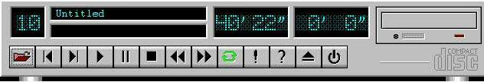

MIDI Player, Wave Player, and CD Player
CD Player (above, similar to Wave Player and MIDI Player)
Sel (or Trk) fielX: If you have multiple selections in your playlist, this shows the number of the current selection or CD track.
Current File or Track: The name of the current MIDI file, wave audio file, or CD track.
Total Length fielX: displays the total length of files or tracks in minutes and seconds.
Current Time fielX: displays the current time of files or tracks in minutes and seconds when playback or recording.
Please refer to the help screen for more detail button function descriptions. (click on help “?” button on the player)

System Mixer
System Mixer allows you to control all the audio output and input levels.
System Mixer displays the volume controls which your audio drivers make available. The names for these controls may vary.
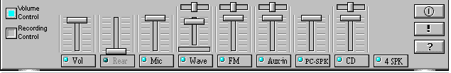
Mixer panel while the four speakers mode is enabled.
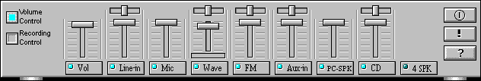
Mixer panel while the four speakers mode is disabled.
Volume Control: Clicking on this button shows and allows you to use the output level controls.
Recording Control: Clicking on this button shows and allows you use the input level controls.
Input and Output Level Sliders and Buttons: For each input or output signal type, the control slider controls the loudness whereas the horizontal slider controls the balance between the two speakers. The mute button temporarily stops input or output without changing slider positions.
Control types and names might vary. The common types are listed below:
- Vol: The master control for all outputs. The strength of an output signal is determined by both the Vol slider and the slider for the individual output. To affect all outputs, move the Vol slider. To change the output of an individual output type, move its slider.
- Line-in/Rear: Controls the audio hardware's Line In or Line Out levels. Line levels might be for an externally attached cassette player, for instance, while the four speakers mode is enabled, this control becomes the Rear speaker volume control.
- Mic: Controls the microphone input level.
- Wave: Controls wave (voice) playback or the recording levels.
- FM: Controls the FM music playback or the recording level.
- Aux-in: Controls the Aux-in music play or the recording level.
- PC-SPK: Controls the external PC speaker input level.
- CX: Controls the CD drive output level, for CD drives configured to play their audio output through the PC’s audio hardware.
- 4SPK: Turn on or turn off the Rear speakers effect.
- SurrounX: Turn on or turn off the 3D surround sound effect.
- SPDIF-in: Turn on or turn off the SPDIF digital signal input.
Mute Buttons: Toggle between muting and enabling the signal. A button with a lit LED is enabled, and when it is not lit, it means it is mute. Several output signals can usually be enabled at once.

The 4 Speakers System
This Audio Adapter provides 2 wave channels(front/rear), known as the 4 speakers system. When games or application programs via DirectSound® 3D or A3D® interface locate the sound sources to the listener's back, the two rear speakers will work to enhance the rear audio positional effect, so as to complement the insufficiency of using only two front speakers to emulate the
audio effect. The following is the hardware installation and the software setups:
- The speaker installation.
Connect the front pair speakers to the Line-out jack of the audio adapter, and then connect rear pair speakers to Line-in/Rear jack of the audio adapter. The original Line-in can be moved to Aux-in.
- The positions of the speakers
Put your speakers the way the following picture suggests, so as to avail yourself to the best
audio result.

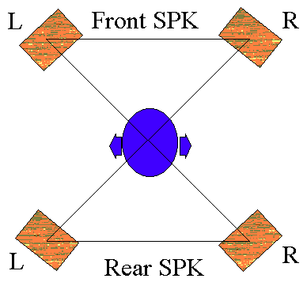

- The mixer setup
There is a 4 speakers option in the volume control of the mixer, and when you enable this option, it means the rear speakers are connected to Line-in/Rear jack. When Line-in/Rear jack is connected to other external Line-in sources, please DO NOT enable this option in order to avoid hardware conflicts. Regarding rear speaker option, you can turn on or turn off the output of the back speakers, and adjust the volume, to have the rear/front speakers have the same volume.
- The demo
Execute the "Helicopter" demo within the C3D HRTF Positional Audio Demos of this audio adapter. When the helicopter flies behind you, the rear speakers will work.
Optical Kid for 9BXAS,9ZXAS,9BXAS-A SPDIF/OUT (Optional)
The Optical Kid includes：
- Optical Module
- Optical Cable
- Software DVD drvier
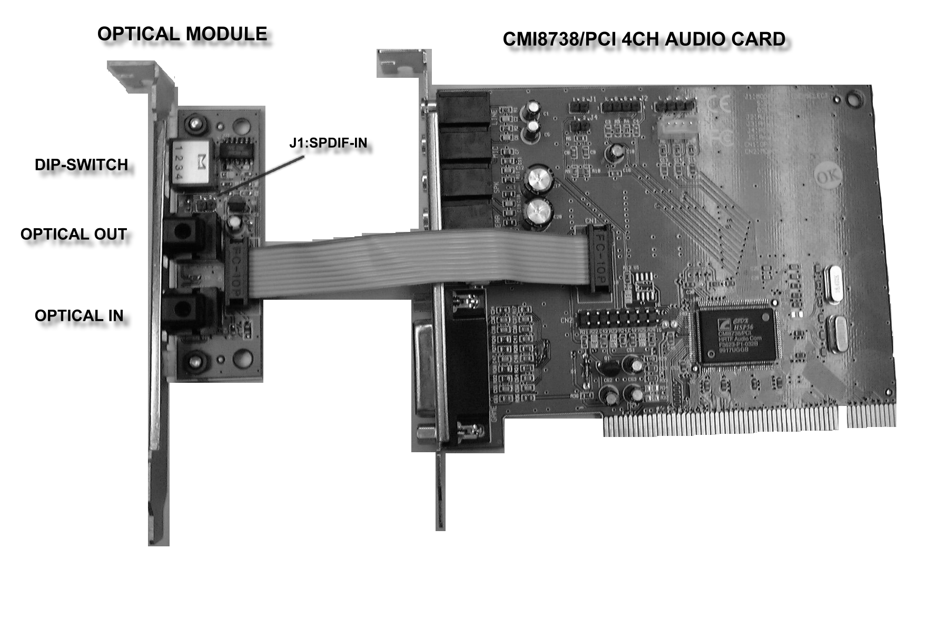
An example of optical kit is used to connect the 9BXAS,9ZXAS,9BXAS-A and the MD.
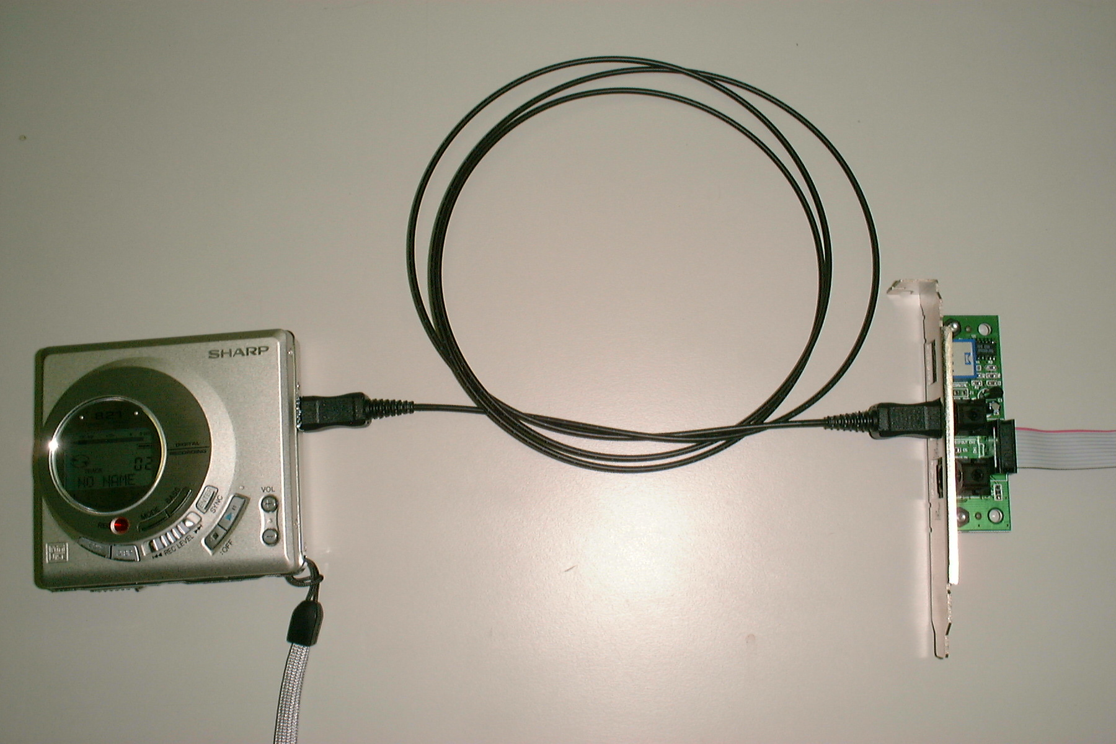
The application program setup(please install CMI8738 application program first)

When the connection is done, please go to the Start menu and select PCI Audio Applications\Audio Environment Setting
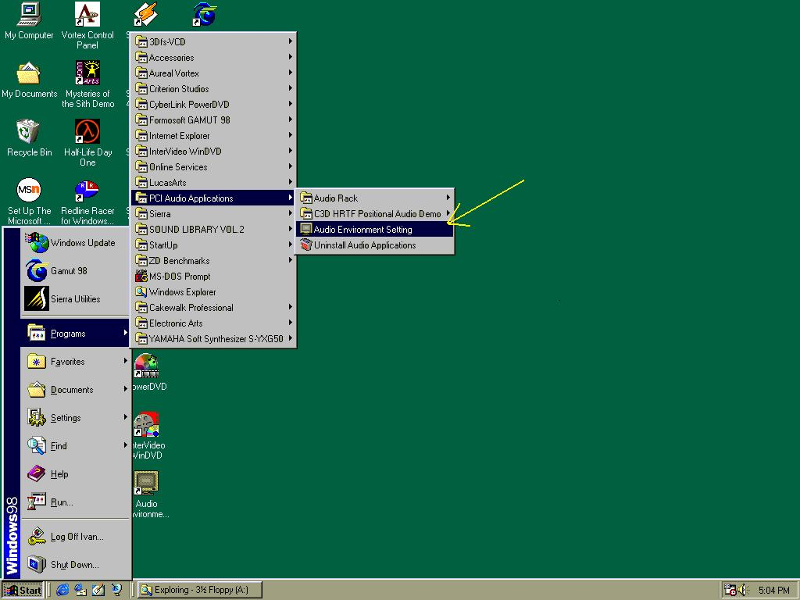
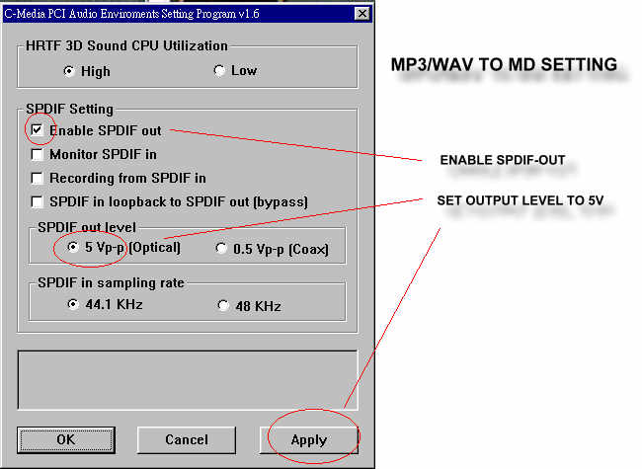
When all the procedures have been completed, there will be an infrared signal coming from the SPDIF/OUT of the optical fiber of the sound card.
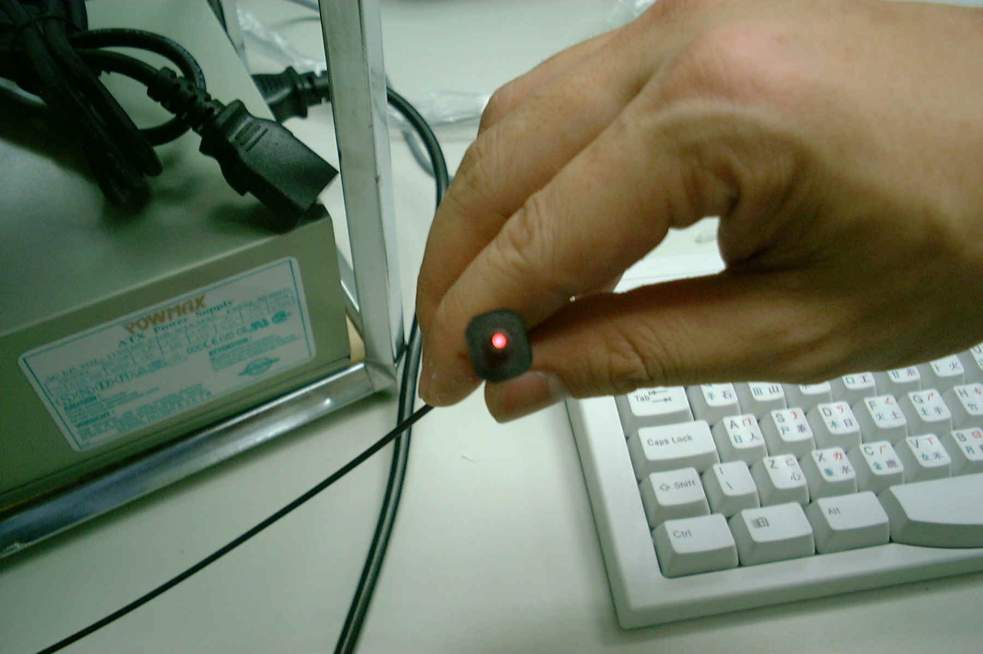
Please note that signal beam may cause severe damage to the eyes. For your safety, please point the output end to a piece of white paper to check if thebeam is in function.
Please connect the output signal to the MD input, then play the music via the MP3 player:
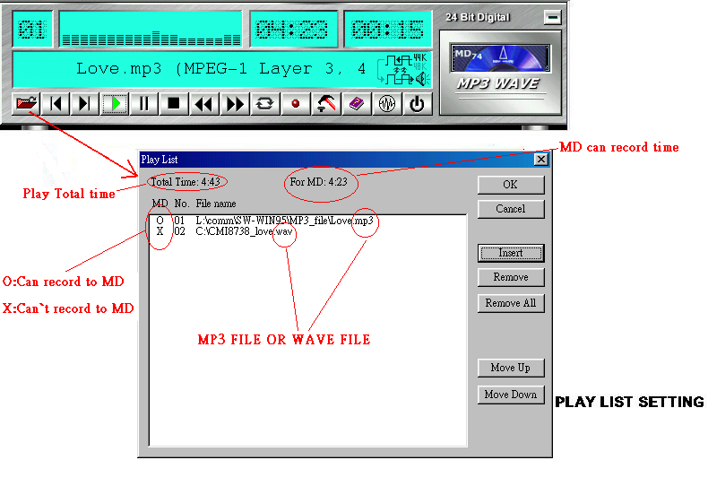
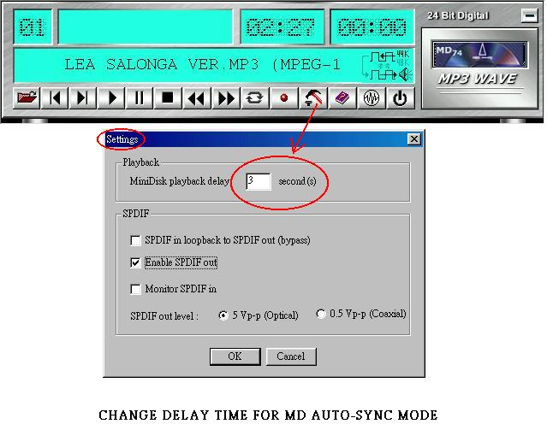
Please note that in playback, if there is no gap longer than three seconds between each track, the MD can not recognize the tracks and will record all of them into one. It is recommended that you set the gap time to 3~5 seconds to meet all type of MD requirements.

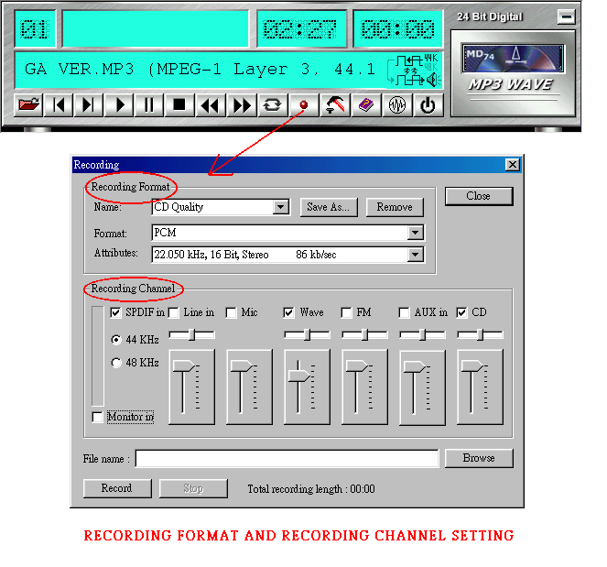
About Recording 24bit Audio Setting

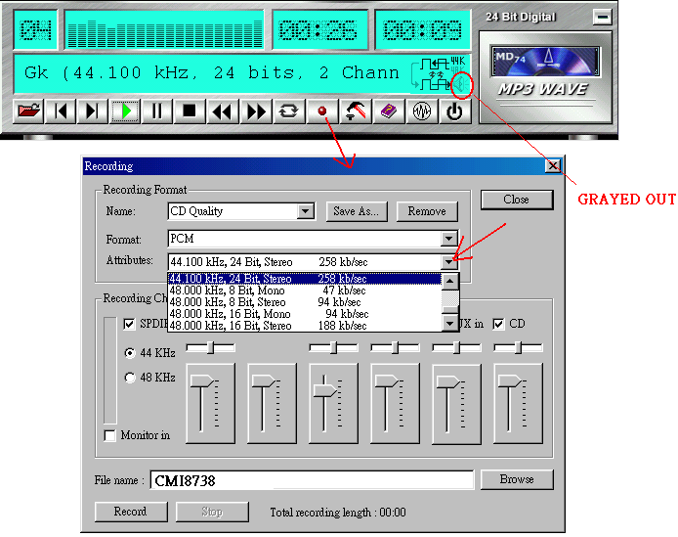

24-bit audio can only be applied to SPDIF IN/OUT mode; it does not apply to other modes such as the four channels or the analog. No sound will be heard while in playback, yet it can be recorded.

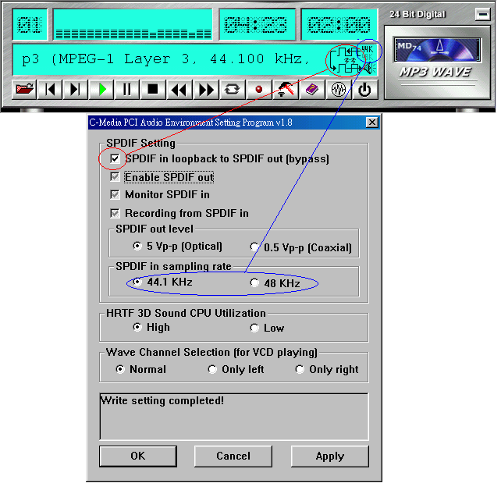
The un-selected area will be gray out.
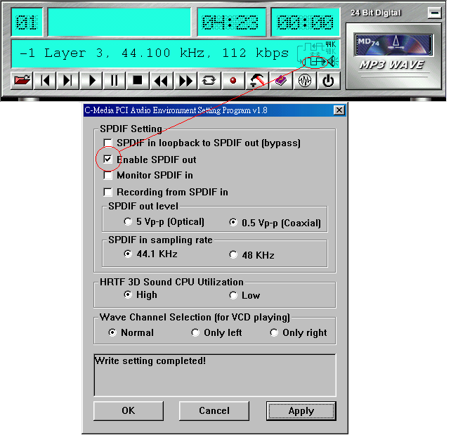
The un-selected area will be gray out.
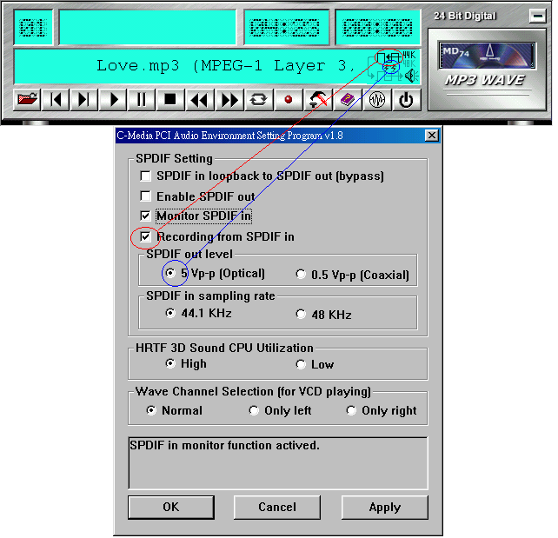
The un-selected area will be gray out.
You can double-click this circuit icon to have the following setting box. By means of this setting box, you can also complete the above-mentioned setting procedures.

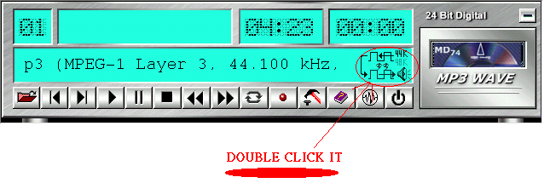
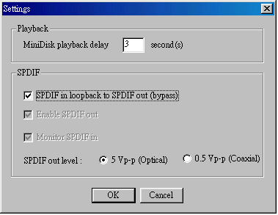
9BXAS,9ZXAS ,9BXAS-A SPDIF/IN
An example of Portable CD Player(Output) to optional Optical Kit (Optical Input)Setup
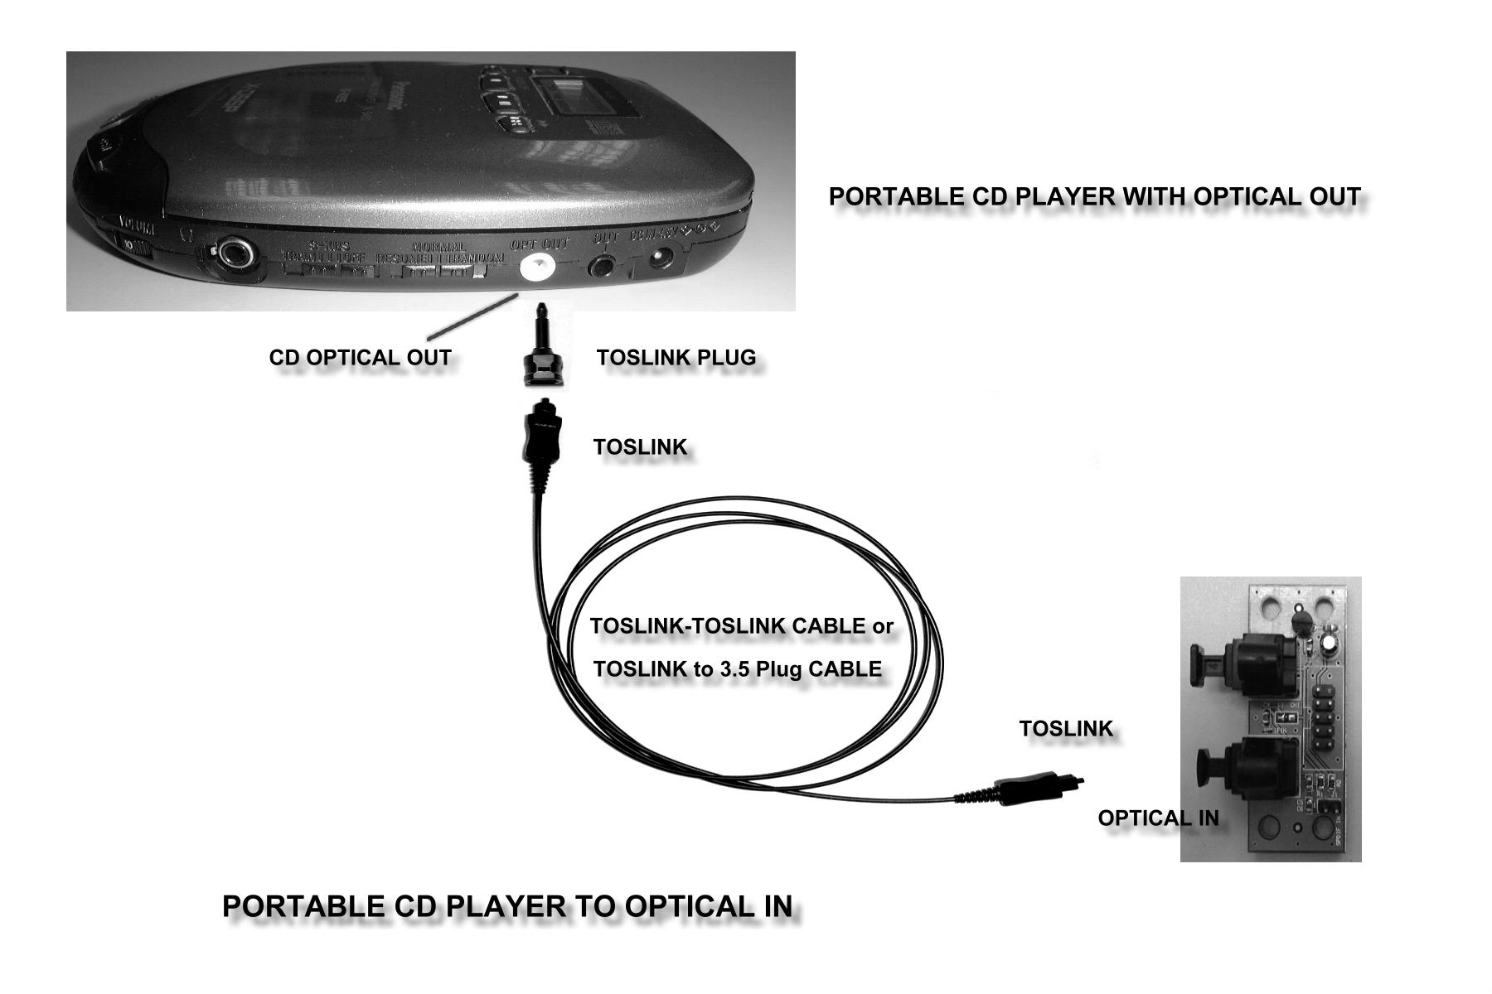

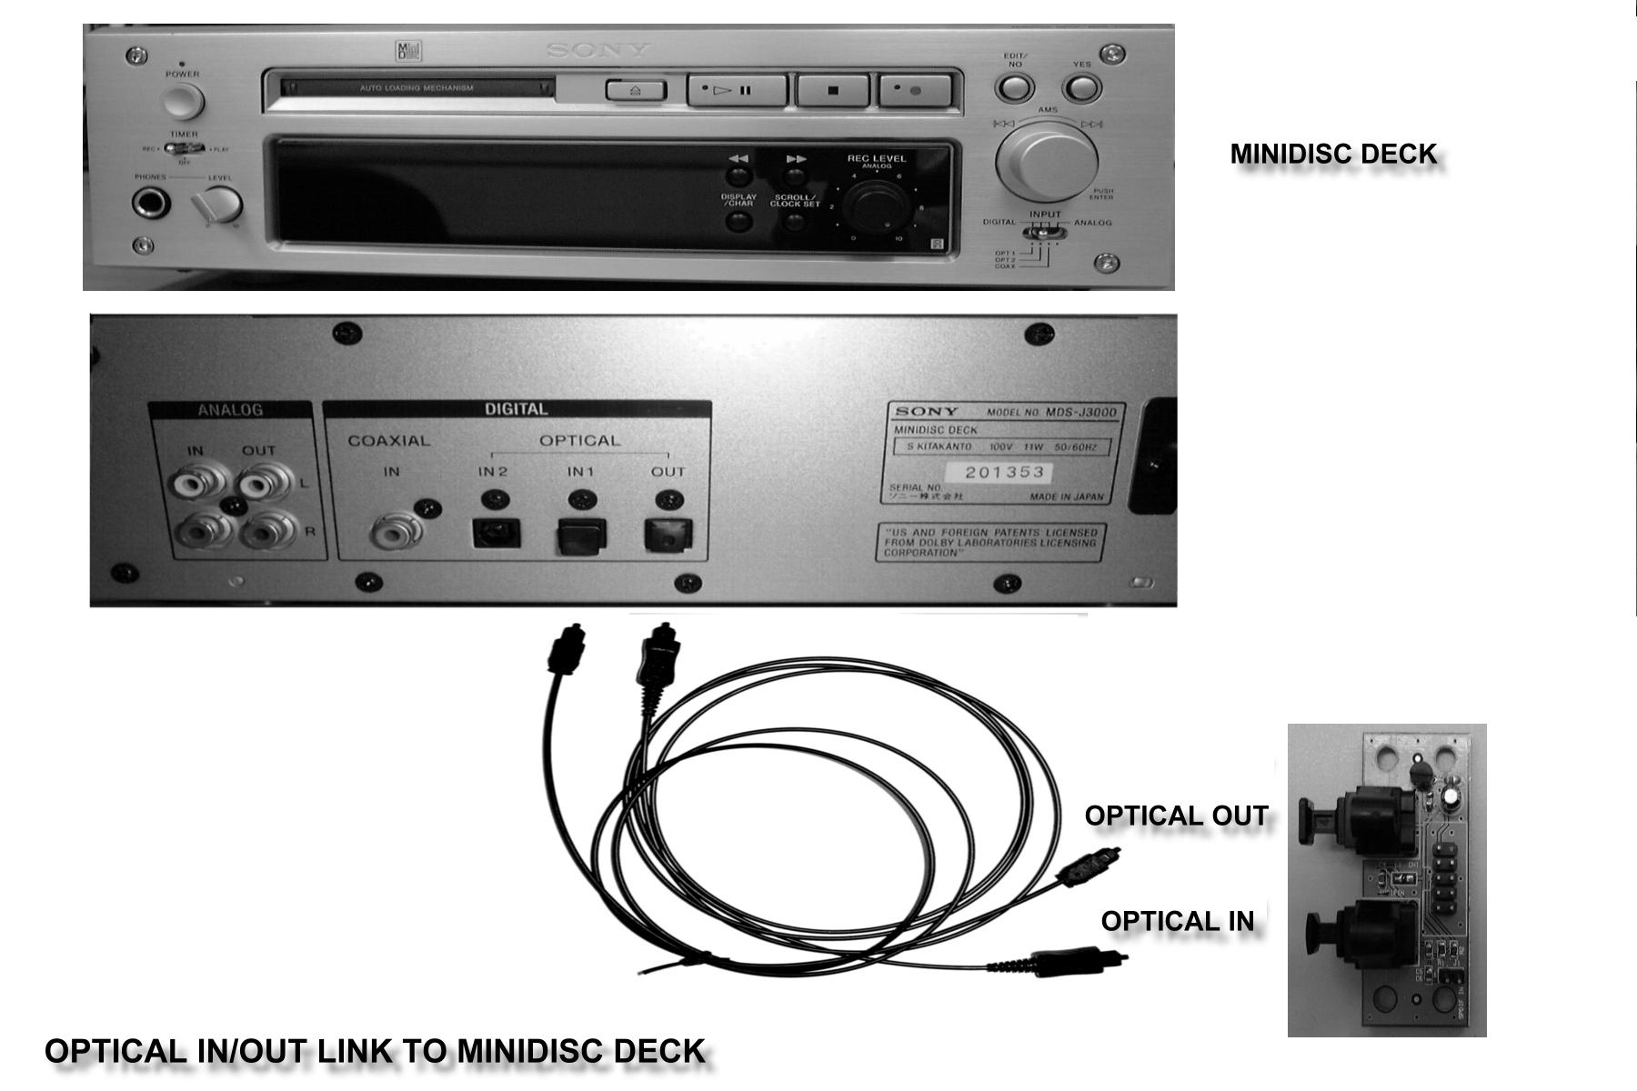

When the connection is done, please go to the Start menu and select PCI Audio Applications\Audio Environment Setting
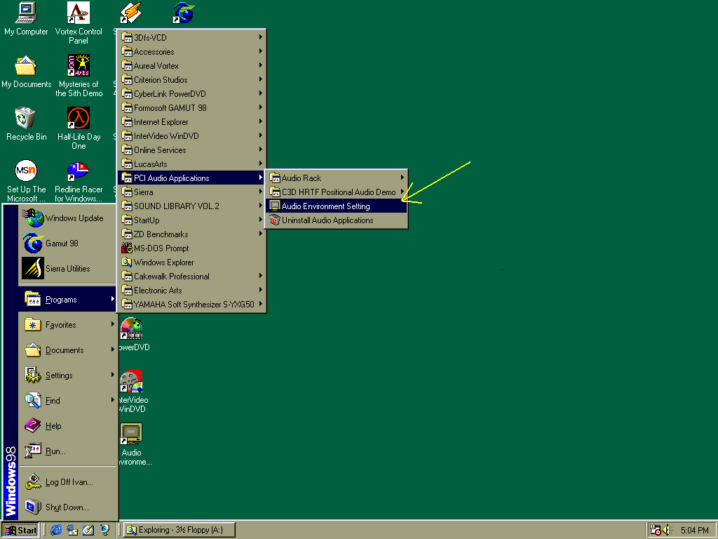
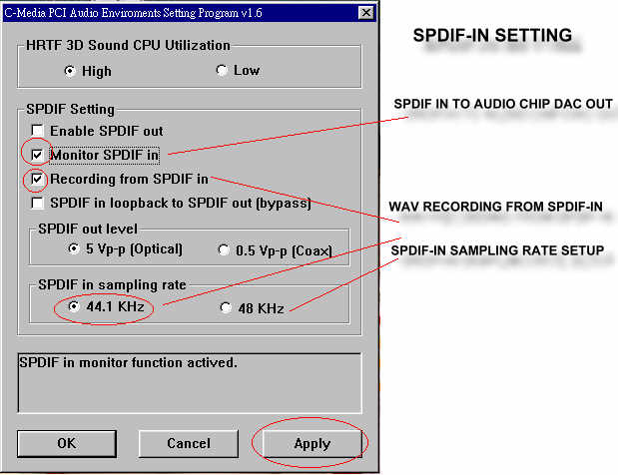

Loopback(bypass)mode setup
CD ROM (Digital Output) to optional Optical Kit (SPDIF/IN)Setup
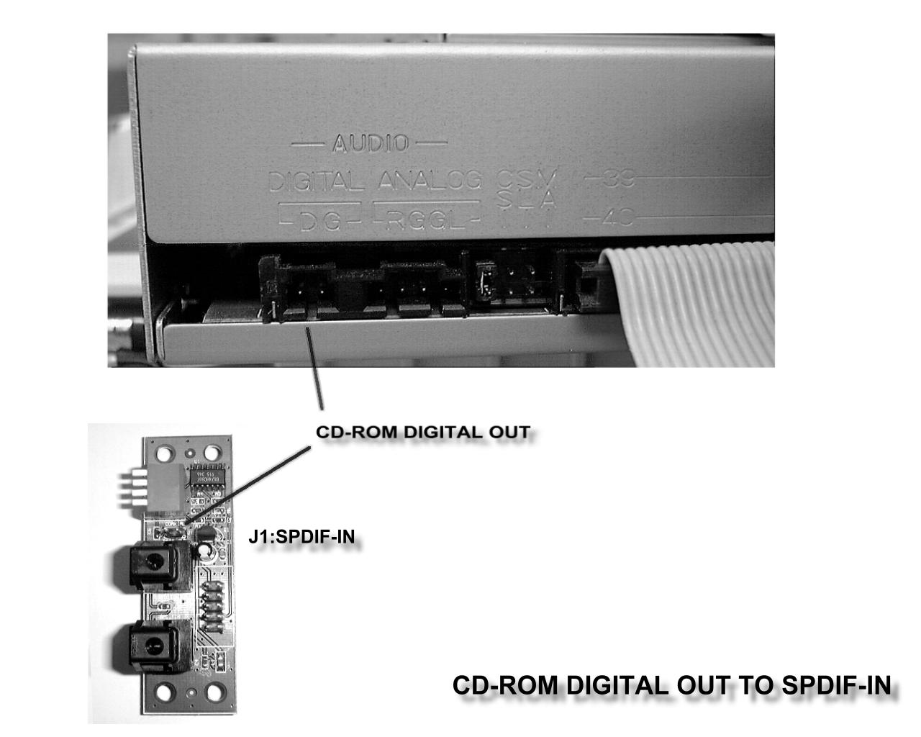
When the connection is done, please go to the Start menu and select PCI Audio Applications\Audio Environment Setting
Please follow these setting procedures.
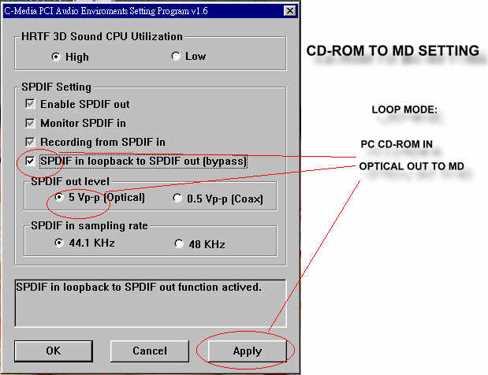
Now you can insert the CD into the CD ROM drive, then activate C-MEDIA CD player and push the ”play” button to do the recording job.

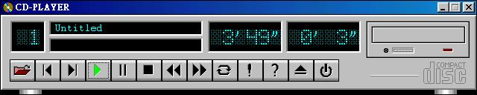

Please note that you have to set the MD in the simultaneous-recording mode.

Chapter 5

Quick Troubleshooting Guide
If the result of your diagnostic is “call service”, please have the following information ready before you contact for any technical support.
- The CPU (Central Processing Unit) you are using along with its require setting.
- BIOS version (The message on third line when you turn on your computer).
- General information about the hardware configuration (e.g. Modem, Video card, and any other Add-on device’s brand and model number, and system RAM type and chip brand).
- Complete description of the problem if possible (What actually happened to make you think the motherboard is the problem, any received error messages, at what point in the boot-up process, and any other information you think might help).

Troubleshooting Table
Problem Description | Diagnostic Procedure
No Screen Display after assembly or the system prematurely stops booting. | - Turn off your computer.  - Make sure you have properly connected all power cord and VGA card connector.  - Make sure both FDD & HDD’s cables are in correct direction at both ends.  - If you have UPS, make sure it has been turn on.  - Make sure your monitor switch is turn on, and its brightness & contrast are in the correct position.  - All add-on device (include CPU, Memory module) are properly attached into its slot.  - Make sure the CPU’s Bus Frequency is set to its correspond requirement.  - If the problem still exist after you turn on system power, please “call service”.
Can not install Windows95/98 | At this point, if you have any problem with OS installation. Please refer to OS installation guide for correspondence information.
Can not install correspond driver for relate device | - If your add-on device has PnP function, please make sure it has been correctly detected at system’s post period.  - Make sure there is nothing conflicts (use same IRQ).  - Remove any unnecessary driver that has previously installed in “Device Manager” under your OS.  - Re-install your device driver.
The system hangs up when running the program or OS | - If you just update the BIOS, please try clear the CMOS (refer to CMOS RAM Clear at page7).  - Check your fan(s) system, and make sure all of them worked correctly (e.g. does not contain any noise).

Chapter 6

Frequently Asked Questions and Answers
Q：The system will hang up when setting “CPU Host / PCI CLK – 133MHz/33Mhz”.
A：Please check your SDRAM, it must support 133MHz. You can not use PC 100 SDRAM to run 133MHz.

Q：Why the CPU temperature show NA when use Pentium II 266MHz CPU?
A：Because old CPU like Pentium II 233MHz, 266MHz do not have thermal diode inside CPU, therefore hardware can not detect the temperature. In newer CPU, they have the thermal diode inside the CPU; therefore system can read the temperature and display it in the BIOS.

Q： Why the motherboard can’t installed both Pentium II/III CPU and Socket 370 CPU together?
A：Because this M/B is design for single CPU. It can’t accept dual CPU at the same time.

Q：Can I disable the onboard sound controller?
A：Please set JP4 1-2 closed to disable onboard sound controller.

Q：What can I do after setting higher frequency in “CPU Host / PCI CLK” the system hang up (do no have display)?
A：Press and hold down “INS” key then turn on computer power (release “INS” key till the screen has display). Get into BIOS setup, and reset correct frequency.

Q：Why I can’t install Intel i740 AGP card’s driver in Windows95?
A：You have to install USB Supplemental Utility in Windows 95 before you can install i740 AGP card’s driver.

Q：Why I find memory conflict under “Device Manager” in Windows 95 when I check resource of display controller?
A：This is a bug of Windows 95. It has been solved in Windows 98.

Q：How to make your own logo in the BIOS?
A：
- You must have CBROM.EXE file (You can find it from Driver Pack CD or download it from our website at www.jetway.com.tw).
- Make your own logo file by “Bitmap” format. The dimension limit is 640 x 464 x 16 color.
- Save your system BIOS data to a binary file by using AWDFLASH.EXE utility or download new BIOS file from our website.
- Execute CBROM xxxx.bin /LOGO xxxx.bmp
xxxx.bin is the BIOS file which you saved or download from our website.
xxxx.bmp is the bitmap file which you made and intent to add into BIOS.
- After execute the above instruction the new BIOS will combine the logo file into xxxx.bin. At this moment, you can use AWDFLASH.EXE utility to flash this file as your new BIOS.

Q：What’s the BIOS flash procedure (Upgrade BIOS)?
A：
- Make a DOS boot able disk (just for boot up, do not contain EMM386.exe or any similar program).
- Put the BIOS (xxxx.bin) and its flash utility at same bootable disk.
- After you boot up the system, at “A：\” prompt, type in
awdflash xxx.bin/sn/py/r/cc.
- After you boot up by disk, computer should ask press DEL to get into BIOS setup.
- Once you are in the BIOS setup, choose "LOAD SETUP DEFAULTS".

