6ABX2
MAIN BOARD
ATX FORM FACTOR
USER'S MANUAL
( VER : 1.0 )

COPYRIGHT
THIS MANUAL AND THE INFORMATION CONTAINED HEREIN ARE PROTECTED BY COPYRIGHT. ALL RIGHTS RESERVED.

WARNING AND DISCLAIMER
THIS MANUAL IS DESIGNED TO PROVIDE INFORMATION ABOUT THE PENTIUM® II SYSTEM BOARD. EVERY EFFORT HAS BEEN MADE TO MAKE THIS MANUAL AS ACCURATE AS POSSIBLE, BUT NO WARRANTY OR FITNESS IS IMPLIED. ALL THE INFORMATIONS ARE PROVIDED ON AN 'AS IS' BASIS. THE AUTHOR AND HIS CORRESPONDING PUBLISHING COMPANY SHALL HAVE NEITHER LIABILITY NOR RESPONSIBILITY TO ANY PERSON OR ENTITY WITH RESPECT TO ANY LOSS OR DAMAGES ARISING FROM THE INFORMATION CONTAINED IN THIS MANUAL OR FROM THE USE OF THE SYSTEM BOARD THAT ACCOMPANIES IT. INFORMATION CONTAINED IN THIS MANUAL IS SUBJECT TO CHANGE WITHOUT NOTICE. THE MANUFACTURER OF THE SYSTEM BOARD WILL NOT BE HELD RESPONSIBLE FOR TECHNICAL OR EDITORIAL OMISSIONS MADE HEREIN, NOR FOR THE INCIDENTAL OR CONSEQUENTIAL DAMAGES RESULTING FROM ITS FURNISHING, PERFORMANCE, FUNCTIONALITY OR USE. SUBSEQUENT CHANGES TO THIS MANUAL WILL BE INCORPORATED INTO THE NEXT EDITION. WE WELCOME ANY SUGGESTION REGARDING THIS MANUAL OR OUR COMPUTER PRODUCTS.

TRADEMARKS
ALL TRADEMARKS ARE THE PROPERTY OF THEIR RESPECTIVE OWNERS.

TABLE OF CONTENTS

CHAPTER 1. INTRODUCTION 1
1-1 OVERVIEW 1
1-2 UNPACKING 2

1-3 SPECIFICATIONS 2
1-4 QUICK REFERENCE FOR CD SOFTWARE DRIVERS 3

CHAPTER 2. INSTALLATION 4
2-1 LAYOUT REFERENCE 4
2-2 JUMPER SETTINGS 5
2-3 DIMM INSTALLATION PROCEDURE S 7
2-4 MEMORY SIZE 8
2-5 CPU RM KIT ASSEMBLING PROCEDURES 9

CHAPTER 3. BIOS SETUP 11
3-1 AWARD BIOS CMOS SETUP 11
3-2 STANDARD CMOS SETUP 12
3-3 BIOS FEATURES SETUP 13
3-4 CHIPSET FEATURES SETUP 16
3-5 POWER MANAGEMENT SETUP 18
3-6 PNP/PCI CONFIGURATION SETU P 20
3-7 INTEGRATED PERIPHERALS 21
3-8 SUPERVISOR/USER PASSWORD 23
3-9 IDE HDD AUTO DETECTION 24
3-10 LOAD SETUP DEFAULTS 26
3-11 SAVE & EXIT SETUP 26
3-12 EXIT WITHOUT SAVING 26
3-13 I/O & MEMORY MAP 27
3-14 TIME & DMA CHANNELS MAP 29
3-15 INTERRUPT MAP 29
3-16 RTC & CMOS RAM MAP 30

CHAPTER 1: INTRODUCTION

1-1 OVERVIEW :

THE I440 BX MAIN BOARD IS DESIGNED WITH INTEL® 82440BX AGPSET WHICH PROVIDES AN INTEGRATED IDE CONTROLLER WITH TWO HIGH PERFORMANCE IDE INTERFACES FOR UP TO FOUR IDE DEVICES ( HARD DEVICES , CD-ROM DEVICES , ETC ), AND USB ( UNIVERSAL SERIAL BUS ) FEATURES ENHANCE THE OVERALL PE7RFORMANCE AND EXTENSION FOR THIS BOARD.

IT SUPPORTS INTEL® PENTIUM® II CPUS FAMILY RUNNING AT 233-450 MHZ SPEED, OR EVEN HIGHER SPEED, WHICH IS IDEAL FOR MS-DOS, WINDOWS, WINDOWS 95, WINDOW NT, NOVELL, OS/2, UNIX…

THE PERFORMANCE, SPEED AND EXTENSIBILITY OF I440BX MAIN BOARD MAKE IT THE PERFECT CHOICE FOR BUILDING A LAN SERVER, A HIGH-END WORKSTATION OR A MULTI-USER SYSTEM.

1-2 UNPACKING :

THE MAIN BOARD PACKAGE CONTAINS:
* I440BX MAIN BOARD
* MANUAL
* CABLES
* RETENTION MODULES

IF ANY OF THESE ITEMS IS MISSING OR DAMAGED,CONTACT THE DEALER FROM WHOM YOU PURCHASED. LEAVE THE I440BX MAIN BOARD IN ITS ORIGINAL PACKING UNTIL YOU ARE READY TO INSTALL IT.

1-3 SPECIFICATIONS

: 233 - 450 MHZ INTEL® PENTIUM® II CPU
CPU

: 3 OF 168-PIN DIMM UP TO 384MB , 3.3V
MEMORY

EXP.SLOT
: ISA SLOTS X3, PCI SLOTS X4, A.G.P. SLOT X1
CHIPSET
: INTEL® I440 BX CHIPSET
INTEL® 82443BX PCI AND A.G.P CONTROLLER
INTEL® 82371EB I/O BRIDGE
BIOS
: AWARD® FULL PNP (PLUG & PLAY) BIOS

: ON BOARD 2 X PCI IDE DEVICES , 1 X FDC , 2 X
I/O FUNCTION
SERIAL PORTS(16550 FAST COM),1X PARALLEL
PORT DEVICE /EPP/ECP, USB CONNECTOR , IR
CONNECTOR
BOARD SIZE
: 30.5 CM X 21 CM.

: COMPLIED WITH APM (ADVANCED POWER
GREEN FUNCTION
MANAGEMENT).
SPECIAL FUNCTION
: LM78 SUPPORTS HARDWARE
MONITORING IS OPTIONAL.

POWER CONNECTOR
: ATX POWER CONNECTOR

SB-LINK
: CREATIVE® “SB-LINK”

1-4 QUICK REFERENCE FOR CD SOFTWARE DRIVERS

THIS CD CONTAINS DRIVERS AS BELOW:

- MAIN BOARDS: I440BX®, I440EX®, I440LX®, I430TX®, VIA® VPX, VP3 MAIN BOARDS
- AGP CARDS: S- 6326 AND T985
- SOLO-1: ESS-SOLO-1 SOUND DRIVER
- GL518SM: CPU VOLTAGE /TEMPERATURE AND FAN SPEED DETECTION SOFTWARE
E. PCCILLIN: ANTI- VIRUS PROTECTION SOFTWARE
PLEASE READ “INDEX” BEFORE INSTALLING REQUIRED DRIVERS. “INDEX” OFFERS ALL THE INFORMATION ON THE BELOW FILES.

CHAPTER 2. INSTALLATION

2-1 LAYOUT REFERENCE
CPUFA1
1
JBAT1
1
JRMS1

SLOT 1
DIMM1
DIMM2
DIMM3
AGP
SLOT
USB1
KB1
I/O
1 6

3 4
BIOS
1
JMDM1
INTEL®
FW82371EB
SYSFA1
J4
IDE2
IDE1
JWOL1
JPC1
1
ISA1
ISA3
ISA2
PCI 3
PCI 2
PCI 1
PCI 4
SPEAKER
RESET
TB-LED

IDE LED
COM1 COM2
PRINTER
IR1
82443BX
SB-LINK
ATX
UPPER LAYER: PS2 MOUSE
LOWER LAYER: KEYBOARD

JRMS1

SUSPEND SW

KEYLOCK

2-2 JUMPER SETTINGS

- SETTING “CPU SPEED“
SW1: CPU SPEED SELECTOR
CPU SPEED | CLOCK SPEED | RATIO | SW1
PENTIUM® II 233MHZ  1 2 3 4  1 2 3 4  1 2 3 4  1 2 3 4  ON  1 2 3 4 | 66MHZ | 3.5X
PENTIUM® II 350MHZ | 100MHZ | 3.5X
PENTIUM® II 266MHZ  ON | 66MHZ | 4X
PENTIUM® II 400MHZ | 100MHZ | 4X
PENTIUM® II 300MHZ  ON | 66MHZ | 4.5X
*PENTIUM® II 450 MHZ | 100MHZ | 4.5X
PENTIUM® II 333 MHZ  ON | 66MHZ | 5X
*PENTIUM® II 500 MHZ | 100MHZ | 5X
PENTIUM® II 366 MHZ  ON | 66MHZ | 5.5X
*PENTIUM® II 550 MHZ | 100MHZ | 5.5X

*PENTIUM® II 450MHZ / 500 MHZ / 550 MHZ ARE FOR REFERENCE ONLY AS THEY
ARE NOT AVAILABLE WHEN THIS MANUAL IS PUBLISHED.

2. JBAT1: RTC - BATTERY SELECTOR
 | NORMAL | CLEAR CMOS
RTC | 1-2 (NORMAL) | 2-3(DEFAULT)
 CUSTOMERS NEED TO CLEAR CMOS, THEN RECONFIGURE
IT IF FORGET PASSWORD FOR BIOS SETUP.

3. JRMS1: ATX POWER SWITCH
THE SYSTEM POWER IS CONTROLLED BY A MOMENTARY SWITCH (WHEN "POWER SWITCH TYPE" IS SET TO MOMENTARY) CONNECTED TO THIS LEAD. PUSHING THE BUTTON ONCE WILL TURN ON THE SYSTEM AND PUSHING ANOTHER TIME WILL TURN OFF THE SYSTEM.
THE SYSTEM POWER LED SHOWS THE STATUS OF THE SYSTEM'S POWER. THIS CONNECTION DOES NOT HAVE A FUNCTION WHEN A STANDARD POWER SUPPLY IS USED.

4. IR1 : IR (INFRARED) CONNECTOR
IR CONNECTOR PIN OUT
PIN 1 RX | PIN 2 GND | PIN 3 TX | PIN 4  +5V | PIN 5  RXH | PIN 6  VCC | PIN 7  GND
NOTE : IR1 USES THE SAME I/O PORT AS COM2. THERE IS NO ANY
HARDWARE JUMPER SETTING FOR IRCON/COM2 ON THIS
MAIN BOARD BUT CUSTOMERS NEED TO SET PROPER BIOS
SETTING FOR "IRDA1.0","ASKIR" OR "STANDARD"(DEFAULT)
UNDER "INFRA RED (IR) FUNCTION" OF "INTEGRATED
PERIPHERALS."

5. OTHER JUMPER SETTINGS AND CONNECTORS :
IDE1 : PRIMARY IDE CONNECTOR
IDE2 : SECONDARY IDE CONNECTOR
J4 : FLOPPY DISK CONNECTOR
COM1 : SERIAL PORT 1 CONNECTOR.
COM2 : SERIAL PORT 2 CONNECTOR.
KB1 : PS/2 KEYBOARD/MOUSE CONNECTOR.
USB1 : USB (UNIVERSAL SERIAL BUS) CONNECTOR
JMDM1 : INTERNAL MODEM RING ON CONNECTOR
JPC1 : CASE CONNECTOR
CPUFA1 : CPU FAN CONNECTOR
SYSFAN : SYSTEM, (CASE) FAN CONNECTOR
J5 : SB-LINK CONNECTOR
JWOL1 : WAKE ON LAN CONNECTOR

2-3 DIMM MEMORY INSTALLATION PROCEDURES

INSERT THE MODULE AS SHOWN. DUE TO DIFFERENT NUMBER OF PINS ON EITHER SIDE OF THE BREAKS, THE MODULE WILL ONLY FIT IN THE ORIENTATION AS SHOWN. DRAM SIMM MODULES HAVE THE SAME PIN CONTACT ON BOTH SIDES. SDRAM DIMM MODULES HAVE DIFFERENT PIN CONTACTSS ON EACH SIDE AND THEREFORE HAVE A HIGHER PIN DENSITY.

NOTE: DIMM SUPPORTS 3.3V SDRAM ONLY.

20 pins
60 pins
84 pins
DIMM

2-4 MEMORY SIZE

THE MOTHER BOARD SUPPORTS 168-PIN DIMMS OF 8MB, 16MB, 32MB, 64MB, 128MB TO FORM A MEMORY SIZE BETWEEN 8MB TO 384MB.

NOTE: DIMM SUPPORTS 3.3V SDRAM ONLY. SINCE THERE ARE VARIOU WAYS OF DIMM INSTALLATIONS, THE FOLLOWING IS ONLY FOR REFERENCES ONLY. THERE ARE STILL OTHER WAYS TO PUT DIMMS ON DIFFERENT SOCKETS.

TOTAL | DIMM1 DIMM2 DIMM3
8MBYTES | 8MB --- ---
16MBYTES | 8MB 8MB ---
24MBYTES | 8MB 8MB 8MB
32MBYTES | 8MB 8MB 16MB
32MBYTES | 16MB 16MB ---
32MBYTES | 32MB --- ---
40MBYTES | 16MB 16MB 8MB
48MBYTES | 16MB 16MB 16MB
64MBYTES | 64MB --- ---
64MBYTES | 32MB 32MB ---
96MBYTES | 32MB 32MB 32MB
128MBYTES | 64MB 64MB ---
128MBYTES | 128MB --- ---
192MBYTES | 64MB 64MB 64MB
256MBYTES | 128MB 128MB ---
384MBYTES | 128MB 128MB 128MB

2-5 CPU RM KIT ASSEMBLING PROCEDURE

THE ENCLOSED RM KIT IS THE LATEST MODEL SUITABLE FOR BOTH KLAMATH AND CELERON. IT IS NOT NECESSARY TO CHANGE DIFFERENT CPU RM KITS FOR DIFFERENT CPU MODELS.

- CHECK IF THE FOLLOWING SET OF PIECE PARTS ARE INCLUDED IN YOUR PACKAGE. 4 SEPERATE PIECE PARTS IN TOTAL.

RETENTION MECHANISM (R.M.): 2 PCS

screw
Front side
Back side
Lock for Klamath™
Lock for Celeron™

RM. ATTACH MOUNT (RMAM): 2 PC

2. MAKE SURE POWER IS OFF DURING ASSEMBLY.

3. INSERT THE RMAMS THROUGH THE BOTTOM OF THE MOTHERBOARD AND ATTACH THEM TO THE RETENTION MECHANISM.

6P2BX

5. FASTEN UP THE SCREWS ON THE RETENTION MECHANISM TO TIGHTEN UP RETENION MECHANISM AND RMAM. CHECK IF ALL THE PIECE PARTS ARE FASTENED TIGHTLY.

- PUT THE CPU IN THE RM KIT. (PUSH THE CPU INTO THE RM KIT HORIZONTALLY.)

DUE TO DIFFERENT PACKAGES OF CELERON AND KLAMATH, THERE ARE 2 LOCATIONS TO GET THEM LOCKED IN THE RM KIT. BELOW IS NTOICE TO UNLOCK THE 2 CPUS.
Lock for Klamath
Lock for Celeron
***Klamath™: push the switch on the CPU, and CPU will be loosen from the lock of RM kit.

***Celeron™: use screw driver or any tool alike to draw this and hold. At the same time, softly pull one side of the CPU out. Then, pull the other side and CPU will be loosen this way.

CHAPTER 3. BIOS SETUP

3-1. AWARD BIOS CMOS SETUP

THE MENU DISPLAYS ALL THE MAJOR SELECTION ITEMS AND ALLOW USER TO SELECT ANY ONE OF SHOWN ITEM. THE SELECTION IS MADE BY MOVING CURSOR( PRESS ANY DIRECTION KEY ) TO THE ITEM AND PRESS <ENTER> KEY. AN ON-LINE HELP MESSAGE IS DISPLAYED AT THE BOTTOM OF THE SCREEN AS CURSOR IS MOVING TO VARIOUS ITEMS WHICH PROVIDES USER BETTER UNDERSTANDING OF EACH FUNCTION. WHEN A SELECTION IS MADE, THE MENU OF SELECTED ITEM WILL APPEAR. SO THE USER CAN MODIFY ASSOCIATED CONFIGURATION PARAMETERS.
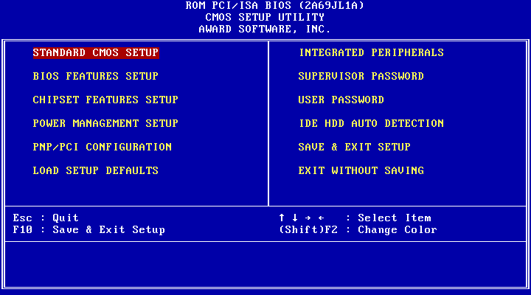

3-2. STANDARD CMOS SETUP

CHOOSE "STANDARD CMOS SETUP" IN THE CMOS SETUP UTILITY MENU. THE STANDARD CMOS SETUP ALLOWS USER TO CONFIGURE SYSTEM SETTING SUCH AS CURRENT DATE AND TIME, TYPE OF HARD DISK DRIVE INSTALLED IN THE SYSTEM, FLOPPY DRIVE TYPE, AND THE TYPE OF DISPLAY MONITOR. MEMORY SIZE IS AUTO DETECTED BY THE BIOS AND DISPLAYED FOR YOUR REFERENCE. WHEN A FIELD IS HIGHLIGHTED (DIRECTION KEYS TO MOVE CURSOR AND <ENTER> KEY TO SELECT). THE ENTRIES IN THE FIELD WILL BE CHANGED BY PRESSING <PAGEDOWN> OR <PAGEUP> KEY OR USER CAN ENTER NEW DATA DIRECTLY FROM THE KEYBOARD.

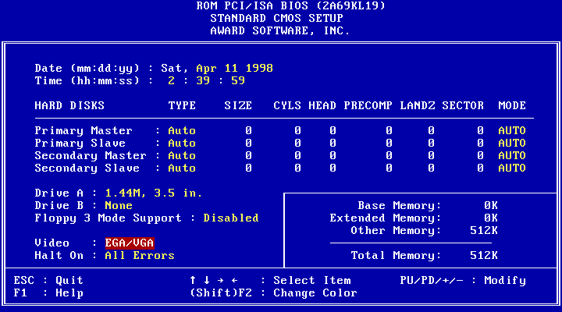

NOTE: IF HARD DISK PRIMARY MASTER/SLAVE AND SECONDARY MASTER/SLAVE WERE USED AUTO, THEN THE HARD DISK SIZE AND MODEL WILL BE AUTO DETECTED ON DISPLAY DURING POST.

NOTE: THE "HALT ON:"FIELD IS TO DETERMINE WHEN TO HALT THE SYSTEM BY THE BIOS IF ERROR OCCURRED DURING POST.

3-3. BIOS FEATURES SETUP

SELECT THE "BIOS FEATURES SETUP" OPTION IN THE CMOS SETUP UTILITY MENU ALLOWS USER TO CHANGE SYSTEM RELATED PARAMETERS IN THE DISPLAYED MENU. THIS MENU SHOWS ALL OF THE MANUFACTURER'S DEFAULT VALUES OF I440BX MAIN BOARD. AGAIN, USER CAN MOVE THE CURSOR BY PRESSING DIRECTION KEYS AND <PAGEDOWN> OR <PAGEUP> KEY TO MODIFY THE PARAMETERS, PRESSING [F1] KEY TO DISPLAY HELP MESSAGE OF THE SELECTED ITEM. THIS SETUP PROGRAM ALSO PROVIDE 2 CONVINENT WAYS TO LOAD THE DEFAULT PARAMETER DATA FROM BIOS [F6] OR CMOS [F7] AREA IF SHOWN DATA IS CORRUPTED. THIS PROVIDES THE SYSTEM A CAPABILITY TO RECOVER FROM ANY POSSIBLE ERROR.

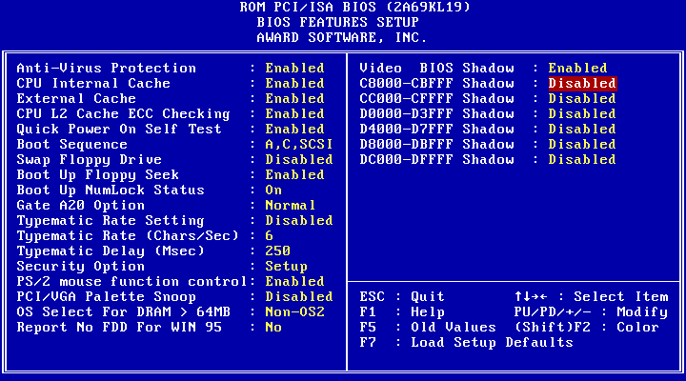

ANTI-VIRUS PROTECTION :
THE OPTION IS AN AUTO ANTI-VIRUS PROTECTION, WHICH AUTOMATICALLY SEARCH FOR DISK VIRUS.
ENABLED: THE SYSTEMS WILL START AUTO ANTI-VIRUS PROTECTION.
DISABLED: THE FUNCTION WILL NOT WORK.

CPU EXTERNAL CACHE:
THIS OPTION SELECTS THE TYPE OF CACHING ALGORITHM USED BY BIOS AND THE COMPUTER FOR L2 (EXTERNAL) SECONDARY CACHE MEMORY. THE SETTINGS ARE ENABLED OR DISABLED.
ENABLED: ENABLE CACHE
DISABLED: DISABLE CACHE

EXTERNAL CACHE:
THIS OPTION SELECTS THE TYPE OF CACHING ALGORITHM USED BY BIOS AND THE COMPUTER FOR L2 (EXTERNAL) SECONDARY CACHE MEMORY. THE SETTINGS ARE ENABLED OR DISABLED.
ENABLED: ENABLE CACHE

QUICK POWER ON SELF TEST:
THIS CATEGORY SPEEDS UP POWER ON SELF TEST. (POST) AFTER YOU POWER ON THE COMPUTER, IF IT IS SET TO ENABLE, BIOS WILL SHORTEN OR SKIP SOME CHECK ITEMS DURING POST.
ENABLE : ENABLE QUICK POST
DISABLED: NORMAL POST

BOOT SEQUENCE:
THIS CATEGORY DETERMINES WHICH DRIVE COMPUTER SEARCHES FIRST FOR THE DOS (DISK OPERATING SYSTEM). DEFAULT VALUE IS A,C.
A,C: SYSTEM WILL FIRST SEARCH FOR FLOPPY DISK DRIVE THEN
HARD DISK DRIVE.
C,A: SYSTEM WILL FIRST SEARCH FOR HARD DISK DRIVE THEN
FLOPPY DISK DRIVE.

SWAP FLOPPY DRIVE:
THE SWAP FLOPPY DRIVE. DEFAULT VALUE IS DISABLED. ENABLED: FLOPPY A&B WILL BE SWAPPED UNDER THE DOS DISABLED: FLOPPY A&B WILL BE NOT SWAPPED.

BOOT UP FLOPPY SEEK:
DURING POST, BIOS WILL DETERMINE IF THE FLOPPY DISK DRIVE INSTALLED IS 40 OR 80 TRACKS. 360K TYPE IS 40 TRACKS WHILE 720K, 1.2M AND 1.44M ARE ALL 80 TRACKS. THE DEFAULT VALUE IS ENABLED.

BOOT UP NUMLOCK STATUS:
THE DEFAULT VALUE IS ON.
ON: KEYPAD IS NUMBER KEYS.
OFF: KEYPAD IS ARROW KEYS.

BOOT UP SYSTEM SPEED:
IT SELECTS THE DEFAULT SYSTEM SPEED-THE SPEED THAT THE SYSTEM WILL RUN AT IMMEDIATELY AFTER POWER UP.
HIGH: SET THE SPEED TO HIGH.
LOW: SET THE SPEED TO LOW.

VIDEO BIOS SHADOW:
IT DETERMINES WHETHER VIDEO BIOS WILL BE COPIED TO RAM, HOWEVER, IT IS OPTIONAL FROM CHIPSET DESIGN. VIDEO SHADOW WILL INCREASE THE VIDEO SPEED.
ENABLED : VIDEO SHADOW IS ENABLED
DISABLED: VIDEO SHADOW IS DISABLED

C8000-CBFFF SHADOW:
CC000-CFFFF SHADOW:
D0000-D3FFF SHADOW:
D4000-D7FFF SHADOW:
D8000-DBFFF SHADOW:
DC000-DFFFF SHADOW:

THESE CATEGORIES DETERMINE WHETHER OPTIONAL ROM WILL BE COPIED TO RAM BY 16K BYTE OR 32K BYTE PER/UNIT AND THE SIZE DEPENDS ON CHIPSET.
ENABLED : OPTIONAL SHADOW IS ENABLED.
DISABLED: OPTIONAL SHADOW IS DISABLED.

3-4. CHIPSET FEATURES SETUP

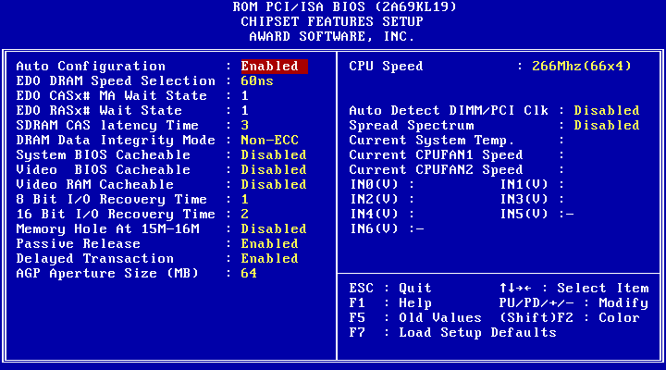

AUTO CONFIGURATION [THE BIOS WILL AUTOMATICALLY DETECT THE CPU SPEED AND WILL AUTO-CONFIGURATE THE BUS FREQUENCY, DRAM SPEED, CACHE AND READ/WRITE CYCLE.]

DRAM RAS# PRECHARGE TIME [THE DRAM PRECHARGE TIME BY RAS.]
: 4
: 3 (DEFAULT)

RAS TO CAS DELAY [CONTROL THE DRAM PAGE MISS AND ROW MISS LEADOFF TIMING.]
: 2
: 3 (DEFAULT)

DRAM READ BURST (B/E/F) [THE TIMING USED DEPENDS ON THE TYPE OF DRAM ON A PER-BASIS. THE DRAM READ BURST TIMING ARE CONTROLLED BY REGISTER.]
: X2222
: X3333
: X4444 (DEFAULT)

DRAM WRITE BURST (B/E/F) [SLOWER RATE MAY BE REQUIRED IN CERTAIN SYSTEM DESIGNS TO SUPPORT LAYOUT WITH LONGER TRACE LENGTH OR SLOWER DRAM. THE DRAM WRITE BURST TIMING ARE CONTROLLED BY REGISTER.]
: X2222
: X3333
: X4444 (DEFAULT)

SYSTEM BIOS CACHEABLE [DEFINE WHETHER SYSTEM BIOS AREA CACHEABLE OR NOT.]
:ENABLED
:DISABLED (DEFAULT)

VIDEO BIOS CACHEABLE [DEFINE WHETHER VIDEO BIOS AREA CACHEABLE OR NOT.]
:ENABLED
:DISABLED (DEFAULT)

8 BIT I/O RECOVERY TIME:
THIS FIELD DEFINES THE RECOVERY TIME FROM 1 TO 8 FOR 8-BIT I/O.

16 BIT I/O RECOVERY TIME:
TO DEFINE THE RECOVERY TIME FROM 1 TO 4 FOR 16-BIT I/O.

MEMORY HOLE AT 15M-16M [THIS FIELD ENABLE A MEMORY HOLE IN MAIN MEMORY SPACE. CPU CYCLES MATCHING AN ENABLED HOLD ARE PASSED ON TO PCI. NOTE THAT A SELECTED CAN NOT BE
CHANGED WHILE THE L2 CACHE IS ENABLED.]
:ENABLED
:DISABLED (DEFAULT)

3-5. POWER MANAGEMENT SETUP
User Define

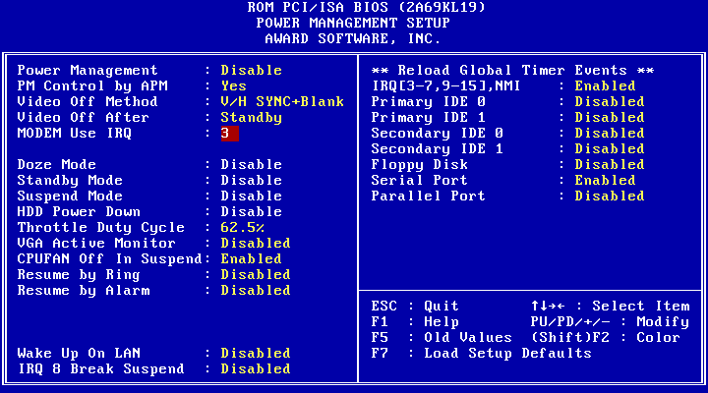
POWER MANAGEMENT:
DISABLED : GLOBAL POWER MANAGEMENT WILL BE DISABLED.
USER DEFINE :USERS CAN CONFIGURE THEIR OWN POWER
MANAGEMENT.
MIN.SAVING :PRE-DEFINE TIMER VALUE ARE USED SUCH THAT ALL
TIMERS ARE IN THEIR MAX . VALUE
MAX.SAVING : PRE-DEFINE TIMER VALUES ARE USED SUCH THAT
ALL TIMERS ARE IN THEIR MIN . VALUE.

PM CONTROL BY APM:
NO : SYSTEM BIOS WILL IGNORE APM.
YES : SYSTEM BIOS WILL WAIT FOR APM'S PROMPT
BEFORE IT ENTER ANY PM MODE, E.G. DOZE, STANDBY
OR SUSPEND.

NOTE 1. IF APM IS INSTALLED, AND THERE IS A TASK RUNNING,
EVEN IF THE TIMER IS TIME OUT, THE APM WILL NOT
PROMPT THE BIOS TO PUT THE SYSTEM INTO ANY POWER
SAVING MODE!
NOTE 2. IF APM IS NOT INSTALLED, THIS OPTION HAS NO EFFECT.

VIDEO OFF METHOD :

BLANK SCREEN : THE SYSTEM BIOS WILL ONLY BLANKS
OFF THE SCREEN WHEN DISABLED.

V/H SYNC+BLANK : BIOS WILL ALSO TURN OFF THE V/H SYNC
SIGNAL FROM VGA CARD TO MONITOR.

DPMS : DISPLAY POWER MANAGEMENT BY VGA
CARD SUPPORT.

DOZE MODE : DISABLED , 1 MIN --- 1 HOUR

STANDBY MODE : DISABLED , 1 MIN --- 1 HOUR

SUSPEND MODE : DISABLED , 1 MIN --- 1 HOUR

HDD POWER DOWN : DISABLED , 1 MIN ---15 MIN

WAKE-UP EVENT : TO IRQ3, IRQ4 , IRQ8 , IRQ12 CHECK POINT.
ANY ACTIVITY. THE SYSTEM WILL WAKE
UP.

POWER DOWN ACTIVITIES: TO COM PORTS, LPT PORTS AND DRIVE
PORTS IRQ3.......IRQ15 CHECK POINT THEN
INTO GREEN FUNCTION.

3-6. PNP / PCI CONFIGURATION SETUP
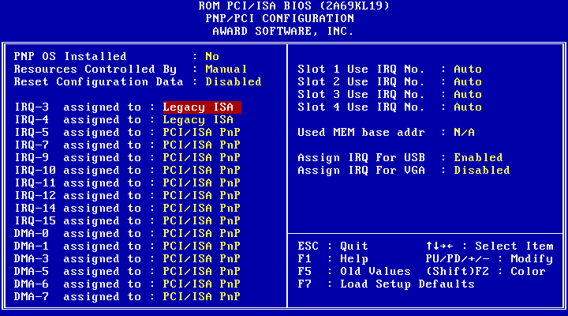

(1-3) AVAILABLE IRQ : ( NA, 3, 4, 5, 7, 9, 10, 11, 12, 13, 14, 15)

PCI IRQ ACTIVED BY : LEVEL

PCI IDE IRQ MAP TO : PCI-AUTO (PCI-SLOT 1, 2, 3)

PRIMARY IDE INT# : A (B, C, D)

SECONDARY IDE INT# : B (C, D, A)

PCI SLOTS ROUTING METHOD:
PCI 1: A, B, C, D
PCI 2: B, C, D, A
PCI 3: C, D, A, B

3-7. INTEGRATED PERIPHERALS

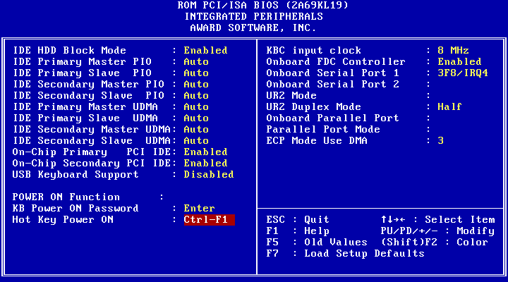
IDE HDD BLOCK MODE [THIS FEATURE ENHANCES HARD DISK PERFORMANCE BY MAKING MULTI SECTOR TRANSFER, INSTEAD OF ONE SECTOR PER TRANSFER, MOST OF IDE DRIVERS, EXCEPT VERY EARLY DESIGNS ,CAN USE THIS FEATURE.]
:ENABLED (DEFAULT)
:DISABLED
IDE PRIMARY MASTER PIO [DETECT YOUR PRIMARY MASTER HARD DISK DEVICE.]
:AUTO (DEFAULT)
:MODE 0,1,2,3,4

IDE PRIMARY SLAVE PIO [DETECT YOUR PRIMARY SLAVE HARD DISK DEVICE.]
:AUTO (DEFAULT)
:MODE 0,1,2,3,4
IDE SECONDARY MASTER PIO[DETECT YOUR SECONDARY MASTER HARD DISK DEVICE.]
:AUTO (DEFAULT)
:MODE 0,1,2,3,4

IDE SECONDARY SLAVE PIO [DETECT YOUR SECONDARY SLAVE HARD DISK DEVICE.]
: AUTO (DEFAULT)
: MODE 0,1,2,3,4

ON-CHIP PRIMARY PCI IDE [SELECT USE CHIP SUPPORT PRIMARY PCI IDE.]
: ENABLED (DEFAULT)
: DISABLED
ON-CHIP SECONDARY PCI IDE [SELECT USE CHIP SUPPORT SECONDARY PCI IDE.]
: ENABLED (DEFAULT)
: DISABLED
PCI SLOT IDE 2ND CHANNEL [USE EXTERNAL IDE. AS ISA IDE OR PCI IDE.]
: ENABLED (DEFAULT)
: DISABLED
ON-BOARD FDD CONTROLLER : ENABLED (DEFAULT)
: DISABLED
ON-BOARD SERIAL PORT 1 : COM1 (DEFAULT)
: COM2
: COM3
: COM4
: DISABLED
ON-BOARD SERIAL PORT 2 : COM1
: COM2 (DEFAULT)
: COM3
: COM4
: DISABLED
ON-BOARD PARALLEL PORT : 378H (DEFAULT)
: 278H
: 3BCH
: DISABLED
ON-BOARD PARALLEL MODE : SPP(DEFAULT)
: EPP
: ECP
: ECP+EPP

3-8. SUPERVISOR/USER PASSWORD

THE " SUPERVISOR/USER PASSWORD SETTING " UTILITY SETS THE PASSWORD. THE MAINBOARD MAY BE SHIPPED WITH THE DEFAULT PASSWORD "AWARD_SW" , OR WITH THE PASSWORD DISABLED. IF YOU WANT TO CHANGE THE PASSWORD, YOU MUST FIRST ENTER THE CURRENT PASSWORD (" AWARD_SW " IN THIS CASE). THEN AT THE PROMPT, TYPE YOUR NEW PASSWORD. THE PASSWORD IS CASE SENSITIVE AND YOU CAN USE UP TO 8 ALPHANUMERIC CHARACTERS. PRESS <ENTER> AFTER THE PASSWORD . AT THE NEXT PROMPT, CONFIRM THE NEW PASSWORD BY TYPING IT AND PRESSING <ENTER> AGAIN. WHEN YOU USE THIS FEATURE, THE " SECURITY OPTION" LINE IN BIOS FEATURES SETUP WILL DETERMINE WHETHER THE PASSWORD WILL BE REQUIRED. TO DISABLE THE PASSWORD, PRESS THE <ENTER> KEY INSTEAD OF ENTERING A NEW PASSWORD WHEN THE " ENTER PASSWORD" DIALOG BOX APPEARS. A MESSAGE WILL APPEAR CONFIRMING THAT THE PASSWORD IS DISABLE. YOU MAY RECEIVE YOUR MAINBOARD SET UP THIS WAY.

THERE ARE TWO KINDS OF PASSWORD FUNCTIONS IN THE SETUP MENU : ONE IS SUPERVISOR PASSWORD, AND THE OTHER IS USER PASSWORD.

THE DIFFERENCES BETWEEN THEM ARE:

SUPERVISOR PASSWORD: THE SUPERVISOR PASSWORD FUNCTION ALLOWS YOU THE RIGHT TO CHANGE THE OPTIONS OF SETUP MENU ONCE YOU ENTER THE SETUP MENU.

USER PASSWORD: THE USER PASSWORD FUNCTION ONLY ALLOWS YOU TO ENTER THE SETUP MENU BUT DO NOT HAVE THE RIGHT TO CHANGE THE OPTIONS OF THE SETUP MENU EXCEPT USER PASSWORD, SAVE & EXIT SETUP, AND EXIT WITHOUT SAVING.

3-9 .IDE HDD AUTO DETECTION

THE "IDE HDD AUTO DETECTION" UTILITY IS A VERY USEFUL TOOL ESPECIALLY WHEN YOU DO NOT KNOW WHICH KIND OF HARD DISK TYPE YOU ARE USING. YOU CAN USE THIS UTILITY TO DETECT THE CORRECT DISK TYPE INSTALLED IN THE SYSTEM AUTOMATICALLY OR YOU CAN SET HARD DISK TYPE TO AUTO IN THE STANDARD CMOS SETUP. YOU DON'T NEED THE "IDE HDD AUTO DETECTION" UTILITY. THE BIOS WILL AUTO-DETECT THE HARD DISK SIZE AND MODEL ON DISPLAY DURING POST.

NOTE: HDD MODES
THE AWARD BIOS SUPPORTS 3 HDD MODES: NORMAL, LBA & LARGE

NORMAL MODE
GENERIC ACCESS MODE IN WHICH NEITHER THE BIOS NOR THE IDE CONTROLLER WILL MAKE ANY TRANSFORMATIONS DURING ACCESSING.

THE MAXIMUM NUMBER OF CYLINDERS, HEAD & SECTORS FOR NORMAL MODE ARE 1024, 16 & 63.

NO. CYLINDER (1024)
X NO. HEAD ( 16)
X NO. SECTOR ( 63)
X NO. PER SECTOR ( 512)
528 MEGABYTES

IF USER SET THIS HDD TO NORMAL MODE, THE MAXIMUM ACCESSIBLE HDD SIZE WILL BE 528 MEGABYTES EVEN THOUGH ITS PHYSICAL SIZE MAY BE GREATER THAN THAT!

LBA (LOGICAL BLOCK ADDRESSING) MODE
A NEW HDD ACCESSING METHOD TO OVERCOME THE 528 MEGABYTE BOTTLENECK. THE NUMBER OF CYLINDERS, HEADS & SECTORS SHOWN IN SETUP MAY NOT BE THE NUMBER PHYSICALLY CONTAINED IN THE HDD.

DURING HDD ACCESSING, THE IDE CONTROLLER WILL TRANSFORM THE LOGICAL ADDRESS DESCRIBED BY SECTOR, HEAD & CYLINDER INTO ITS OWN PHYSICAL ADDRESS INSIDE THE HDD.

THE MAXIMUM HDD SIZE SUPPORTED BY LBA MODE IS 8.4 GIGABYTES WHICH IS OBTAINED BY THE FOLLOWING FORMULA:

NO. CYLINDER (1024)
X NO. HEAD ( 255)
X NO. SECTOR ( 63)
X NO. BYTES PER SECTOR ( 512) 8.4 GIGABYTES

LARGE MODE
EXTENDED HDD ACCESS MODE SUPPORTED BY AWARD SOFTWARE.

SOME IDE HDDS CONTAIN MORE THAN 1024 CYLINDER WITHOUT LBA SUPPORT (IN SOME CASES, USER DO NOT WANT LBA).
THE AWARD BIOS PROVIDES ANOTHER ALTERNATIVE TO SUPPORT THESE KINDS OF LARGE MODE:

CYLS. HEAD SECTOR MODE
1120 16 59 NORMAL
560 32 59 LARGE

BIOS TRICKS DOS (OR OTHER OS) THAT THE NUMBER OF CYLINDERS IS LESS THAN 1024 BY DIVIDING IT BY 2. AT THE SAME TIME, THE NUMBER OF HEADS IS MULTIPLIED BY 2. A REVERSE TRANSFORMATION PROCESS WILL BE MADE INSIDE INT 12H IN ORDER TO ACCESS THE RIGHT HDD ADDRESS THE RIGHT HDD ADDRESS!

MAXIMUM HDD SIZE:
NO. CYLINDER (1024)
X NO. HEAD ( 32)
X NO. SECTOR ( 63)
X NO. BYTES PER SECTOR ( 512)
1 GIGABYTES

NOTE: TO SUPPORT LBA OR LARGE MODE OF HDDS, THERE MUST
BE SOME SOFTWARES INVOLVED. ALL THESE SOFTWARES
ARE LOCATED IN THE AWARD HDD SERVICE ROUTINE
(INT 13H). IT MAY BE FAILED TO ACCESS A HDD WITH LBA
(LARGE) MODE SELECTED IF YOU ARE RUNNING UNDER AN
OPERATING SYSTEM WHICH REPLACES THE WHOLE INT 13H.
UNIX OPERATING SYSTEMS DO NOT SUPPORT EITHER LBA
OR LARGE AND MUST UTILITY THE STANDARD MODE. UNIX
CAN SUPPORT DRIVES LARGER THAN 528MB.

3-10 .LOAD SETUP DEFAULTS

"LOAD SETUP DEFAULTS" LOADS OPTIMIZED SETTINGS WHICH ARE STORED IN THE BIOS ROM. THE AUTO-CONFIGURED SETTINGS ONLY AFFECT THE BIOS FEATURE SETUP AND CHIPSET FEATURES SETUP SCREENS. THERE IS NO EFFECT ON THE STANDARD CMOS SETUP. TO USE THIS FEATURE, HIGHLIGHT IT ON THE MAIN SCREEN AND PRESS THE <ENTER> KEY. A LINE WILL APPEAR ON SCREEN ASKING IF YOU WANT TO LOAD THE SETUP DEFAULT VALUES. PRESS THE <Y> KEY AND THEN PRESS THE <ENTER> KEY . THE SETUP DEFAULTS WILL THEN LOAD. PRESS <N> IF YOU DON'T WANT TO

3-11 SAVE & EXIT SETUP

THE "SAVE & EXIT SETUP" OPTION WILL BRING YOU BACK TO BOOT UP PROCEDURE WITH ALL THE CHANGES, YOU JUST MADE WHICH ARE RECORDED IN THE CMOS RAM.

3-12 EXIT WITHOUT SAVING

THE "EXIT WITHOUT SAVING" OPTION WILL BRING YOU BACK TO NORMAL BOOT UP PROCEDURE WITHOUT SAVING ANY DATA INTO CMOS RAM. ALL OF THE OLD DATA IN THE CMOS WILL NOT BE DESTROYED.

3-13 I/O & MEMORY MAP

MEMORY MAP

ADDRESS RANGE | SIZE | DESCRIPTION
00000-7FFFF | 512K | CONVENTIONAL MEMORY
80000-9FBFF | 127K | EXTENDED CONVENTIONAL MEMORY
9FC00-9FFFF | 1K | EXTENDED BIOS DATA AREA IF PS/2 MOUSE IS INSTALLED
A0000-C7FFF | 160K | AVAILABLE FOR HI DOS MEMORY
C8000-DFFFF | 96K | AVAILABLE FOR HI DOS MEMORY AND ADAPTER ROMS
E0000-EEFFF | 60K | AVAILABLE FOR UMB
EF000-EFFFF | 4K | VIDEO SERVICE ROUTINE FOR MONOCHROME & CGA ADAPTER
F0000-F7FFF | 32K | BIOS CMOS SETUP UTILITY
F8000-FCFFF | 20K | BIOS RUNTIME SERVICE ROUTINE (2)
FD000-FDFFF | 4K | PLUG AND PLAY ESCD DATA AREA
FE000-FFFFF | 8K | BIOS RUNTIME SERVICE ROUTINE (1)

I/O MAP

000-01F | DMA CONTROLLER (MASTER)
020-021 | INTERRUPT CONTROLLER (MASTER)
022-023 | CHIPSET CONTROL REGISTERS. I/O POSTS
040-05F | TIMER CONTROL REGISTERS
060-06F | KEYBOARD INTERFACE CONTROLLER (8042)
070-07F | RTC PORTS & CMOS I/O PORTS
080-09F | DMA REGISTER
0A0-0BF | INTERRUPT CONTROLLER (SLAVE)
0C0-0DF | DMA CONTROLLER (SLAVE)
0F0-0FF | MATH COPROCESSOR
1F0-1FB | HARD DISK CONTROLLER
278-27F | PARALLEL PORT 2
2B0-2DF | GRAPHICS ADAPTER CONTROLLER
2F8-2FF | SERIAL PORT 2
360-36F | NETWORK PORTS
378-37F | PARALLEL PORT 1
3B0-3BF | MONOCHROME & PARALLEL PORT ADAPTER
3C0-3CF | EGA ADAPTER
3D0-CDF | CGA ADAPTER
3F0-3F7 | FLOPPY DISK CONTROLLER
3F8-3FF | SERIAL PORT-1

3-14 TIME & DMA CHANNELS MAP

TIME MAP: TIMER CHANNEL 0 SYSTEM TIMER INTERRUPT TIMER CHANNEL 1 DRAM REFRESH REQUEST TIMER CHANNEL 2 SPEAKER TONE GENERATOR

DMA CHANNELS: DMA CHANNEL 0 AVAILABLE
DMA CHANNEL 1 ONBOARD ECP (OPTION) DMA CHANNEL 2 FLOPPY DISK (SMC CHIP) DMA CHANNEL 3 ONBOARD ECP (DEFAULT) DMA CHANNEL 4 CASCADE FOR DMA CONTROLLER 1 DMA CHANNEL 5 AVAILABLE
DMA CHANNEL 6 AVAILABLE
DMA CHANNEL 7 AVAILABLE

3-15 INTERRUPT MAP

NIMI: NON-MASKABLE INTERRUPT

IRQ(H/W): 0 SYSTEM TIMER INTERRUPT FROM TIMER 0
1 KEYBOARD OUTPUT BUFFER FULL
2 CASCADE FOR IRQ8-15
3 SERIAL PORT2
4 SERIAL PORT1
5 PARALLEL PORT 2
6 FLOPPY DISK (SMC CHIP)
7 PARALLEL PORT 1
8 RTC CLOCK
9 AVAILABLE
10 AVAILABLE
11 AVAILABLE
12 PS/2 MOUSE
13 MATH COPROCESSOR
14 ONBOARD HARD DISK (IDE1) CHANNEL
15 ONBOARD HARD DISK (IDE2) CHANNEL

3-16 RTC & CMOS RAM MAP

RTC & CMOS:00 SECONDS
01 SECOND ALARM
02 MINUTES
03 MINUTES ALARM
04 HOURS
05 HOURS ALARM
06 DAY OF WEEK
07 DAY OF MONTH
08 MONTH
09 YEAR
0A STATUS REGISTER A
0B STATUS REGISTER B
0C STATUS REGISTER C
0D STATUS REGISTER D
0E DIAGNOSTIC STATUS BYTE
0F SHUTDOWN BYTE
10 FLOPPY DISK DRIVE TYPE BYTE
12 HARD DISK TYPE BYTE
13 RESERVE
14 EQUIPMENT TYPE
15 BASE MEMORY LOW BYTE
16 BASE MEMORY HIGH BYTE
17 EXTENSION MEMORY LOW BYTE
18 EXTENSION MEMORY HIGH BYTE
19-2D
2E-2F
- RESERVED FOR EXTENSION MEMORY LOW BYTE
31 RESERVED FOR EXTENSION MEMORY HIGH BYTE 32 DATE CENTURY BYTE
33 INFORMATION FLAG
34-3F RESERVE
40-7F RESERVED FOR CHIPSET SETTING DATA

---END---

