ALTServer
Baseboard & Platform

Preliminary Technical Product Summary

(SUBJECT TO CHANGE)

Version 0.6
December, 1994
Order Number 281657-001



ALTServer
Technical Product Summary

Table of Contents

- Introduction
- Board Level Features
Pentium Processors
Second Level (L2) Cache
System Memory
Expansion Slots (PCI and EISA)
Peripheral Component Interconnect (PCI) Chip Set
Interrupt Control Asic (INCA) Component
Graphics Subsystem
PCI SCSI Interface
Standard I/O and Advanced Integrated Peripheral (AIP) Component
Keyboard and Mouse Interface
Dallas DS12887 Real Time Clock, CMOS RAM and Battery
I/O Riser Board
System BIOS
- System Level Features
Chassis
Peripheral Bays
Fan
Expansion Slots
Front and Back Panels
Power Supply and Power Consumption
Floppy Drive
Speaker
Chassis Color
- Appendix A − User-Installable Upgrades
- Appendix B − Jumpers
- Appendix C − Connectors
- Appendix D − System Configuration Utility
- Appendix E − AMIBIOS Messages and Beep Codes
- Appendix F − BIOS Upgrades & Recovery
- Appendix G − Memory Map
- Appendix H − I/O Map
- Appendix I − Interrupts & DMA Channels
- Appendix J − Graphics Resolutions and Frequencies
- Appendix K − Environmental & Reliability Standards
- Appendix L − Customer Support

Intel Corporation disclaims all warranties and liabilities for the use of this document and the information contained herein, and assumes no responsibility for any errors which may appear in this document. Intel makes no commitment to update the information contained herein, and may make changes at any time without notice. There are no express or implied licenses granted hereunder to any intellectual property rights of Intel Corporation or others to design or fabricate Intel integrated circuits or integrated circuits based on the information in this document. Contact your local sales office to obtain the latest specifications before placing your order.
*All other brands and names are the property of their respective owners.

© INTEL CORPORATION, 1994 281657-001

Introduction
The ALTServer baseboard and platform have been clearly designed to meet the needs of the server marketplace, and continue a tradition of performance and reliability set by Intel’s Xpress technology. In contrast with the Xpress modular architecture, ALTServer offers a ‘flat’ design with the processor and memory subsystems residing on the main baseboard. The ALTServer design uses members of the Intel 82430 Neptune PCIset to provide high performance and a highly integrated system at multiple price/performance levels.
Two Zero Insertion Force (ZIF) sockets for Pentium™ processors provide scalability using Symmetric MultiProcessing (SMP) operating systems, such as UnixWare*, SCO UNIX, Solaris*, OS/2*, and WindowsNT*. The ALTServer’s multiprocessing capabilities comply with the Intel Multiprocessing Specification v1.1. Additional simple and cost-effective performance upgrades are available through a variety of plug-in cache module options.
The ALTServer’s expansion capabilities meet the needs of file and application servers for high performance I/O by providing a combination of PCI local bus and EISA connectors. The baseboard offers two dedicated PCI slots, five dedicated EISA slots, and one shared PCI/EISA slot. The high-performance PCI local bus allows the adoption of newer networking technology, such as ATM and 100 MB/second Ethernet NICs, with a minimum of effort and without concern for I/O bottlenecks. The PCI local bus offers a 133 MB/second bandwidth and has been a proven high-speed solution on the desktop. The ALTServer’s architecture, as shown in the diagram below, brings these benefits to servers:
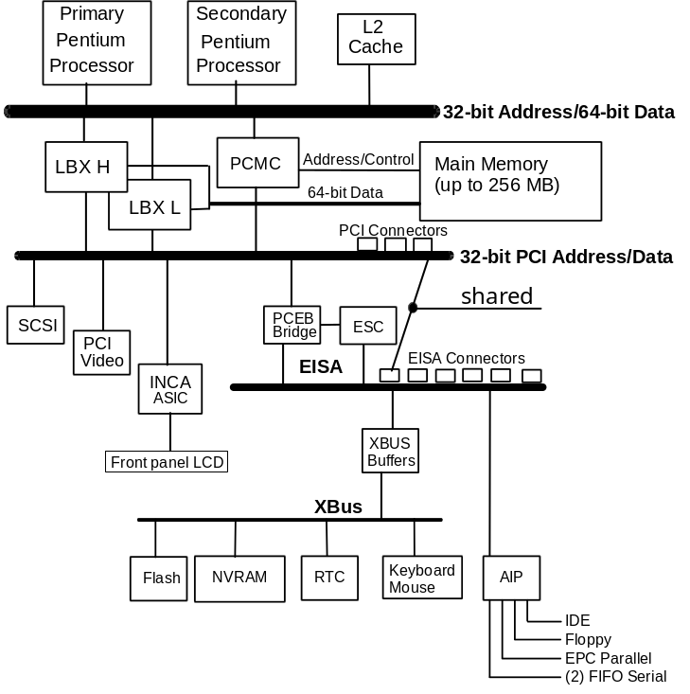
Figure 1. ALTServer block diagram
This combination of PCI and EISA expansion offers continuing support for existing special function EISA add-in boards, such as X.25 Multiport Serial cards. All of the add-in slots are available to the user because the high-performance PCI fast SCSI-2 interface and a PCI graphics controller are integrated on the baseboard.
A number of security, reliability, and management features also have been incorporated into the ALTServer’s design to meet vital server needs. These features can be further enhanced with accessory products like the Intel Server Monitor Module and either intelligent EISA or PCI RAID controllers.

AT FORM FACTOR
The ALTServer baseboard measures 12” by 13” and is designed to fit into a standard AT-style chassis. Maximum chassis flexibility is provided by a special baseboard header which allows the connection of a riser with any of the following configurations of standard external I/O connections (keyboard, mouse, serial ports, etc.):
- Wide SCSI internal to chasis
- Wide SCSI external to chasis
- Narrow SCSI external to chasis
- Standard AT form factor
The following diagram shows the dimensions and mounting hole locations.
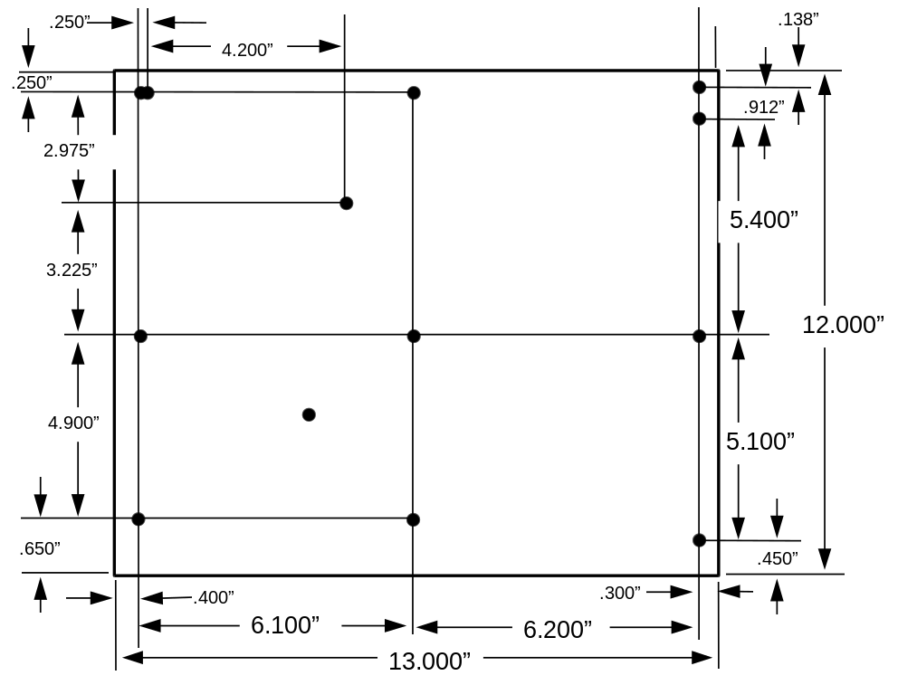
Figure 2. ALTServer board dimensions

Board Level Features
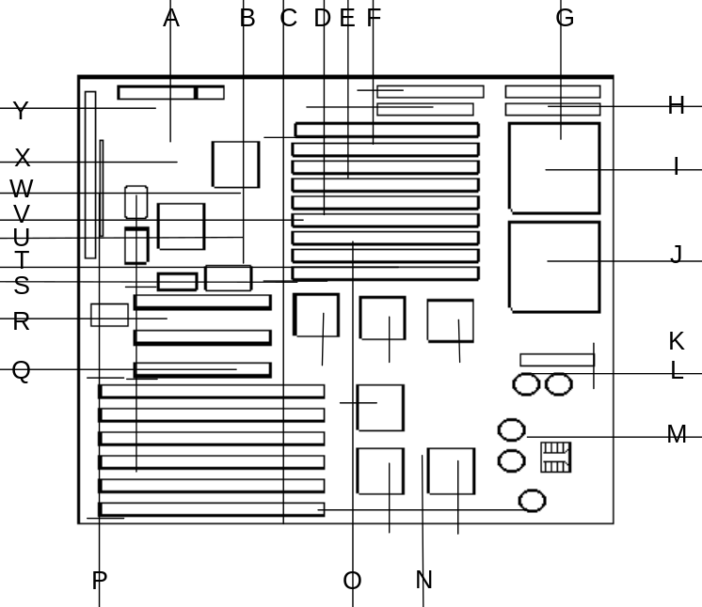
A − Primary power connector
B − Adaptec 7870 PCI SCSI Controller
C − SIMM sockets for up to 256 MB system memory
D − Socket for second level cache
E − PCI IDE connector
F − PCI SCSI connector (termination adjacent)
G − Floppy drive connector
H − Front panel LCD connector
I − Primary Pentium processor
J − Second Pentium processor socket
K − Intel Neptune PCIset
L − Server Monitor feature connector
M − Voltage regulation circuitry
N − EISA bus bridge chip set
O − Interrupt Control ASIC (INCA component)
P − EISA expansion slot connectors
Q − PCI expansion slot connectors
R − Flash memory component holding BIOS
S − 3.3 volt PCI power connector
T − Real Time Clock and battery
U − Socket for video memory upgrade to 1 MB
V − Cirrus Logic 5430 PCI Graphics controller
W − 512 KB video memory
X − Termination for SCSI devices connected to riser(all 3 removed for wide devices, first two removed for narrrow devices)
Y − Header for I/O riser connector
Figure 3. ALTServer board features

Pentium Processors
The ALTServer baseboard is designed to operate with 75 MHz, 90 MHz, 100 MHz or 120 MHz Pentium processors and is shipped with a single processor installed in the main Zero Insertion Force (ZIF) socket. A second ZIF socket is provided to upgrade to a dual processor SMP configuration. When two processors are installed, both should be of the same frequency, stepping and voltage specifications to ensure correct operation.When upgrading to dual processing, care should be taken to ensure the second processor is correctly oriented in the ZIF socket next to the primary processor.
The Pentium processor has an internal speed of 75, 90, or 100 MHz and an external speed of 50, 60, or 66 MHz respectively and is backward-compatible with the Intel486™ processor. The Pentium processor supports both read and write burst mode bus cycles and includes a 16 KB on-chip cache core (8 KB for code and 8 KB for data caches) employing a write-back policy. Also integrated into the Pentium processor is an advanced numeric coprocessor which significantly increases the speed of floating point operations, while maintaining backward compatibility with the i486™DX math coprocessor and complying with ANSI/IEEE standard 754-1985. Based on 0.6 micron processes, the Pentium processor is powered by 3.3 volts and supports Intel's System Management Mode (SMM) power-management operation.

3.3 Volt regulation
A patented onboard voltage regulator circuit provides the required 3.3 volts to the processor from the 5 volts provided by a standard power supply. This allows the ALTServer baseboard to be used with a ‘standard’ PC supply, instead of more costly supplies with 3.3V outputs. It should be noted that the onboard 3.3 volt regulator provides power for the processor(s) and not the PCI slots. When 3.3V PCI cards are used, the baseboard’s 3.3 volt connector for the PCI slots must be used with a separate 3.3 volt power supply or with an external voltage converter.

Symmetric Multiprocessing (SMP) Software Considerations
The ALTServer Baseboard and BIOS comply with the Intel MultiProcessor (MPS) Specification, revision 1.1. This standard defines a method of constructing systems in which two or more processors operate concurrently. These processors operate in a tightly coupled architecture in which each processor has the same ‘view’ of the system, and in which each processor can interrupt any other processor. This architecture has the following features:

- Each processor sees the same memory and I/O space, requiring only one copy of the operating system.
- Any task can run on any processor, reducing the chance that the failure of one or more processors will render the system unusable. Tasks can be written generically, without regard for which processor they will be executing on.
The use of an Advanced Programmable Interrupt Controller (APIC) is specified for interrupt detection and notification. This reduces the load on the system bus, since the APICs use a serial bus to transmit and receive interrupts.

SMP Operating System Requirements
To obtain the benefits from using a second processor on the ALTServer platform, it is essential to use an operating system that is capable of Symmetric MultiProcessing and which has driver support for the Intel MultiProcessor Specification, version 1.1. This allows the software load to be distributed across the processors and for the operating system and application process to be shared efficiently. Most server operating systems now have this functionality. However, DOS and Microsoft Windows 3.1, 3.11 and Windows ‘95 do not have this capability and will see no performance increase from adding a second processor.
The following table shows which server operating systems support Intel MPS v1.1 and ALTServer:

Operating System | Version
Microsoft Windows NT | 3.1, 3.5
Novell UnixWare | 2. 0
Novell USL/USG | System V.4.2 MP
IBM OS/2* | 2.11 SMP
SunSoft Solaris for x86 | 2.4
SCO OpenServer + MPX | 3.1
Banyan Vines* | 5.54
Table 1. MultiProcessing operating system support

Second Level (L2) Cache
To provide a cost effective solution using standard chip set components, the ALTServer offers an upgradeable second level cache using Integrated Device Technology (IDT) or Corsair cache devices. This provides five options and price/performance points: No cache, 256 KB or 512 KB asynchronous cache, 256 KB or 512 KB Burst Synchronous cache.
The performance of each option depends on many factors, such as operating system, number of processors, amount of system memory, and other variables. However, as a general rule, overall system performance increases with larger cache sizes. The use of a Burst Synchronous cache should provide even higher performance than the equivalent size Asynchronous cache device.
The second level cache may be Enabled or Disabled using the BIOS Configuration Utility. When Enabled, the caching policy is always write-back mode to support the internal (L1) 16 KB cache of the Pentium processor. With a burst cache device installed, the processor read and write clock latencies are 3-1-1-1. With the Asynchronous modules, the processor read latency is 4-2-2-2 and the write latency is 3-1-1-1.
The single cache resource is shared in SMP configurations where two Pentium processors are installed. Cache coherency and control is provided by the 82434NX PCI/Cache Memory Controller.

SYSTEM MEMORY
The main system memory is provided by eight 72-pin SIMM sockets for up to 256 MB of memory expansion on the baseboard. The eight 90° angled sockets support 256K x 36 (1 MB), 512K x 36 (2 MB), 1M x 36 (4 MB), 2M x 36 (8 MB), 4M x 36 (16 MB), and 8M x 36 (32 MB) SIMMs. The minimum memory size is 2 MB and the maximum memory size, using eight 32 MB SIMMs, is 256 MB. Memory timing requires 70 ns fast page devices. Parity generation/checking is provided for each byte, but parity generation/checking can be disabled using the System Configuration Utility (SCU) to allow for use of non-parity 32-bit SIMMs.
The eight SIMM sockets are arranged as four banks (Bank 0, 1, 2, and 3) with each bank consisting of two sockets and providing a 64-bit wide data path and 8 parity bits. The memory array is controlled by the Intel 82434NX PCMC and data buffering is provided by two Intel 82433NX Local Bus Extension devices. Both SIMMs in a bank must be of the same memory size and type, although separate banks may have different sizes and types of memory installed. Any (or all) banks may be populated to provide the required system memory. In some instances, for electrical reasons only, it may be essential to populate Bank 0 first.
System memory begins at address 0 and is contiguous (flat addressing) up to the maximum amount of system memory installed. The only places where system memory is non-contiguous is in the ranges from 00080000 - 000FFFFF (the DOS compatibility region) and 00F00000 - 00FFFFFF (the system BIOS region). Memory regions holes at any other location may result in DRAM beyond that hole unusable.

EXPANSION SLOTS (PCI and EISA)
The ALTServer baseboard allows the addition of up to eight I/O expansion cards, and provides interfaces to the the ISA bus, the EISA bus, and the PCI loca bus. There are six EISA bus expansion connectors and three PCI expansion connectors. One expansion slot is shared by connectors which will accommodate either an EISA or a PCI expansion card, but not both at the same time. All three PCI expansion slots accept PCI master cards and fully support the PCI 2.0 specification. The six EISA bus expansion connectors will accept either EISA or ISA add-in cards. All six slots will accept either EISA/ISA bus masters or EISA/ISA slave cards.
The PCI bus on the ALTServer runs at half the external bus speed of the installed processor. For example, the external bus speed of the 100 MHz processor is 66 MHz, and the PCI bus is clocked at 33MHz. By dividing the PCI bus clock by either 3 or 4, the EISA bus clock can be derived. The table below shows an example:
Processor Clock Speed | External Bus Speed | PCI Bus Speed | Divisor | EISA Clock
75 MHz | 50 MHz | 25 MHz | 3 | 8.33 MHz
90 MHz | 60 MHz | 30 MHz | 4 | 7.5 MHz
100MHz | 66 MHz | 33 MHz | 4 | 8.33 MHz
Table 2. ALTServer clock frequencies and bus speeds

Peripheral Component Interconnect (PCI) Chip Set
The baseboard’s two dedicated PCI expansion slots and one PCI/EISA combination slot are controlled by the Intel Neptune PCIset. The ALTServer uses one 82434NX PCI/Cache/Memory Controller (PCMC) and two 82433NX Local Bus Extension (LBX) devices. Together they provide a PCI interface, as well as DRAM memory and cache controller functions, including:

• Processor reset control
• Processor L1 cache control
• Processor burst mode control
• Processor interface control
• Integrated second level write-back cache
controller with tag comparator

• Fast Page-mode DRAM controller
• Burst memory read/write control logic
• Data bus conversion to PCI
• Parity generation/detection to memory

82434NX PCI/Cache/Memory Controller (PCMC)
The 82434NX provides all control signals necessary to drive a second level cache and the DRAM array, including multiplexed address signals. It also controls system access to memory and generates snoop controls to maintain cache coherency. The PCMC integral memory controller manages up to 256 MB of SIMM DRAM and controls either a Burst or Asynchronous Cache of either 256 KB or 512 KB. It also maintains full cache coherency between the Cache and main memory when both processors are installed.

82433NX Local Bus eXtension (LBX)
There are two 82433NX components which provide data bus buffering and dual port buffering to the memory array, LBX-H and LBX-L. LBX-H decodes the 64-bit data lines (16:31) & data lines (48:63), while LBX-L decodes the other data lines (0:15) & (32:47). The use of two 82433NX components provides a 64-bit data path from the processors to main memory. Controlled by the 82434NX, the 82433NX devices add one load each to the PCI bus and perform all the necessary byte and word swapping required. Memory and I/O write buffers are included in these devices.

Host-to-pci bridge
The PCI control section of the PCMC and the two LBX components form a Host-to-PCI bridge subsystem. This subsystem provides the interface between the processors and the PCI bus, providing for a transfer rate of up to 132 MB/second and full concurrence between processor Host bus and PCI bus transactions. Five integral Write Posting and Read Prefetch buffers increase PCI Master add-in performance.
The PCMC/LBX Host-to-PCI bridge is designed to conform to the PCI Local Bus Specification 2.0, and guidelines in the PCI System Design Guide.

PCI/EISA BrIDGE (PCEB)
The baseboard has five dedicated and one shared 32-bit EISA I/O expansion slots. The 82375EB PCI-EISA Bridge (PCEB) and 82374EB EISA System Component (ESC) provide a bridge between the PCI local bus and the EISA bus. The PCEB has the following features:
- Address, data paths, and bus protocol translation for PCI-EISA transfers
- Extensive data buffering in both directions that increases system performance and allows concurrence between the PCI bus and EISA bus
- Bus parity checking and error reporting
The ESC provides support for an EISA-compatible I/O subsystem, including:
- EISA (master and slave) interface
- EISA bus controller and arbitration
- Enhanced 7-channel DMA controller with scatter/gather support
- 14-channel interrupt controller, five programmable timer/counters, and NMI logic.
- Support logic for Xbus buffer and devices, including chip selects for Flash BIOS, Real time Clock (RTC), NVRAM and keyboard/mouse controller.

Interrupt Control ASIC (INCA) Component
The Interrupt Control ASIC (INCA) collects many functions into a single component to enhance functionality, reduce part count, and reduce system cost. The main functions include providing both PCI interrupt control and unique security and server management features.
The following INCA features are used on the ALTServer baseboard:
- Interrupt control:
- I/O Advanced Programmable Interrupt Controller (APIC)
- Serial port interrupt steering to any ISA interrupt
- IDE interrupt steering to any ISA interrupt
- PCI interrupt steering for the PCI auto-configuration
- Security and Server Monitoring features:
- Watchdog timer (software start/reset) will reset system if it expires
- Keyboard/mouse inactivity; if detected, blanks video and locks floppy, requires password to re-enable
- Baseboard voltage (12V, -12V, 5V, -5V, 3.3V) monitoring.
- Baseboard temperature monitoring for out of range
- Chassis door switch or improper entry monitoring
- PCI Clock generation - 14 PCI clock drivers
- General purpose I/O bits, used for 3-mode (720KB, 1.44MB, 2.88MB) floppy control, and other functions
- DMA steering for IDE and parallel port to one of four possible ISA DRQs/DACKs
- Support for front panel interface and LCD display

Interrupt Handling
This important element of the ALTServer design provides great flexibility in interrupt routing. Interrupt sources come from the PCI and EISA/ISA slots and onboard devices and need to be routed to either a single or dual processor. The following diagram illustrates the interrupt structure on the ALTServer Baseboard.
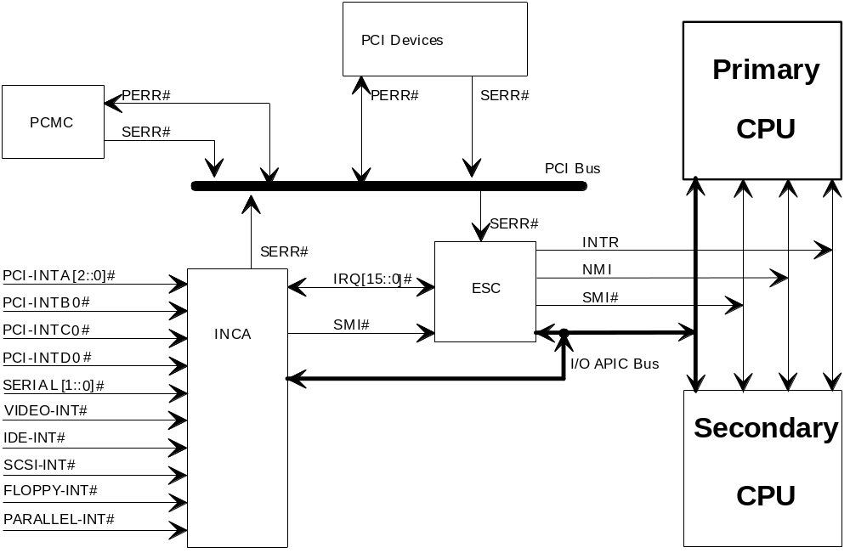
Figure 4. ALTServer interrupt structure

Dual Pentium Processor (SMP) Operation
In the dual processor configuration, the interrupt routing is performed by the Advanced Programmable Interrupt Controller (APIC) bus. Each processor has an on-chip local APIC device that can receive interrupts driven onto the APIC bus by I/O APIC devices. Both the INCA and 82374EB EISA System Component (ESC) incorporate I/O APICs that drive individual interrupts onto the APIC bus. All of the EISA/ISA interrupts are routed to the ESC component and all PCI interrupts are routed to the INCA component. This allows any external interrupt to be routed to the processor. For further details, refer to the operating system documentation and the Intel 82489 APIC data sheet.

Single Processor Operation
All EISA/ISA interrupts are routed to the ESC component and all PCI interrupts from onboard PCI devices and PCI slots are routed to the INCA component. Under software control, the PCI interrupts can be routed from the INCA inputs to any of the ESC interrupt inputs. This allows PCI interrupts to be ‘patched’ into the standard PC interrupt structure. This routing is done dynamically at power-on by the Plug and Play BIOS by examining each device, assigning an interrupt to it, and programming the INCA device accordingly.

Error Interrupts
The traditional server platform will typically generate a Non-Maskable Interrupt (NMI) whenever a memory or bus error occurs. Traditional sources for an NMI are memory system parity error, EISA bus master time-out, or IOCHK#. The PCI bus adds two new sources of error detection which must be managed: PCI bus parity and PCI system error (SERR).
PCI bus parity is performed by the PCI source of the transaction which generates the bus parity while the destination checks it. If a parity error occurs (PERR# asserted one clock after the offending bus cycle), the current PCI bus master manages the error. The master may retry the transfer or may pulse SERR#. An asserted SERR# causes the ESC to generate an NMI. The PCMC manages the SERR# assertion for various conditions.

System Management Interrupt (SMI) Support
The EISA System Component (ESC) has added an SMIin# (pin 185). This pin is under software control and if enabled, asserts SMI# to the Processor. SMI# is of higher priority than NMI or INTR to the Pentium Processor. Assertion of SMIin# causes an SMI# and the processor switches memory space and begins execution of the SMM handler. SMM creates a secure memory space that the processor can use for ALTServer fault management.

Critical Event Logging
During POST, the BIOS will initialize the SMI RAM with code to log errors into non-volatile memory. Each processor will have a private area of SMI RAM dedicated to it for SMI processing. The INCA and PCEB/ESC will be programmed to generate SMI for memory errors, bus parity errors, PCI SERR and PERR, EISA bus time-outs, EISA software generated NMI, I/O channel check, and EISA watchdog time-out. When these errors are detected, the SMI routines will log the error or event, and then will cause an NMI to be generated, so that operating systems can respond appropriately.
If the OS is using the INCA watchdog timer to detect software or hardware failures, and that timer expires, an Asynchronous System Reset (ASR) will be generated, which is equivalent to a hard reset, except that the watchdog timer status will not be reset. The POST portion of the BIOS will detect this event as the system reboots, and will log this event to the logging area.
The System Management Log Area will be a minimum of 8192 bytes of non-volatile memory space. The format of the System Management Log Area will be based on the Xpress Server Management Critical Event Logging area format. The event logs will be a superset of the Xpress event logs. For more detail, please refer contact your Intel sales representative for the BIOS Extrernal Product Specification.

SECURITY AND Server MONITORING FEATURES
Incorporated into the ALTServer design are a number of features that enhance the reliability and security of the platform and meet the needs for high availability servers. Most of the hardware functionality is incorporated into the INCA device, which provides the following monitoring features:
- Watchdog timer (software start/reset) will reset system if it expires
- Keyboard/mouse inactivity; if detected, blanks video and locks floppy, requires password to re-enable
- Baseboard voltage (12V, -12V, 5V, -5V, 3.3V); if out of range, generates System Management Interrupt
- Baseboard temperature and chassis door switch monitoring for out of range or illegal entry
In addition the BIOS incorporates further security and monitoring functionality:
- Front panel push-button that disables keyboard and mouse input when activated
- User password - when specified must be entered to allow system boot
- Administrative password - when specified it must be entered to enter the System Configuration Utility (SCU) and change the configuration of the system
- Inactivity timer - if there is no keyboard or mouse activity within a specified time then the screen blanks and the User password must be entered to resume operation
- Hot key activation - allows the Inactivity timer to be activated by using a definable ‘Hot Key’ sequence

Graphics Subsystem
The SVGA subsystem is based on the Cirrus Logic 5430 PCI graphics controller. The Cirrus 5430 supports backward software compatibility with MDA, CGA, Hercules Graphics, EGA, and VGA graphics standards.
The standard configuration includes 512 KB of graphics DRAM soldered on the ALTServer baseboard. Graphics memory can be upgraded to a total of 1 MB by adding a 256 KB x 16 fast page mode 70 ns DRAM to the SOIC socket on the baseboard. The upgrade will allow higher display resolutions and performance. The display ram is paged into 128 KB of RAM located between A0000H and BFFFFh. The 15-pin VGA Connector appears on the I/O riser board. Graphics VRAM vendors and the VGA connector pinout is listed in the Appendix.

graphics Drivers and Utilities
Graphics drivers and utilities for Windows 3.1, WIN-NT 3.1, MS-DOS software applications and OS/2 2.1 are shipped with the ALTServer platform. Additional drivers for other common applicationsmay be available from the Intel Applications Support BBS. Drivers for SCO* and Interactive UNIX* should be obtained from the respective UNIX vendor.

PCI SCSI Interface
The ALTServer platform integrates an Adaptec AIC-7870 SCSI controller, which supports both narrow SCSI-2 (10 MB/s) and wide SCSI-2 (20 MB/s). The AIC-7870 supports processor-to-PCI and PCI-to-PCI transfers, with an embedded 8 MIPs processor and 256 byte FIFO. As a PCI bus master, the SCSI controller supports burst data transfer rates of up to 133 MB/second at a 66 MHz bus speed. Transfer rates are 120 MB/second at 60 MHz and 100 MB/second at 50 MHz bus speeds.
Although the board supports both narrow and wide devices, there is a limit to how many devices can be connected at one time and identified by the BIOS. The table below shows the allowed narrow/wide configurations:
Device ID | Wide Devices | Narrow devices
1-15 | 15 | 0
1-7 | 6 | 1
1-7 | 5 | 2
1-7 | 4 | 3
1-7 | 3 | 4
1-7 | 2 | 5
1-7 | 1 | 6
1-7 | 0 | 7
Table 3. Allowed narrow/wide SCSI configurations

PCI SCSI CONNECTORS
The baseboard contains a 50-pin Fast/Narrow SCSI-2 connector for narrow SCSI-2 peripherals such as disk drives, CD-ROMs, and tape drives that are installed within the system chassis. Signals for both narrow and wide SCSI interfaces are routed to the header for the I/O riser. A selection of I/O risers offers a variety of combinations of either narrow or wide SCSI connections.
For wide SCSI devices, I/O riser cards are available that provide either an internal or external SCSI connection. The internal I/O riser for wide SCSI has the connector on the opposite side of the video and serial port connectors. This allows wide SCSI cabling to wide SCSI disk drives mounted inside the system chassis. The external version is similar to the narrow SCSI riser and could be used, for example, to connect with an external disk drive unit.

SCSI Termination
Termination for all SCSI devices attached to the ALTServer baseboard must be done manually. The baseboard design includes passive termination at one end of the SCSI channel and passive termination at the device. If any SCSI devices are connected to the bus, the passive terminators for that end of the chain must be removed. See the appendix for jumper locations, and the Board Level Features section on page 7 forterminator settings of various narrow/wide devices.

Standard I/O and Advanced Integrated Peripheral (AIP) Component
The EISA bus on the ALTServer baseboard supports the Intel Advanced Integrated Peripheral (AIP) component for standard I/O devices. The AIP contains a floppy disk controller (FDC), two serial ports, a multi-function parallel port, an IDE interface, and a game port on a single chip. The high integration provides low-cost, low-power consumption, and minimal impact on board real estate. The FDC is an 82078 core with a data rate of up to 2 MB/second. The serial ports are 16550-compatible with 16-byte FIFOs. The parallel port supports the Enhanced Capabilities Port (ECP) protocol with DMA, EPP protocol, and IEEE-1284 protocol for PS/2 bi-directional compatibility. The IDE interface supports 8- or 16-bit I/O and 16-bit DMA. The AIP host interface is 8-bit ISA.

IDE Interface
IDE is an interface for intelligent disk drives with onboard AT disk controller electronics. The 16-bit IDE interface consists of address decode (provided by the AIP), address, command, and data buffers, 40-pin connector, and 4-pin hard disk activity LED connector. The AIP selects the IDE device and enables the data buffers between the IDE cable and the bus. When IDE is disabled via the BIOS configuration utility, the I/O address space and interrupt (IRQ14) are available for use by add-in cards. The system BIOS may disable the interface when it finds the registers of another hard disk controller. When IDE DMA is enabled by the AIP and INCA, the IDE hard disk is then accessible through the DMA channel configured in the INCA. The standard I/O logic accommodates both compatible and Type F DMA cycles to IDE. AC timing constraints allow support for only Type 2 IDE drives in the CAM specification (or faster).

Keyboard and Mouse Interface
An Intel 8242 surface mount microcontroller contains the AMI-based PS/2 compatible keyboard/mouse PE controller code. PS/2-style keyboard and mouse connectors are located on the I/O riser that connects at the back panel side of the baseboard. The 5V line on this connector is protected with a PolySwitch* circuit which acts much like a self-healing fuse, re-establishing the connection after an over-current condition is removed. While this device eliminates the possibility of having to replace a fuse, care should be taken to turn off the system power before installing or removing a keyboard.
The 8242 microcontroller code supports Power-On/Reset (POR) password protection. The POR password is set via the System Configuration Utility. The keyboard controller also provides for the following "hot key" sequences:
- • CTRL-ALT-DEL: System software reset. This sequence performs a software reset of the system by jumping to the beginning of the BIOS code and running the POST operation.
- • CTRL-ALT+ and CTRL-ALT-: Turbo mode selection. CTRL-ALT- sets the system for de-turbo mode and CTRL-ALT+ sets the system for turbo mode (normal operation). Changing the Turbo mode may be prohibited by an operating system or application software.
- • HOT Key X (Immediate Secure): Disables mouse and keyboard immediately. It also disables the power down timer, but it does not place the system into a powered down state. This hot key will work only if a password is enabled in the BIOS.

Dallas DS12887 Real Time Clock, CMOS RAM and Battery
The Real Time Clock (RTC) is implemented using a Dallas DS1587 device. The DS1587 is accurate to within 13 minutes/year and requires no external support. The oscillator and battery are integrated into the device and the estimated life-span of the battery is 10 years. The RTC can be set via the System Configuration Utility (SCU). CMOS memory supports the standard 128-byte battery-backed RAM, fourteen bytes for clock and control registers, and 114 bytes of general purpose non-volatile CMOS RAM. All CMOS RAM is reserved for BIOS use. The CMOS RAM can be set to specific values or cleared to the system default values using the SCU. Also, the CMOS RAM values can be cleared to the system defaults by using a hardware jumper.

I/O RISER board
I/O connectors appear on a riser, not on the ALTServer baseboard. This allows great flexibility in chassis design and external I/O connector types, whether the customer desires PS/2 style keyboard and mouse connectors or an AT-style DIN keyboard connector.
The I/O riser also can provide either a Wide or Narrow SCSI connection to the SCSI-2 controller on the baseboard. The SCSI connector may be on either side of the I/O Riser, allowing for cabling to external SCSI peripherals or internal peripherals. The use of an internal Wide SCSI connector is appropriate because the baseboard itself provides only a Narrow SCSI connector.
A number of I/O riser options are available. The following diagram is an example of a riser that provides PS/2 style keyboard/mouse connectors and an external Narrow SCSI connector.
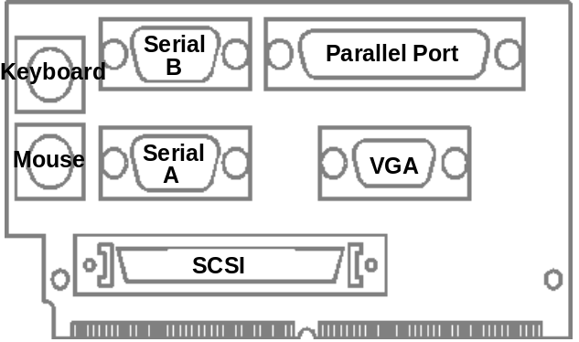
Figure 5. Example of I/O riser board
The I/O riser uses a 144-pin connector that is mechanically similar to a 72-bit SIMM module connector, but has 144-pins. The appendix details the pin-out of this connector.

System BIOS
The ALTServer baseboard uses an American Megatrends Incorporated (AMI) ROM BIOS, which is stored in an Intel Flash memory device and can be easily upgraded using a floppy disk-based program. The baseboard has an Intel 28F004BX-T 4 Mb FLASH component organized as 512 KB (512kbit x 8). This Flash memory device contains the following software elements:

- The AMI BIOS code
- The System Configuration Utility (SCU)
- Power-On Self Tests (POST)
- Update recovery code
- On-board Video BIOS
- On-board SCSI BIOS
- The PCI auto-configuration utility
- ISA Plug-N-Play software

The BIOS displays a sign-on message during POST identifying the type of BIOS and a five-digit revision code. This ASCII string has the following format:
- BIOSVersionx.yy.aa.pphvv
- - indicates an ASCII space character.
- X - The major revision as assigned by AMI (1). If this is an Alpha or Beta BIOS, this number will be '0'.
- YY - The minor revision as assigned by Intel. The minor revision will be ZERO for all production and Alpha BIOS versions, and will be the level of Beta for all Beta BIOS versions.
- AA - The release level of the BIOS.
- PP - The product identifier ('AD')
- H - The hardware revision level. This starts at 0 for the first fab and is revised each time a hardware change is made that requires a BIOS change.

Information on BIOS functions can be found in the IBM PS/2 and Personal Computer BIOS Technical Reference published by IBM, and the ISA and EISA Hi-Flex AMIBIOS Technical Reference published by AMI. Both manuals are available at most technical bookstores.

FLASH Implementation
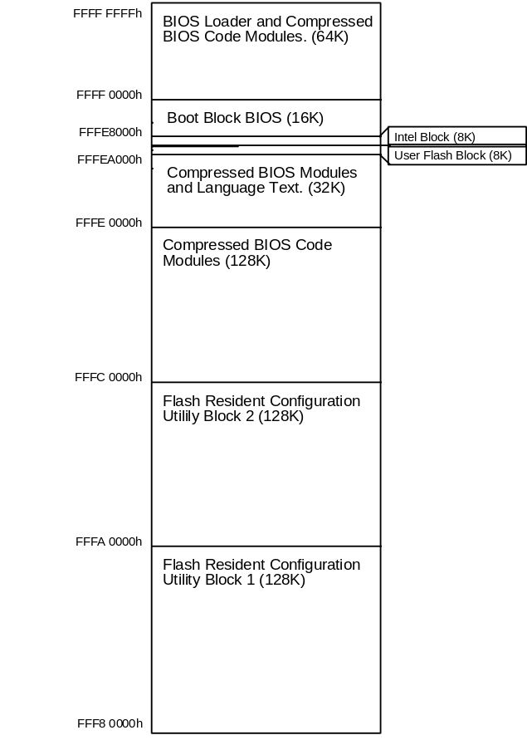
Figure 6. Flash memory implementation

System Configuration Utility (SCU)
The System Configuration Utility (SCU) is stored in the BIOS FLASH ROM and is a combination of the functionality previously contained in the EISA Configuration Utility (ECU) and the BIOS Setup utility.
The SCU, system configuration (CFG), and overlay (OVL) files are compressed and stored in the system BIOS ROM. Up to 256 KB of ROM is available for storage of the SCU and CFG/OVL files. Any additional files are maintained on floppy disk in DOS format. The SCU is decompressed into RAM and executed during POST if the user elects to reconfigure the system. This is activated by the user when the F1 key is typed in response to the BIOS prompt.
The SCU conforms to the version 3.12 of the EISA standard and version 1.1 of the ISA Plug and Play Specification. It can be used with any compliant CFG or OVL files that are supplied by an add-in peripheral device manufacturer. The ALTServer platform contains the PCI overlay (OVL) and PCI configuration (CFG) files for the embedded controllers on the system baseboard.
The SCU modifies the ISA CMOS and EISA NVRAM, under direction of the user. The actual hardware configuration is accomplished by the BIOS Power-On-Self-Test routines and the ISA Plug and Play Auto Configuration Manager.
The appendix lists the features that may be configured with the SCU and the defaults as shipped.

Power-On Self Tests (POST)
The system BIOS performs a Power On Self Test (POST) to confirm the correct operation of the baseboard hardware. Error messages are displayed on the video screen after the video subsystem has been tested and initialized. Prior to video initialization, beep codes are used to inform the user of errors. The POST error codes are logged into NVRAM and the Extended BIOS data area, according to the IBM PS/2 standard and are displayed on the LCD display. Refer to the Appendix for POST error codes and messages, POST beep codes, and their definitions

Update recovery code
A Flash Memory Update (FMUP) Utility is supplied, allowing the system BIOS and the System Configuration Utility to be updated from a diskette and without the need to open the chassis or remove any hardware.

Graphics and SCSI BIOS
The System BIOS contains the video BIOS for the Cirrus PCI graphics subsystem and also the SCSI BIOS for the on-board Adaptec PCI SCSI subsystem.

The PCI auto-configuration Utility
The PCI auto-configuration utility operates in conjunction with the System Configuration Utility to allow the insertion and removal of PCI cards without user intervention. When the system is turned on after adding a PCI add-in card, the BIOS automatically configures interrupts, DMA channels, I/O space, and other parameters. The user does not have to configure jumpers or worry about potential resource conflicts. Since PCI cards use the same interrupt resources as ISA cards, the user must specify the interrupts used by ISA add-in cards in the BIOS configuration utility. The PCI Auto-Configuration function complies with version 2.0g of the PCI BIOS specification.

ISA Plug & Play Capability
The BIOS will incorporate ISA Plug and Play capabilities as delivered by Intel Architecture Labs Plug and Play Release 1.2. This will allow auto-configuration of Plug and Play ISA cards, and of older non Plug and Play ISA cards.

System Level Features

Chassis
The ALTServer offers the expansion capabilities required by server applications with ten peripheral bays, expansion slots for up to seven add-in cards, a 230 watt power supply and an additional fan to cool a fully-loaded server configuration. Four of the peripheral bays (including the standard 3.5” floppy drive) can be accessed from the front of the chassis. The ALTServer also meets stringent environmental requirements.

Peripheral Bays
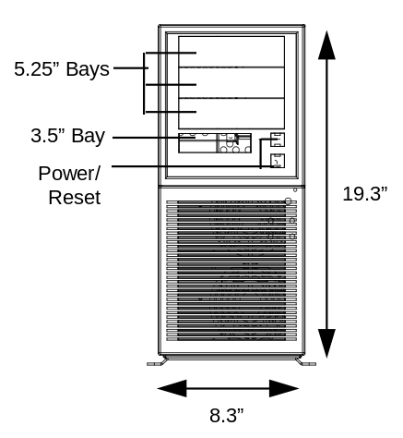
Figure 7. ALTServer front panel
Ten expansion bays are available for peripherals, including hard drives, tape drives, CD-ROMs, and other devices. These include three 5¼" half-height bays and one 3½" one-inch bay accessible from the front panel (filled in system configurations with a floppy drive). Six internal 3½" one-inch bays are located in a peripheral carrier than is hinged and swings out from the chassis for easy access and integration.

FAN
The ALTServer has two fans to keep the system cool. One fan within the power supply provides 28 cfm of air movement. The second fan, located at he chassis front, provides up 500lfmcacross the add-in cards and the processor. The second fan receives 12 Vdc directly from the baseboard.

Expansion slots
The ALTServer has eight expansion card slots, all of which are intended for use with full-length cards. Five of the slots are dedicated for use with EISA or ISA cards and two of the slots are dedicated for use with PCI add-ins. One slot is shared by connectors for either an EISA/ISA or PCI card, but not both at the same time.

Front Panel
The ALTServer front panel consists of a power switch, reset switch, a power-on LED and a hard disk access LED. Four peripheral bays also can be accessed from the front panel, as shown in Figure 7.

Back panel
The back panel consists of access panels for the expansion slots (one location is unused), a 115/230 voltage switch, a power supply input, an auxiliary power output and the power supply fan. Access also is provided for any of the ALTServer riser boards, which provide connections to the baseboard I/O devices and interfaces, including the parallel port, serial ports, video, keyboard, mouse, and narrow or wide SCSI-2. The riser is available in several configurations, routing the SCSI signals to either external devices or into the chassis.
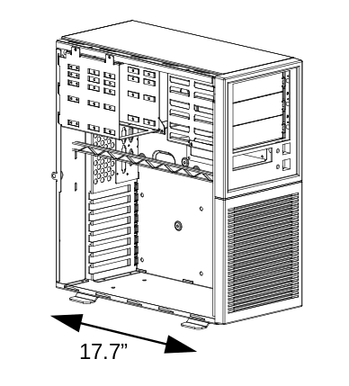
Figure 8. ALTServer angle view, showing slot locations and peripheral bays

Power Supply
The ALTServer integrates a 230 watt switchable power supply for all onboard resources, add-in cards, and peripherals. The Astec Corp. model SA230-3415 supports operating settings at 100-120 VAC (5 Amps AC) or 200-240 VAC (3 Amps AC). The input voltage is selected using a switch on the back of the system.

AC Power input SPEcifications
Input frequency 50/60 Hz
AC Voltage | Current
90-135 | 5.0 A
 | 4.0 A
Table 4. Power Supply Input Specifications.

DC output SPECIFICATIONS
DC Voltage | Max. Current Load | Minimum Current Load
+5V | 30.0A | 2.0A
-5V | 0.5A | 0A
+12V | 8.0A | .25A
-12V | 1.0A | 0A
Table 5. Power Supply DC Output Specifications.

Power Consumption
The following tables list the current and power consumed by system resources in a configuration which includes two Pentium processors and 8 SIMMs (two active and six standby). This information is preliminary and is provided as a guide for calculating approximate total system power usage with additional resources added.

Current
DC Voltage | Typical Current* | Max. Continuous Current
+5V | 8.85 amps | 15.75
-5V | Not required | Not required
+12V | 38 milliamps | 80 milliamps
-12V | 18 milliamps | 23 milliamps
Table 6. ALTServer current consumption (preliminary)

Watts
Resource | Max Power | Typical Power
Two 90 MHz processors with 32 MB SIMMs,  no add-in cards and no peripherals | 80 Watts | 45 Watts
Table 7. ALTServer wattage consumption (preliminary)

Floppy Drive
The ALTServer integrates a 3½" Teac Floppy drive Model FD-235HF into the external 3½" bay. This is the same proven floppy disk drive that has been used on many previous Intel systems.

Speaker
The standard system ships with an external speaker installed. The user may enable/disable the device using the System Configuration Utility or program the speaker via port 61H. The speaker provides error beep code information during POST if the system cannot use the video interface.

Chassis color
The chassis color is beige. The bottom and back of the chassis are not painted.

Appendix A − User-Installable Upgrades

PROCESSORS
Single-processor ALTServer platforms can be upgraded by using a processor with a faster clock speed. The baseboard is designed to operate with 75 MHz, 90 MHz, 100 MHz or 120 MHz Pentium processors.
Dual-processor configurations must always have Pentium processors with the same clock installed in the two Zero Insertion Force (ZIF) sockets. Users also must observe the table below in matching the voltage regulation characteristics of the processors:
Primary | Intel Part # | Secondary
STD | TBD | VRE or VR
VRE | TBD | VRE
VR | TBD | VR
When upgrading processors, it is also important to ensure the CPU Speed and voltage jumpers are set properly. See the appendix for details.

System Memory
Eight 72-pin sockets on the baseboard will accept up to 256 MB of system memory using 70 ns fast page SIMMs of the following sizes: 256K x 36 (1 MB), 512K x 36 (2 MB), 1M x 36 (4 MB), 2M x 36 (8 MB), 4M x 36 (16 MB), and 8M x 36 (32 MB) SIMMs. The minimum memory size is 2 MB and the maximum memory size, using eight 32 MB SIMMs, is 256 MB. Non-parity memory can be used by disabling parity checking with the SCU.
The eight SIMM sockets are arranged as four banks (Bank 0, 1, 2, and 3) with each bank consisting of two sockets. Both SIMMs in a bank must be of the same memory size and type, although separate banks may have different sizes and types of memory installed. In some instances, for electrical reasons only, it may be essential to populate Bank 0 first.
Because of the constant changes in the memory market, Intel engineering continually analyzes SIMMs by comparing information in the SIMM vendor's data book with the required timings on the ALTServer baseboard. Memory also is tested by either Intel or by respected OEM customers. A list of compatible/qualified SIMMs and those known to be incompatible is maintained on the Intel FaxBack* service (1-800-628-2283).

Secondary (L2) Cache Memory
The ALTServer provides an upgradeable second level (L2) cache using Integrated Device Technology (IDT) or Corsair cache modules. Five cache upgrade options are available, as shown in the table below:
Cache SRAM Type | Total Cache Size | Module
None | 0KB | None installed
Asynchronous | 256KB | IDT7MP6189-15(ns)
Asynchronous | 512KB | Corsair
Burst Synchronous | 256KB | IDT7MP6181-9(ns)
Burst Synchronous | 512KB | IDT7MP6182-9(ns)

Graphics DRAM
Video DRAM memory can be upgraded using one 256K x 16, 60 ns, DIP component. While some DRAM parts rated at 70 ns will function in ALTServer platforms, Intel does not warrant the use of these 70 ns parts, or assume any liability concerning the use of these parts.

DRAM Size | Vendor | DRAM Part #
256K x 16 | TBD | TBD

Appendix B − Jumpers
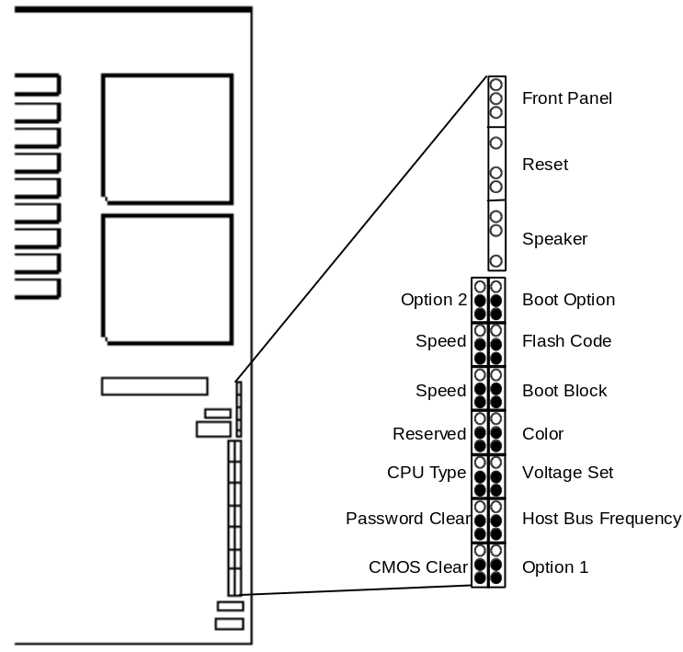

Purpose | Location | Selection | Description
CMOS Clear | J1B | *1-2, Protect  2-3, Clear | When set to 'Clear' the NVRAM settings will be set to their default values.
Option 1&2 | J1A&J7B | *1-2, Option High  2-3, Option Low | Reserved for future feature enhancement options.
Host Bus Frequency | J2A | *1-2, Bus:Core=2:3  2-3,.Bus:Core=1:2 | When set to ‘Bus:Core=2:3”, CPU sockets contain P54C Pentium Processors. If P54CS Processors are installed, this jumper must be set to ‘Bus:Core=1:2’.
Password Clear | J2B | *1-2, Protect  2-3, Clear | When set to 'Clear' the password stored in CMOS will be cleared
Voltage Set | J3A | *1-2, VR  2-3, VRE | When set to ‘VR’, the primary socket contains a STD or VR Pentium Processor.
CPU Type | J3B | *1-2, CPU1=Primary  2-3, CPU2=Primary | When set to ‘CPU1’, the primary CPU is installed in ZIF socket U7H1
Color | J4A | *1-2, Color  2-3, Monochrome | When set to 'Color', the primary video display supports color graphics.
Reserved | J4B | *1-2, Disable & Ground  2-3, Enable Kick Start | Reserved for future feature enhancement options.
Boot Block | J5A | *1-2, Protect  2-3, Erase/Program | When set to 1-2, the FLASH BIOS region that contains the actual system booting code is protected and cannot be updated.
Speed | J5B  J6B | *1-2, 60MHz  2-3, 66MHz  (1-2), 50MHz  *1-2, 60MHz  2-3, 66MHz  (2-3), 50MHz | When set to 1-2, either the only CPU or both CPUs are 60/90 Mhz Pentium Processors. These jumpers select the speed of both CPUs and must always be adjusted as a set (J5B and J6B) and not individually.
Flash Code | J6A | *1-2, Erase/Program  2-3, Protected | When set to 2-3, the Flash BIOS is protected and cannot be updated. This setting also protects the BIOS setup and EISA configuration information and prevents the user from changing any system settings. Default jumper (1-2) allows the user to enter and modify selections in the System Config. Utility.
Boot Option | J7A | *1-2, Normal Boot  2-3, Recovery | When set to 'Normal Boot' the system will run from the normal section of the Flash BIOS. Move only when the Flash BIOS becomes corrupted and the system needs to boot from protected recovery BIOS section.

Appendix C − Connectors

I/O Riser Board
The following table shows the pinout of the I/O riser board connector on the motherboard, indicating corresponding I/O connector pins. This connector is similar to a standard 144-pin SIMM connector.
Pin | I/O Connector Pin | Pin | I/O Connector Pin | Pin | I/O Connector Pin | Pin | I/O Connector Pin
1 | Mouse 4 | 37 | SCSI 48 | 73 | SCSI 68 | 109 | SCSI 39
2 | Mouse 1 | 38 | SCSI 47 | 74 | SCSI 67 | 110 | SCSI 38
3 | Mouse 5 | 39 | SCSI 46 | 75 | SCSI 66 | 111 | SCSI 37
4 | Keyboard 4 | 40 | SCSI 45 | 76 | SCSI 65 | 112 | SCSI 36
5 | Keyboard 1 | 41 | Video 15 | 77 | SCSI 64 | 113 | SCSI 35
6 | Keyboard 5 | 42 | Ground | 78 | Ground | 114 | Ground
7 | Serial Port A 4 | 43 | Video 14 | 79 | Ground | 115 | Ground
8 | Serial Port A 3 | 44 | Video 13 | 80 | Ground | 116 | Ground
9 | Serial Port A 2 | 45 | Ground | 81 | Ground | 117 | Ground
10 | Serial Port A 1 | 46 | Video 12 | 82 | Ground | 118 | Ground
11 | Serial Port A 6 | 47 | Video 11 | 83 | Ground | 119 | Ground
12 | Serial Port A 7 | 48 | Video 1 | 84 | Ground | 120 | Ground
13 | Serial Port A 8 | 49 | Video 2 | 85 | Ground | 121 | Ground
14 | Serial Port A 9 | 50 | Video 3 | 86 | Ground | 122 | Ground
15 | Serial Port B 4 | 51 | Ground | 87 | Ground | 123 | Ground
16 | Serial Port B 3 | 52 | Video 4 | 88 | Ground | 124 | Ground
17 | Serial Port B 2 | 53 | Parallel Port 13 | 89 | Ground | 125 | Ground
18 | Serial Port B 1 | 54 | Parallel Port 12 | 90 | Ground | 126 | Ground
19 | Serial Port B 6 | 55 | Parallel Port 11 | 91 | Ground | 127 | Ground
20 | Serial Port B 7 | 56 | Ground | 92 | Ground | 128 | Ground
21 | Serial Port B 8 | 57 | Parallel Port 10 | 93 | Ground | 129 | Ground
22 | Serial Port B 9 | 58 | Ground | 94 | Ground | 130 | Ground
23 | SCSI 17 | 59 | Parallel Port 9 | 95 | Ground | 131 | Ground
24 | SCSI 18 | 60 | Parallel Port 8 | 96 | Ground | 132 | Ground
25 | SCSI 19 | 61 | Parallel Port 7 | 97 | Ground | 133 | Ground
26 | SCSI 63 | 62 | Parallel Port 6 | 98 | Ground | 134 | Ground
27 | SCSI 62 | 63 | Parallel Port 5 | 99 | Ground | 135 | Ground
28 | SCSI 61 | 64 | Parallel Port 17 | 100 | Ground | 136 | Ground
29 | SCSI 60 | 65 | Parallel Port 4 | 101 | Ground | 137 | Ground
30 | SCSI 59 | 66 | Parallel Port 16 | 102 | Ground | 138 | Ground
31 | SCSI 58 | 67 | Parallel Port 3 | 103 | Ground | 139 | Ground
32 | SCSI 57 | 68 | Parallel Port 15 | 104 | SCSI 44 | 140 | Ground
33 | SCSI 55 | 69 | Parallel Port 2 | 105 | SCSI 43 | 141 | Ground
34 | SCSI 53 | 70 | Parallel Port 14 | 106 | SCSI 42 | 142 | Ground
35 | SCSI 52 | 71 | Ground | 107 | SCSI 41 | 143 | Ground
36 | SCSI 51 | 72 | Parallel Port 1 | 108 | SCSI 40 | 144 | Ground

PS/2 Style Mouse/Keyboard
The keyboard and mouse connectors are mounted on the I/O riser board. The mouse connector is normally stacked over the keyboard connector. I/O riser connector pin numbers are shown in parentheses.

Pin | Keyboard Signal | Description
1 (5) | KEYDAT | Keyboard Data
2 | (NC) | Not connected
3 | GND | Ground
4 (4) | FUSED_VCC | Supply voltage (via fuse, shared by mouse connector)
5 (6) | KEYCLK | Keyboard Clock
6 | (NC) | Not connected
The mouse connector is PS/2 compatible, with pinout shown below:
1 (2) | MSEDAT | Mouse Data
2 | (NC) | Not connected
3 | GND | Ground
4 (1) | FUSED_VCC | Supply voltage
5 (3) | MSECLK | Mouse Clock
6 | (NC) | Not connected

Serial Ports
Two 9-pin connectors are provided on the I/O riser board for Serial ports A and B. By default, port A is the top connector. Each port can be set to one of four different COMx ports (refer to the I/O address map), and can be enabled separately. When enabled, each port can be programmed to generate edge or level sensitive interrupts. When disabled, serial port interrupts are available to add-in cards. I/O riser connector pins for ports A and B respectively, are shown in parentheses.
Pin | Name | Description
1 (7, 18) | DCD | Data Carrier Detected
2 (8, 17) | RXD | Receive Data
3 (9, 16) | TXD | Transmit Data
4 (10, 15) | DTR | Data Terminal Ready
5 | GND | Ground
6 (11, 19) | DSR | Data Set Ready
7 (12, 20) | RTS | Return to Send
8 (13, 21) | CTS | Clear to Send
9 (14, 22) | RIA | Ring Indication Active

Parallel Port
The AIP provides one PS/2-compatible, 25-pin bi-directional parallel port. BIOS programming of the AIP configuration registers enable the port, and determine the port address and interrupt. When disabled, the interrupt is available to add-in cards. The parallel port connector appears on the I/O riser board (pins shown in parentheses):
Pin | Name | Pin | Name
1 (72) | STROBE# | 14 (70) | AUFDXT#
2 (69) | D0 | 15 (68) | ERROR#
3 (67) | D1 | 16 (66) | INIT#
4 (65) | D2 | 17 (64) | SLCTIN#
5 (63) | D3 | 18 | GND
6 (62) | D4 | 19 | GND
7 (61) | D5 | 20 | GND
8 (60) | D6 | 21 | GND
9 (59) | D7 | 22 | GND
10 (57) | ACK# | 23 | GND
11 (55) | BUSY | 24 | GND
12 (54) | PE | 25 | GND
13 (53) | SLCT

Graphics Monitor Port
Pin | Signal | Pin | Signal
1 (48) | RED | 9 | GND
2 (49) | GREEN | 10 | GND
3 (50) | BLUE | 11 (47) | Pull-up
4 (52) | Pull-up | 12 (46) | Pull-up
5 | GND | 13 (44) | HSYNC
6 | GND | 14 (43) | VSYNC
7 | GND | 15 (41) | Pull-up
8 | GND

Front Panel and LCD Display
The INCA component drives a front panel interface and LCD display. Additional required circuitry consists primarily of two ICs and one 34-pin connector. The electrical interface on the ALTServer is compatible with the Sharp P/N LM16X21A (Intel P/N 201508-001) LCD Display. For complete information, refer to the data sheet for the Sharp component. The connector is for a 34-pin ribbon cable that connects to a distribution board for LEDs, key lock assembly and LCD display, with pinout shown below:
Pin | Signal | Function
1 | SPKDAT | Speaker DATA
2 | +5V
3 | +5V STANDBY
4 | PS-ON | Power Supply on status
5 | FP-RESET# | Front Panel Reset
6 | 0V
7 | N/C
8 | 0V
9 | HD1 LED VCC | Internal Controller Drive LED
10 | HD1 LED RTN | Internal Controller Drive LED RETURN
11 | HD2 LED RTN | ADD-IN Controller Drive LED RETURN
12 | HD2 LED VCC | ADD-IN Controller Drive LED
13 | KEYBD KEYLOCK# | Front Panel Keylock Switch
14 | 0V
15 | SECURE MODE | Secure Mode Status from Main Board
16 | CHASSIS SWT | Chassis Door Switch
17 | KEY
18 | +5V
19 | I2C-SDA | I2C Serial Data
20 | CHASSIS SWT RET | Chassis Door Switch Return
21 | LCD-SD | LCD Serial Data
22 | KS# | Kick Start RTC
23 | LCD-SCLK | LCD Serial Clock
24 | I2C-SCL | I2C Clock
25 | LCD-PCLK | LCD Parallel Clock
26 | 0V
27 | EN | Reserved
28 | 0V
29 | RW | LCD READ/WRITE
30 | N/C
31 | RS | Reserved
32 | PWR# | Shut Down Power
33 | LCD-VDD | LCD Voltage
34 | 0V

Primary Power
The ALTServer uses a 12-pin standard AT power supply connector with the following pinout:
Pin | Signal | Pin | Signal
1 | PWRGOOD | 7 | GND
2 | +5V | 8 | GND
3 | +12V | 9 | -5V
4 | -12V | 10 | +5V
5 | GND | 11 | +5V
6 | GND | 12 | +5V

12V Fan Power
There are two fan connectors, both appropriately located for the placement of a fan. The connectors are 3-pin, single in-line, .025 in. square pin with the following pinout:
Pin | Signal
1 | Fan Rotation Sense
2 | +12V
3 | GND

IDE Interface
The 40 pin IDE connector is located on the baseboard. The IDE interface does not support the Enhanced IDE (E-IDE) specification so the maximum number of disk drives that may be connected is two.
Pin | Function | Pin | Function
1 | IDERST* | 21 | IDEDRQ
2 | GND | 22 | GND
3 | ID7 | 23 | IDEIOW*
4 | ID8 | 24 | GND
5 | ID6 | 25 | IDEIOR*
6 | ID9 | 26 | GND
7 | ID5 | 27 | CHRDY
8 | ID10 | 28 | SPSYNC
9 | ID4 | 29 | IDEDAK*
10 | ID11 | 30 | GND
11 | ID3 | 31 | IDEIRQ14
12 | ID12 | 32 | IDEIO16*
13 | ID2 | 33 | IDESA1
14 | ID13 | 34 | PDIAG*
15 | ID1 | 35 | IDESA0
16 | ID14 | 36 | IDESA2
17 | ID0 | 37 | IDECS0*
18 | ID15 | 38 | IDECS1*
19 | GND | 39 | IDEHDACT*/DRVPRES*
20 | Keyed | 40 | GND

PCI Connectors
Following is a summary of PCI signal pins, including the signal mnemonic, electrical type, full name, and brief description. The electrical types are as follows:
Type | Description
in | Input is a standard input-only signal.
out | Totem Pole Output is a standard active driver.
t/s | Tri-State is a bi-directional, tri-state input/output pin.
s/t/s | Sustained Tri-State is an active low tri-state signal owned and driven by one and only one agent at a time, subject to specific timing restrictions.
o/d | Open Drain allows multiple devices to share signals as a wired-OR.

Signal(s) | Type | Name and Description
AD[31::00] | t/s | Address and Data are multiplexed; during the first clock of a transaction (address phase) they contain a 32-bit physical address; during subsequent clocks, data. As address bits, AD0 and AD1 have no significance; instead, they are encoded to indicate the burst type.
C/BE[3::0]# | t/s | Bus Command and Byte Enable are multiplexed; during the address phase of a transaction, they define the bus command; during the data phase they determine which byte lanes carry valid data.
DEVSEL# | s/t/s | Device Select, when actively driven, indicates the driving device has decoded its address as the target of the current access. As an input, it indicates whether any device on the bus has been selected.
FRAME# | s/t/s | Cycle Frame is driven by the current master to indicate the beginning and duration of an access.
GNT# | in | Grant indicates to the agent that the arbiter has granted access to the bus. This is a point to point signal. Every master has its own GNT#.
IDSEL | in | Initialization Device Select is used as a chip select instead of the upper 24 address lines during configuration read and write transactions.
IRDY# | s/t/s | Initiator Ready indicates the initiating agent's (bus master's) ability to complete the current data phase of the transaction. During a write, IRDY# indicates that valid data is present. During a read, it indicates the master is prepared to accept data.
INT[A-D]# | o/d | Interrupts are defined as “level sensitive” and asserted low using open drain output drivers. The assertion and deassertion of INT[A-D]# lines is asynchronous to CLK.
LOCK# | s/t/s | Lock indicates an atomic operation that may require multiple transactions to complete.
PAR | t/s | Indicates even parity across AD[31::00] and C/BE[3::0]#. Parity generation is required by all PCI agents.
PERR# | s/t/s | Parity Error reports a data parity error on all commands except Special Cycle.
PRSNT1#  PRSNT2# | in | Present Lines indicate the presence of a PCI add-in board in the connector, and the power requirements of the add-in board.
REQ# | out | Request indicates to the arbiter that this agent desires use of the bus. This is a point to point signal. Every master has its own REQ#.
RST# | in | Reset forces the PCI sequencer of each device to a known state.
SBO# | in/out | Snoop Backoff indicates whether the current memory access may proceed or is required to be retried.
SDONE | in/out | Snoop Done indicates the status of the snoop for the current cache access.
SERR# | o/d | System Error reports address parity errors, data parity errors on Special Cycle commands, or any other system error where the result will be catastrophic.
STOP# | s/t/s | Stop indicates the current target is requesting the Master to stop the current transaction.
TCK | in | Test Clock clocks state information and data into and out of the device during boundary scan. All of the test related pins conform to the Test Access Port (TAP) and Boundary Scan Architecture defined by IEEE Standard 1149.1
TDI | in | Test Input shifts data and instructions into the TAP in a serial manner.
TDO | out | Test Output shifts data out of the device. If an add-in card does not implement a TAP, TDI and TDO should be tied together.
TMS | in | Test Mode Select controls the state of the TAP controller.
TRDY# | s/t/s | Target Ready indicates the target agent's (selected device's) ability to complete the current data phase of the transaction. During a read TRDY# indicates that valid data is present. During a write it indicates the target is prepared to accept data.
TRST# | in | Test Reset is used to force the TAP controller into a test logic reset state.

EISA Bus Signals
Following is a summary of EISA signal pins, including the signal mnemonic, name, and brief description. A “bus master” can be either the PCEB, or EISA expansion board with master capability.
Signal(s) | Name and Description
AENx | Address Enable for slot x (x = 1 to 6). When asserted, an I/O slave in the slot responds to addresses and I/O commands
BALE | Bus Address Latch Enable. When asserted, indicates a valid address on LA[31::24]# and LA[23::2].
BCLK | Bus Clock. Synchronizes events on the EISA bus (at 8.33 MHz nominal).
BE[3::0]# | Byte Enables identify specific bytes in a Dword. Combinations determine which byte lane carries valid data.
CHRDY | Channel Ready. Driven low (never high) by a memory or I/O slave to lengthen the current bus cycle by an integral number of BCLK ticks.
CMD# | Provides timing control within a cycle.
D[15::8] | Third-highest-order 8-bits of 32-bit data bus (byte lane 1) on EISA connector.
D[23::16] | Second-highest-order 8-bits of 32-bit data bus (byte lane 2) on EISA connector.
D[31::24] | High-order 8-bits of 32-bit data bus (byte lane 3) on EISA connector.
D[7::0] | Low-order 8-bits of 32-bit data bus (byte lane 0) on EISA connector.
DAK[7::0]# | DMA Acknowledge lines.
DRQ[7::0] | DMA Request lines.
EX16# | Asserted by slaves to indicate support of 16-bit transfers only.
EX32# | Asserted by slaves to indicate support of 32-bit transfers.
EXRDY | Negated by slaves to request wait states (wait state = 1 BCLK tick).
IO16# | 16-bit I/O Capable. Indicates that this is a 16-bit I/O slave.
IOCHK# | Signals a serious error.
IORC# | I/O Read Command. Asserted by the bus master to indicate that the I/O slave may drive data (qualified by AENx).
IOWC# | I/O Write Command. Asserted by the bus master to indicate valid data for an I/O slave (qualified by AENx).
IRQ[15::14], IRQ[12::9], IRQ[7::3] | Interrupt request lines.
LA[23::2] | Portion of the Latchable Address bus seen by all devices (16- and 32-bit).
LA[31::24]# | High-byte of the Latchable Address bus, wired to 32-bit portion of connector only. The latchable address is pipelined from one bus cycle to the next.
LOCK# | Guarantees exclusive access to memory or I/O cycles for the bus master asserting this signal.
M/IO# | Memory or I/O. Indicates the current cycle type that the bus master is using.
M16# | 16-bit Memory Capable. Only ISA memory slaves generate this signal.
MAKx | Master Bus Acknowledge. Asserted by system board to grant bus access to requesting EISA master (x = slot number).
MASTER16# | 16-bit EISA master indicator.
MRDC# | Master Memory Read Command. When asserted by bus master, indicates the addressed memory slave may drive data.
MREQx# | Master Bus Request. Asserted by EISA masters until sys. board responds with MAKx# (x = slot) to obtain access to bus.
MSBURST# | Master Burst. Indicates to an EISA slave that the bus master is capable of burst cycles.
MWTC# | Master Memory Write Command. When asserted by bus master, indicates the addressed memory slave may latch data.
NOWS# | No Wait State. An ISA slave asserts NOWS# to indicate that no more clock cycles are required to complete this transaction. An EISA asserts NOWS# to generate compressed cycles (1.5 BCLKs/cycle).
OSC | 14.31818 MHz clock for timer loops.
REFRESH# | When asserted, indicates that a memory refresh cycle is in progress.
RESDRV | When asserted, causes a hard reset of ISA and EISA expansion boards.
SA[19::0] | Low-order 20-bits of the 32-bit address, valid throughout the entire bus command cycle.
SBHE# | System Bus High Enable. When asserted, indicates the 16-bit expansion board should drive data on high half of D[15::0]
SLBURST# | Slave Burst. Asserted by slaves that support burst cycles.
SMRDC# | System Memory Read Command. . When asserted by the system board, indicates that the addressed memory slave may drive data. Only asserted during ISA read accesses from 00000000H through 000FFFFFH.
SMWTC# | System Memory Write Command. When asserted by the system board, indicates that the addressed memory slave may latch data. Only asserted during ISA write accesses to 00000000H through 000FFFFFH.
START# | Provides timing control for the bus master at the start of a cycle.
TC | Terminal Count. As an output, indicates that the DMA word count rolls over from 0 to FFFFFFH. As an input, indicates that the DMA slave wants to terminate the transfer.
W/R# | When high, indicates a write cycle; when low a read.

Appendix D − System Configuration Utility
The System Configuration Utility (SCU) and system CFG/OVL files will be compressed and stored in the system BIOS ROM. Up to 256 KB of ROM is available for storage of the CU and CFG/OVL files. Any additional files will be maintained on floppy disk in DOS format. The CU will be decompressed into RAM and executed during POST if the user elects to re configure the system. This will be activated by the user when the F1 key is typed in response to the BIOS prompt.
The CU modifies the ISA CMOS RAM and EISA non-volatile RAM, under direction of the user. The actual hardware configuration is accomplished by the BIOS Power-On-Self-Test routines and the ISA Plug-N-Play Auto Configuration Manager.
The CU always updates a checksum for both areas, so that any potential data corruption will be detectable by the BIOS, before the actual hardware configuration takes place. If the data has been corrupted, the BIOS will request that the user configure the system, before the system is booted.

SCU-Configurable Features (Default values are in bold type)
Configuration Feature | Selection Options |  | Notes
System ID String | None |  | Configured by the User or System Integrator, using the ROM-based or disk-based configuration utility.
Display Processor Type(s) and Max. Speed and Failed Status | N/A |  | Display only
Power-On Speed | Fast / Slow |  | BIOS programs the SLOWH timer before boot.
Cache control | Disabled / Enabled |  | BIOS will enable cache before booting OS.
Display BIOS version string | N/A |  | Display only
Display CFG and OVL versions | N/A |  | Display only
 | Video Subsystem
Video | N/A |  | Auto configured, see text.
 | Memory Subsystem
Base Memory | 512 / 640 KB
Total Memory |  |  | Display only.
Automatic Memory Resizing | Enable / Disable
Skip Memory Test | Enable/ Disable
Memory 15M-16M | Enable/Disable
 | Floppy Subsystem
Floppy Autodetect | Enable / Disable
Floppy Drive Type | *Auto / 360 / 1.2 / 1.44
 | IDE Subsystem
Onboard IDE Controller | Auto / Disable
Number of Hard Disks supported. | Not user selectable, always 4
IDE Auto configuration | Auto / Custom
 | SCSI Subsystem
SCSI Controller | Enable / Disable
SCSI BIOS Shadow | None |  | Must be shadowed, not user selectable.
SCSI Channel Selection | Internal / External
SCSI Boot Selection | SCSI-A / SCSI-B
 |  | KB/Mouse Subsystem
NumLock State at Boot |  | On / Off
Typematic Speed |  | Slow / Medium / Fast
Mouse |  | Auto detected | Using AMI Keyboard Controller
 |  | Serial Subsystem
Serial Port Address |  | 220h, 228h, 238h, 2E8h, 2F8h, 338h, 3E8h, 3F8h | Serial-A = COM1(3F8), Serial-B = COM2 (2F8)
Serial Port IRQ |  | 3 or 4 | Serial-A=IRQ 4, Serial-B=IRQ 3
Select Serial Port Redirection |  | Disable/ port 1/ port 2 | 2 ports
Serial Port Baud Rate |  | 19.2Kb/ 9600b/ 2400b
Serial Port Terminal Type |  | VT100 / IBM-PC ANSI

SCU-Configurable Features (Continued / Default values are in bold type)
 | Parallel Subsystem
Parallel Port Address | 378h, 278h, 3BCh | 1 port
Parallel Port IRQ | 5 or 7 | 1 port
Parallel Port Mode | ISA-compatible, PS/2, EPP/ECP
 | Security Subsystem
Administrative Password | Set/Not Set
User Password | Set/Not Set
Keyboard Pushbutton Lock | N/A | Enable security only if either user or administration password is enabled.
Keyboard Lockout Timer | Timeout, 1-127 (10 min), Disabled
Network Server Mode | Enable / Disable
Video Blanking | Enable / Disable
Reset Button and Power Switch Locking | Enable / Disable
Floppy Boot | A: then C:, C: then A:, C: only, A: only
Floppy Writes | Enable / Disable
Secure Mode Hot-Key | Ctrl-Alt-key or None | Ctrl-Alt-Key enters secure mode immediately.
Boot Without Keyboard | N/A | No error message will be displayed.
CMOS Lock Switch | N/A | Not supported in HW. See 'Admin Password'
 | LCD Display
LCD | Enable / Disable
LCD Display String After Boot | (user defined string or default) | Default is "N x PID Speed System Ready "  where N = number of processors, PID is processor ID string, and Speed is the processor in MHz.
 | Management Subsystem
+5 V Upper Warning Level | 0.02 - 5.4 V in 0.02 V steps | 5.26V default
+5 V Lower Warning Level | 0.02 - 5.4 V in 0.02 V steps | 4.76V default
+5 V Upper Critical Level | 0.02 - 5.4 V in 0.02 V steps | 5.4V default
+5 V Lower Critical Level | 0.02 - 5.4 V in 0.02 V steps | 4.6V default
+12 V Upper Warning Level | 0.1 - 14.9 V in 0.1 V steps | 12.6 V default
+12 V Lower Warning Level | 0.1 - 14.9 V in 0.1 V steps | 11.4 V default
+12 V Upper Critical Level | 0.1 - 14.9 V in 0.1 V steps | 12.96 V default
+12 V Lower Critical Level | 0.1 - 14.9 V in 0.1 V steps | 11.04 V default
+3.3 V Upper Warning Level | 0.02 - 3.74 V in 0.02 V steps | 3.62 V default
+3.3 V Lower Warning Level | 0.02 - 3.74 V in 0.02 V steps | 3.14 V default
+3.3 V Upper Critical Level | 0.02 - 3.74 V in 0.02 V steps | 3.72 V default
+3.3 V Lower Critical Level | 0.02 - 3.74 V in 0.02 V steps | 2.96 V default
-12 V Upper Warning Level | -16.7 to -5.9V in .1V steps | -11.4 V default
-12 V Lower Warning Level | -16.7 to -5.9V in .1V steps | -12.6 V default
-12 V Upper Critical Level | -16.7 to -5.9V in .1V steps | -11.0 V default
-12 V Lower Critical Level | -16.7 to -5.9V in .1V steps | -13.0 V default
Temp. Probe #1 Upper Warning Level | 0 °C to 200 °C in 2 °C steps | TBD
Temp. Probe #1 Lower Warning Level | 0 °C to 200 °C in 2 °C steps | 0
Temp. Probe #1 Upper Critical Level | 0 °C to 200 °C in 2 °C steps | TBD
Temp. Probe #1 Lower Critical Level | 0 °C to 200 °C in 2 °C steps | 0
Temp. Probe #2 Upper Warning Level | 0 °C to 200 °C in 2 °C steps | TBD
Temp. Probe #2 Lower Warning Level | 0 °C to 200 °C in 2 °C steps | 0
Temp. Probe #2 Upper Critical Level | 0 °C to 200 °C in 2 °C steps | TBD
Temp. Probe #2 Lower Critical Level | 0 °C to 200 °C in 2 °C steps | 0
Event Logging | Enable / Disable | Controls onboard event logging.

Appendix E − AMIBIOS Messages and Beep Codes

Error Messages

Beep Codes
The BIOS indicates failures with beep codes prior to the initialisation of the video adapter. The beep code is a series of individual beeps, each equal in length. The following table describes the error conditions associated with each beep code:
Beep Count | Error Condition
1 | Refresh failure
2 | Parity can't be reset
3 | First 64KBmemory failure
4 | Timer not operational
5 | Processor failure
6 | 8042 gate a20 is off (v_mode)
7 | Exception interrupt error
8 | Display memory r/w error
9 | ROM checksum error
10 | Shutdown reg. r/w error

POST Codes and Countdown Codes
The BIOS indicates the current stage of the Power-On Self Test (POST) after the video adapter has been successfully initialized. A two-digit hex code is sent to I/O location 80h. This code can be shown on an LED display if a Port 80h card is installed. The current countdown code will also be displayed on the LCD panel, once it is initialized.

CODES DISPLAYED DURING RECOVERY BOOT PROCESS
The following table contains the Port 80 codes and the POST countdown codes displayed during the recovery boot process. This process is enabled by moving the Flash jumper from the position marked Boot to the opposite position, and cold-booting the system. During this process the floppy disk in drive A is booted and a BIOS image is automatically installed.
CP | YY | Reason
02h |  | Disable internal cache
08h |  | Disable DMA controller #1, #2, disable interrupt cntlr #1, #2, reset video display.
13h |  | Init all chipset registers (Enable LCD display here)
*15h | 900 | Initialise system timer
*1Bh | 800 | Real mode base 64k test
*20h | 700 | 16k base ram test
*23h | 650 | SDetup interrupt vectors
*40h | 600 | Test memory in virtual mode.
*65h | 500 | Initialise 8237 dma cntlr
*67h | 400 | 8259 interrupt cntlr test
*80h | 300 | Unmask diskette, kb and timer interrupts
*88h | 200 | Floppy unit initialisation
*A0h | 100 | Cache enable
*00h | 000 | Boot OS.
CP= AMIBIOS check point (Port 80) code; YY= ALTServer BIOS countdown code

CODES DISPLAYED DURING NORMAL BOOT PROCESS

CP | XX | Reason
D0h |  | Returned from ResetInit
D1h |  | PowerOnInit
D2h |  | Return from PowerOnInit
D3h |  | SoftResetEntryPoint:
D4h |  | Test to see if we are in Protected mode (entered from POST.BIN not
D5h |  | Checksum only the LOADER.BIN
D6h |  | Loader.bin checksum good. (Enable LCD in InitBeforeKBCInit)
*D7h | 900 | Issue BAT command to KBD controller.
D8h |  | After waitForEmptyBuffer
D9h |  | After Empty8042InputBufferX
DAh |  | After Retrieve8042OutputBufferX
DBh | 820 | Keyboard Init Passed
DDh |  | After initAfterKBCInitEnd
DFh |  | 2nd Empty8042InputBufferX
*E0h | 780 | Initialize Master/Slave PICs
E1h |  | Before ChipsetInitEnd (before chip set initialization ends)
E2h |  | After ChipsetInitEnd (after chip set initialization ends)
*E3h | 760 | Initialize timer channel 0 for system timer.
E4h |  | Before beginning memory test need to clear any pending parity errors.
E6h | 740 | Test RAM from 0-640KB
E7h |  | GetMinPartitionSizeX(get minimum partition size)
E8h |  | RAM failure, call RemapMemoryPartitionX(memory failure)
E9h |  | RAM test complete, passed.
EBh | 730 | Set up stack at 30:100
EBh |  | BIOS just shadowed
ECh |  | Make F000h DRAM R/W Enabled
EDh |  | Dispatch POST
*23h | 700 | Setup interrupt vectors
24h |  | Just after call to SetPostEnvironment(after a call to setup the POST environment)
0Dh |  | CustomCheckManufacturingMode and CheckDefaultJumper
0Eh | 690 | Check validity of CMOS
0Fh |  | Force CMOS defaults
10h |  | CMOS init complete
25h |  | After Initialize CMOS pointers in EBDA
*F0h | 600 | EISA slot initialization
F1h |  | Enable extended NMI sources
F2h |  | Test extended NMI sources
28h |  | Set monochrome mode
29h |  | Set color display
2Ah |  | Clear parity status if any
2Bh |  | Call ChipsetBeforeVideoInit
2Ch | 580 | Video option ROM search
2Dh |  | Call CustomAfterVideoInit (calls custom code aftyer video has initialized)
2Eh | 570 | After video init
2Fh | 560 | After mono display setup
30h |  | Before check for vertical retrace
31h |  | Test for color display memory
32h |  | Check for vertical retrace
34h |  | Video card detected

35h | 520 | Initialize Console Redirection
36h |  | InitializeMessagingServices and ClearScreen
37h | 500 | CustomDisplaySignon
F3h |  | EISA ErrorDisplay
80h | 370 | KB/mouse port check
81h |  | Keyboard error determination.
82h |  | Enable Keyboard Interrupts and initialize keyboard circular buffer
83h |  | Check if keyboard is locked
F5h | 330 | Initialize mouse
39h |  | CustomUpdateScreenPointers,CustomDisplaySetupMessage,CustomDisplayKeyboardSignon,CustomDisplayMouseSignon
3Bh |  | Jumps to 'StartMemoryTesting' in next module.
43h | 290 | call GetMinPartitionSizeX
4Fh |  | call DisableEnhancedPost
52h |  | call ChipsetAdjustMemorySize
*61h | 250 | DMA register tests
62h |  | DMA test OK
64h |  | DMA controller latch test
65h |  | Initialize 8237 DMA controller
66h |  | clear DMA write request reg and mask set/reset reg
*67h | 220 | 8259 Interrupt cntlr test
F4h |  | Enable extended NMI sources
8Ch | 140 | Chipset@Devinit and ConfigurePeripheralController
8Fh | 130 | Floppy Initialization
91h | 120 | HD initialization
92h |  | Set printer, rs-232 time out
96h |  | Before Option ROM scan
97h | 080 | Option ROM scan C800h-E000h
98h |  | After Option Rom scan
9Ah |  | Soft reset (1234) --> (1200)
9Dh | 070 | Timer data area initialization
A0h |  | Printer setup
A1h |  | RS_232 setup
A2h |  | After KB circular buffer set up
ABh |  | Before NPX test and init
*ACh | 060 | NPX test and init
ADh |  | Update coProcessor info in cmos and recalculate checksum
AEh |  | Set typematic rate
*AFh | 050 | KBD read ID command
B0h |  | Wait for READ ID response
A3h |  | Display POST errors
A6h |  | Before Setup
*A7h | 030 | Call Setup
B1h |  | Enable Cache for boot
B3h |  | Setup display mode set
B4H |  | Jmp preos.asm (jump to program outside)
BBh | 020 | Start of PreOS
00h | 000 | Execute BOOT

Appendix F − BIOS Upgrades & Recovery
The ALTServer incorporates the AMIBIOS in a Flash memory component. Flash BIOS allows easy upgrades without the need to replace an EPROM. The upgrade utility fits on a floppy diskette and provides the capability to save, verify, and update the system BIOS. The upgrade utility can be run from a hard drive or a network drive, but no memory managers can be installed during upgrades. The latest upgrade utility and BIOS code are available to qualified customers on the Intel bulletin board. Once the utility is obtained, UNZIP the archive and copy the files to a bootable MS-DOS 5.0, or 6 diskette. Reboot the system with the upgrade diskette in the bootable floppy drive.

In the unlikely event that a Flash upgrade is interrupted catastrophically, it is possible the BIOS may be left in an unusable state. Recovering from this condition requires the following steps (be sure a power supply and speaker have been attached to the board, and a floppy drive is connected as drive A:)
- 1. Change Boot Option jumper (J7A) to the recovery mode position (2-3)
- 2. Install the bootable upgrade diskette into drive A: and reboot the system
- 3. Because of the small code in the non-erasable boot block area, no video is available to direct the procedure. It can be monitored using the speaker and the drive LED. When the system beeps and the drive LED is lit, the system is copying recovery code into the Flash device. When the LED goes off, recovery is complete.
- 4. Turn the system off.
- 5. Change the Boot Option jumper back to the default position (1-2)
- 6. Leave the upgrade floppy in drive A:, turn the system on, and continue with the original upgrade.

Appendix G − Memory Map
Address Range (in Hex)[Block Range] | Block Size | Resource | Notes
0000_0000 - 0003_FFFF | 256 KB | System memory
0004_0000 - 0007_FFFF | 256 KB | System memory
0008_0000 - 0009_FFFF  [512 KB - 640 KB] | (4) 32 KB  blocks | System memory  or ISA memory | 1. Configurable.  2. DRAM is lost if ISA Memory.
000A_0000 - 000B_FFFF  [640 KB - 768 KB] | (4) 32 KB  blocks | System memory  or ISA memory | 1. ISA Video Data RAM  2. Supports SMM attribute.
000C_0000 - 000E_FFFF  [768 KB - 960 KB] | (12) 16 KB  blocks | System memory  or ISA memory | 1. Configurable. 2. Can be shadowed/cached.  3. DRAM is lost if ISA Memory.
000F_0000 - 000F_FFFF  [960 KB - 1024 KB] | 64 KB | ISA memory | 1. System BIOS (Fixed). 2. Can be shadowed / cached. 3. DRAM is lost if not Shadowed.
0010_0000 - 00EF_FFFF  [1 MB - 15 MB] | 14 MB | System memory  or unused | 1. Depends on installed DRAM.
00F0_0000 - 00FF_FFFF  [15 MB - 16 MB] | 1 MB | System memory  or EISA/ISA memory | 1. Depends on installed DRAM. 2. Can be configured for AT EPROM space*. 3. If AT EPROM enabled, DRAM is lost. 4. Supports SMM attribute
0100_0000 - 3FFF_FFFF  [16 MB - 1 GB] | 1008 MB | System memory  or Unused | 1. Depends on installed DRAM
4000_0000 - BFFF_FFFF  [2 GB - 3 GB] | 1024 MB | EISA memory or Xpress I/O slave memory
C000_0000 - C1FF_FFFF  [3 GB - (3G + 32 MB)] | 32 MB | Memory mapped math coprocessor (Weitek)
C200_0000 - FEBF_FFFF  [(3GB + 32 MB) - (3GB + 976 MB)] | 944 MB | EISA memory
FEC0_0000 - FEC0_0FFF | 4 KB | I/O APIC #1 | Default for ESC
FEC0_1000 - FEC0_1FFF | 4 KB | I/O APIC #2 | Default for INCA
FEC0_2000 - FEC0_2FFF | 4 KB | I/O APIC #3
FEC0_3000 - FEC0_3FFF | 4 KB | I/O APIC #4
FEC0_4000 - FFDF_FFFF | 32752 KB | EISA memory
FFE0_0000 - FFFF_FFFF  [(3GB + 1008 MB) - (3 G + 1024 MB)] | 32 MB | EISA (BIOS/ECU)
*The top 128 KB of this area is used for EPROM. The remaining 896 KB is available for AT add-in cards.

Appendix H − I/O Map
Hex Address(es) | Resource | Notes
0000 - 001F | DMA Controller 1 | ESC
0020 - 0021 | Interrupt Controller 1 | ESC
0022 - 0023 | ESC Configuration Space Access Ports
0024 - 0025 | AIP Configuration Space Access Ports
0026 - 0027
0040 - 005F | Programmable Timer | ESC
0060 - 0064 | Keyboard Controller | Keyboard chip select from ESC
0061 | NMI Status & Control Register | ESC
0070 | NMI Mask (bit 7) & RTC Address (bits 6:0) | Write Only.
0071 | Real Time Clock (RTC) | RTC chip select from ESC
0080 - 0081 | PCEB BIOS Timer
0080 - 008F | DMA Low Page Register | ESC
0092 | System Control Port A ( PC-AT control Port) | INCA Register
0094 | Video Display Controller | Cirrus 5430
00A0 - 00BF | Interrupt Controller 2 | ESC; 82374EB
00C0 - 00DF | DMA Controller 2 | ESC;82374EB
00F0 | Clear NPX error | Resets IRQ13
00F8 - 00FF | x87 Numeric CoProcessor
0102 | Video Display Controller
0170 - 0177 | Secondary Fixed Disk Controller (IDE)
01F0 - 01F7 | Primary Fixed Disk Controller (IDE)
0200 - 0207 | Game I/O Port
0220 - 022F | Serial Port A
0238 - 023F | Serial Port A
0278 - 027F | Parallel Port 3
02E8 - 02EF | Serial Port B
02F8 - 02FF | Serial Port B
0338 - 033F | Serial Port B
0370 - 0375 | Secondary Floppy
0376 | Secondary IDE
0377 | Secondary IDE/Floppy
0378 - 037F | Parallel Port 2
03B4 - 03BA | Monochrome Display Port
03BC - 03BF | Parallel Port 1
03C0 - 03CF | Video Display Controller
03D4 - 03DA | Color Graphics Controller
03E8 - 03EF | Serial Port A
03F0 - 03F5 | Floppy Disk Controller
03F6 - 03F7 | Primary IDE - Secondary. Floppy
03F8 - 03FF | Serial Port A (Primary)
0400 - 043F | DMA Controller 1, Extended Mode Registers. | ESC
0461 | Extended NMI / Reset Control | ESC
0462 | Software NMI | ESC
0464 | Last EISA Bus master granted
0480 - 048F | DMA High Page Register. | ESC
04C0 - 04CF | DMA Controller 2, High Base Register.
04D0 - 04D1 | Interrupt Controllers 1 and 2 Control Register.
04D4 - 04D7 | DMA Controller 2, Extended Mode Register.
04D8 - 04DF | Reserved
04E0 - 04FF | DMA Channel Stop Registers
0678-067A | Parallel Port (ECP)
0778-077A | Parallel Port (ECP)
07BC-07BE | Parallel Port (ECP)
0800 - 08FF | NVRAM
0C80 - 0C83 | EISA System Identifier Registers | ESC

I/O Map (Continued)
Hex Address(es) | Resource | Notes
0C84 | Board Revision Register
0C85 - 0C86 | BIOS Function Control
0CF8 | PCI CONFIG_ADDRESS Register | PCMC
0CF9 | PCMC Turbo and Reset control
0CFC | PCI CONFIG_DATA Register | PCMC
n000 - n0FF | EISA Slot n I/O Space | n = 1 to 15.
x100 - x3FF | ISA I/O slot alias address | alias of 100H - 3FFH.
n400 - n4FF | EISA Slot n I/O Space | n = 1 to 15.
x500 - x7FF | ISA I/O slot alias address | alias of 100H - 3FFH.
n800 - n8FF | EISA Slot n I/O Space | n = 1 to 15.
x900 - xBFF | ISA I/O slot alias address | alias of 100H - 3FFH.
nC00 - nCFF | EISA Slot n I/O Space | n = 1 to 15.
xD00 - xFFF | ISA I/O slot alias address | alias of 100H - 3FFH.
46E8 | Video Display Controller
xx00 - xx1F* | SCSI registers | AIC-7870
*SCSI I/O base address is set using configuration registers.

Appendix I − Interrupts & DMA Channels
Source | PCI or ISA Interrupt | Device Input
PCI Conn. A | INTA# | INCA PCI 0
PCI Conn. B | INTA# | INCA PCI 1
PCI Conn. C | INTA# | INCA PCI 2
PCI Conns. A,B,C | INTB# | INCA PCI 5
PCI Conns. A,B,C | INTC# | INCA PCI 6
PCI Conns. A,B,C | INTD# | INCA PCI 7
Timer | IRQ00 | ESC IRQ0
Keyboard | IRQ01 | ESC IRQ1
Serial Port B | IRQ03 for COM2 (typ.) | INCA PCI 11
Serial Port A | IRQ04 for COM1 (typ.) | INCA PCI 10
SCSI IRQ |  | INCA SCSI 0
Parallel Port | IRQ05 | INCA SCSI 1
Floppy | IRQ06 | INCA XXINT 0
Parallel Port | IRQ07 | INCA XXINT 1
Video | IRQ09 | INCA PCI 8
 | IRQ10 | ESC IRQ10
 | IRQ11 | ESC IRQ11
Mouse | IRQ12 | ESC IRQ12
Math error | IRQ13 | ESC IRQ13
IDE | IRQ14 | INCA PCI 9
 | IRQ15 | ESC IRQ15

Appendix J − Graphics Resolutions and Frequencies
The Cirrus 5430 video controller provides all standard IBM VGA modes. With 512 KB of video memory, the standard ALTServer goes beyond standard VGA support. The following tables show all supported video modes using the standard 512 KB of video memory, as well as with a user-installable upgrade to 1 MB of video memory. The following tables show the standard and extended modes that the chip supports, including the number of colors and palette size (e.g., 16 colors out of 256K colors), resolution, pixel frequency, and scan frequencies. All modes are supported with 512KB of video memory unless otherwise specified.
Mode(s)[Hex] | Colors (number /palette size) | Resolution | Pixel Freq. (MHz) | Horiz. Freq. (KHz) | Vert. Freq. (Hz)
0, 1 | 16/256K | 360 X 400 | 14 | 31.5 | 70
2, 3 | 16/256K | 720 X 400 | 28 | 31.5 | 70
4, 5 | 4/256K | 320 X 200 | 12.5 | 31.5 | 70
6 | 2/256K | 640 X 200 | 25 | 31.5 | 70
7 | Mono | 720 X 400 | 28 | 31.5 | 70
D | 16/256K | 320 X 200 | 12.5 | 31.5 | 70
E | 16/256K | 640 X 200 | 25 | 31.5 | 70
F | Mono | 640 X 350 | 25 | 31.5 | 70
10 | 16/256K | 640 X 350 | 25 | 31.5 | 70
11 | 2/256K | 640 X 480 | 25 | 31.5 | 60
12 | 16/256K | 640 X 480 | 25 | 31.5 | 60
12+ | 16/256K | 640 X 480 | 31.5 | 37.5 | 75
13 | 256/256K | 320 X 200 | 12.5 | 31.5 | 70
14, 55 | 16/256K | 1056 X 400 | 41.5 | 31.5 | 70
54 | 16/256K | 1056 X 350 | 41.5 | 31.5 | 70
58, 6A | 16/256K | 800 X 600 | 40 | 37.8 | 60
58, 6A | 16/256K | 800 X 600 | 49.5 | 46.9 | 75
5C | 256/256K | 800 X 600 | 36 | 35.2 | 56
5C | 256/256K | 800 X 600 | 40 | 37.9 | 60
5C | 256/256K | 800 X 600 | 49.5 | 46.9 | 75
5D | 16/256K (interlaced) | 1024 X 768 | 44.9 | 35.5 | 87
5D | 16/256K | 1024 X 768 | 65 | 48.3 | 60
5D | 16/256K | 1024 X 768 | 75 | 56 | 70
5D | 16/256K | 1024 X 768 | 78.7 | 60 | 75
5F | 256/256K | 640 X 480 | 25 | 31.5 | 60
5F | 256/256K | 640 X 480 | 31.5 | 37.5 | 75
60* | 256/256K (interlaced) | 1024 X 768 | 44.9 | 35.5 | 87
60* | 256/256K | 1024 X 768 | 65 | 48.3 | 60
60* | 256/256K | 1024 X 768 | 75 | 56 | 70
60* | 256/256K | 1024 X 768 | 78.7 | 60 | 75
64* | 64K | 640 X 480 | 25 | 31.5 | 60
64* | 64K | 640 X 480 | 31.5 | 37.5 | 75
65* | 64K | 800 X 600 | 36 | 35.2 | 56
65* | 64K | 800 X 600 | 40 | 37.8 | 60
65* | 64K | 800 X 600 | 49.5 | 46.9 | 75
66* | 32K Direct/256 Mixed | 640 X 480 | 25 | 31.5 | 60
66* | 32K Direct/256 Mixed | 640 X 480 | 31.5 | 37.5 | 75
67* | 32K Direct/256 Mixed | 800 X 600 | 40 | 37.8 | 60
67* | 32K Direct/256 Mixed | 800 X 600 | 49.5 | 46.9 | 75
6C* | 16/256K (interlaced) | 1280 X 1024 | 75 | 48 | 87
* Requires 1MB video memory option

Appendix K − Environmental & Reliability Standards
The topics in this section specify the normal operating conditions for the ALTServer. Exposure to absolute maximum rating conditions for extended periods may affect system reliability.

Absolute Maximum Ratings
Stresses beyond those shown in the following table may cause permanent damage (provided for stress testing only).
Operating Temperature | 0°C to +55°C
Storage Temperature | -55°C to +150°C
Voltage on any signal with respect to VSS | -0.3 to VCC +0.3 V
Supply Voltage with Respect to VSS | -0.3 to +5.5 V

Environmental
The ALTServer is intended for use in a Class B environment (residential). It meets the Intel Board Environmental Specification 112000 Rev. G. The following table summarizes environmental limits for the ALTServer:
Parameter | Condition | Specification
Temperature | Non-Operating | -40oC to +70oC
 | Operating | +0oC to +50oC
Airflow | 300 LFM | 40oC
 | 400LFM | 45oC
 | 500LFM | 50oC
Humidity | Non-Operating | 92% Relative Humidity max. @ 36oC
 | Operating | 80% Relative Humidity max. @ 36°C
Altitude | Non-Operating | 50,000 feet (15,240 meters)
 | Operating | 10,000 feet (3048 meters)
ESD | 1.0kV | No Errors
 | 2.5kV | No Errors
 | 5.0kV | 5% Soft Errors, 0% Hard Errors, No physical damage
 | 7.5kV | 10% Soft Errors, 0% Hard Errors, No physical damage
 | 10.0kV | 25% Soft Errors, 5% Hard Errors, No physical damage
 | 12.5kV | 50% Soft, 10% Hard, No physical damage
 | 15.0kV | 100% Soft, 25% Hard, No physical damage
 | 25.0kV | 100% Soft, 100% Hard, No physical damage
Shock | Non-Operating | 30.0G, 11ms, 1/2 sine

Electrical
ALTServer DC specifications are summarized here, for motherboard signaling environment, power connectors, and 5V power budget. Refer to PCI Local Bus Specification Rev. 2.0, and EISA Bus Specification for PCI and EISA/ISA DC and AC electrical specifications. Refer also to the documentation for ASIC devices used on the ALTServer. The following tables show the required DC specifications for 5V and 3.3V Altair bus signaling environments.
Symbol | Parameter | Condition | Min | Max | Units
Vcc | Supply Voltage |  | 4.75 | 5.25 | V
TA | Operating Temp. | Still Air | 0 | 55 | °C
Vih | Input High Voltage |  | 2.2 | Vcc +1.2 | V
Vil | Input Low Voltage |  | -1.2 | 0.8 | V
Iih | Input High Current | Vin = 2.7 |  | 1.0 | mA
Iil | Input Low Current | Vin = 0.5 |  | -1.6 | mA
Voh | Output High Voltage | Ioh, max Vcc, min | 2.4 |  | V
Vol | Output Low Voltage | Iol,max Vcc, min |  | 0.55 | V
ALTServer 5 Volt DC Specification

Symbol | Parameter | Condition | Min | Max | Units
Vcc3 | Supply Voltage |  | 3.0 | 3.6 | V
Vih | Input High Voltage |  | 0.475 x Vcc3 | Vcc +0.5 | V
Vil | Input Low Voltage |  | -0.5 | 0.325 x Vcc3 | V
Iih | Input High Leakage Current | Vin = 2.7 |  | ±10 | mA
Iil | Input Low Leakage Current | Vin = 0.5 |  | ±10 | mA
Voh | Output High Voltage | Iout = -0.5 mA | 0.9 x Vcc3 |  | V
Vol | Output Low Voltage | Iout = -1.5 mA |  | 0.1 x Vcc3 | V
ALTServer 3.3 Volt DC Specification

Reliability Data
The Mean-Time-Between-Failures (MTBF) data is calculated from predicted data @ 55C.
MTBF | Temperature
73,189 Hours. | 55°C

Appendix L − Customer Support
The ALTServer is backed by Intel's industry-leading support groups in the OEM Products and Services Division (OPSD), including IntelTechDirect, which includes these major services:

iNTEL applications Support
A direct link to highly qualified and well trained technical personnel.
- Toll-free access to Intel support engineers for problem resolution
- Responses within 24 hours Monday-Friday
- Expert assistance geared to the special needs of OEMs and VARs

Intel Applications Support BBS
A full service bulletin board with product information, demo software and more.
- Available worldwide through direct-dial
Americas 916-356-3600
Europe 44-793-496340
- Modem speeds up to 14.4k baud with standard software
- FLASH BIOS upgrade files
- Modem set at no parity, 8 data bits, 1 stop bit.
- Master BBS file list and FaxBack catalog available at 800-897-2536.

WINDOWS HELP FILES
- Monthly Product updates available to qualified users on the bulletin board
- Official notification of engineering changes and technical data
- Easy information retrieval using Windows Help file format
- Intel platform system, board, and BIOS revision histories
- Hardware and software compatibility notes
- Documentation updates, spare parts and order information

FaxBack
- Product descriptions and technical data sent to any fax machine from a touch-tone phone
- Information on End-of-Life products
- Available worldwide through direct dial
U.S. Toll Free 800-628-2283 (Americas: 916-356-3105)
Europe 44-793-496646

