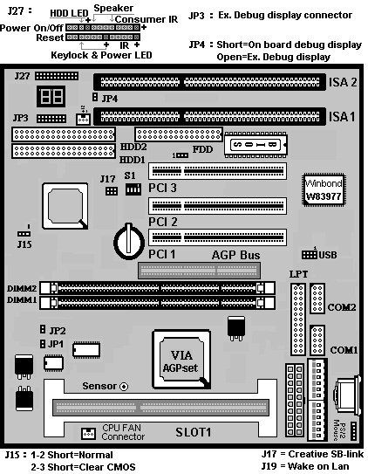

JP3:External Debug display connector.
JP4:
JP4
Open | External Debug Display
Short | On Board Debug Display

S1:Clock Ratio Table
In case the CPU you use is belonged old style - Multiplier type, you may refer to following set up. All the new frequency-fixed CPU are Auto-Detect so that
don’t need to set up S1.
S1
1-2 | 3-4 | 5-6 | 7-8 | Ratio
On | On | On | On | X2
On | On | On | Off | X2.5
On | On | Off | On | X3
On | On | Off | Off | X3.5
On | Off | On | On | X4
On | Off | On | Off | X4.5
On | Off | Off | On | X5
On | Off | Off | Off | X5.5
Off | On | On | On | X6
Off | On | On | Off | X6.5
Off | On | Off | On | X7
Off | On | Off | Off | X7.5
Off | Off | On | On | X8
Off | Off | On | Off | X8.5
Off | Off | Off | On | X9

J15:Clear CMOS

J15
1-2 | Normal Operation(Default)
2-3 | For Clearing CMOS Data

CPU Host Clock Setting:

JP1 | JP2 | Speed
On | On | 66MHz
On | Off | 100MHz
Off | On | 105MHz
Off | Off | 133MHz

J12: USB Header
